[MS-IEDOCO]:
Internet Explorer Standards Support Documentation Overview

Intellectual Property Rights Notice for Open Specifications Documentation
- Technical Documentation. Microsoft publishes Open Specifications documentation (“this documentation”) for protocols, file formats, data portability, computer languages, and standards support. Additionally, overview documents cover inter-protocol relationships and interactions.
- Copyrights. This documentation is covered by Microsoft copyrights. Regardless of any other terms that are contained in the terms of use for the Microsoft website that hosts this documentation, you can make copies of it in order to develop implementations of the technologies that are described in this documentation and can distribute portions of it in your implementations that use these technologies or in your documentation as necessary to properly document the implementation. You can also distribute in your implementation, with or without modification, any schemas, IDLs, or code samples that are included in the documentation. This permission also applies to any documents that are referenced in the Open Specifications documentation.
- No Trade Secrets. Microsoft does not claim any trade secret rights in this documentation.
- Patents. Microsoft has patents that might cover your implementations of the technologies described in the Open Specifications documentation. Neither this notice nor Microsoft's delivery of this documentation grants any licenses under those patents or any other Microsoft patents. However, a given Open Specifications document might be covered by the Microsoft Open Specifications Promise or the Microsoft Community Promise. If you would prefer a written license, or if the technologies described in this documentation are not covered by the Open Specifications Promise or Community Promise, as applicable, patent licenses are available by contacting iplg@microsoft.com.
- License Programs. To see all of the protocols in scope under a specific license program and the associated patents, visit the Patent Map.
- Trademarks. The names of companies and products contained in this documentation might be covered by trademarks or similar intellectual property rights. This notice does not grant any licenses under those rights. For a list of Microsoft trademarks, visit www.microsoft.com/trademarks.
- Fictitious Names. The example companies, organizations, products, domain names, email addresses, logos, people, places, and events that are depicted in this documentation are fictitious. No association with any real company, organization, product, domain name, email address, logo, person, place, or event is intended or should be inferred.
Reservation of Rights. All other rights are reserved, and this notice does not grant any rights other than as specifically described above, whether by implication, estoppel, or otherwise.
Tools. The Open Specifications documentation does not require the use of Microsoft programming tools or programming environments in order for you to develop an implementation. If you have access to Microsoft programming tools and environments, you are free to take advantage of them. Certain Open Specifications documents are intended for use in conjunction with publicly available standards specifications and network programming art and, as such, assume that the reader either is familiar with the aforementioned material or has immediate access to it.
Support. For questions and support, please contact dochelp@microsoft.com.
Revision Summary
Date | Revision History | Revision Class | Comments
2/24/2010 | 0.1 | New | Released new document.
3/17/2010 | 0.2 | Minor | Clarified the meaning of the technical content.
3/26/2010 | 1.0 | Minor | Clarified the meaning of the technical content.
5/26/2010 | 1.2 | None | Introduced no new technical or language changes.
6/29/2010 | 1.21 | Editorial | Changed language and formatting in the technical content.
9/8/2010 | 1.3 | Major | Significantly changed the technical content.
2/10/2011 | 2.0 | Minor | Clarified the meaning of the technical content.
12/7/2011 | 2.1 | Minor | Clarified the meaning of the technical content.
2/22/2012 | 3.0 | Major | Significantly changed the technical content.
7/25/2012 | 3.1 | Minor | Clarified the meaning of the technical content.
6/26/2013 | 4.0 | Major | Significantly changed the technical content.
3/31/2014 | 4.0 | None | No changes to the meaning, language, or formatting of the technical content.
1/22/2015 | 4.0 | None | No changes to the meaning, language, or formatting of the technical content.
4/17/2015 | 4.1 | Minor | Clarified the meaning of the technical content.
7/7/2015 | 4.2 | Minor | Clarified the meaning of the technical content.
11/2/2015 | 4.3 | Minor | Clarified the meaning of the technical content.
2/5/2016 | 4.4 | Minor | Clarified the meaning of the technical content.
3/22/2016 | 4.5 | Minor | Clarified the meaning of the technical content.
7/19/2016 | 4.6 | Minor | Clarified the meaning of the technical content.
11/2/2016 | 4.6 | None | No changes to the meaning, language, or formatting of the technical content.
3/14/2017 | 4.6 | None | No changes to the meaning, language, or formatting of the technical content.
4/25/2017 | 4.6 | None | No changes to the meaning, language, or formatting of the technical content.
5/17/2017 | 4.6 | None | No changes to the meaning, language, or formatting of the technical content.
10/3/2017 | 4.6 | None | No changes to the meaning, language, or formatting of the technical content.
12/5/2017 | 4.6 | None | No changes to the meaning, language, or formatting of the technical content.
2/22/2018 | 4.6 | None | No changes to the meaning, language, or formatting of the technical content.
3/5/2018 | 4.6 | None | No changes to the meaning, language, or formatting of the technical content.
Table of Contents
1 Documentation Scope and Objectives 5
1.1 Audience 5
1.2 Glossary 5
1.3 References 5
1.3.1 Normative References 5
1.3.2 Informative References 10
1.4 Microsoft Implementations 10
2 Documentation Architecture 11
2.1 Overview and Reference Documents 11
2.1.1 Versions of Standards 11
2.1.2 Microsoft Edge 11
2.1.3 Document Modes 11
2.1.3.1 How Internet Explorer Chooses Between Document Modes 13
2.1.3.2 Developer Tools 13
2.1.3.3 Enterprise Mode IE (EMIE) 14
2.1.3.4 iframe Handling 15
2.1.3.5 X-UA-Compatibility Meta Tag and HTTP Response Header 16
2.1.3.6 Compatibility View 19
2.1.3.7 !DOCTYPE Declaration 21
2.1.3.8 X-UA-Compatible Processing Instruction 23
2.1.4 Microsoft XML Core Services (MSXML) 24
2.1.5 Character Set Standards 24
2.2 Standards Support Summary 24
3 Change Tracking 34
4 Index 35

Documentation Scope and Objectives
This document provides an overview of certain final approved web standards supported by Microsoft web browsers. It is intended for use in conjunction with publicly available specifications and assumes that the reader either is familiar with this material or has immediate access to it.

Audience
The documentation set provides the following levels of audience support:
- For implementers—Provides conceptual and reference information for implementation of one or more specifications.
- For reviewers—Provides a resource for readers who want to evaluate or understand one or more specification implemented by Microsoft web browsers.

Glossary
MAY, SHOULD, MUST, SHOULD NOT, MUST NOT: These terms (in all caps) are used as defined in [RFC2119]. All statements of optional behavior use either MAY, SHOULD, or SHOULD NOT.

References

Normative References
We conduct frequent surveys of the normative references to assure their continued availability. If you have any issue with finding a normative reference, please contact dochelp@microsoft.com. We will assist you in finding the relevant information.
[HTML5] Berjon, R., Faulkner, S., Leithead, T., Navara, E., et al., Eds., "HTML5 -- A vocabulary and associated APIs for HTML and XHTML", http://www.w3.org/TR/html5/
[MS-ARIA] Microsoft Corporation, "Internet Explorer Accessible Rich Internet Applications (WAI-ARIA) 1.0 Standards Support Document".
[MS-CANVAS2D] Microsoft Corporation, "Microsoft Edge / Internet Explorer HTML Canvas 2D Context Standards Support Document".
[MS-CORSXF] Microsoft Corporation, "Internet Explorer Standards Support Cross-Origin Resource Sharing for XDomainRequest, Images, and Fonts Document".
[MS-CORS] Microsoft Corporation, "Internet Explorer Standards Support Cross-Origin Resource Sharing Document for XMLHttpRequest".
[MS-CSP2] Microsoft Corporation, "Microsoft Edge Content Security Policy Level 2 Standards Support Document".
[MS-CSS21E] Microsoft Corporation, "Internet Explorer Extensions to Cascading Style Sheets (CSS) 2.1 and DOM Level 2 Style Specifications".
[MS-CSS21] Microsoft Corporation, "Internet Explorer Cascading Stylesheets (CSS) 2.1 Standards Support Document".
[MS-CSS3COLR] Microsoft Corporation, "Internet Explorer CSS Color Module Level 3 Standards Support".
[MS-CSS3MQ] Microsoft Corporation, "Internet Explorer CSS Media Queries Module Level 3 Standards Support".
[MS-CSS3NS] Microsoft Corporation, "Internet Explorer CSS3 Namespaces Module Standards Support".
[MS-CSS3SEL] Microsoft Corporation, "Internet Explorer Selectors Level 3 Module Standards Support".
[MS-CSSATTR] Microsoft Corporation, "Internet Explorer CSS Style Attributes Standards Support Document".
[MS-DOM1X] Microsoft Corporation, "Microsoft XML Document Object Model (DOM) Level 1 Standards Support".
[MS-DOM1] Microsoft Corporation, "Internet Explorer Document Object Model (DOM) Level 1 Standards Support Document".
[MS-DOM2CEX] Microsoft Corporation, "Microsoft XML Extensions to the Document Object Model (DOM) Level 2 Core Specification".
[MS-DOM2CE] Microsoft Corporation, "Internet Explorer Extensions to the Document Object Model (DOM) Level 2 Core Specification".
[MS-DOM2CX] Microsoft Corporation, "Microsoft XML Document Object Model (DOM) Level 2 Core Standards Support".
[MS-DOM2C] Microsoft Corporation, "Internet Explorer Document Object Model (DOM) Level 2 Core Standards Support Document".
[MS-DOM2EE] Microsoft Corporation, "Internet Explorer Extensions to the Document Object Model (DOM) Level 2 Events Specification".
[MS-DOM2E] Microsoft Corporation, "Internet Explorer Document Object Model (DOM) Level 2 Events Standards Support Document".
[MS-DOM2H] Microsoft Corporation, "Internet Explorer Document Object Model (DOM) Level 2 HTML Standards Support Document".
[MS-DOM2S] Microsoft Corporation, "Internet Explorer Document Object Model (DOM) Level 2 Style Standards Support Document".
[MS-DOM2TR] Microsoft Corporation, "Internet Explorer Document Object Model (DOM) Level 2 Traversal and Range Standards Support Document".
[MS-DOM2V] Microsoft Corporation, "Internet Explorer Document Object Model (DOM) Level 2 Views Standards Support Document".
[MS-DOM3C] Microsoft Corporation, "Internet Explorer Document Object Model (DOM) Level 3 Core Standards Support Document".
[MS-DOM4] Microsoft Corporation, "Microsoft Edge / Internet Explorer DOM4 Standards Support Document".
[MS-ECMA402] Microsoft Corporation, "Internet Explorer ECMA-402 ECMAScript Internationalization API Standards Support".
[MS-ECMA404] Microsoft Corporation, "Microsoft Edge JSON Data Interchange Format Standards Support Document".
[MS-ELTRAV] Microsoft Corporation, "Internet Explorer Element Traversal Standards Support".
[MS-EPUB3] Microsoft Corporation, "Microsoft Edge / Internet Explorer EPUB Publications 3.0.1 Standards Support Document".
[MS-ES2016] Microsoft Corporation, "Microsoft Edge ECMA-262 ECMAScript Language Specification (7th Edition) Standards Support Document".
[MS-ES2017-INTL] Microsoft Corporation, "Microsoft Edge ECMAScript 2017 Internationalization API Specification (ECMA-402, 4th Edition, June 2017) Standards Support Document".
[MS-ES2017] Microsoft Corporation, "Microsoft Edge ECMAScript 2017 Language Specification (ECMA-262, 8th edition, June 2017) Standards Support Document".
[MS-ES3EX] Microsoft Corporation, "Microsoft JScript Extensions to the ECMAScript Language Specification Third Edition".
[MS-ES3] Microsoft Corporation, "Microsoft JScript ECMA-262-1999 ECMAScript Language Specification Standards Support Document".
[MS-ES51] Microsoft Corporation, "Internet Explorer ECMA-262 ECMAScript Language Specification (5.1 Edition) Standards Support".
[MS-ES5EX] Microsoft Corporation, "Internet Explorer Extensions to the ECMA-262 ECMAScript Language Specification (Fifth Edition)".
[MS-ES5] Microsoft Corporation, "Internet Explorer ECMA-262 ECMAScript Language Specification (Fifth Edition) Standards Support Document".
[MS-ES6] Microsoft Corporation, "Microsoft Edge / Internet Explorer ECMA-262 ECMAScript Language Specification (Sixth Edition) Standards Support Document".
[MS-ESI2] Microsoft Corporation, "Microsoft Edge / Internet Explorer ECMA-402 ECMAScript Internationalization API (2nd Edition) Specification Standards Support Document".
[MS-GEOLOC] Microsoft Corporation, "Internet Explorer Geolocation API Standards Support Document".
[MS-HIREST] Microsoft Corporation, "Internet Explorer High Resolution Time Standards Support".
[MS-HTML401E] Microsoft Corporation, "Internet Explorer Extensions to HTML 4.01 and DOM Level 2 HTML Specifications".
[MS-HTML401] Microsoft Corporation, "Internet Explorer HTML 4.01 Standards Support Document".
[MS-HTML51] Microsoft Corporation, "Microsoft Edge / Internet Explorer HTML5.1 Standards Support Document".
[MS-HTML5E] Microsoft Corporation, "Microsoft Edge / Internet Explorer Extensions to the HTML5 Specification".
[MS-HTML5] Microsoft Corporation, "Microsoft Edge / Internet Explorer HTML5 Standards Support Document".
[MS-INDEXDB] Microsoft Corporation, "Microsoft Edge / Internet Explorer Indexed Database API Standards Support Document".
[MS-ISO10646] Microsoft Corporation, "Microsoft Universal Multiple-Octet Coded Character Set (UCS) Standards Support Document".
[MS-ISO14496-10] Microsoft Corporation, "Microsoft Edge Coding of Audio-Visual Objects (Part 10: Advanced Video Coding) Standards Support Document".
[MS-ISO8859] Microsoft Corporation, "Microsoft 8-bit Single-byte Coded Graphic Character Sets Standards Support Document".
[MS-JPEG] Microsoft Corporation, "Internet Explorer ISO 10918-1 Image Compression and Encoding Standards Support".
[MS-LONGDESC] Microsoft Corporation, "Microsoft Edge / Internet Explorer HTML5 Image Description Extension (longdesc) Standards Support Document".
[MS-MEDIA-SOURCE] Microsoft Corporation, "Microsoft Edge / Internet Explorer Media Source Extensions Standards Support Document".
[MS-NAVTIM] Microsoft Corporation, "Internet Explorer Navigation Timing Standards Support Document".
[MS-P3P] Microsoft Corporation, "Internet Explorer Platform for Privacy Preferences (P3P) Standards Support Document".
[MS-PAGEVIS] Microsoft Corporation, "Internet Explorer Page Visibility Standards Support Document".
[MS-PDF] Microsoft Corporation, "Microsoft Edge ISO 32000-1 Portable Document Format (PDF) Standards Support Document".
[MS-PERFTL] Microsoft Corporation, "Internet Explorer Performance Timeline Standards Support Document".
[MS-PICSL] Microsoft Corporation, "Internet Explorer PICS Label Distribution and Syntax Standards Support Document".
[MS-PICSRL] Microsoft Corporation, "Internet Explorer PICSRules Standards Support Document".
[MS-PICSRS] Microsoft Corporation, "Internet Explorer PICS Rating Services and Systems Standards Support Document".
[MS-PNG] Microsoft Corporation, "Internet Explorer Portable Network Graphics (PNG) Standards Support Document".
[MS-POINTERLOCK] Microsoft Corporation, "Microsoft Edge / Internet Explorer Pointer Lock Standards Support Document".
[MS-POINTER] Microsoft Corporation, "Microsoft Edge / Internet Explorer Pointer Events Standards Support Document".
[MS-RUBY] Microsoft Corporation, "Internet Explorer Ruby Annotation Standards Support Document".
[MS-SELAPI1] Microsoft Corporation, "Internet Explorer Selectors API Level 1 Standards Support Document".
[MS-SVG] Microsoft Corporation, "Internet Explorer Scalable Vector Graphics (SVG) Standards Support Document".
[MS-TOUCH] Microsoft Corporation, "Microsoft Edge Touch Events Standards Support Document".
[MS-TTML] Microsoft Corporation, "Internet Explorer Timed Text Markup Language (TTML) 1.0 Standards Support Documentation".
[MS-USERTIM] Microsoft Corporation, "Internet Explorer User Timing Standards Support Document".
[MS-WEBCRYPTO] Microsoft Corporation, "Microsoft Edge Web Cryptography API Standards Support Document".
[MS-WEBIDL1] Microsoft Corporation, "Microsoft Edge / Internet Explorer WebIDL Level 1 Standards Support Document".
[MS-WEBMSG] Microsoft Corporation, "Microsoft Edge / Internet Explorer HTML5 Web Messaging Standards Support Document".
[MS-WEBNOT] Microsoft Corporation, "Microsoft Edge Web Notifications Standards Support Document".
[MS-WEBSTG2] Microsoft Corporation, "Microsoft Edge Web Storage (Second Edition) Standards Support Document".
[MS-WEBSTG] Microsoft Corporation, "Internet Explorer Web Storage Standards Support Document".
[MS-WOFF1] Microsoft Corporation, "Internet Explorer WOFF File Format 1.0 Standards Support".
[MS-XHTML] Microsoft Corporation, "Internet Explorer Extensible HyperText Markup Language (XHTML) Standards Support Document".
[MS-XMLH] Microsoft Corporation, "Internet Explorer XML 1.0 (Fifth Edition) Standards Support Document".
[MS-XMLNSH] Microsoft Corporation, "Internet Explorer XML Namespaces 1.0 Standards Support Document".
[MS-XMLNS] Microsoft Corporation, "Microsoft XML Namespaces Standards Support Document".
[MS-XMLSD] Microsoft Corporation, "Microsoft XML Schema (Part 2: Datatypes) Standards Support Document".
[MS-XMLSS] Microsoft Corporation, "Microsoft XML Schema (Part 1: Structures) Standards Support Document".
[MS-XMLSTYL] Microsoft Corporation, "Microsoft XML Associating Style Sheets with XML Standards Support Document".
[MS-XML] Microsoft Corporation, "Microsoft Extensible Markup Language (XML) 1.0 Fourth Edition Standards Support Document".
[MS-XPATHH] Microsoft Corporation, "Internet Explorer XPath Standards Support Document".
[MS-XPATH] Microsoft Corporation, "Microsoft XML XPath Standards Support Document".
[MS-XSLT] Microsoft Corporation, "Microsoft XSLTransformations (XSLT) Standards Support Document".
[RFC2119] Bradner, S., "Key words for use in RFCs to Indicate Requirement Levels", BCP 14, RFC 2119, March 1997, http://www.rfc-editor.org/rfc/rfc2119.txt
[W3C-XHTML1.0] World Wide Web Consortium, "XHTML™ 1.0 The Extensible HyperText Markup Language (Second Edition)", W3C Recommendation 26 January 2000 revised 1 August 2002, http://www.w3.org/TR/xhtml1/
[W3C-XML-StyleSheets] World Wide Web Consortium, "Associating Style Sheets with XML documents 1.0 (Second Edition)", W3C Recommendation 28 October 2010, http://www.w3.org/TR/xml-stylesheet/
[W3C-XSLT] World Wide Web Consortium, "XSL Transformations (XSLT) Version 1.0", W3C Recommendation 16 November 1999, http://www.w3.org/TR/1999/REC-xslt-19991116
[XML10] World Wide Web Consortium, "Extensible Markup Language (XML) 1.0 (Third Edition)", February 2004, http://www.w3.org/TR/2004/REC-xml-20040204/
[XMLNS] Bray, T., Hollander, D., Layman, A., et al., Eds., "Namespaces in XML 1.0 (Third Edition)", W3C Recommendation, December 2009, http://www.w3.org/TR/2009/REC-xml-names-20091208/

Informative References
[MSDN-DefiningDocCompat] Microsoft Corporation, "Defining document compatibility", Updated: November 2012, http://msdn.microsoft.com/en-us/library/cc288325(VS.85).aspx
[MSDN-EncodeXMLData] Microsoft Corporation, "How to Encode XML Data", March 2000, http://msdn.microsoft.com/en-us/library/aa468560.aspx
[MSDN-METATagsLocking] Microsoft Corporation, "META Tags and Locking in Future Compatibility", http://msdn.microsoft.com/en-us/library/cc817574.aspx
[MSDN-responseXML] Microsoft Corporation, "responseXML Property", http://msdn.microsoft.com/en-us/library/ms534370(VS.85).aspx
[MSDN-SECZONES] Microsoft Corporation, "About URL Security Zones", http://msdn.microsoft.com/en-us/library/ms537183.aspx
[MSDN-UnderstandingCompViewList] Microsoft Corporation, "Understanding the Compatibility View List", Updated: March 2011, http://msdn.microsoft.com/en-us/library/dd567845(VS.85).aspx
[MSDN-XMLDataIslands] Microsoft Corporation, "XML Data Islands", http://msdn.microsoft.com/en-us/library/ms766512(VS.85).aspx

Microsoft Implementations
The implementation of the specifications listed in section 2.2 is applicable to the following Microsoft browser versions:
- Windows Internet Explorer 7
- Windows Internet Explorer 8
- Windows Internet Explorer 9
- Windows Internet Explorer 10
- Internet Explorer 11
- Internet Explorer 11 for Windows 10
- Microsoft Edge
This document covers and is limited to variations and clarifications by these versions to the implementation of the listed final approved web standards.

Documentation Architecture
This section discusses the scope and organization of the standards support documentation for Microsoft web browsers.

Overview and Reference Documents
Microsoft web browsers rely on certain final approved web standards—including HTML5 [HTML5] and CSS 2.1 [MS-CSS21] —for some of their behavior. This documentation details the variations or extensions from the standards listed in the Standards Summary as implemented by Microsoft web browsers.

Versions of Standards
It is common for web standards to evolve over time, and multiple versions of the same standard may exist. This documentation covers the version of each standard that was targeted by the browser implementation. For example, HTML 4.01 is documented, but HTML 3.2, which is superseded by the 4.01 version, is not.

Microsoft Edge
Microsoft Edge is a new browser and rendering engine replacing Windows Internet Explorer. This new browser is designed to be interoperable with the web. This design allows for a simplification of architecture and design. Microsoft Edge removes the functionality to switch document modes and only renders in an interoperable standards compliant way (using the EdgeHTML engine). The following features have been removed in Microsoft Edge:
- Document Modes: Removed, always uses EdgeHTML
- Developer tools (F12) emulation switching: Removed
- X-UA-Compatibility Meta Tag and HTTP Response Header: Removed
- Compatibility View settings: Removed

Document Modes
Each major release of Internet Explorer adds new features. As Internet Explorer adds features, there is a risk that websites that are designed for older versions of the browser might not display as they are intended. To minimize this risk, Internet Explorer includes document compatibility, which enables a web developer to specify which Internet Explorer versions that a website is designed to support. Internet Explorer uses the "document modes," such as IE7 mode and IE8 mode, to interpret and render the website. For example, "Quirks Mode" displays webpages as if users view them with older versions of the browser. For more information, see "Defining Document Compatibility" at [MSDN-DefiningDocCompat].
Microsoft Edge is the browser version documented here that has the highest level of support for industry standards.
The following table shows the document modes supported by each browser implementation.
Browser version | Supported document modes
Windows Internet Explorer 7 | Quirks Mode  Standards Mode
Windows Internet Explorer 8 | Quirks Mode  IE7 Mode  IE8 Mode
Windows Internet Explorer 9 | Quirks Mode  IE7 Mode  IE8 Mode  IE9 Mode
Windows Internet Explorer 10 | Quirks Mode  IE7 Mode  IE8 Mode  IE9 Mode  IE10 Mode
Internet Explorer 11 | Quirks Mode  IE7 Mode  IE8 Mode  IE9 Mode  IE10 Mode  IE11 Mode
Internet Explorer 11 for Windows 10 | Quirks Mode  IE7 Mode  IE8 Mode  IE9 Mode  IE10 Mode  IE11 Mode
Microsoft Edge | EdgeHTML Mode
The standards mode of Internet Explorer 7 implements standards that have the same variations and extensions as IE7 mode in Internet Explorer 8 unless it is otherwise indicated in the individual specifications of the standards that the browser supports, as listed in section 2.2.
The standards mode of Internet Explorer 8 implements standards that have the same variations and extensions as IE8 mode in Internet Explorer 9 unless it is otherwise indicated in the individual specifications of the standards that the browser supports.
The document mode name sometimes includes "standards", such as IE8 standards mode, to differentiate the mode from "Almost Standards" mode. For brevity, the extra word is not included in this documentation.
Note Almost Standards mode enables the browser to properly render sliced-images-in-tables layouts. Rendering in Almost Standards mode matches standards mode except for the layout of images inside table cells. This type of table layout is handled the same way that Quirks Mode handles it. For more information, see [MS-CSS21], section 6, Appendix D: Almost Standards Mode.
Inline elements contribute to line height only under conditions described in [MS-CSS21], section 6.2. Otherwise, rendering is handled the same as in standards mode.

How Internet Explorer Chooses Between Document Modes
By default, Internet Explorer 8 uses IE8 mode, Internet Explorer 9 uses IE9 mode, etc. However, Internet Explorer uses several criteria to determine which document mode to use. For example, if an HTML page contains a valid <!DOCTYPE> declaration (see [HTML5]), Internet Explorer uses one of the standards-based document modes. But, if there is no valid <!DOCTYPE> declaration, Internet Explorer uses Quirks Mode. Microsoft Edge is designed to be interoperable for the web and is designed primarily to run in EdgeHTML mode. Only when there is no <!DOCTYPE> declaration does a page render in Quirks Mode.
The following rules determine how Internet Explorer selects the document mode:
- The Developer Tools setting overrides any document mode specified by a webpage. The setting remains active for the lifetime of the tab.
- In Internet Explorer 9, if the document is hosted in an iframe element, the document mode is determined by the document mode of the top-level webpage. Subdocuments cannot be rendered in IE9 mode unless the top-level document is also in IE9 mode.
- A meta tag with a value of X-UA-Compatible or a HTTP response header can override items in the Compatibility View Settings list and the doctype unless the X-UA-Compatible value is a Compatibility View setting, such as IE=EmulateIE7 or IE=EmulateIE8.
- The Compatibility View settings can force a webpage to be displayed in a less-standard document mode.
- The Local Compatibility Site list, the Microsoft Compatibility Site list and the Enterprise Mode IE Compatibility Site list can force a webpage to be displayed in other document modes.
- Group Policy settings override settings and force all webpages to be displayed in the specified document mode.
- If none of these rules apply, the <!DOCTYPE> declaration determines whether the webpage renders in a standards mode, Almost Standards mode, or Quirks Mode.
The following rules determine how Microsoft Edge selects the document mode:
The <!DOCTYPE> declaration determines whether the webpage renders some specific Quirks Mode emulation (QME) behaviors called out in the [MS-HTML5] and [MS-CSS21] documentation.
The following sections explain how these rules affect how Internet Explorer selects between document modes. Most of these sections do not apply to Microsoft Edge unless explicitly called out.

Developer Tools
This functionality will not be implemented in any version of Microsoft Edge.
In Internet Explorer 8, Internet Explorer 9, and Internet Explorer 10, a user can select the browser mode and document mode by using the Developer Tools (F12) in Internet Explorer. These settings remain active for subsequent navigations in the same tab. The following diagram shows how Developer Tools settings impact the browser mode and document mode. This diagram also includes a screen shot of the Document Mode menu in the Developer Tools window.
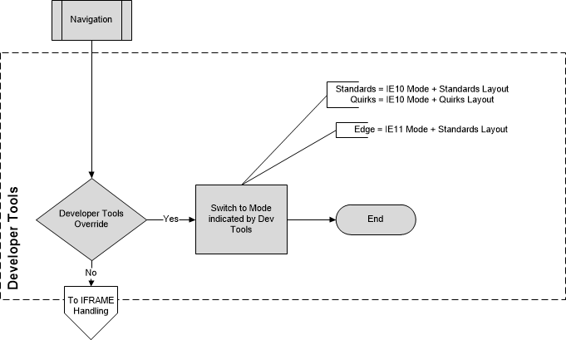
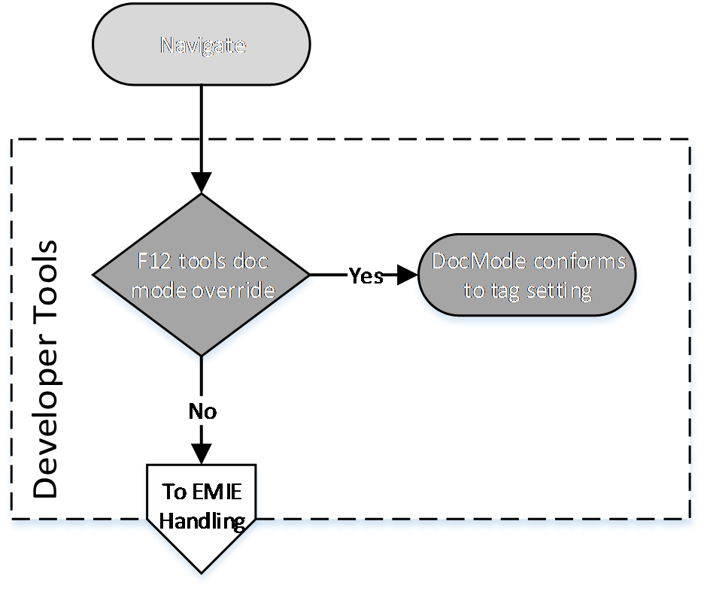

Enterprise Mode IE (EMIE)
This functionality will not be implemented in any version of Microsoft Edge.
In Internet Explorer 11, within an enterprise environment, a system administrator can configure enterprise web apps and websites to emulate Internet Explorer 8, avoiding the common compatibility problems associated with web apps, and website written and tested on older versions of Internet Explorer.
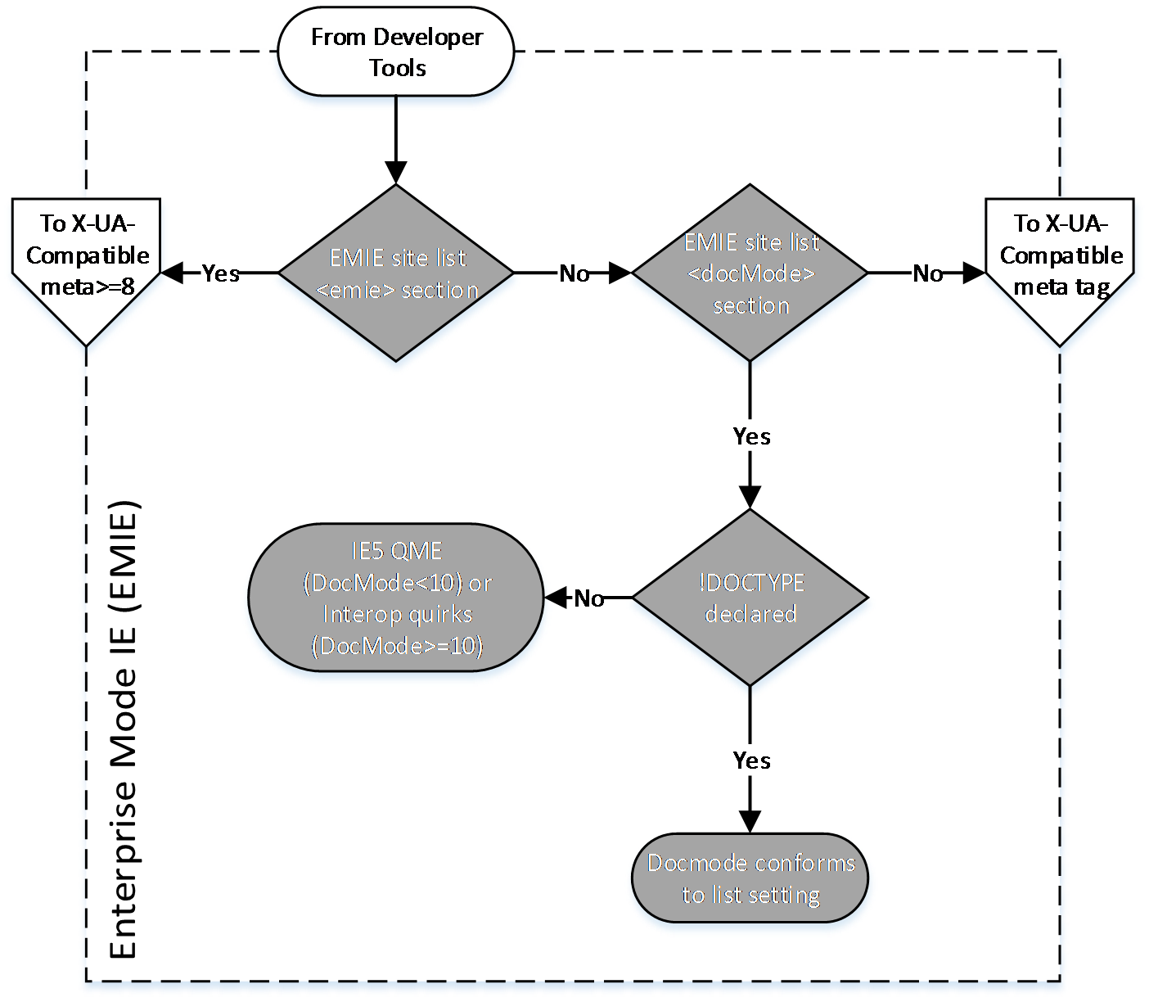

iframe Handling
Internet Explorer 9 restricts the document mode of webpages that are hosted within iframe elements. If the top-level page is not in IE9 mode, the iframe element cannot render its contents in IE9 mode, even if the web developer specifies it.
This behavior is available only in Internet Explorer 9. The following diagram shows how iframe elements impact the document mode.
Internet Explorer 10 and Internet Explorer 11 both use Quirks Mode emulation if the top-level page is not in EdgeHTML Mode. Quirks Mode in Internet Explorer 10 and Internet Explorer 11 is based on the definition of Quirks Mode from the HTML5 standard.
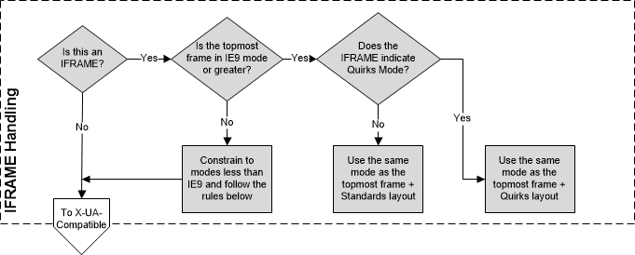

X-UA-Compatibility Meta Tag and HTTP Response Header
This functionality will not be implemented in any version of Microsoft Edge.
Web developers can also specify a document mode by including instructions in a meta element or HTTP response header:
- Webpages that include a meta element (see [HTML5]) with an http-equivalent value of X-UA-Compatible.
- Webpages that are served with an HTTP header named "X-UA-Compatible".
If both of these instructions are sent, the developer's preference (meta element) takes precedence over the web server setting (HTTP header).
For more information about how to control default rendering with document modes, see "META Tags and Locking in Future Compatibility" at [MSDN-METATagsLocking].
The X-UA-Compatible value determines Internet Explorer's document as follows:
X-UA-Compatible value | Document modes
IE=5 | Quirks Mode
IE=7 | IE7 mode
IE=8 | IE8 mode
IE=9 | IE9 mode
IE=10 | IE10 mode
IE=11 | IE11 mode
IE=edge | The highest supported document mode of the browser
IE=EmulateIE7 | IE7 mode (if a valid <!DOCTYPE> declaration is present)  Quirks Mode (otherwise)
IE=EmulateIE8 | IE8 mode (if a valid <!DOCTYPE> declaration is present)  Quirks Mode (otherwise)
IE=EmulateIE9 | IE9 mode (if a valid <!DOCTYPE> declaration is present)  Quirks Mode (otherwise)
IE=EmulateIE10 | IE10 mode (if a valid <!DOCTYPE> declaration is present)  Quirks Mode (otherwise)
IE=EmulateIE11 | IE11 mode (if a valid <!DOCTYPE> declaration is present)  Quirks Mode (otherwise)
For example, in Internet Explorer 8, IE=9, IE=Edge, and IE=EmulateIE9 result in IE8 mode.
Browser emulation modes are not document modes. They instruct Internet Explorer about how to select a document mode when a valid <!DOCTYPE> declaration is included.
The following diagram shows how Internet Explorer determines the appropriate document mode based on the meta element or HTTP header.
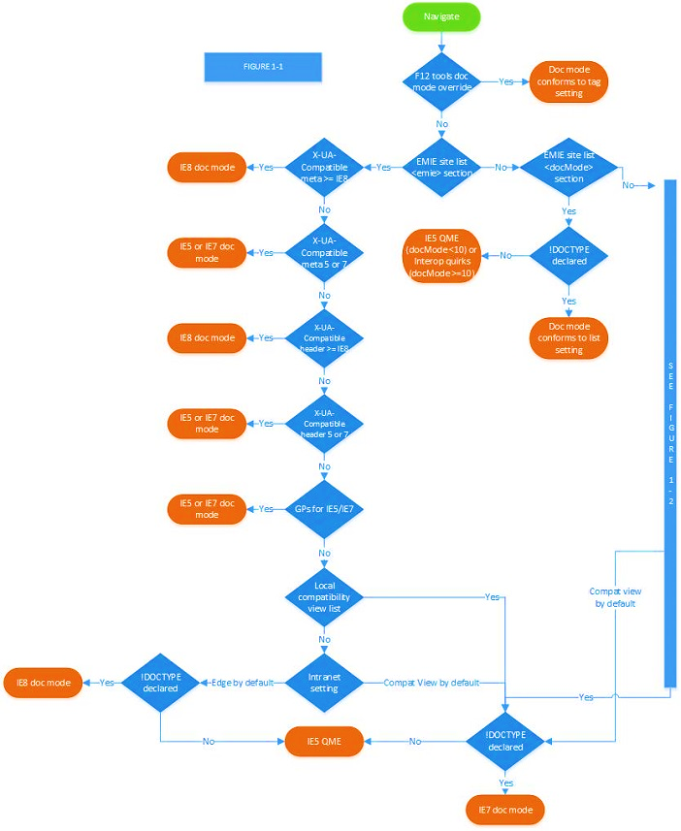
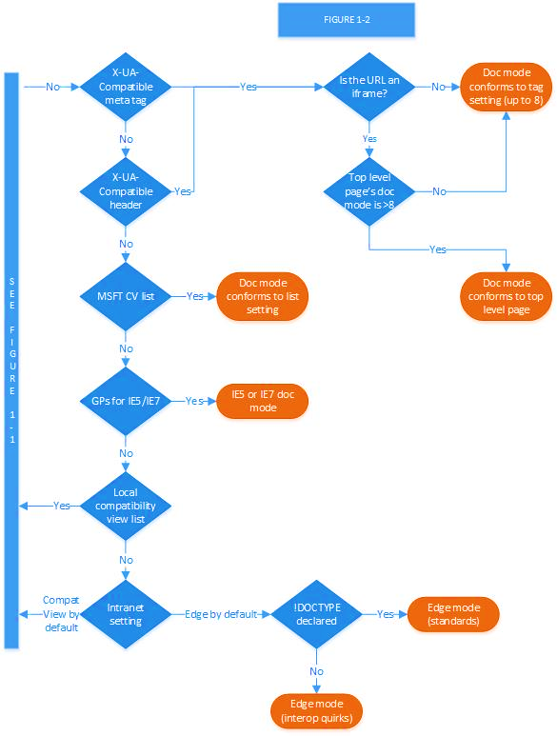

Compatibility View
This functionality will not be implemented in any version of Microsoft Edge.
Compatibility View settings can also impact the document mode selection:
- If a webpage is retrieved from a website in the Local intranet zone (see "About URL Security Zones" at [MSDN-SECZONES]), IE7 mode is used.
- If the webpage is retrieved from a site in a domain on the Compatibility View list (and the list is active), IE7 mode is used (see "Understanding the Compatibility View List" at [MSDN-UnderstandingCompViewList]).
Compatibility View is controlled by browser settings. When a user clicks the Compatibility View button next to the Address bar in Internet Explorer, the website is added to a local list of exceptions called the "Compatibility View list." The user can manage the list in the Compatibility View Settings dialog box.
The "Display all websites in Compatibility View" feature is not available in Internet Explorer 11.
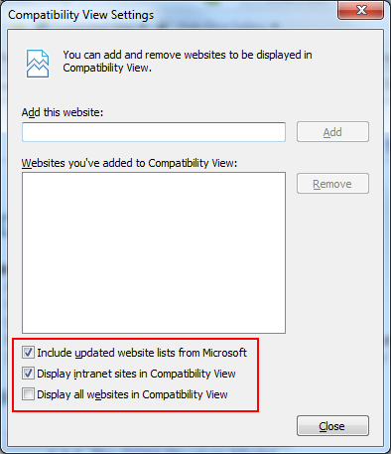
In addition to the user's local Compatibility View list, Microsoft regularly publishes a list of popular sites that render better in Compatibility View. The user can choose to use this list by selecting the Include updated website lists from Microsoft check box in the Compatibility View Settings dialog box.
Finally, the user can choose to view all websites or intranet sites in Compatibility View by selecting the Display intranet sites in Compatibility View or Display all websites in Compatibility View check boxes in the Compatibility View Settings dialog box.
The following diagram shows how Internet Explorer determines the appropriate document mode based on Compatibility View settings.
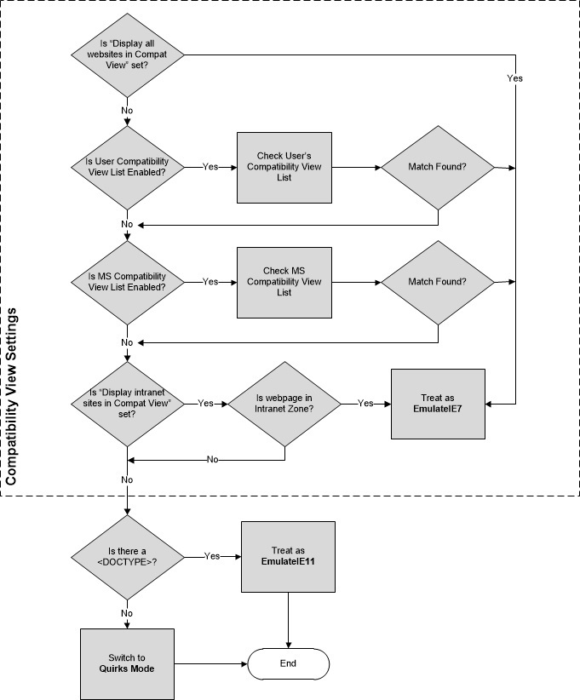

!DOCTYPE Declaration
The following table lists examples of the most common <!DOCTYPE> declarations and how they influence which document mode is used.
<!DOCTYPE> declaration | Document Mode Impact
HTML 4.0 and higher  <!DOCTYPE HTML PUBLIC "-//W3C//DTD HTML 4.0//EN">  <!DOCTYPE HTML PUBLIC "-//W3C//DTD HTML 4.01//EN">  <!DOCTYPE HTML PUBLIC "-//W3C//DTD HTML 4.0//EN" "http://www.w3org/TR/html4/strict.dtd">  <!DOCTYPE HTML PUBLIC "-//W3C//DTD HTML 4.01//EN" "http://www.w3org/TR/html4/strict.dtd">  XHTML with or without a system identifier  <!DOCTYPE html PUBLIC "-//W3C//DTD XHTML 1.1//EN" "http://www.w3org/TR/xhtml11/DTD/xhtml11.dtd">  <!DOCTYPE html PUBLIC "-//W3C//DTD XHTML Basic 1.0//EN" "http://www.w3org/TR/xhtml-basic/xhtml-basic10.dtd">  <!DOCTYPE html PUBLIC "-//W3C//DTD XHTML 1.0 Strict//EN" "http://www.w3org/TR/xhtml1/DTD/xhtml1-strict.dtd">  Unknown  <!DOCTYPE html> | Standards mode or EdgeHTML in Microsoft Edge
XHTML Transitional or Frameset  <!DOCTYPE html PUBLIC "-//W3C//DTD XHTML 1.0 Transitional//EN">  <!DOCTYPE html PUBLIC "-//W3C//DTD XHTML 1.0 Frameset//EN">  <!DOCTYPE html PUBLIC "-//W3C//DTD XHTML 1.0 Transitional//EN" "http://www.w3.org/TR/xhtml1/DTD/xhmlt1-transitional.dtd">  HTML 4.0 or HTML 4.01 Transitional or Frameset with a system identifier  <!DOCTYPE HTML PUBLIC "-//W3C//DTD HTML 4.0 Transitional//EN" "http://www.w3org/TR/html4/loose.dtd">  <!DOCTYPE HTML PUBLIC "-//W3C//DTD HTML 4.01 Transitional//EN" "http://www.w3org/TR/html4/loose.dtd">  <!DOCTYPE HTML PUBLIC "-//W3C//DTD HTML 4.0 Transitional//EN" "http://www.w3org/TR/1999/REC-html401-19991224/loose.dtd"> | "Almost Standards" mode (standards mode in IE7)
HTML 4 and lower, or no DOCTYPE  <!DOCTYPE HTML PUBLIC "-//W3C//DTD HTML 3.2 Final//EN">  <!DOCTYPE HTML PUBLIC "-//W3C//DTD HTML 4.0 Transitional//EN">  <!DOCTYPE HTML PUBLIC "-//W3C//DTD HTML 4.01 Transitional//EN">  None | Quirks Mode or Quirks Mode emulation in Microsoft Edge

X-UA-Compatible Processing Instruction
This functionality will not be implemented in any version of Microsoft Edge.
Internet Explorer 10 and Internet Explorer 11 use the x-ua-compatible processing instruction to switch the document mode of XML and XHTML documents:
<?x-ua-compatible content="IE=10"?>
This processing instruction (PI), in combination with other IE document mode settings, produces the following behavior for XML:
The x-ua-compatible PI can affect document mode just like the meta tag in HTML:
- The X-UA-Compatible HTTP header can affect the document mode just like in HTML.
- The minimum selectable document mode for XML is 9 (this differs from HTML).
Note that if the Browser Mode (set via CV List, CV Button, Dev Tools, Intranet, etc.) is less than IE9, then the legacy MSXML Mime Viewer will be used for "text/xml" documents regardless of any other versioning information.
- Quirks emulation mode (QME) is not supported in XML documents.
- The x-ua-compatible PI can only be preceded by the XML Declaration and/or whitespace, anything else causes it to be ignored.
- The value of the x-ua-compatible PI must in the form of well-formed XML attributes, else it will be ignored.
- Only the "content" attribute from the x-ua-compatible PI will be read, but other attributes are allowed.
- The supported format for the "content" attribute on the x-ua-compatible PI must match the meta tag from HTML.
- Using the x-ua-compatible PI prior to an XSLT transform sets the "ceiling" mode of the output from XSLT. For example if the PI opts into IE9 mode in Internet Explorer 10 and the transform produces HTML output with the HTML5 DOCTYPE, then that output will render in IE9 mode. Conversely if the output does not contain a DOCTYPE, it will render in Quirks Mode.

Microsoft XML Core Services (MSXML)
This functionality will not be implemented in any version of Microsoft Edge.
Microsoft XML Core Services (MSXML) version 3 provides the XML functionality of Internet Explorer in Quirks Mode, IE7 Mode, and IE8 Mode. In IE9 Mode, MSXML6 is used for rendering XSLT [W3C-XSLT], however Internet Explorer 9 natively implements XML [XML10], XHTML [W3C-XHTML1.0], XML Namespaces [XMLNS], and XML Stylesheets [W3C-XML-StyleSheets].
The MSXML or native parser is loaded whenever Internet Explorer encounters one or more of the following conditions:
- A document is served with one of the following Content-Type HTTP headers:
  - text/xml
  - application/xml
  - application/xml+xhtml (Internet Explorer 9)
  - image/svg+xml
- An XMLHttpRequest object provides access to an XML DOM containing the network response in the responseXML property (see [MSDN-responseXML]).
- An XML data island is accessed with the XMLDocument property (see [MSDN-XMLDataIslands]). Data islands are not supported IE10 Mode and IE11 Mode.
The Internet Explorer Standards Support Documentation also includes documents that describe MSXML and Internet Explorer 9 conformance to DOM and XML standards.

Character Set Standards
Character sets in the HTML 5 standard [HTML5] are referenced in ISO/IEC 10646-2003, Information technology -- Universal Multiple-Octet Coded Character Set (UCS) (see [MS-ISO10646]). All versions of Internet Explorer support ISO/IEC 8859-1 and others, Information Technology -- 8-bit Single-byte Coded Graphic Character Sets (see [MS-ISO8859]). In general, string handling is performed as UTF-16.
Character set values are supplied to HTML using either the Content-Type header or the META element. The following example specifies the character set for the Latin alphabet set number 1:
<META HTTP-EQUIV="Content-Type" CONTENT="text/html; charset=ISO-8859-1">
The following example does the same with an XML processing instruction:
<?xml version="1.0" charset="iso-8859-1"?>
For more information, see [MSDN-EncodeXMLData].

Standards Support Summary
The tables below provide a list of certain final-approved Internet standards implemented by Internet Explorer and / or Microsoft Edge.
Standards in this table enable functionality in web documents.
Standard Name | Description | Link
Accessible Rich Internet Applications (WAI-ARIA) 1.0 | This specification provides an ontology of roles, states, and properties that define accessible user interface elements that can be used to improve the accessibility and interoperability of web content and applications. | [MS-ARIA]
HTML Canvas 2D Context | This specification defines the 2D Context for the HTML canvas element. The 2D Context provides objects, methods, and properties to draw and manipulate graphics on a canvas drawing surface. | [MS-CANVAS2D]
Cross-Origin Resource Sharing | This document defines a mechanism to enable client-side cross-origin requests. Specifications that enable an API to make cross-origin requests to resources can use the algorithms defined by this specification. | [MS-CORS]  [MS-CORSXF]
Content Security Policy Level 2 | This document defines a policy language used to declare a set of content restrictions for a web resource, and a mechanism for transmitting the policy from a server to a client where the policy is enforced. | [MS-CSP2]
Cascading Style Sheets (CSS) 1.0 and 2.1 | These specifications define Cascading Style Sheets (CSS) level 1 (CSS1) and level 2 revision 1 (CSS 2.1). CSS is a style sheet language that allows authors and users to attach style (for example, fonts, colors, and spacing) to structured documents (for example, HTML documents and XML applications). By separating the presentation style of documents from the content of documents, CSS simplifies Web authoring and site maintenance. | [MS-CSS21]  [MS-CSS21E]
CSS3 Color Module Level 3 | This specification describes color values and properties for foreground color and group opacity. These include properties and values from CSS level 2 and new values. | [MS-CSS3COLR]
Media Queries | This specification defines media queries, which enable a document to tailor presentations to different media types, for example, ‘screen’ and ‘print’. | [MS-CSS3MQ]
W3C CSS Namespaces Module Level 3 | This specification defines the syntax for using namespaces in CSS. It also defines a syntax that other specifications can adopt for using those prefixes in namespace-qualified names. | [MS-CSS3NS]
W3C Selectors Level 3 | This specification describes the selectors that already exist in CSS1 and CSS2, and further introduces new selectors for CSS3 and other languages that may need them. A selector is a pattern that matches against elements in a tree; it is used to select nodes in an XML document. | [MS-CSS3SEL]
CSS Style Attributes | This specification describes the syntax and interpretation of the CSS fragment that can be used in the style attributes that markup languages such as HTML and SVG provide on most elements. | [MS-CSSATTR]
Document Object Model (DOM) Level 1 | This specification defines the Document Object Model Level 1, a platform- and language-neutral interface that allows programs and scripts to dynamically access and update the content, structure and style of documents. | [MS-DOM1]
Document Object Model (DOM) Level 2 Core | This specification defines the Document Object Model Level 2 Core, a platform- and language-neutral interface that allows programs and scripts to dynamically access and update the content and structure of documents. The Document Object Model Level 2 Core builds on the Document Object Model Level 1 Core. | [MS-CSS21E]  [MS-DOM2C]  [MS-DOM2CE]
Document Object Model (DOM) Level 2 Events | This specification defines the Document Object Model Level 2 Events, a platform- and language-neutral interface that gives to programs and scripts a generic event system. The Document Object Model Level 2 Events builds on the Document Object Model Level 2 Core and on Document Object Model Level 2 Views. | [MS-DOM2E]  [MS-DOM2EE]
Document Object Model (DOM) Level 2 HTML | This specification defines the Document Object Model Level 2 HTML, a platform- and language-neutral interface that allows programs and scripts to dynamically access and update the content and structure of HTML 4.01 and XHTML 1.0 documents. The Document Object Model Level 2 HTML builds on the Document Object Model Level 2 Core. It is not backward compatible with DOM Level 1 HTML. | [MS-DOM2H]
Document Object Model (DOM) Level 2 Style | This specification defines the Document Object Model Level 2 Style Sheets and Cascading Style Sheets (CSS), a platform- and language-neutral interface that allows programs and scripts to dynamically access and update the content and of style sheets documents. The Document Object Model Level 2 Style builds on the Document Object Model Level 2 Core and on the Document Object Model Level 2 Views. | [MS-DOM2S]
Document Object Model (DOM) Level 2 Traversal and Range Specification | This specification defines the Document Object Model Level 2 Traversal and Range, platform- and language-neutral interfaces that allow programs and scripts to dynamically traverse and identify a range of content in a document. The Document Object Model Level 2 Traversal and Range builds on the Document Object Model Level 2 Core. | [MS-DOM2TR]
Document Object Model (DOM) Level 2 Views | This specification defines the Document Object Model Level 2 Views, a platform- and language-neutral interface that allows programs and scripts to dynamically access and update the content of a representation of a document. The Document Object Model Level 2 Views builds on the Document Object Model Level 2 Core. | [MS-DOM2V]
Document Object Model (DOM) Level 3 Core | This specification defines the Document Object Model Core Level 3, a platform- and language-neutral interface that allows programs and scripts to dynamically access and update the content, structure and style of documents. The Document Object Model Core Level 3 builds on the Document Object Model Core Level 2. | [MS-DOM3C]
W3C DOM4 | DOM defines a platform-neutral model for events and node trees. DOM4 adds Mutation Observers as a replacement for Mutation Events. | [MS-DOM4]
W3C Element Traversal | This specification defines the ElementTraversal interface, which allows script navigation of the elements of a DOM tree, excluding all other nodes in the DOM, such as text nodes. It also provides an attribute to expose the number of child elements of an element. It is intended to provide a more convenient alternative to existing DOM navigation interfaces, with a low implementation footprint. | [MS-ELTRAV]
EPUB Publications 3.01 | This specification defines semantics and conformance requirements for EPUB® Publications, including the format of the Package Document that describes each Rendition of the content and rules for how this document and other Publication Resources are associated to create a conforming EPUB Publication. | [MS-EPUB3]
W3C Geolocation API Specification | This specification defines an API that provides scripted access to geographical location information associated with the hosting device. | [MS-GEOLOC]
W3C High Resolution Time | This specification defines a JavaScript interface that provides the current time in sub-millisecond resolution such that it is not subject to system clock skew or adjustments. | [MS-HIREST]
HTML 4.01 | This specification defines the HyperText Markup Language (HTML), the publishing language of the World Wide Web. Specifically, it defines HTML 4.01, which is a subversion of HTML 4. In addition to the text, multimedia, and hyperlink features of the previous versions of HTML (HTML 3.2 and HTML 2.0), HTML 4 supports more multimedia options, scripting languages, style sheets, better printing facilities, and documents that are more accessible to users with disabilities. HTML 4 also takes great strides towards the internationalization of documents, with the goal of making the Web truly World Wide. | [MS-HTML401]  [MS-HTML401E]
HTML5 | This specification defines the fifth major revision of the core language of the Hypertext Markup Language (HTML), which is the standard markup language of the World Wide Web. In this version, new features are introduced to help Web application authors, new elements are introduced based on research into prevailing authoring practices, and special attention has been given to defining clear conformance criteria for user agents to improve interoperability. | [MS-HTML5]  [MS-HTML5E]
HTML 5.1 | This specification defines the first minor revision of the fifth major version of the Hypertext Markup Language (HTML), which is the standard markup language of the World Wide Web. In this version, there are new features to help Web application authors, and new elements based on research into prevailing authoring practices. There are also clear conformance criteria for user agents, to improve interoperability. | [MS-HTML51]
Indexed Database API | This document defines APIs for a database of records holding simple values and hierarchical objects. Each record consists of a key and some value. Moreover, the database maintains indexes over records it stores. | [MS-INDEXDB]
ISO/IEC 14496-10:2014  Information technology -- Coding of audio-visual objects -- Part 10: Advanced Video Coding | This specification defines advanced video coding for audio-visual objects. | [MS-ISO14496-10]
HTML5 Image Description Extension (longdesc) | This specification defines a longdesc attribute (based on the longdesc attribute of HTML 4) to link descriptions to images in HTML5 content. | [MS-LONGDESC]
Media Source Extensions™ | This specification extends HTMLMediaElement (HTML 5.1) to allow JavaScript to generate media streams for playback, facilitating use cases such as adaptive streaming and time shifting of live streams. | [MS-MEDIA-SOURCE]
Navigation Timing | This specification defines an interface for web applications to access timing information related to navigation and elements. | [MS-NAVTIM]
The Platform for Privacy Preferences 1.0 (P3P1.0) | This document, along with its normative references, includes all the specification necessary for the implementation of interoperable P3P applications. | [MS-P3P]
Page Visibility | This specification defines a means for site developers to programmatically determine the current visibility state of the page to develop powerful and CPU-efficient web applications. | [MS-PAGEVIS]
ISO 32000-1:2008  Document management -- Portable document format -- Part 1: PDF 1.7 | This document specifies Portable Document Format (PDF) a digital form for representing electronic documents to enable users to exchange and view them independent of the environment in which they were created or the environment in which they are viewed or printed. | [MS-PDF]
Performance Timeline | This specification defines a unified interface to store and retrieve performance metric data. It does not cover individual performance metric interfaces. | [MS-PERFTL]
PICS Label Distribution Label Syntax and Communication Protocols | This specification defines a general format for labels (metadata) and three methods by which these labels may be transmitted. Labels were originally designed to help control what children access on the Internet, but have other uses, including code signing and privacy. | [MS-PICSL]
PICSRules 1.1 | This document defines a language for writing profiles, which are filtering rules that allow or block access to URLs based on PICS labels that describe those URLs. This language is intended as a transmission format; individual implementations must be able to read and write their specifications in this language, but need not use this format internally. | [MS-PICSRL]
Pointer Events | This document defines events and related interfaces for handling hardware-agnostic pointer input from devices such as mouse, pen, and touchscreen. For compatibility with existing mouse-based content, this specification also describes a mapping to fire Mouse Events for other pointer device types. | [MS-POINTER]
Pointer Lock | This specification defines an API that provides scripted access to raw mouse movement data while locking the target of mouse events to a single element and removing the cursor from view. This is an essential input mode for certain classes of applications, especially first person perspective 3D applications and 3D modeling software. | [MS-POINTERLOCK]
Rating Services and Rating Systems (and Their Machine Readable Descriptions) | This document defines a language for describing rating services. Software programs read service descriptions written in this language to interpret content labels and assist end-users in configuring selection software. | [MS-PICSRS]
Ruby Annotation | This specification defines markup for ruby - short runs of text alongside the base text - in the form of an XHTML module. Ruby are typically used in East Asian documents to indicate pronunciation or to provide a short annotation. | [MS-RUBY]
Selectors API Level 1 | This specification defines methods for retrieving element nodes from the DOM by matching against a group of selectors. A selector is a pattern that matches against elements in a tree. | [MS-SELAPI1]
Scalable Vector Graphics (SVG) 1.1 (Second Edition) | This specification defines the features and syntax for Scalable Vector Graphics (SVG) Version 1.1, a modularized language for describing two-dimensional vector and mixed vector/raster graphics in XML. | [MS-SVG]
Touch Events | This specification defines a set of low-level events that represent one or more points of contact with a touch-sensitive surface, and changes of those points with respect to the surface and any DOM elements displayed upon it (e.g. for touch screens) or associated with it (e.g. for drawing tablets without displays). It also addresses pen-tablet devices, such as drawing tablets, with consideration toward stylus capabilities. | [MS-TOUCH]
Timed Text Markup Language (TTML) 1.0 | This document specifies the Timed Text Markup Language (TTML) in terms of a vocabulary and semantics thereof. TTML is a content type that represents timed text media to exchange such media among authoring systems. Timed text is textual information that is associated with timing information. | [MS-TTML]
User Timing | This specification defines an interface to help web developers measure the performance of their applications by giving them access to high precision timestamps. | [MS-USERTIM]
Web Cryptography API | This specification describes a JavaScript API for performing basic cryptographic operations in web applications, such as hashing, signature generation and verification, and encryption and decryption. Uses for this API include user and service authentication, document and code signing, and the confidentiality and integrity of communications. | [MS-WEBCRYPTO]
WebIDL Level 1 | This document defines an interface definition language, Web IDL, that can be used to describe interfaces that are intended to be implemented in web browsers. Web IDL is an IDL variant with features that allow the behavior of common script objects in the web platform to be specified more readily. | [MS-WEBIDL1]
HTML5 Web Messaging | This specification defines two mechanisms for communicating between browsing contexts in HTML documents. | [MS-WEBMSG]
Web Notifications | This specification defines an API for end-user notifications. A notification allows alerting the user outside the context of a web page of an occurrence, such as the delivery of email. | [MS-WEBNOT]
Web Storage | This specification defines an API for persistent data storage of key-value pair data in web clients. | [MS-WEBSTG]
Web Storage (Second Edition) | This specification defines an API for persistent data storage of key-value pair data in Web clients. | [MS-WEBSTG2]
WOFF File Format 1.0 | This document specifies the WOFF font packaging format, which was designed to provide lightweight, easy-to-implement compression of font data, suitable for use with CSS @font-face rules. | [MS-WOFF1]
XHTML™ 1.0 The Extensible HyperText Markup Language (Second Edition) | XHTML is a family of current and future document types and modules that reproduce, subset, and extend HTML 4. XHTML family document types are XML based, and ultimately are designed to work in conjunction with XML-based user agents. | [MS-XHTML]
Standards in this table enable functionality in XML documents.
Where Internet Explorer 7 and Internet Explorer 8 use MSXML3 exclusively, Internet Explorer 9, Internet Explorer 10, and Internet Explorer 11 use MSXML3 to support such specifications only in Quirks Mode, IE7 mode, and IE8 mode. Internet Explorer also includes built-in support for XML specifications in Internet Explorer 9, Internet Explorer 10, and Internet Explorer 11. The built-in support is described in [MS-XMLH] and [MS-XMLNSH].
Standard Name | Description | Link
Document Object Model (DOM) Level 1 | DOM Level 1 provides a platform- and language-neutral interface that allows programs and scripts to dynamically access and update the content, structure and style of documents. The Document Object Model provides a standard set of objects for representing HTML and XML documents, a standard model of how these objects can be combined, and a standard interface for accessing and manipulating them. | [MS-DOM1X]
Document Object Model (DOM) Level 2 Core | The DOM Level 2 Core is made of a set of core interfaces to create and manipulate the structure and contents of a document. The Core also contains specialized interfaces dedicated to XML. The DOM Level 2 Core builds on the DOM Level 1 Core. | [MS-DOM2CX]  [MS-DOM2CEX]
Extensible Markup Language (XML) 1.0 (Fourth Edition) | The Extensible Markup Language (XML) allows generic data to be served, received, and processed on the Web in the way that is now similar to HTML. XML was designed for ease of implementation and for interoperability with both SGML and HTML. | [MS-XML]  [MS-XMLH]
Namespaces in XML 1.0 (Third Edition) | XML namespaces provide a simple method for qualifying element and attribute names used in Extensible Markup Language (XML) documents by associating them with namespaces identified by IRI references. | [MS-XMLNS]  [MS-XMLNSH]
XML Schema Part 2: Datatypes Second Edition | This specification defines facilities for defining datatypes to be used in XML Schemas as well as other XML specifications. The datatype language provides a superset of the capabilities found in XML 1.0 document type definitions (DTDs) for specifying datatypes. | [MS-XMLSD]
XML Schema Part 1: Structures (Second Edition) | This specification sets out the structural part of the XML Schema definition language. | [MS-XMLSS]
Associating Style Sheets with XML documents 1.0 (Second Edition) | This specification describes how a style sheet can be associated with an XML document by including one or more processing instructions. | [MS-XMLSTYL]
XML Path Language (XPath) Version 1.0 | This specification defines XPath, a language for addressing parts of an XML document. XPath is designed to be used by both XSLT and XPointer. | [MS-XPATH]  [MS-XPATHH]
XSL Transformations (XSLT) Version 1.0 | XSLT is a language for transforming XML documents into other XML documents. | [MS-XSLT]
Standards in this table enable support of image files (for Internet Explorer 7 and Internet Explorer 8 only.)
Standard Name | Description | Link
ISO-10918-1:1994 Information technology -- Digital compression and coding of continuous-tone still images: Requirements and guidelines | This specification defines processes for converting source image data to compressed image data. The method is used in JPEG files. | [MS-JPEG]
Portable Network Graphics (PNG) (Second Edition) | PNG is an extensible file format for the lossless, portable, well-compressed storage of raster images. It is also published as ISO/IEC 15948:2003. | [MS-PNG]
Standards in this table enable support of character sets.
Standard Name | Description | Link
ISO/IEC 10646:2003 Information technology -- Universal Multiple-Octet Coded Character Set (UCS) | Specifies the representation, transmission, interchange, processing, storage, input and presentation of the written form of the languages of the world as well as additional symbols. | [MS-ISO10646]
ISO/IEC 8859-1:1998  ISO/IEC 8859-8:1999  ISO/IEC 8859-9:1999  ISO/IEC 8859-15:1999  ISO/IEC 8859-16:2001  Information technology -- 8-bit single-byte coded graphic character sets  Parts 1, 8, 9, 15 and 16 | Specifies the character-encoding scheme for characters such as "Latin alphabet no. 1" consisting of 191 characters from the Latin script. | [MS-ISO8859]
Standards in this table enable support of the Microsoft JScript Object Model.
Standard Name | Description | Link
ECMAScript® Internationalization API Specification (ECMA-402 1st Edition / December 2012) | This specification provides key language-sensitive functionality as a complement to the ECMAScript Language Specification, 5.1 edition or successor. Its functionality was selected from well-established internationalization APIs such as the Internationalization Components for Unicode (ICU) library, the .NET framework, and the Java platform. | [MS-ECMA402]
ECMAScript® 2015 Internationalization API Specification (ECMA-402 2nd Edition / June 2015) | This specification is the 2nd edition of the standard for ECMAScript Internationalization APIs. It provides key language-sensitive functionality to complement the ECMAScript 2015 Language Specification. | [MS-ESI2]
ECMAScript® 2017 Internationalization API Specification (ECMA-402 4th Edition / June 2017) | This specification is the 4th edition of the standard for ECMAScript Internationalization APIs. It provides key language-sensitive functionality to complement the ECMAScript 2017 Language Specification. | [MS-ES2017-INTL]
ECMA-404 The JSON Data Interchange Format | This specification defines JSON, a text format that facilitates structured data interchange between all programming languages. | [MS-ECMA404]
ECMAScript® Language Specification (ECMA-262 3rd Edition / December 1999) | This specification is the 3rd edition of the standard for ECMAScript, a web page scripting language. ECMAScript is based on several originating technologies, the best known being JavaScript (Netscape) and JScript (Microsoft). The language was invented (as JavaScript) by Brendan Eich at Netscape and first appeared in that company’s Navigator 2.0 browser. After publication of this 3rd edition of the ECMAScript specification, ECMAScript achieved massive adoption in conjunction with the growth of the World Wide Web. ECMAScript is now supported by essentially all web browsers. | [MS-ES3]  [MS-ES3EX]
ECMAScript® Language Specification (ECMA-262 5th Edition / December 2009) | This specification is the 5th edition of the standard for ECMAScript, a web page scripting language. It codifies de facto interpretations of the language specification that have become common among browser implementations, and adds support for new features that have emerged since the publication of the third edition. | [MS-ES5]  [MS-ES5EX]
ECMAScript® Language Specification (ECMA-262 5.1 Edition / June 2011) | This specification is the 5.1 edition of the standard for ECMAScript, a web page scripting language. It is fully aligned with third edition of the international standard ISO/IEC 16262:2011. | [MS-ES51]  [MS-ES5EX]
ECMAScript® 2015 Language Specification (ECMA-262 6th Edition / June 2015) | This specification is the 6th edition of the standard for ECMAScript, a web page scripting language. It is the most extensive update to ECMAScript since the publication of the first edition in 1997. It provides better support for large applications, library creation, and for the use of ECMAScript as a compilation target for other languages. | [MS-ES6]
ECMAScript® 2016 Language Specification (ECMA-262 7th Edition / June 2016) | This specification is the 7th edition of the standard for ECMAScript, a web page scripting language. It s the first ECMAScript edition released under Ecma TC39's new yearly release cadence and open development process. A plain-text source document was built from the ECMAScript 2015 source document to serve as the base for further development entirely on GitHub. | [MS-ES2016]
ECMAScript® 2017 Language Specification (ECMA-262 8th Edition / June 2017) | This specification is the 8th edition of the standard for ECMAScript, a web page scripting language. It introduces Async Functions, Shared Memory, Atomics, other language and library enhancements. | [MS-ES2017]

Change Tracking
No table of changes is available. The document is either new or has had no changes since its last release.

Index
C

Change tracking 34

D

Document modes 11

G

Glossary 5

S

Specifications
Associating Style Sheets with XML Documents 24
Document Object Model (DOM) Level 1 24
Document Object Model (DOM) Level 2 Core 24
ECMAScript Language Specification 3rd Edition 24
Extensible Markup Language (XML) 1.0 (Fourth Edition) 24
Information Technology -- 8-bit Single-byte Coded Graphic Character Sets (section 2.1.5 24, section 2.2 24)
Information technology -- Universal Multiple-Octet Coded Character Set (UCS) (section 2.1.5 24, section 2.2 24)
ISO/IEC 10646-2003 (section 2.1.5 24, section 2.2 24)
ISO/IEC 8859-1 (section 2.1.5 24, section 2.2 24)
ISO-10918-1-1994 24
Namespaces in XML 1.1 (Second Edition) 24
Portable Network Graphics (PNG) 24
XHTML™ 1.0 The Extensible HyperText Markup Language (Second Edition) 24
XML Schema Part 1
Structures Second Edition 24
XML Schema Part 2
Datatypes Second Edition 24
XSL Transformations (XSLT) Version 1.0 24

T

Tracking changes 34

