[MS-XLOGIN]:
Simple Mail Transfer Protocol (SMTP) AUTH LOGIN Extension

Intellectual Property Rights Notice for Open Specifications Documentation
- Technical Documentation. Microsoft publishes Open Specifications documentation (“this documentation”) for protocols, file formats, data portability, computer languages, and standards support. Additionally, overview documents cover inter-protocol relationships and interactions.
- Copyrights. This documentation is covered by Microsoft copyrights. Regardless of any other terms that are contained in the terms of use for the Microsoft website that hosts this documentation, you can make copies of it in order to develop implementations of the technologies that are described in this documentation and can distribute portions of it in your implementations that use these technologies or in your documentation as necessary to properly document the implementation. You can also distribute in your implementation, with or without modification, any schemas, IDLs, or code samples that are included in the documentation. This permission also applies to any documents that are referenced in the Open Specifications documentation.
- No Trade Secrets. Microsoft does not claim any trade secret rights in this documentation.
- Patents. Microsoft has patents that might cover your implementations of the technologies described in the Open Specifications documentation. Neither this notice nor Microsoft's delivery of this documentation grants any licenses under those patents or any other Microsoft patents. However, a given Open Specifications document might be covered by the Microsoft Open Specifications Promise or the Microsoft Community Promise. If you would prefer a written license, or if the technologies described in this documentation are not covered by the Open Specifications Promise or Community Promise, as applicable, patent licenses are available by contacting iplg@microsoft.com.
- License Programs. To see all of the protocols in scope under a specific license program and the associated patents, visit the Patent Map.
- Trademarks. The names of companies and products contained in this documentation might be covered by trademarks or similar intellectual property rights. This notice does not grant any licenses under those rights. For a list of Microsoft trademarks, visit www.microsoft.com/trademarks.
- Fictitious Names. The example companies, organizations, products, domain names, email addresses, logos, people, places, and events that are depicted in this documentation are fictitious. No association with any real company, organization, product, domain name, email address, logo, person, place, or event is intended or should be inferred.
Reservation of Rights. All other rights are reserved, and this notice does not grant any rights other than as specifically described above, whether by implication, estoppel, or otherwise.
Tools. The Open Specifications documentation does not require the use of Microsoft programming tools or programming environments in order for you to develop an implementation. If you have access to Microsoft programming tools and environments, you are free to take advantage of them. Certain Open Specifications documents are intended for use in conjunction with publicly available standards specifications and network programming art and, as such, assume that the reader either is familiar with the aforementioned material or has immediate access to it.
Support. For questions and support, please contact dochelp@microsoft.com.
Preliminary Documentation. This particular Open Specifications document provides documentation for past and current releases and/or for the pre-release version of this technology. This document provides final documentation for past and current releases and preliminary documentation, as applicable and specifically noted in this document, for the pre-release version. Microsoft will release final documentation in connection with the commercial release of the updated or new version of this technology. Because this documentation might change between the pre-release version and the final version of this technology, there are risks in relying on this preliminary documentation. To the extent that you incur additional development obligations or any other costs as a result of relying on this preliminary documentation, you do so at your own risk.
Revision Summary
Date | Revision History | Revision Class | Comments
4/4/2008 | 0.1 | New | Initial Availability.
6/27/2008 | 1.0 | Major | Initial Release.
8/6/2008 | 1.01 | Minor | Revised and edited technical content.
9/3/2008 | 1.02 | Minor | Updated references.
12/3/2008 | 1.03 | Minor | Updated IP notice.
4/10/2009 | 2.0 | Major | Updated applicable product releases.
7/15/2009 | 3.0 | Major | Revised and edited for technical content.
11/4/2009 | 4.0.0 | Major | Updated and revised the technical content.
2/10/2010 | 4.1.0 | Minor | Updated the technical content.
5/5/2010 | 4.1.1 | Editorial | Revised and edited the technical content.
8/4/2010 | 5.0 | Major | Significantly changed the technical content.
11/3/2010 | 5.0 | None | No changes to the meaning, language, or formatting of the technical content.
3/18/2011 | 5.0 | None | No changes to the meaning, language, or formatting of the technical content.
8/5/2011 | 5.1 | Minor | Clarified the meaning of the technical content.
10/7/2011 | 5.1 | None | No changes to the meaning, language, or formatting of the technical content.
1/20/2012 | 6.0 | Major | Significantly changed the technical content.
4/27/2012 | 6.0 | None | No changes to the meaning, language, or formatting of the technical content.
7/16/2012 | 6.0 | None | No changes to the meaning, language, or formatting of the technical content.
10/8/2012 | 7.0 | Major | Significantly changed the technical content.
2/11/2013 | 8.0 | Major | Significantly changed the technical content.
7/26/2013 | 9.0 | Major | Significantly changed the technical content.
11/18/2013 | 9.0 | None | No changes to the meaning, language, or formatting of the technical content.
2/10/2014 | 9.0 | None | No changes to the meaning, language, or formatting of the technical content.
4/30/2014 | 9.0 | None | No changes to the meaning, language, or formatting of the technical content.
7/31/2014 | 9.0 | None | No changes to the meaning, language, or formatting of the technical content.
10/30/2014 | 9.0 | None | No changes to the meaning, language, or formatting of the technical content.
3/16/2015 | 10.0 | Major | Significantly changed the technical content.
5/26/2015 | 10.0 | None | No changes to the meaning, language, or formatting of the technical content.
9/14/2015 | 11.0 | Major | Significantly changed the technical content.
6/13/2016 | 12.0 | Major | Significantly changed the technical content.
9/14/2016 | 12.0 | None | No changes to the meaning, language, or formatting of the technical content.
3/16/2017 | 13.0 | Major | Significantly changed the technical content.
9/15/2017 | 14.0 | Major | Significantly changed the technical content.
12/12/2017 | 15.0 | Major | Significantly changed the technical content.
7/24/2018 | 16.0 | Major | Significantly changed the technical content.
10/1/2018 | 17.0 | Major | Significantly changed the technical content.
4/7/2021 | 18.0 | Major | Significantly changed the technical content.
4/22/2021 | 19.0 | Major | Significantly changed the technical content.
Table of Contents
1 Introduction 6
1.1 Glossary 6
1.2 References 6
1.2.1 Normative References 6
1.2.2 Informative References 7
1.3 Overview 7
1.4 Relationship to Other Protocols 7
1.5 Prerequisites/Preconditions 7
1.6 Applicability Statement 7
1.7 Versioning and Capability Negotiation 8
1.8 Vendor-Extensible Fields 8
1.9 Standards Assignments 8
2 Messages 9
2.1 Transport 9
2.2 Message Syntax 9
2.2.1 SASL Mechanism Name 9
2.2.2 Command and Response ABNF Grammar 9
3 Protocol Details 10
3.1 Client Details 10
3.1.1 Abstract Data Model 10
3.1.2 Timers 10
3.1.3 Initialization 10
3.1.4 Higher-Layer Triggered Events 10
3.1.4.1 Initiating Authentication 10
3.1.5 Message Processing Events and Sequencing Rules 10
3.1.5.1 Receiving a Server Challenge 10
3.1.6 Timer Events 11
3.1.7 Other Local Events 11
3.2 Server Details 11
3.2.1 Abstract Data Model 11
3.2.2 Timers 12
3.2.3 Initialization 12
3.2.4 Higher-Layer Triggered Events 12
3.2.5 Message Processing Events and Sequencing Rules 12
3.2.5.1 Processing AUTH LOGIN 12
3.2.5.2 Processing a Request in the AuthReceived State 12
3.2.5.3 Processing a Request in the UsernameReceived State 12
3.2.6 Timer Events 13
3.2.7 Other Local Events 13
4 Protocol Example 14
5 Security 16
5.1 Security Considerations for Implementers 16
5.2 Index of Security Parameters 16
6 Appendix A: Product Behavior 17
7 Change Tracking 19
8 Index 20

Introduction
The Simple Mail Transfer Protocol (SMTP) AUTH LOGIN Extension is an authentication mechanism that provides an easily implemented method for clients to authenticate to SMTP servers over a standard SMTP connection. This extension uses the SMTP Service Extension for Authentication, as specified in [RFC4954], to extend SMTP.
Sections 1.5, 1.8, 1.9, 2, and 3 of this specification are normative. All other sections and examples in this specification are informative.

Glossary
This document uses the following terms:
Augmented Backus-Naur Form (ABNF): A modified version of Backus-Naur Form (BNF), commonly used by Internet specifications. ABNF notation balances compactness and simplicity with reasonable representational power. ABNF differs from standard BNF in its definitions and uses of naming rules, repetition, alternatives, order-independence, and value ranges. For more information, see [RFC5234].
base64 encoding: A binary-to-text encoding scheme whereby an arbitrary sequence of bytes is converted to a sequence of printable ASCII characters, as described in [RFC4648].
NT LAN Manager (NTLM) Authentication Protocol: A protocol using a challenge-response mechanism for authentication in which clients are able to verify their identities without sending a password to the server. It consists of three messages, commonly referred to as Type 1 (negotiation), Type 2 (challenge) and Type 3 (authentication).
SASL: The Simple Authentication and Security Layer, as described in [RFC2222]. This is an authentication mechanism used by the Lightweight Directory Access Protocol (LDAP).
Simple Mail Transfer Protocol (SMTP): A member of the TCP/IP suite of protocols that is used to transport Internet messages, as described in [RFC5321].
Transport Layer Security (TLS): A security protocol that supports confidentiality and integrity of messages in client and server applications communicating over open networks. TLS supports server and, optionally, client authentication by using X.509 certificates (as specified in [X509]). TLS is standardized in the IETF TLS working group.
MAY, SHOULD, MUST, SHOULD NOT, MUST NOT: These terms (in all caps) are used as defined in [RFC2119]. All statements of optional behavior use either MAY, SHOULD, or SHOULD NOT.

References
Links to a document in the Microsoft Open Specifications library point to the correct section in the most recently published version of the referenced document. However, because individual documents in the library are not updated at the same time, the section numbers in the documents may not match. You can confirm the correct section numbering by checking the Errata.

Normative References
We conduct frequent surveys of the normative references to assure their continued availability. If you have any issue with finding a normative reference, please contact dochelp@microsoft.com. We will assist you in finding the relevant information.
[RFC2119] Bradner, S., "Key words for use in RFCs to Indicate Requirement Levels", BCP 14, RFC 2119, March 1997, http://www.rfc-editor.org/rfc/rfc2119.txt
[RFC4648] Josefsson, S., "The Base16, Base32, and Base64 Data Encodings", RFC 4648, October 2006, http://www.rfc-editor.org/rfc/rfc4648.txt
[RFC4954] Siemborski, R., and Melnikov, A., Eds., "SMTP Service Extension for Authentication", RFC 4954, July 2007, http://www.rfc-editor.org/rfc/rfc4954.txt
[RFC5234] Crocker, D., Ed., and Overell, P., "Augmented BNF for Syntax Specifications: ABNF", STD 68, RFC 5234, January 2008, http://www.rfc-editor.org/rfc/rfc5234.txt
[RFC5321] Klensin, J., "Simple Mail Transfer Protocol", RFC 5321, October 2008, http://rfc-editor.org/rfc/rfc5321.txt

Informative References
[MS-OXPROTO] Microsoft Corporation, "Exchange Server Protocols System Overview".
[RFC4346] Dierks, T., and Rescorla, E., "The Transport Layer Security (TLS) Protocol Version 1.1", RFC 4346, April 2006, http://www.ietf.org/rfc/rfc4346.txt

Overview
Client applications use SMTP to transfer mail to a server for submission. Client applications that connect to an SMTP server can use a number of different authentication mechanisms. In some scenarios, clients can use existing authentication mechanisms to authenticate with the SMTP server, such as the NT LAN Manager (NTLM) Authentication Protocol. However, in other scenarios, existing authentication mechanisms are unavailable or clients may not implement them. This extension provides an authentication mechanism for SMTP clients that is simple to implement.
The SMTP Service Extension for Authentication, as specified in [RFC4954], defines a service extension to SMTP, as specified in [RFC5321], where a client specifies an authentication method to the server and performs an authentication protocol exchange. This extension is one such authentication method for SMTP. It allows clients to authenticate to SMTP servers over a standard SMTP connection by passing authentication information in SMTP commands and responses.

Relationship to Other Protocols
This extension uses the methods provided by the SMTP Service for Authentication, as specified in [RFC4954], to extend SMTP, as specified in [RFC5321], by providing a new authentication method. This extension relies on SMTP to provide the transport for the authentication commands and responses.
For conceptual background information and overviews of the relationships and interactions between this and other protocols, see [MS-OXPROTO].

Prerequisites/Preconditions
This extension conforms to all of the prerequisites and preconditions of SMTP, as specified in [RFC5321], and the extension to SMTP provided by the SMTP Service for Authentication, as specified in [RFC4954].

Applicability Statement
This extension is used by clients to support authentication to SMTP servers that implement the AUTH LOGIN extension. This extension is used by SMTP servers to provide an authentication method to control access to the SMTP service.
Since this extension does not encrypt the password sent over the network, it is only applicable to environments where a secure channel exists under the SMTP connection, such as Transport Layer Security (TLS), as specified in [RFC4346].

Versioning and Capability Negotiation
None.

Vendor-Extensible Fields
None.

Standards Assignments
This extension defines a SASL mechanism for use with the SMTP Service Extension for Authentication.
Parameter | Value | Reference
SASL mechanism | LOGIN | http://www.iana.org/assignments/sasl-mechanisms/sasl-mechanisms.xml

Messages

Transport
This extension does not change the base transport specified by [RFC5321], or its extension specified by [RFC4954].

Message Syntax

SASL Mechanism Name
The SASL mechanism name for this extension is defined as "LOGIN".

Command and Response ABNF Grammar
This section uses Augmented Backus-Naur Form (ABNF) (as specified in [RFC5234]) to define the format of commands and responses used by this extension, where CRLF, SP, and CHAR are specified in [RFC5234]. Note that the values of username and password MUST be encoded using base64 encoding, as specified in [RFC4648], before being transmitted.
username = 1*CHAR ; Base64-encoded username
password = 1*CHAR ; Base64-encoded password

auth_login_command = "AUTH LOGIN" [SP username] CRLF
auth_login_username_challenge = "334 VXNlcm5hbWU6" CRLF
auth_login_username_response = username CRLF
auth_login_password_challenge = "334 UGFzc3dvcmQ6" CRLF
auth_login_password_response = password CRLF
The auth_login_command ABNF rule is consistent with the AUTH command syntax specified in [RFC4954], where the mechanism parameter is "LOGIN" and the initial-response parameter is the base64-encoded username.

Protocol Details
This extension defines both a client and server role. The choice of which roles to support is implementation-specific.<1>

Client Details

Abstract Data Model
This section describes a conceptual model of possible data organization that an implementation maintains to participate in this protocol. The described organization is provided to facilitate the explanation of how the protocol behaves. This document does not mandate that implementations adhere to this model as long as their external behavior is consistent with that described in this document.
The client maintains the following state for a given connection to an SMTP server:
Username: The username provided by the application or higher-layer protocol.
Password: The password provided by the application or higher-layer protocol.

Timers
None.

Initialization
None.

Higher-Layer Triggered Events

Initiating Authentication
When the client initiates authentication, it MUST compose an AUTH command that conforms to the auth_login_command ABNF rule, as specified in section 2.2.2. The client SHOULD include the Username (encoded with base64 encoding) in the command. It MAY<2> instead omit the Username.

Message Processing Events and Sequencing Rules
This extension does not change the message processing events or sequencing rules of messages specified in [RFC4954].

Receiving a Server Challenge
When the client receives a 334 response, as specified in [RFC4954] section 6, it SHOULD check whether the response matches the format specified by the auth_login_username_challenge or auth_login_password_challenge ABNF rules, as specified in section 2.2.2. If the response does not match either format, it SHOULD cancel the authentication, as specified in [RFC4954]. The client MAY<3> instead simply assume that the server challenges are in the proper format, according to the following rules:
- If the client omits the Username in the auth_login_command, the client assumes that the first server challenge matches the auth_login_username_challenge ABNF rule and any subsequent server challenge matches the auth_login_password_challenge ABNF rule. The client MAY cancel the authentication if a third server challenge is received.
- If the client includes the Username in the auth_login_command, the client assumes that the first server challenge matches the auth_login_password_challenge ABNF rule. The client MAY cancel the authentication if a second server challenge is received.
In response to a challenge that matches the auth_login_username_challenge ABNF rule, the client MUST send a response that conforms to the auth_login_username_response ABNF rule with the Username, as specified in section 2.2.2.
In response to a challenge that matches the auth_login_password_challenge ABNF rule, the client MUST send a response that conforms to the auth_login_password_response ABNF rule with the Password, as specified in section 2.2.2.

Timer Events
None.

Other Local Events
None.

Server Details
The following state machine diagram illustrates the states used in the authentication process.
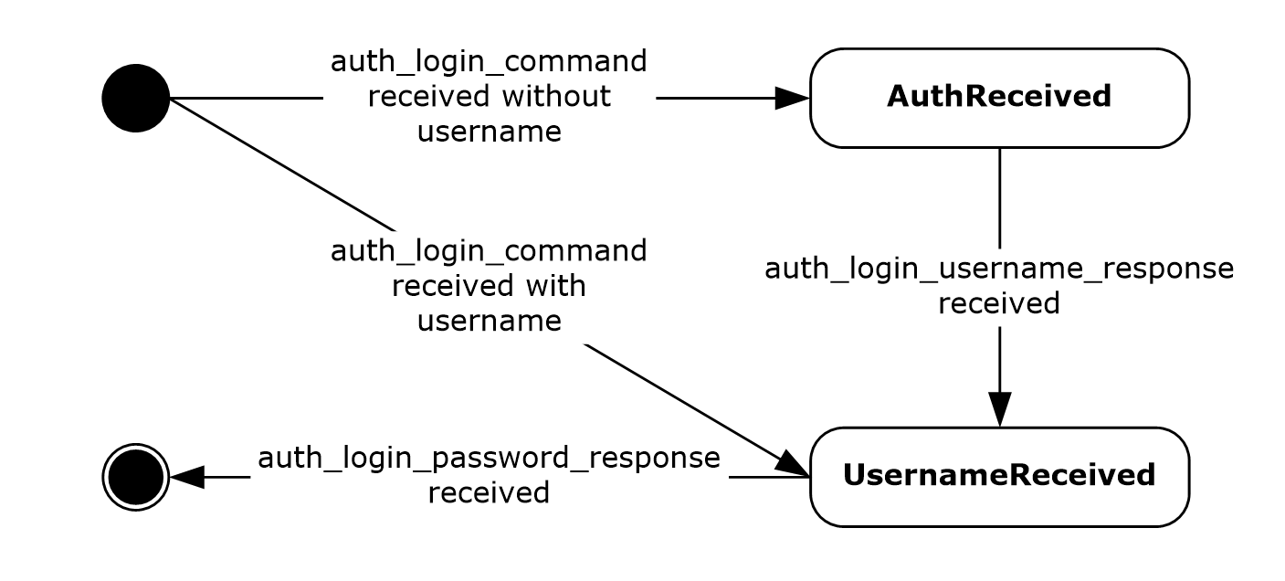
Figure 1: Server state machine diagram

Abstract Data Model
This section describes a conceptual model of possible data organization that an implementation maintains to participate in this protocol. The described organization is provided to facilitate the explanation of how the protocol behaves. This document does not mandate that implementations adhere to this model as long as their external behavior is consistent with that described in this document.
The server maintains the following global state:
List of SASL Mechanisms: The list of SASL mechanisms names to be returned in an EHLO response, as specified in [RFC5321].
For each connection from an SMTP client, the server has access to a set of authorized credentials consisting of a username and password. In addition, the server maintains the following state for each connection:
Substate: The state of the authentication, which can be either AuthReceived or UsernameReceived.
Username: The base64-encoded username value provided by the client.

Timers
None.

Initialization
When the server is initialized, it MUST place "LOGIN" in its List of SASL Mechanisms abstract data model element.

Higher-Layer Triggered Events
None.

Message Processing Events and Sequencing Rules

Processing AUTH LOGIN
When the server receives an AUTH command that conforms to the auth_login_command ABNF rule specified in section 2.2.2, it MUST respond according to the following rules.
- If the username is not included in the command, the server MUST set the Substate to AuthReceived and send a response that conforms to the auth_login_username_challenge ABNF rule.
- If the username is included in the command, the server MUST save the username in the Username associated with the connection, set the Substate to UsernameReceived, and send a response that conforms to the auth_login_password_challenge ABNF rule.

Processing a Request in the AuthReceived State
When the server receives a request in the AuthReceived state, the server MUST attempt to parse it according to the auth_login_username_response ABNF rule specified in section 2.2.2. The server MUST save the username in the Username associated with the connection, set the Substate to UsernameReceived, and send a response that conforms to the auth_login_password_challenge ABNF rule..

Processing a Request in the UsernameReceived State
When the server receives a request in the UsernameReceived state, the server MUST attempt to parse it according to the auth_login_password_response ABNF rule specified in section 2.2.2. The server MUST attempt to base64-decode the Username associated with the connection and the password included in the request and check that the Username corresponds to a valid user and that the password is a valid password for that user. The process of validating the Username and password is implementation-specific.
If the username and password are valid, the server MUST end the authentication by responding with a 235 response, as specified in [RFC4954] section 6. If the username or password is invalid, the server MUST end the authentication by responding with a 535 response, as specified in [RFC4954] section 6.

Timer Events
None.

Other Local Events
None.

Protocol Example
The following is an example of the use of the AUTH LOGIN extension. The example demonstrates SMTP authentication using the AUTH LOGIN extension. In this example, the user name is "Charlie" and the password is "password". The following diagram illustrates the sequence of events following the client's initial connection to the SMTP server.
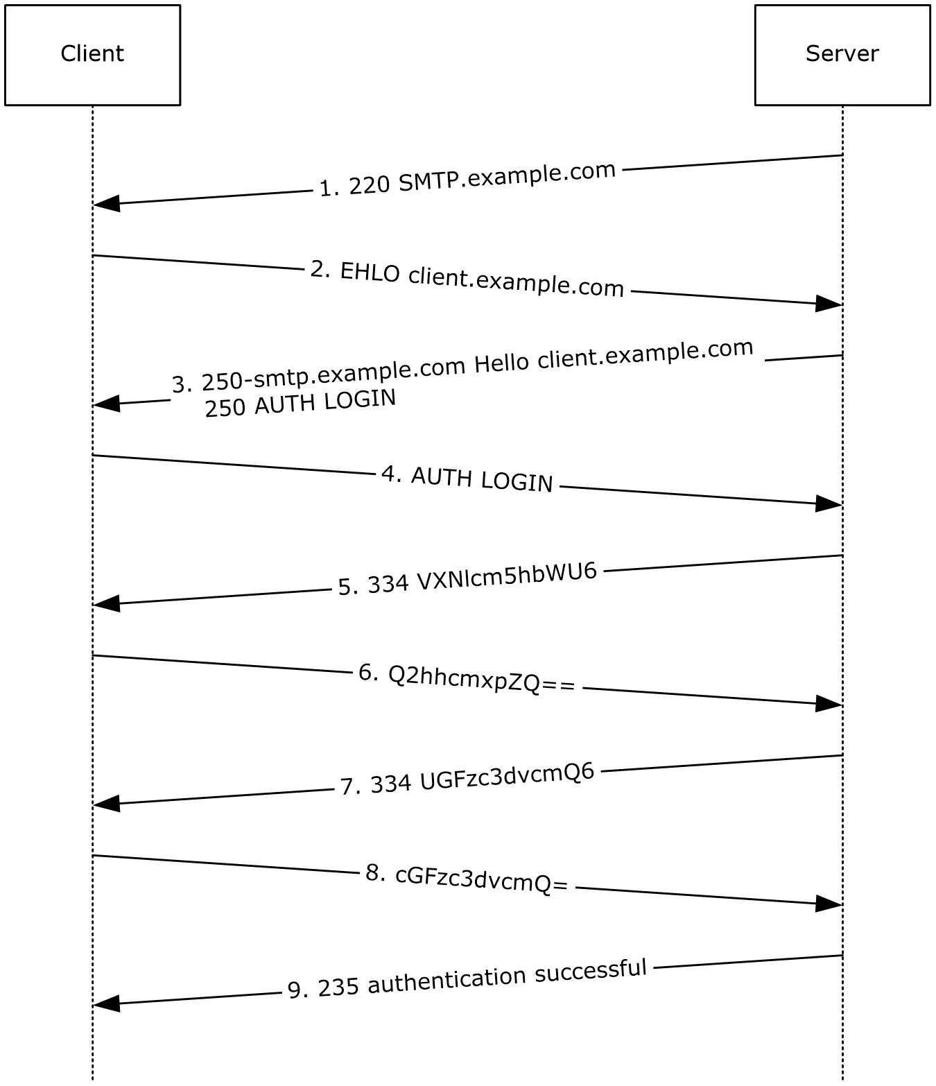
Figure 2: Example Authentication Exchange
- The initial response by the SMTP server ("220 SMTP.example.com") is the greeting by the server as specified in [RFC5321].
- The client sends the EHLO command.
- The server responds with, among other things, an indication of support for AUTH LOGIN.
- The client then issues the AUTH LOGIN command. In this example, the client omits the username in the AUTH LOGIN command.
- The server responds with the username challenge.
- The client responds with "Q2hhcmxpZQ==", which is the username "Charlie", encoded with base64 encoding.
- The server stores the value "Q2hhcmxpZQ==" then issues the password challenge.
- The client responds with "cGFzc3dvcmQ=", which is the password "password", encoded with base64 encoding.
- The server base64-decodes the username and password and verifies that the username "Charlie" and the password "password" are valid credentials. The server then responds with "235 authentication successful".

Security

Security Considerations for Implementers
This extension offers no inherent security mechanisms to protect user credentials during authentication. Because of this, it is extremely important to only use this extension when also using a secure communication channel such as Transport Layer Security (TLS), as specified in [RFC4346].
In environments where the use of TLS or other external security is mandated, it is strongly recommended that the AUTH LOGIN advertisement be suppressed until a secure channel is negotiated. TLS in particular exhibits this behavior where the SMTP session is restarted after TLS is negotiated.

Index of Security Parameters

Security parameter | Section
SASL mechanism name | section 2.2.1
Username | section 3.1.1
Password | section 3.1.1

Appendix A: Product Behavior
The information in this specification is applicable to the following Microsoft products or supplemental software. References to product versions include updates to those products.
- Microsoft Exchange Server 2003
- Microsoft Exchange Server 2007
- Microsoft Exchange Server 2010
- Microsoft Exchange Server 2013
- Microsoft Exchange Server 2016
- Microsoft Exchange Server 2019
- Microsoft Office Outlook 2003
- Microsoft Office Outlook 2007
- Microsoft Outlook 2010
- Microsoft Outlook 2013
- Microsoft Outlook 2016
- Microsoft Outlook 2019
- Microsoft .NET Framework 2.0
- Microsoft .NET Framework 3.5
- Microsoft .NET Framework 4
- Microsoft .NET Framework 4.5
- Microsoft .NET Framework 4.7
- Microsoft .NET Framework 4.8
- Windows 2000 Professional operating system
- Windows XP operating system
- Windows Vista operating system
- Windows 7 operating system
- Windows 8 operating system
- Windows 8.1
- Windows 10 operating system
- Windows 2000 Server operating system
- Windows Server 2003 operating system
- Windows Server 2008 operating system
- Windows Server 2012 operating system
- Windows Server 2012 R2
- Windows Server 2016 operating system
- Windows Server 2019 operating system
- Windows Server 2022 operating system
- Microsoft Outlook 2021
Exceptions, if any, are noted in this section. If an update version, service pack or Knowledge Base (KB) number appears with a product name, the behavior changed in that update. The new behavior also applies to subsequent updates unless otherwise specified. If a product edition appears with the product version, behavior is different in that product edition.
Unless otherwise specified, any statement of optional behavior in this specification that is prescribed using the terms "SHOULD" or "SHOULD NOT" implies product behavior in accordance with the SHOULD or SHOULD NOT prescription. Unless otherwise specified, the term "MAY" implies that the product does not follow the prescription.
<1> Section 3: Exchange 2003, Exchange 2007, Exchange 2010, Exchange 2013, Exchange 2016, and Exchange 2019 only implement the server role. Office Outlook 2003, Office Outlook 2007, Outlook 2010, Outlook 2013, Outlook 2016, Outlook 2019, .NET Framework 2.0, .NET Framework 3.5, .NET Framework 4, .NET Framework 4.5, Windows Vista, Windows 7, and Windows 8 only implement the client role. Windows 2000 Professional, Windows XP, Windows 2000 Server, Windows Server 2003, Windows Server 2008, and Windows Server 2012 implement both client and server roles.
<2> Section 3.1.4.1: Office Outlook 2003, Office Outlook 2007, Outlook 2010, Outlook 2013, Outlook 2016, Outlook 2019, and inetcomm.dll in Windows 2000 Professional, Windows XP, Windows Vista, Windows 7, Windows 8, Windows 2000 Server, Windows Server 2003, Windows Server 2008, and Windows Server 2012 do not include the username in the initial AUTH command.
<3> Section 3.1.5.1: .NET Framework 2.0, .NET Framework 3.5, .NET Framework 4, and .NET Framework 4.5 do not verify the syntax of 334 responses and instead keep state to remember whether it is the first server challenge or a subsequent server challenge.

Change Tracking
This section identifies changes that were made to this document since the last release. Changes are classified as Major, Minor, or None.
The revision class Major means that the technical content in the document was significantly revised. Major changes affect protocol interoperability or implementation. Examples of major changes are:
- A document revision that incorporates changes to interoperability requirements.
- A document revision that captures changes to protocol functionality.
The revision class Minor means that the meaning of the technical content was clarified. Minor changes do not affect protocol interoperability or implementation. Examples of minor changes are updates to clarify ambiguity at the sentence, paragraph, or table level.
The revision class None means that no new technical changes were introduced. Minor editorial and formatting changes may have been made, but the relevant technical content is identical to the last released version.
The changes made to this document are listed in the following table. For more information, please contact dochelp@microsoft.com.
Section | Description | Revision class
6 Appendix A: Product Behavior | Updated list of supported products. | major

Index
A

Abstract data model
client 10
server 11
Applicability 7

C

Capability negotiation 8
Change tracking 19
Client
abstract data model 10
initialization 10
message processing 10
other local events 11
sequencing rules 10
timer events 11
timers 10
Command and Response ABNF Grammar message 9

D

Data model - abstract
client 10
server 11

F

Fields - vendor-extensible 8

G

Glossary 6

H

Higher-layer triggered events
server 12

I

Implementer - security considerations 16
Index of security parameters 16
Informative references 7
Initialization
client 10
server 12
Introduction 6

M

Message processing
client 10
Messages
Command and Response ABNF Grammar 9
SASL Mechanism Name 9
transport 9

N

Normative references 6

O

Other local events
client 11
server 13
Overview (synopsis) 7

P

Parameters - security index 16
Preconditions 7
Prerequisites 7
Product behavior 17
Protocol Details
overview 10

R

References 6
informative 7
normative 6
Relationship to other protocols 7

S

SASL Mechanism Name message 9
Security
implementer considerations 16
parameter index 16
Sequencing rules
client 10
Server
abstract data model 11
higher-layer triggered events 12
initialization 12
other local events 13
overview 11
timer events 13
timers 12
Standards assignments 8

T

Timer events
client 11
server 13
Timers
client 10
server 12
Tracking changes 19
Transport 9
Triggered events - higher-layer
server 12

V

Vendor-extensible fields 8
Versioning 8

