[MS-USRPCH]:
User Profile Change Log Web Service Protocol

Intellectual Property Rights Notice for Open Specifications Documentation
- Technical Documentation. Microsoft publishes Open Specifications documentation (“this documentation”) for protocols, file formats, data portability, computer languages, and standards support. Additionally, overview documents cover inter-protocol relationships and interactions.
- Copyrights. This documentation is covered by Microsoft copyrights. Regardless of any other terms that are contained in the terms of use for the Microsoft website that hosts this documentation, you can make copies of it in order to develop implementations of the technologies that are described in this documentation and can distribute portions of it in your implementations that use these technologies or in your documentation as necessary to properly document the implementation. You can also distribute in your implementation, with or without modification, any schemas, IDLs, or code samples that are included in the documentation. This permission also applies to any documents that are referenced in the Open Specifications documentation.
- No Trade Secrets. Microsoft does not claim any trade secret rights in this documentation.
- Patents. Microsoft has patents that might cover your implementations of the technologies described in the Open Specifications documentation. Neither this notice nor Microsoft's delivery of this documentation grants any licenses under those patents or any other Microsoft patents. However, a given Open Specifications document might be covered by the Microsoft Open Specifications Promise or the Microsoft Community Promise. If you would prefer a written license, or if the technologies described in this documentation are not covered by the Open Specifications Promise or Community Promise, as applicable, patent licenses are available by contacting iplg@microsoft.com.
- License Programs. To see all of the protocols in scope under a specific license program and the associated patents, visit the Patent Map.
- Trademarks. The names of companies and products contained in this documentation might be covered by trademarks or similar intellectual property rights. This notice does not grant any licenses under those rights. For a list of Microsoft trademarks, visit www.microsoft.com/trademarks.
- Fictitious Names. The example companies, organizations, products, domain names, email addresses, logos, people, places, and events that are depicted in this documentation are fictitious. No association with any real company, organization, product, domain name, email address, logo, person, place, or event is intended or should be inferred.
Reservation of Rights. All other rights are reserved, and this notice does not grant any rights other than as specifically described above, whether by implication, estoppel, or otherwise.
Tools. The Open Specifications documentation does not require the use of Microsoft programming tools or programming environments in order for you to develop an implementation. If you have access to Microsoft programming tools and environments, you are free to take advantage of them. Certain Open Specifications documents are intended for use in conjunction with publicly available standards specifications and network programming art and, as such, assume that the reader either is familiar with the aforementioned material or has immediate access to it.
Support. For questions and support, please contact dochelp@microsoft.com.
Revision Summary
Date | Revision History | Revision Class | Comments
4/4/2008 | 0.1 | New | Initial Availability
6/27/2008 | 1.0 | Major | Revised and edited the technical content
12/12/2008 | 1.01 | Editorial | Revised and edited the technical content
7/13/2009 | 1.02 | Major | Revised and edited the technical content
8/28/2009 | 1.03 | Editorial | Revised and edited the technical content
11/6/2009 | 1.04 | Editorial | Revised and edited the technical content
2/19/2010 | 2.0 | Major | Updated and revised the technical content
3/31/2010 | 2.01 | Editorial | Revised and edited the technical content
4/30/2010 | 2.02 | Editorial | Revised and edited the technical content
6/7/2010 | 2.03 | Editorial | Revised and edited the technical content
6/29/2010 | 2.04 | Editorial | Changed language and formatting in the technical content.
7/23/2010 | 2.04 | None | No changes to the meaning, language, or formatting of the technical content.
9/27/2010 | 2.04 | None | No changes to the meaning, language, or formatting of the technical content.
11/15/2010 | 2.04 | None | No changes to the meaning, language, or formatting of the technical content.
12/17/2010 | 2.04 | None | No changes to the meaning, language, or formatting of the technical content.
3/18/2011 | 2.04 | None | No changes to the meaning, language, or formatting of the technical content.
6/10/2011 | 2.04 | None | No changes to the meaning, language, or formatting of the technical content.
1/20/2012 | 2.5 | Minor | Clarified the meaning of the technical content.
4/11/2012 | 2.5 | None | No changes to the meaning, language, or formatting of the technical content.
7/16/2012 | 2.5 | None | No changes to the meaning, language, or formatting of the technical content.
9/12/2012 | 2.5 | None | No changes to the meaning, language, or formatting of the technical content.
10/8/2012 | 2.6 | Minor | Clarified the meaning of the technical content.
2/11/2013 | 2.6 | None | No changes to the meaning, language, or formatting of the technical content.
7/30/2013 | 2.7 | Minor | Clarified the meaning of the technical content.
11/18/2013 | 2.7 | None | No changes to the meaning, language, or formatting of the technical content.
2/10/2014 | 2.8 | Minor | Clarified the meaning of the technical content.
4/30/2014 | 2.9 | Minor | Clarified the meaning of the technical content.
7/31/2014 | 2.9 | None | No changes to the meaning, language, or formatting of the technical content.
10/30/2014 | 2.9 | None | No changes to the meaning, language, or formatting of the technical content.
2/26/2016 | 3.0 | Major | Significantly changed the technical content.
7/15/2016 | 3.0 | None | No changes to the meaning, language, or formatting of the technical content.
9/14/2016 | 3.0 | None | No changes to the meaning, language, or formatting of the technical content.
7/24/2018 | 4.0 | Major | Significantly changed the technical content.
10/1/2018 | 5.0 | Major | Significantly changed the technical content.
12/11/2018 | 5.0 | None | No changes to the meaning, language, or formatting of the technical content.
6/18/2019 | 5.0 | None | No changes to the meaning, language, or formatting of the technical content.
7/20/2021 | 6.0 | Major | Significantly changed the technical content.
10/5/2021 | 7.0 | Major | Significantly changed the technical content.
Table of Contents
1 Introduction 6
1.1 Glossary 6
1.2 References 7
1.2.1 Normative References 7
1.2.2 Informative References 8
1.3 Protocol Overview (Synopsis) 8
1.4 Relationship to Other Protocols 8
1.5 Prerequisites/Preconditions 9
1.6 Applicability Statement 9
1.7 Versioning and Capability Negotiation 9
1.8 Vendor-Extensible Fields 9
1.9 Standards Assignments 9
2 Messages 10
2.1 Transport 10
2.2 Common Message Syntax 10
2.2.1 Namespaces 10
2.2.2 Messages 11
2.2.3 Elements 11
2.2.4 Complex Types 11
2.2.4.1 ArrayOfUserProfileChangeData 11
2.2.4.2 ProfileBaseChangeQuery 12
2.2.4.3 UserProfileChangeData 12
2.2.4.4 UserProfileChangeDataContainer 13
2.2.4.5 UserProfileChangeQuery 14
2.2.4.6 UserProfileChangeToken 15
2.2.5 Simple Types 15
2.2.5.1 ChangeTypes 15
2.2.5.2 ObjectTypes 16
2.2.5.3 GUID 17
2.2.6 Attributes 17
2.2.7 Groups 17
2.2.8 Attribute Groups 17
3 Protocol Details 18
3.1 Server Details 18
3.1.1 Abstract Data Model 18
3.1.2 Timers 19
3.1.3 Initialization 19
3.1.4 Message Processing Events and Sequencing Rules 19
3.1.4.1 GetAllChanges 20
3.1.4.1.1 Messages 20
3.1.4.1.1.1 GetAllChangesSoapIn 20
3.1.4.1.1.2 GetAllChangesSoapOut 21
3.1.4.1.2 Elements 21
3.1.4.1.2.1 GetAllChanges 21
3.1.4.1.2.2 GetAllChangesResponse 21
3.1.4.2 GetChanges 21
3.1.4.2.1 Messages 22
3.1.4.2.1.1 GetChangesSoapIn 22
3.1.4.2.1.2 GetChangesSoapOut 22
3.1.4.2.2 Elements 22
3.1.4.2.2.1 GetChanges 22
3.1.4.2.2.2 GetChangesResponse 22
3.1.4.3 GetCurrentChangeToken 23
3.1.4.3.1 Messages 23
3.1.4.3.1.1 GetCurrentChangeTokenSoapIn 23
3.1.4.3.1.2 GetCurrentChangeTokenSoapOut 23
3.1.4.3.2 Elements 24
3.1.4.3.2.1 GetCurrentChangeToken 24
3.1.4.3.2.2 GetCurrentChangeTokenResponse 24
3.1.4.4 GetUserAllChanges 24
3.1.4.4.1 Messages 24
3.1.4.4.1.1 GetUserAllChangesSoapIn 25
3.1.4.4.1.2 GetUserAllChangesSoapOut 25
3.1.4.4.2 Elements 25
3.1.4.4.2.1 GetUserAllChanges 25
3.1.4.4.2.2 GetUserAllChangesResponse 25
3.1.4.5 GetUserChanges 25
3.1.4.5.1 Messages 26
3.1.4.5.1.1 GetUserChangesSoapIn 26
3.1.4.5.1.2 GetUserChangesSoapOut 26
3.1.4.5.2 Elements 26
3.1.4.5.2.1 GetUserChanges 26
3.1.4.5.2.2 GetUserChangesResponse 27
3.1.4.6 GetUserCurrentChangeToken 27
3.1.4.6.1 Messages 28
3.1.4.6.1.1 GetUserCurrentChangeTokenSoapIn 28
3.1.4.6.1.2 GetUserCurrentChangeTokenSoapOut 28
3.1.4.6.2 Elements 28
3.1.4.6.2.1 GetUserCurrentChangeToken 28
3.1.4.6.2.2 GetUserCurrentChangeTokenResponse 28
3.1.5 Timer Events 29
3.1.6 Other Local Events 29
4 Protocol Examples 30
4.1 Sample Data 30
4.2 Profile Replication 31
4.3 Profile Caching 33
5 Security 36
5.1 Security Considerations for Implementers 36
5.2 Index of Security Parameters 36
6 Appendix A: Full WSDL 37
7 Appendix B: Product Behavior 44
8 Change Tracking 45
9 Index 46

Introduction
The User Profile Change Log Web Service Protocol enables a protocol client to query and synchronize changes from user profiles.
Sections 1.5, 1.8, 1.9, 2, and 3 of this specification are normative. All other sections and examples in this specification are informative.

Glossary
This document uses the following terms:
change token: A serialized token that can be used to determine whether changes occurred in the system. It can also be used to deserialize packages in the correct sequence during import or restore operations.
colleague: A user who has a social networking relationship with another user.
crawl: The process of traversing a URL space to acquire items to record in a search catalog.
distribution list: A collection of users, computers, contacts, or other groups that is used only for email distribution, and addressed as a single recipient.
Hypertext Transfer Protocol (HTTP): An application-level protocol for distributed, collaborative, hypermedia information systems (text, graphic images, sound, video, and other multimedia files) on the World Wide Web.
Hypertext Transfer Protocol Secure (HTTPS): An extension of HTTP that securely encrypts and decrypts web page requests. In some older protocols, "Hypertext Transfer Protocol over Secure Sockets Layer" is still used (Secure Sockets Layer has been deprecated). For more information, see [SSL3] and [RFC5246].
item: A unit of content that can be indexed and searched by a search application.
multivalue property: A property that can contain multiple values of the same type.
organization: A security group that contains additional fields for describing hierarchical relationships between organizations.
personal site: A type of SharePoint site that is used by an individual user for personal productivity. The site appears to the user as My Site.
single-value property: A property that can have only one value and can be added, modified, or deleted by using a Change Type operation.
site: A group of related pages and data within a SharePoint site collection. The structure and content of a site is based on a site definition. Also referred to as SharePoint site and web site.
site membership: The status of being a member of a site and having a defined set of user rights for accessing or managing content on that site.
SOAP: A lightweight protocol for exchanging structured information in a decentralized, distributed environment. SOAP uses XML technologies to define an extensible messaging framework, which provides a message construct that can be exchanged over a variety of underlying protocols. The framework has been designed to be independent of any particular programming model and other implementation-specific semantics. SOAP 1.2 supersedes SOAP 1.1. See [SOAP1.2-1/2003].
SOAP action: The HTTP request header field used to indicate the intent of the SOAP request, using a URI value. See [SOAP1.1] section 6.1.1 for more information.
SOAP body: A container for the payload data being delivered by a SOAP message to its recipient. See [SOAP1.2-1/2007] section 5.3 for more information.
SOAP fault: A container for error and status information within a SOAP message. See [SOAP1.2-1/2007] section 5.4 for more information.
Uniform Resource Locator (URL): A string of characters in a standardized format that identifies a document or resource on the World Wide Web. The format is as specified in [RFC1738].
user profile: A collection of properties that pertain to a specific person or entity within a portal site.
user profile change entry log: A repository that logs all of the changes that occur in a user profile.
user profile privacy policy: A set of rules that governs all interactions with user profiles.
user profile store: A database that stores information about each user profile.
web log: See blog.
Web Services Description Language (WSDL): An XML format for describing network services as a set of endpoints that operate on messages that contain either document-oriented or procedure-oriented information. The operations and messages are described abstractly and are bound to a concrete network protocol and message format in order to define an endpoint. Related concrete endpoints are combined into abstract endpoints, which describe a network service. WSDL is extensible, which allows the description of endpoints and their messages regardless of the message formats or network protocols that are used.
WSDL operation: A single action or function of a web service. The execution of a WSDL operation typically requires the exchange of messages between the service requestor and the service provider.
MAY, SHOULD, MUST, SHOULD NOT, MUST NOT: These terms (in all caps) are used as defined in [RFC2119]. All statements of optional behavior use either MAY, SHOULD, or SHOULD NOT.

References
Links to a document in the Microsoft Open Specifications library point to the correct section in the most recently published version of the referenced document. However, because individual documents in the library are not updated at the same time, the section numbers in the documents may not match. You can confirm the correct section numbering by checking the Errata.

Normative References
We conduct frequent surveys of the normative references to assure their continued availability. If you have any issue with finding a normative reference, please contact dochelp@microsoft.com. We will assist you in finding the relevant information.
[MS-USPSWS] Microsoft Corporation, "User Profile Service Web Service Protocol".
[RFC2119] Bradner, S., "Key words for use in RFCs to Indicate Requirement Levels", BCP 14, RFC 2119, March 1997, http://www.rfc-editor.org/rfc/rfc2119.txt
[RFC2616] Fielding, R., Gettys, J., Mogul, J., et al., "Hypertext Transfer Protocol -- HTTP/1.1", RFC 2616, June 1999, http://www.rfc-editor.org/rfc/rfc2616.txt
[SOAP1.1] Box, D., Ehnebuske, D., Kakivaya, G., et al., "Simple Object Access Protocol (SOAP) 1.1", W3C Note, May 2000, http://www.w3.org/TR/2000/NOTE-SOAP-20000508/
[SOAP1.2-1/2007] Gudgin, M., Hadley, M., Mendelsohn, N., et al., "SOAP Version 1.2 Part 1: Messaging Framework (Second Edition)", W3C Recommendation, April 2007, http://www.w3.org/TR/2007/REC-soap12-part1-20070427/
[SOAP1.2-2/2007] Gudgin, M., Hadley, M., Mendelsohn, N., et al., "SOAP Version 1.2 Part 2: Adjuncts (Second Edition)", W3C Recommendation, April 2007, http://www.w3.org/TR/2007/REC-soap12-part2-20070427
[WSDL] Christensen, E., Curbera, F., Meredith, G., and Weerawarana, S., "Web Services Description Language (WSDL) 1.1", W3C Note, March 2001, http://www.w3.org/TR/2001/NOTE-wsdl-20010315
[XMLNS] Bray, T., Hollander, D., Layman, A., et al., Eds., "Namespaces in XML 1.0 (Third Edition)", W3C Recommendation, December 2009, http://www.w3.org/TR/2009/REC-xml-names-20091208/
[XMLSCHEMA1] Thompson, H., Beech, D., Maloney, M., and Mendelsohn, N., Eds., "XML Schema Part 1: Structures", W3C Recommendation, May 2001, http://www.w3.org/TR/2001/REC-xmlschema-1-20010502/
[XMLSCHEMA2] Biron, P.V., Ed. and Malhotra, A., Ed., "XML Schema Part 2: Datatypes", W3C Recommendation, May 2001, http://www.w3.org/TR/2001/REC-xmlschema-2-20010502/

Informative References
[RFC2818] Rescorla, E., "HTTP Over TLS", RFC 2818, May 2000, http://www.rfc-editor.org/rfc/rfc2818.txt

Protocol Overview (Synopsis)
This protocol is used by a protocol client to query and synchronize changes from a user profile store. This protocol enables a protocol client to query for changes to specific user profiles or for changes to all profiles on the protocol server. This protocol is also designed to support incremental search engine crawling, back-up, and data transfer from the user profile store.

Relationship to Other Protocols
This protocol uses the SOAP message protocol for formatting request and response messages, as described in [SOAP1.1], [SOAP1.2-1/2007] and [SOAP1.2-2/2007]. It transmits those messages by using HTTP, as described in [RFC2616], or Hypertext Transfer Protocol over Secure Sockets Layer (HTTPS), as described in [RFC2818].
The following diagram shows the underlying messaging and transport stack used by the protocol:
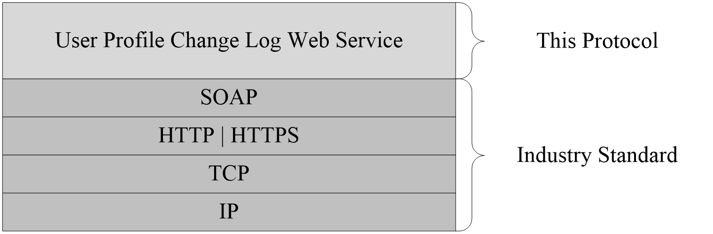
Figure 1: This protocol in relation to other protocols

Prerequisites/Preconditions
This protocol operates against a site that is identified by a URL that is known by protocol clients. The protocol server endpoint is formed by appending "/_vti_bin/UserProfileChangeService.asmx" to the URL of the site; for example "http://www.example.com/Repository/_vti_bin/UserProfileChangeService.asmx".
This protocol assumes that authentication has been performed by the underlying protocols.

Applicability Statement
This protocol is applicable in scenarios where one protocol server replicates the user profile information from another protocol server for the search engine crawl process against the user profile data, and for situations where the profile data is cached on the protocol client and kept synchronized with the protocol server.

Versioning and Capability Negotiation
This document covers versioning issues in the following areas:
- Supported Transports: This protocol uses multiple transports with SOAP, as specified in section 2.1.

Vendor-Extensible Fields
None.

Standards Assignments
None.

Messages
In the following sections, the schema definition might differ from the processing rules imposed by the protocol. The WSDL in this specification matches the WSDL that shipped with the product and provides a base description of the schema. The text that introduces the WSDL might specify differences that reflect actual Microsoft product behavior. For example, the schema definition might allow for an element to be empty, null, or not present but the behavior of the protocol as specified restricts the same elements to being non-empty, not null, and present.

Transport
Protocol servers need to support SOAP over HTTP. Additionally, protocol servers SHOULD support SOAP over HTTPS for securing communication with protocol clients.
This protocol uses SOAP for formatting requests and responses, as specified in [SOAP1.1] section 4 or as specified in [SOAP1.2-1/2007] section 5. Protocol server faults are returned either by using an HTTP Status Code as specified in [RFC2616] section 10, or by using a SOAP fault, as specified either in [SOAP1.1] section 4.4 or in [SOAP1.2-1/2007] section 5.4.

Common Message Syntax
This section contains common definitions used by this protocol. The syntax of the definitions uses XML schema as defined in [XMLSCHEMA1] and [XMLSCHEMA2], and WSDL as defined in [WSDL].

Namespaces
This specification defines and references various XML namespaces using the mechanisms specified in [XMLNS]. Although this specification associates a specific XML namespace prefix for each XML namespace that is used, the choice of any particular XML namespace prefix is implementation-specific and not significant for interoperability.
Prefix | Namespace URI | Reference
soap | http://schemas.xmlsoap.org/wsdl/soap | [SOAP1.1]
tm | http://microsoft.com/wsdl/mime/textMatching
soapenc | http://schemas.xmlsoap.org/soap/encoding
mime | http://schemas.xmlsoap.org/wsdl/mime
tns | http://microsoft.com/webservices/SharePointPortalServer/UserProfileChangeService
s1 | http://microsoft.com/wsdl/types/
s | http://www.w3.org/2001/XMLSchema | [XMLSCHEMA1]  [XMLSCHEMA2]
soap12 | http://schemas.xmlsoap.org/wsdl/soap12/ | [SOAP1.2-1/2007]  [SOAP1.2-2/2007]
(none) | http://microsoft.com/webservices/SharePointPortalServer/UserProfileChangeService
wsdl | http://schemas.xmlsoap.org/wsdl/ | [WSDL]

Messages
This specification does not define any common WSDL message definitions.

Elements
This specification does not define any common XML schema element definitions.

Complex Types
The following table summarizes the set of common XML schema complex type definitions defined by this specification. XML schema complex type definitions that are specific to a particular operation are described with the operation.
Complex type | Description
ArrayOfUserProfileChangeData | An array of UserProfileChangeData.
ProfileBaseChangeQuery | A base type that is used to specify the ChangeTypes (section 2.2.5.1) and ObjectTypes (section 2.2.5.2) simple types, which are used to query the user profile change entries log.
UserProfileChangeData | A data type that contains one user profile change entry.
UserProfileChangeDataContainer | A container for user profile change entries returned by Web methods.
UserProfileChangeQuery | A data type that describes filter criteria for retrieving user profile change entries.
UserProfileChangeToken | A base type that is used to specify the unique sequential location of a change within the user profile change entries log.

ArrayOfUserProfileChangeData
The ArrayOfUserProfileChangeData complex type contains an array of user profile change entries as part of the response to any of the following request operations.
GetAllChanges (section 3.1.4.1)
GetChanges (section 3.1.4.2)
GetUserAllChanges (section 3.1.4.4)
GetUserChanges (section 3.1.4.5)
<s:complexType name="ArrayOfUserProfileChangeData">
<s:sequence>
<s:element name="UserProfileChangeData" type="tns:UserProfileChangeData"
nillable="true" minOccurs="0" maxOccurs="unbounded"/>
</s:sequence>
</s:complexType>
UserProfileChangeData: A UserProfileChangeData (section 2.2.4.3) type is a property that MUST contain the data that identifies one change in the current request response.

ProfileBaseChangeQuery
ProfileBaseChangeQuery is a complex base type that is used to specify the ChangeTypes (section 2.2.5.1) and ObjectTypes (section 2.2.5.2) simple types, which are used to query the user profile change entries log.
<s:complexType name="ProfileBaseChangeQuery">
<s:sequence>
<s:element minOccurs="1" maxOccurs="1"
name="SingleValueProperty" type="s:boolean" />
<s:element minOccurs="1" maxOccurs="1"
name="MultiValueProperty" type="s:boolean" />
<s:element minOccurs="1" maxOccurs="1" name="Custom" type="s:boolean" />
<s:element minOccurs="1" maxOccurs="1" name="Add" type="s:boolean" />
<s:element minOccurs="1" maxOccurs="1" name="Update" type="s:boolean" />
<s:element minOccurs="1" maxOccurs="1"
name="UpdateMetadata" type="s:boolean" />
<s:element minOccurs="1" maxOccurs="1" name="Delete" type="s:boolean" />
<s:element minOccurs="0" maxOccurs="1"
name="ChangeTokenStart" type="tns:UserProfileChangeToken" />
</s:sequence>
</s:complexType>
SingleValueProperty: A Boolean that specifies whether or not to query for single value property changes. A query run based on this value specifies the modified ChangeTypes records. True indicates to query for single value property changes; false indicates not to query for single value property changes.
MultiValueProperty: A Boolean that specifies whether or not to query for multiple property value changes. A query run based on this value specifies all ChangeTypes records that match the individual values of the multiple property values. True indicates to query for multiple property value changes; false indicates not to query for multiple property value changes.
Custom: A Boolean that specifies whether or not to include Custom ObjectTypes in the query. True indicates to include Custom ObjectTypes in the query; false indicates not to include Custom ObjectTypes in the query.
Add: A Boolean that specifies whether or not to query for Add (section 2.2.5.1) changes. True indicates to query for Add changes; false indicates not to query for Add changes.
Update: A Boolean that specifies whether or not to query for Modify changes. True indicates to query for Modify changes; false indicates not to query for Modify changes.
UpdateMetadata: A Boolean that specifies whether or not to query for Metadata update changes. True indicates to query for Metadata update changes; false indicates not to query for Metadata update changes.
Delete: A Boolean that specifies whether or not to query for Delete (section 2.2.5.1) changes. True indicates to query for Delete changes; false indicates not to query for Delete changes.
ChangeTokenStart: Specifies the starting location in the user profile change logs for the query. The UserProfileChangeToken type MUST support construction from a string representation of a change token (section 2.2.4.4).

UserProfileChangeData
The UserProfileChangeData complex type contains the data that identifies a change in the request response.
<s:complexType name="UserProfileChangeData">
<s:sequence>
<s:element minOccurs="1" maxOccurs="1" name="Id" type="s:long" />
<s:element minOccurs="0" maxOccurs="1"
name="UserAccountName" type="s:string" />
<s:element minOccurs="0" maxOccurs="1"
name="UserRemotePersonalSiteHostUrl" type="s:string" />
<s:element minOccurs="1" maxOccurs="1"
name="ChangeType" type="tns:ChangeTypes" />
<s:element minOccurs="1" maxOccurs="1"
name="ObjectType" type="tns:ObjectTypes" />
<s:element minOccurs="1" maxOccurs="1" name="EventTime" type="s:dateTime" />
<s:element minOccurs="0" maxOccurs="1" name="Value" />
<s:element minOccurs="1" maxOccurs="1" name="PolicyId" type="s1:guid" />
<s:element minOccurs="0" maxOccurs="1" name="PropertyName" type="s:string" />
</s:sequence>
</s:complexType>
Id: A long type that is a property that MUST contain a unique identifier for the user profile change entry.
UserAccountName: A string that is a property that MUST contain the user name.
UserRemotePersonalSiteHostUrl: A string that is a property that MUST contain a value representing the URL of the personal site of the user.
ChangeType: This property MUST contain the ChangeTypes (section 2.2.5.1) instance for the user profile change entry.
ObjectType: This property MUST contain the ObjectTypes (section 2.2.5.2) instance for the user profile change entry.
EventTime: A dateTime type that is a property that MUST contain the date and time of the user profile change entry.
Value: This property is the value of the user profile change entry. This property does not have a specific type.
PolicyId: A GUID type that is a property that MUST contain a unique identifier for a user profile privacy policy item.
PropertyName: A string that is a property that MUST be the name of a property in the user profile change entry if the ObjectTypes (section 2.2.5.2) has the value "SingleValueProperty" or "MultiValueProperty". Otherwise, this property MUST be NULL.

UserProfileChangeDataContainer
The UserProfileChangeDataContainer type contains data about user profile change entries.
<s:complexType name="UserProfileChangeDataContainer">
<s:sequence>
<s:element minOccurs="0" maxOccurs="1"
name="Changes" type="tns:ArrayOfUserProfileChangeData" />
<s:element minOccurs="0" maxOccurs="1" name="ChangeToken" type="s:string" />
<s:element minOccurs="1" maxOccurs="1"
name="HasExceededCountLimit" type="s:boolean" />
</s:sequence>
</s:complexType>
Changes: An ArrayOfUserProfileChangeData (section 2.2.4.1) type that represents a set of user profile change entries that MUST be older than or include the value referred to by ChangeToken.
ChangeToken: A string that specifies the user profile change token value that can be used to retrieve any user profile change entries that occur after the returned changes.
HasExceededCountLimit: A Boolean that MUST be true if the number of results exceeds 1000. Otherwise, HasExceededCountLimit MUST be false. If HasExceededCountLimit is true, only the 1000 most recent changes will be retrieved.

UserProfileChangeQuery
UserProfileChangeQuery is a complex type that is used to specify the filter criteria for retrieving user profile change entries.
<s:complexType name="UserProfileChangeQuery">
<s:complexContent mixed="false">
<s:extension base="tns:ProfileBaseChangeQuery">
<s:sequence>
<s:element minOccurs="1" maxOccurs="1"
name="Anniversary" type="s:boolean" />
<s:element minOccurs="1" maxOccurs="1"
name="DistributionListMembership" type="s:boolean" />
<s:element minOccurs="1" maxOccurs="1"
name="SiteMembership" type="s:boolean" />
<s:element minOccurs="1" maxOccurs="1" name="QuickLink" type="s:boolean" />
<s:element minOccurs="1" maxOccurs="1" name="Colleague" type="s:boolean" />
<s:element minOccurs="1" maxOccurs="1" name="WebLog" type="s:boolean" />
<s:element minOccurs="1" maxOccurs="1"
name="PersonalizationSite" type="s:boolean" />
<s:element minOccurs="1" maxOccurs="1"
name="UserProfile" type="s:boolean" />
<s:element minOccurs="1" maxOccurs="1"
name="OrganizationMembership" type="s:boolean" />
</s:sequence>
</s:extension>
</s:complexContent>
</s:complexType>
Anniversary: A Boolean that specifies a query for Anniversary (section 2.2.5.2) changes to be executed. True indicates to query for Anniversary changes; false indicates not to query for Anniversary change.
DistributionListMembership: A Boolean that specifies a query for DLMembership (section 2.2.5.2) changes to be executed. True indicates to query for DLMembership changes; false indicates not to query for DLMembership changes.
SiteMembership: A Boolean that specifies a query for SiteMembership (section 2.2.5.2) changes to be executed. True indicates to query for SiteMembership changes; false indicates not to query for SiteMembership changes.
QuickLink: A Boolean that specifies whether or not to query for QuickLink (section 2.2.5.2)changes. True indicates to query for QuickLink changes; false indicates not to query for QuickLink changes.
Colleague: A Boolean that specifies whether or not to query for Colleague (section 2.2.5.2) changes. True indicates to query for Colleague changes; false indicates not to query for Colleague changes.
WebLog: A Boolean that specifies whether or not to query for WebLog (section 2.2.5.2) changes. True indicates to query for WebLog changes; false indicates not to query for WebLog changes.
PersonalizationSite: A Boolean that specifies whether or not to query for PersonalizationSite (section 2.2.5.2) changes. True indicates to query for PersonalizationSite changes; false indicates not to query for PersonalizationSite changes.
UserProfile: A Boolean that specifies whether or not to query for UserProfile (section 2.2.5.2) changes. True indicates to query for UserProfile changes; false indicates not to query for UserProfile changes.
OrganizationMembership: A Boolean that specifies whether or not to query for OrganizationMembership (section 2.2.5.2) changes. True indicates to query for OrganizationMembership changes; false indicates not to query for OrganizationMembership changes.

UserProfileChangeToken
UserProfileChangeToken is a complex base type that is used to specify the unique sequential location of a change within the user profile change entries log. The UserProfileChangeToken type MUST support construction from a string representation of a change token.
<s:complexType name="UserProfileChangeToken" />

Simple Types
The following table summarizes the set of common XML schema simple type definitions defined by this specification. XML schema simple type definitions that are specific to a particular operation are described with the operation.
Simple type | Description
ChangeTypes | Type of user profile change entry made on the object.
ObjectTypes | Type of object represented

ChangeTypes
ChangeTypes is a simple type that enumerates the valid operation types applied to user profile data.
<s:simpleType name="ChangeTypes">
<s:list>
<s:simpleType>
<s:restriction base="s:string">
<s:enumeration value="None"/>
<s:enumeration value="Add"/>
<s:enumeration value="Modify"/>
<s:enumeration value="Delete"/>
<s:enumeration value="Metadata"/>
<s:enumeration value="All"/>
</s:restriction>
</s:simpleType>
</s:list>
</s:simpleType>
The following table defines the allowable values for ChangeTypes:
Value | Meaning
None | None.
Add | An object has been added to user profile.
Modify | An existing object has been modified.
Delete | An existing object has been deleted.
Metadata | The metadata of an object has been modified.
All | Multiple operations were performed on an object.

ObjectTypes
ObjectTypes is a simple type that enumerates the supported types.
<s:simpleType name="ObjectTypes">
<s:list>
<s:simpleType>
<s:restriction base="s:string">
<s:enumeration value="None"/>
<s:enumeration value="SingleValueProperty"/>
<s:enumeration value="MultiValueProperty"/>
<s:enumeration value="Anniversary"/>
<s:enumeration value="DLMembership"/>
<s:enumeration value="SiteMembership"/>
<s:enumeration value="QuickLink"/>
<s:enumeration value="Colleague"/>
<s:enumeration value="PersonalizationSite"/>
<s:enumeration value="UserProfile"/>
<s:enumeration value="WebLog"/>
<s:enumeration value="Custom" />
<s:enumeration value="OrganizationProfile" />
<s:enumeration value="OrganizationMembership" />
<s:enumeration value="All"/>
</s:restriction>
</s:simpleType>
</s:list>
</s:simpleType>
The following table defines the allowable values for ObjectTypes:
Value | Meaning
None | None.
SingleValueProperty | A user profile single-value property change.
MultiValueProperty | A user profile multivalue property change.
Anniversary | A user profile anniversary change, which is an event that occurs when a date in the user’s profile matches the current date.
DLMembership | A user profile distribution list membership change.
SiteMembership | A user profile site membership change.
QuickLink | A link item change.
Colleague | A colleague relationship addition, deletion, or update.
PersonalizationSite | A personal site item change.
UserProfile | A user profile change.
WebLog | A user profile Web log change.
Custom<1> | A custom change to a user profile.
OrganizationProfile<2> | An Organization object change.
OrganizationMembership<3> | A user profile organization membership change.
All | A set of all object types.

GUID
GUID is a simple type that is used to represent a GUID.
<s:simpleType name="guid">
<s:restriction base="s:string">
<s:pattern value="[0-9a-fA-F]{8}-[0-9a-fA-F]{4}-[0-9a-fA-F]{4}-[0-9a-fA-F]{4}-[0-9a-fA-F]{12}"/>
</s:restriction>
</s:simpleType>

Attributes
This specification does not define any common XML schema attribute definitions.

Groups
This specification does not define any common XML schema group definitions.

Attribute Groups
This specification does not define any common XML schema attribute group definitions.

Protocol Details
In the following sections, the schema definition might differ from the processing rules imposed by the protocol. The WSDL in this specification matches the WSDL that shipped with the product and provides a base description of the schema. The text that introduces the WSDL might specify differences that reflect actual Microsoft product behavior. For example, the schema definition might allow for an element to be empty, null, or not present but the behavior of the protocol as specified restricts the same elements to being non-empty, not null, and present.
The client side of this protocol is simply a pass-through. That is, no additional timers or other state is required on the client side of this protocol. Calls made by the higher-layer protocol or application are passed directly to the transport, and the results returned by the transport are passed directly back to the higher-layer protocol or application.

Server Details

Abstract Data Model
This section describes a conceptual model of possible data organization that an implementation maintains to participate in this protocol. The described organization is provided to facilitate the explanation of how the protocol behaves. This document does not mandate that implementations adhere to this model, as long as their external behavior is consistent with the information that is described in this document.
This protocol is contingent on the abstract data model as specified by [MS-USPSWS] section 3.1.1.
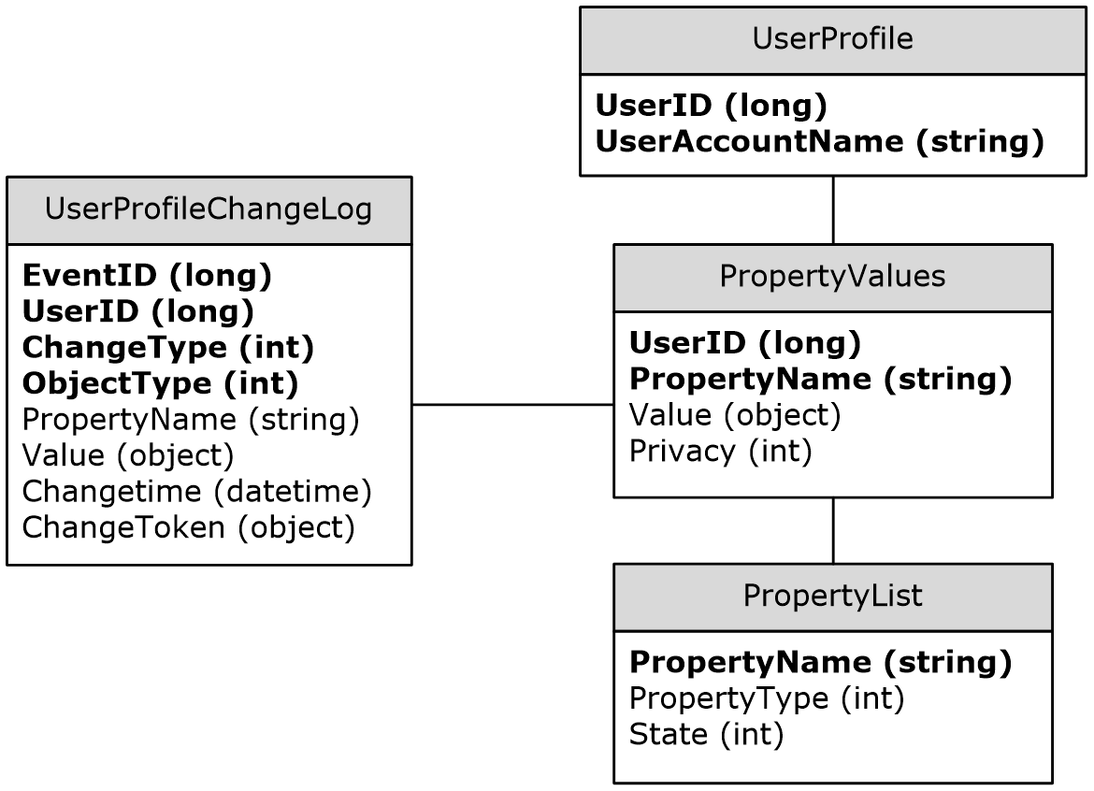
Figure 2: Abstract data model
In the preceding diagram, each table specifies a type of entity in the model, and each line specifies that one type of entity contains a reference to another.
UserProfile Table: A collection of entries corresponding to the user profile available on the protocol server.
- UserID: A unique number that identifies the user.
- userAccountName: A unique string name that identifies the user.
PropertyList Table: A collection of entries, each one corresponding to a property.
- PropertyName: A unique name for the property.
- PropertyType: An integer identifying the type of the property.
- State: An integer identifying what is the property state.
PropertyValues Table: A collection of entries with the values of the user properties.
- UserID: The unique identifier of the user.
- PropertyName: The unique name of the property.
- Value: The value of the property identified by PropertyName for the user identified by UserID.
- Privacy: An integer indicating what the privacy policy is for this property value.
UserProfileChangeLog: A collection of entries containing the user profile change entries.
- EventID: A unique identifier for the user profile change log entry.
- UserID: The unique identifier for the user for whom the user profile change log entry was created.
- ChangeType: An integer identifying the change type of the user profile change log entry.
- ObjectType: An integer identifying the object type of the user profile change log entry.
- PropertyName: The name of the single value property or multivalue property which the user profile change log entry refers to.
- Value: The value of the property for the user profile change log entry.
- ChangeTime: The date and time at which the user profile change log entry was created.
- ChangeToken: The Change Token of the user profile change log entry. It uniquely identifies the specified change.

Timers
None.

Initialization
None.

Message Processing Events and Sequencing Rules
The following table summarizes the list of WSDL operations as defined by this specification:
Operation | Description
GetAllChanges | Retrieves all user profile change entries available on the protocol server.
GetChanges | Retrieves a subset of user profile change entries available on the protocol server.
GetCurrentChangeToken | Retrieves the change token for the most recent user profile change entry available on the protocol server.
GetUserAllChanges | Retrieves all user profile change entries available on the protocol server for the specified user.
GetUserChanges | Retrieves of the user profile change entries available on the protocol server for the specified user.
GetUserCurrentChangeToken | Retrieves the change token for the most recent user profile change entry available on the protocol server for the specified user.

GetAllChanges
The GetAllChanges operation is used to get all user profile change entries available on the protocol server.
<wsdl:operation name="GetAllChanges">
<wsdl:input message="tns:GetAllChangesSoapIn" />
<wsdl:output message="tns:GetAllChangesSoapOut" />
</wsdl:operation>
This method has no input parameters. It is used to retrieve up to 1000 user profile change entries on the protocol server. Only a user with administrator privileges can call this method.
The protocol client sends a GetAllChangesSoapIn request message (section 3.1.4.1.1.1) and the protocol server responds with a GetAllChangesSoapOut response message (section 3.1.4.1.1.2), as shown in the following figure.
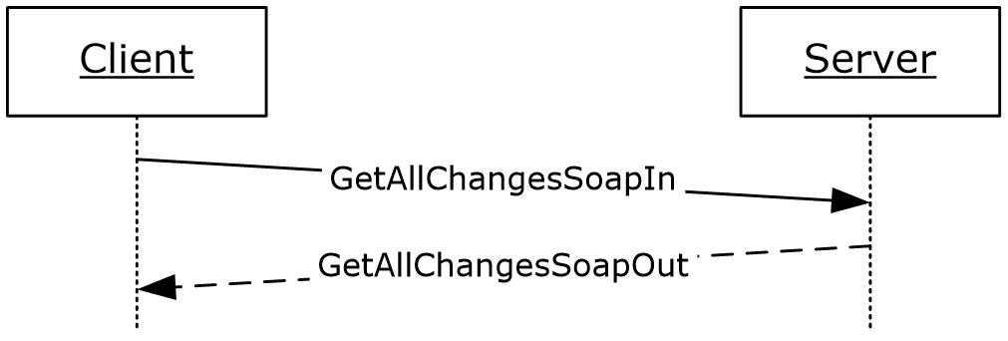
Figure 3: GetAllChanges operation

Messages

GetAllChangesSoapIn
The request WSDL message for a GetAllChanges WSDL operation.
The SOAP action value is:
http://microsoft.com/webservices/SharePointPortalServer/UserProfileChangeService/GetAllChanges
The SOAP body contains a GetAllChanges element.

GetAllChangesSoapOut
The response WSDL message for a GetAllChanges WSDL operation.
The SOAP body contains a GetAllChangesResponse element.

Elements

GetAllChanges
The input for a GetAllChanges WSDL operation.
<s:element name="GetAllChanges">
<s:complexType/>
</s:element>

GetAllChangesResponse
The response WSDL message for a GetAllChanges WSDL operation.
<s:element name="GetAllChangesResponse">
<s:complexType>
<s:sequence>
<s:element minOccurs="0" maxOccurs="1" name="GetAllChangesResult"
type="tns:UserProfileChangeDataContainer" />
</s:sequence>
</s:complexType>
</s:element>
GetAllChangesResult: The UserProfileChangeDataContainer, which MUST contain the returned user profile change entries.

GetChanges
The GetChanges operation is used to retrieve a subset of all user profile change entries available on the protocol server.
<wsdl:operation name="GetChanges">
<wsdl:input message="tns:GetChangesSoapIn" />
<wsdl:output message="tns:GetChangesSoapOut" />
</wsdl:operation>
This method takes a ChangeToken, as described in (section 2.2.4.4), and a query parameter used to filter the user profile change entries available on the protocol server. Only a user with administrator privileges can call this method.
The protocol client sends a GetChangesSoapIn request message (section 3.1.4.2.1.1) and the protocol server responds with a GetChangesSoapOut response message (section 3.1.4.2.1.2), as shown in the following figure.
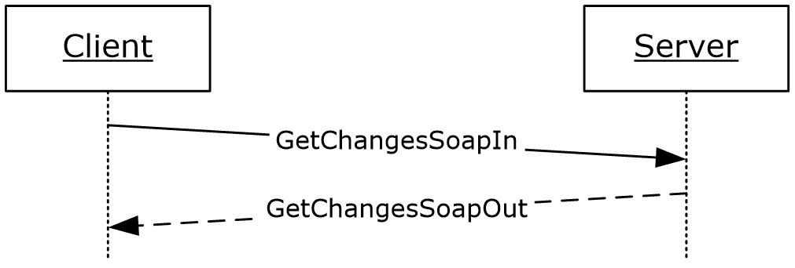
Figure 4: GetChanges operation

Messages

GetChangesSoapIn
The request WSDL message for a GetChanges WSDL operation.
The SOAP action value of the message is defined as follows:
http://microsoft.com/webservices/SharePointPortalServer/UserProfileChangeService/GetChanges
The SOAP body contains a GetChanges element.

GetChangesSoapOut
The response WSDL message for a GetChanges WSDL operation.
The SOAP body contains a GetChangesResponse element.

Elements

GetChanges
The input data for a GetChanges WSDL operation.
<s:element name="GetChanges">
<s:complexType>
<s:sequence>
<s:element minOccurs="0" maxOccurs="1" name="changeToken" type="s:string" />
<s:element minOccurs="0" maxOccurs="1" name="changeQuery"
type="tns:UserProfileChangeQuery" />
</s:sequence>
</s:complexType>
</s:element>
changeToken: A value specifying a change token. This value is acquired from the value of "GetCurrentChangeTokenResult" (section 3.1.4.3.2.2). All returned user profile change entries MUST follow the user profile change entry identified by this change token.
changeQuery: A value that defines the ObjectTypes and ChangeTypes that the returned data SHOULD contain.<4>

GetChangesResponse
The result data for a GetChanges WSDL operation.
<s:element name="GetChangesResponse">
<s:complexType>
<s:sequence>
<s:element minOccurs="0" maxOccurs="1" name="GetChangesResult"
type="tns:UserProfileChangeDataContainer" />
</s:sequence>
</s:complexType>
</s:element>
GetChangesResult: A UserProfileChangeDataContainer that MUST contain all user profile change entries between 0 and 1000.
The response MUST contain a SOAP fault in the following cases:
- The change token provided precedes the earliest change available on the protocol server.
- The change token is invalid.

GetCurrentChangeToken
The GetCurrentChangeToken operation is used to get a change token that identifies the most recent user profile change entry available on the protocol server.
<wsdl:operation name="GetCurrentChangeToken">
<wsdl:input message="tns:GetCurrentChangeTokenSoapIn" />
<wsdl:output message="tns:GetCurrentChangeTokenSoapOut" />
</wsdl:operation>
The protocol client sends a GetCurrentChangeTokenSoapIn request message (section 3.1.4.3.1.1) and the protocol server responds with a GetCurrentChangeTokenSoapOut response message (section 3.1.4.3.1.2), as shown in the following figure.
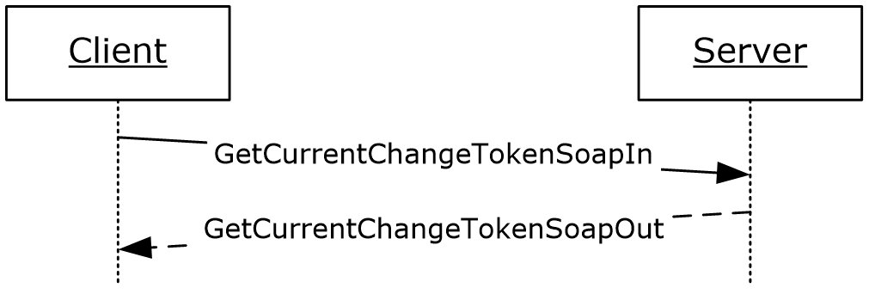
Figure 5: GetCurrentChangeToken operation

Messages

GetCurrentChangeTokenSoapIn
The request WSDL message for a GetCurrentChangeToken WSDL operation.
The SOAP action value is:
http://microsoft.com/webservices/SharePointPortalServer/UserProfileChangeService/GetCurrentChangeToken
The SOAP body contains a GetCurrentChangeToken element.

GetCurrentChangeTokenSoapOut
The response WSDL message for a GetAllChanges WSDL operation.
The SOAP body contains a GetCurrentChangeTokenResponse element.

Elements

GetCurrentChangeToken
The request WSDL message for a GetCurrentChangeToken WSDL operation.
<s:element name="GetCurrentChangeToken">
<s:complexType/>
</s:element>

GetCurrentChangeTokenResponse
The response WSDL message for a GetCurrentChangeToken WSDL operation.
<s:element name="GetCurrentChangeTokenResponse">
<s:complexType>
<s:sequence>
<s:element minOccurs="0" maxOccurs="1" name="GetCurrentChangeTokenResult"
type="s:string" />
</s:sequence>
</s:complexType>
</s:element>
GetCurrentChangeTokenResult: A value that MUST identify the most recent user profile change entry available on the protocol server.

GetUserAllChanges
The GetUserAllChanges operation is used to get all user profile change entries available on the protocol server for the specified user.
<wsdl:operation name="GetUserAllChanges">
<wsdl:input message="tns:GetUserAllChangesSoapIn" />
<wsdl:output message="tns:GetUserAllChangesSoapOut" />
</wsdl:operation>
This method takes a user name as a parameter, and retrieves up to 1000 user profile change entries on the protocol server.
The protocol client sends a GetUserAllChangesSoapIn request message (section 3.1.4.4.1.1) and the protocol server responds with a GetUserAllChangesSoapOut response message (section 3.1.4.4.1.2), as shown in the following figure.
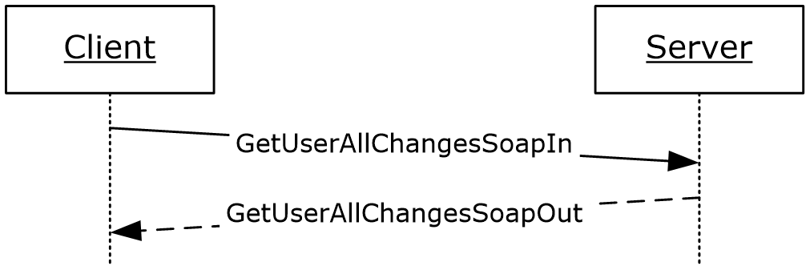
Figure 6: GetUserAllChanges operation

Messages

GetUserAllChangesSoapIn
The request WSDL message for a GetUserAllChangesSoapIn WSDL operation.
The SOAP action value is:
http://microsoft.com/webservices/SharePointPortalServer/UserProfileChangeService/GetUserAllChanges
The SOAP body contains a GetUserAllChanges element.

GetUserAllChangesSoapOut
The response WSDL message for a GetUserAllChangesSoapOut WSDL operation.
The SOAP body contains a GetUserAllChangesResponse element.

Elements

GetUserAllChanges
The request WSDL message for a GetUserAllChanges WSDL operation.
<s:element name="GetUserAllChanges">
<s:complexType>
<s:sequence>
<s:element minOccurs="0" maxOccurs="1" name="userAccountName"
type="s:string" />
</s:sequence>
</s:complexType>
</s:element>
userAccountName: A value that identifies the user whose profile change entries MUST be retrieved.

GetUserAllChangesResponse
The response WSDL message for a GetUserAllChanges WSDL operation.
<s:element name="GetUserAllChangesResponse">
<s:complexType>
<s:sequence>
<s:element minOccurs="0" maxOccurs="1" name="GetUserAllChangesResult"
type="tns:UserProfileChangeDataContainer" />
</s:sequence>
</s:complexType>
</s:element>
GetUserAllChangesResult: A UserProfileChangeDataContainer that MUST contain the user profile change entries of the specified user.
The response MUST contain a SOAP fault when the userAccountName does not have a corresponding profile on the protocol server.

GetUserChanges
The GetUserChanges operation is used to retrieve a subset of all of the user profile change entries that are available on the protocol server for the specified user.
<wsdl:operation name="GetUserChanges">
<wsdl:input message="tns:GetUserChangesSoapIn" />
<wsdl:output message="tns:GetUserChangesSoapOut" />
</wsdl:operation>
This method takes a change token and a query parameter used to filter the user profile change entries that are available on the protocol server for the specified user.
The protocol client sends a GetUserChangesSoapIn request message (section 3.1.4.5.1.1) and the protocol server responds with a GetUserChangesSoapOut response message (section 3.1.4.5.1.2), as shown in the following figure.
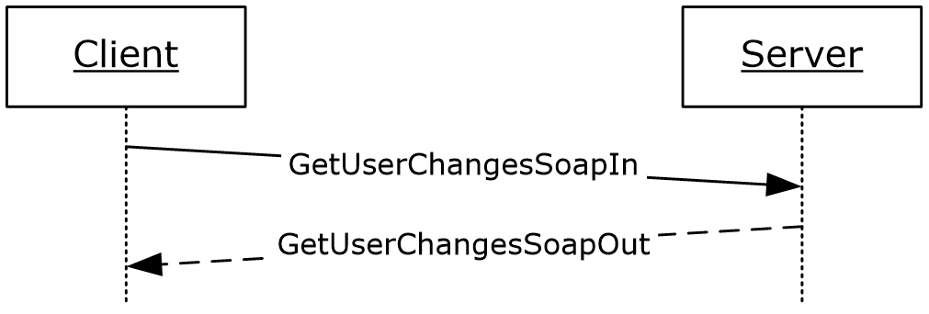
Figure 7: GetUserChanges operation

Messages

GetUserChangesSoapIn
The request WSDL message for a GetUserChanges WSDL operation.
The SOAP action value of the message is defined as follows:
http://microsoft.com/webservices/SharePointPortalServer/UserProfileChangeService/GetUserChanges
The SOAP body contains a GetUserChanges element.

GetUserChangesSoapOut
The response WSDL message for a GetUserChanges WSDL operation.
The SOAP body contains a GetUserChangesResponse element.

Elements

GetUserChanges
The GetUserChanges complex type is used to represent the input data of a GetUserChanges WSDL operation.
<s:element name="GetUserChanges">
<s:complexType>
<s:sequence>
<s:element minOccurs="0" maxOccurs="1" name="userAccountName"
type="s:string" />
<s:element minOccurs="0" maxOccurs="1" name="changeToken" type="s:string" />
<s:element minOccurs="0" maxOccurs="1" name="changeQuery"
type="tns:UserProfileChangeQuery" />
</s:sequence>
</s:complexType>
</s:element>
userAccountName: A value that identifies the user whose profile change entries MUST be retrieved.
changeToken: A value specifying a change token. This value is acquired from the value of "GetUserCurrentChangeTokenResult" (section 3.1.4.6.2.2). All returned user profile change entries MUST follow the user profile change entry identified by this change token.
changeQuery: A value that defines the ObjectTypes and ChangeTypes that the returned data SHOULD contain.<5>

GetUserChangesResponse
The response WSDL message for a GetUserChanges WSDL operation.
<s:element name="GetUserChangesResponse">
<s:complexType>
<s:sequence>
<s:element minOccurs="0" maxOccurs="1" name="GetUserChangesResult"
type="tns:UserProfileChangeDataContainer" />
</s:sequence>
</s:complexType>
</s:element>
GetUserChangesResult: A UserProfileChangeDataContainer that MUST contain the user profile change entries of the specified user. It occurs after the value is identified by the change token.
The response MUST contain a SOAP fault in the following cases:
- The userAccountName does not have a corresponding profile on the protocol server.
- The change token provided precedes the earliest change available on the protocol server.
- The change token is invalid.

GetUserCurrentChangeToken
The GetUserCurrentChangeToken operation is used to return a change token that identifies the most recent user profile change entry available on the protocol server for the specified user.
<wsdl:operation name="GetUserCurrentChangeToken">
<wsdl:input message="tns:GetUserCurrentChangeTokenSoapIn" />
<wsdl:output message="tns:GetUserCurrentChangeTokenSoapOut" />
</wsdl:operation>
The protocol client sends a GetUserCurrentChangeTokenSoapIn request message (section 3.1.4.6.1.1) and the protocol server responds with a GetUserCurrentChangeTokenSoapOut response message (section 3.1.4.6.1.2), as shown in the following figure.
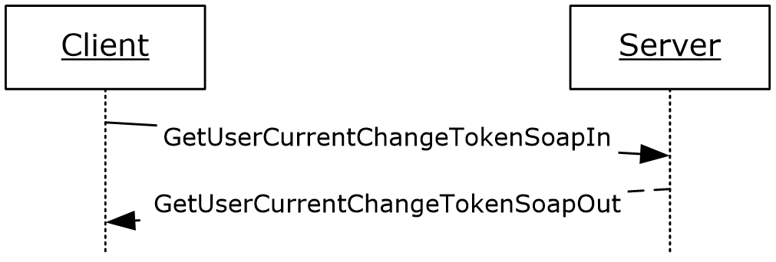
Figure 8: GetUserCurrentChangeToken operation

Messages

GetUserCurrentChangeTokenSoapIn
The request WSDL message for a GetUserCurrentChangeToken WSDL operation.
The SOAP action value is:
http://microsoft.com/webservices/SharePointPortalServer/UserProfileChangeService/GetUserCurrentChangeToken
The SOAP body contains a GetUserCurrentChangeToken element.

GetUserCurrentChangeTokenSoapOut
The response WSDL message for a GetUserCurrentChangeToken WSDL operation.
The SOAP body contains a GetUserCurrentChangeTokenResponse element.

Elements

GetUserCurrentChangeToken
The GetUserCurrentChangeToken complex type is used to represent the input data of a GetUserCurrentChangeToken WSDL operation.
<s:element name="GetUserCurrentChangeToken">
<s:complexType>
<s:sequence>
<s:element minOccurs="0" maxOccurs="1"
name="userAccountName" type="s:string" />
</s:sequence>
</s:complexType>
</s:element>
userAccountName: The specified user to whom the user profile change entry change token applies. This value MUST be retrieved and MUST NOT be NULL.

GetUserCurrentChangeTokenResponse
The response WSDL message for a GetUserCurrentChangeToken WSDL operation.
<s:element name="GetUserCurrentChangeTokenResponse">
<s:complexType>
<s:sequence>
<s:element minOccurs="0" maxOccurs="1"
name="GetUserCurrentChangeTokenResult" type="s:string" />
</s:sequence>
</s:complexType>
</s:element>
GetUserCurrentChangeTokenResult: A value that identifies the most recent user profile change entry that is available on the protocol server for a specified user.
The response MUST contain a SOAP fault when the userAccountName does not have a corresponding profile on the protocol server.

Timer Events
None.

Other Local Events
None.

Protocol Examples

Sample Data
The user profile store contains five user profiles representing five different users. This sample data is used in the following two examples.

User | Colleague list
1 | 2, 3
2 | 1, 4, 5
3 | 1
4 | 2, 5
5 | 2, 4

The property store contains four properties and their privacy policy.
Property name | Type | State
Name | String | Enabled
Address | String | Enabled
Birthday | Date | Enabled
Marriage Date | Date | Enabled

The user profile property store contains ten user profile property values.
User | Property | Value | Privacy
1 | Name | User1 | Public
1 | Address | 123 New Road, New City, ST | Manager
1 | Marriage Data | 02/29/2008 | Public
2 | Name | One More User2 | Public
3 | Name | Different User3 | Public
3 | Birthday | 01/02/1973 | Contacts
4 | Name | Another User4 | Public
4 | Marriage Data | 02/03/1974 | Private
5 | Name | Last User5 | Public
5 | Address | 456 Some Road, Some City, ST | Organization

The user profile change entry log contains six user profile change entries.
EventId | User | Change type | Object Type | Property name | Value | Change time
1 | 1 | Modify | SingleValue Property | Address | 123 New Road, New City, ST | 02/13/2008  1:23:45 PM
2 | 2 | Add | Colleague |  | Another User4 | 02/13/2008  2:34:56 PM
3 | 4 | Add | Colleague |  | One More User2 | 02/13/2008  2:34:56 PM
4 | 5 | Add | WebLog |  | <?xml version="1.0"  encoding="utf-16"?>  <WebLog>  <Title>  My New Post  </Title>  <Permalink>  http://site/p5/newpost  </Permalink>  </WebLog> | 02/13/2008  3:45:07 PM
5 | 3 | Delete | WebLog |  | <?xml version="1.0"  encoding="utf-16"?>  <WebLog>  <Title>  My Old Post  </Title>  <Permalink>  http://site/p3/oldpost  </Permalink>  </WebLog> | 02/13/2008  4:56:18 PM
6 | 1 | Add | SingleValue Property | Marriage Data | 02/29/2008 | 03/01/2008  3:21:17 PM

Profile Replication
This scenario describes the protocol that is used to replicate the user profile information from one protocol server to another, for search engine crawling of user profiles, back-up, transfer, and so forth.
Initially, the protocol client retrieves the current change token to use as a starting point, and sends the following request:
<?xml version="1.0" encoding="utf-8"?>
<soap:Envelope xmlns:soap="http://schemas.xmlsoap.org/soap/envelope/"
xmlns:xsi="http://www.w3.org/2001/XMLSchema-instance" xmlns:xsd="http://www.w3.org/2001/XMLSchema">
<soap:Body>
<GetCurrentChangeToken
xmlns="http://microsoft.com/webservices/SharePointPortalServer/UserProfileChangeService"/>
</soap:Body>
</soap:Envelope>
The protocol server returns the current change token in the form of the following SOAP response:
<?xml version="1.0" encoding="utf-8"?>
<soap:Envelope xmlns:soap="http://schemas.xmlsoap.org/soap/envelope/" xmlns:xsi="http://www.w3.org/2001/XMLSchema-instance" xmlns:xsd="http://www.w3.org/2001/XMLSchema">
<soap:Body>
<GetCurrentChangeTokenResponse
xmlns="http://microsoft.com/webservices/SharePointPortalServer/UserProfileChangeService">
<GetCurrentChangeTokenResult>
1;42703492;02/13/2008 14:34:56
</GetCurrentChangeTokenResult>
</GetCurrentChangeTokenResponse>
</soap:Body>
</soap:Envelope>
The protocol client uses the change token to retrieve all user profile change entries that occurred after the date and time of the specified change token, by sending the following request:
<?xml version="1.0" encoding="utf-8"?>
<soap:Envelope xmlns:soap="http://schemas.xmlsoap.org/soap/envelope/" xmlns:xsi="http://www.w3.org/2001/XMLSchema-instance" xmlns:xsd="http://www.w3.org/2001/XMLSchema">
<soap:Body>
<GetChanges
xmlns="http://microsoft.com/webservices/SharePointPortalServer/UserProfileChangeService">
<changeToken>
1;42703492;02/13/2008 14:34:56
</changeToken>
<changeQuery>
<SingleValueProperty>true</SingleValueProperty>
<MultiValueProperty>true</MultiValueProperty>
<Custom>true</Custom>
<Anniversary>true</Anniversary>
<DistributionListMembership>true</DistributionListMembership>
<SiteMembership>true</SiteMembership>
<QuickLink>true</QuickLink>
<Colleague>true</Colleague>
<PersonalizationSite>true</PersonalizationSite>
<UserProfile>true</UserProfile>
<OrganizationMembership>true</OrganizationMembership>
<WebLog>true</WebLog>
<Add>true</Add>
<Update>true</Update>
<UpdateMetadata>true</UpdateMetadata>
<Delete>true</Delete>
</changeQuery>
</GetChanges>
</soap:Body>
</soap:Envelope>
The protocol server retrieves all user profile change entries that occurred after the specified change token and replies with the following response:
<?xml version="1.0" encoding="utf-8"?>
<soap:Envelope xmlns:soap="http://schemas.xmlsoap.org/soap/envelope/" xmlns:xsi="http://www.w3.org/2001/XMLSchema-instance" xmlns:xsd="http://www.w3.org/2001/XMLSchema">
<soap:Body>
<GetChangesResponse
xmlns="http://microsoft.com/webservices/SharePointPortalServer/UserProfileChangeService">
<GetChangesResult>
<Changes>
<UserProfileChangeData>
<Id>42703511</Id>
<UserAccountName>Another User4</UserAccountName>
<ChangeType>Add</ChangeType>
<ObjectType>Colleague</ObjectType>
<EventTime>2008-02-13T14:34:56.183</EventTime>
<Value xsi:type="xsd:string">One More User2</Value>
<PolicyId>a88b9dcb-5b82-41e4-8a19-17672f307b95</PolicyId>
</UserProfileChangeData>
<UserProfileChangeData>
<Id>42703578</Id>
<UserAccountName>Another User4</UserAccountName>
<ChangeType>Add</ChangeType>
<ObjectType>WebLog</ObjectType>
<EventTime>2008-02-13T15:45:07.183</EventTime>
<PolicyId>a88b9dcb-5b82-41e4-8a19-17672f307b95</PolicyId>
</UserProfileChangeData>
<UserProfileChangeData>
<Id>42703599</Id>
<UserAccountName>Another User4</UserAccountName>
<ChangeType>Delete</ChangeType>
<ObjectType> WebLog </ObjectType>
<EventTime>2008-02-13T16:56:18.183</EventTime>
<PolicyId>a88b9dcb-5b82-41e4-8a19-17672f307b95</PolicyId>
</UserProfileChangeData>
<UserProfileChangeData>
<Id>42703604</Id>
<UserAccountName>User1</UserAccountName>
<ChangeType>Add</ChangeType>
<ObjectType>SingleValueProperty</ObjectType>
<EventTime>2008-03-01T15:21:17.183</EventTime>
<Value xsi:type="xsd:string">02/29/2008 </Value>
<PolicyId>a88b9dcb-5b82-41e4-8a19-17672f307b95</PolicyId>
<PropertyName>Marriage Data</PropertyName>
</UserProfileChangeData>
</Changes>
<ChangeToken>1; 42703604;03/01/2008 15:21:17</ChangeToken>
<HasExceededCountLimit>false</HasExceededCountLimit>
</GetChangesResult>
</GetChangesResponse>
</soap:Body>
</soap:Envelope>
The protocol client parses each UserProfileChangeData record and saves data according to its own storage mechanism, then uses the value of the ChangeToken node to initiate a new GetChanges request. If HasExceededCountLimit is true, not all user profile change entries have been retrieved and only the most recent ones have been sent. The protocol client will then reduce the time period between two consecutive GetChanges requests until HasExceededCountLimit is false, thus ensuring that no further data is lost.

Profile Caching
This scenario describes the protocol that is used to maintain user profile information about a cached user. This example assumes that the protocol client includes data that is already cached.
The protocol client retrieves the desired user’s current change token, which it uses as a starting point to send the following request:
<?xml version="1.0" encoding="utf-8"?>
<soap:Envelope xmlns:soap="http://schemas.xmlsoap.org/soap/envelope/"
xmlns:xsi="http://www.w3.org/2001/XMLSchema-instance" xmlns:xsd="http://www.w3.org/2001/XMLSchema">
<soap:Body>
<GetUserCurrentChangeToken
xmlns="http://microsoft.com/webservices/SharePointPortalServer/UserProfileChangeService">
<userAccountName>User1</userAccountName>
</GetUserCurrentChangeToken>
</soap:Body>
</soap:Envelope>
The protocol server returns the current change token in the form of the following SOAP response:
<?xml version="1.0" encoding="utf-8"?>
<soap:Envelope xmlns:soap="http://schemas.xmlsoap.org/soap/envelope/" xmlns:xsi="http://www.w3.org/2001/XMLSchema-instance" xmlns:xsd="http://www.w3.org/2001/XMLSchema">
<soap:Body>
<GetUserCurrentChangeTokenResponse
xmlns="http://microsoft.com/webservices/SharePointPortalServer/UserProfileChangeService">
<GetUserCurrentChangeTokenResult>
1;1;02/13/2008 13:23:45
</GetUserCurrentChangeTokenResult>
</GetUserCurrentChangeTokenResponse>
</soap:Body>
</soap:Envelope>
The protocol client then uses the change token to retrieve all user profile change entries that occurred after the date and time of the specified change token, by sending the following request:
<?xml version="1.0" encoding="utf-8"?>
<soap:Envelope xmlns:soap="http://schemas.xmlsoap.org/soap/envelope/" xmlns:xsi="http://www.w3.org/2001/XMLSchema-instance" xmlns:xsd="http://www.w3.org/2001/XMLSchema">
<soap:Body>
<GetUserChanges
xmlns="http://microsoft.com/webservices/SharePointPortalServer/UserProfileChangeService">
<userAccountName>User1</userAccountName>
<changeToken>1;1;02/13/2008 13:23:45</changeToken>
<changeQuery>
<SingleValueProperty>true</SingleValueProperty>
<MultiValueProperty>true</MultiValueProperty>
<Custom>true</Custom>
<Anniversary>true</Anniversary>
<DistributionListMembership>true</DistributionListMembership>
<SiteMembership>true</SiteMembership>
<QuickLink>true</QuickLink>
<Colleague>true</Colleague>
<PersonalizationSite>true</PersonalizationSite>
<UserProfile>true</UserProfile>
<OrganizationMembership>true</OrganizationMembership>
<WebLog>true</WebLog>
<Add>true</Add>
<Update>true</Update>
<UpdateMetadata>true</UpdateMetadata>
<Delete>true</Delete>
</changeQuery>
</GetUserChanges>
</soap:Body>
</soap:Envelope>
The protocol server retrieves all user profile change entries that occurred after the specified change token and replies with the following response:
<?xml version="1.0" encoding="utf-8"?>
<soap:Envelope xmlns:soap="http://schemas.xmlsoap.org/soap/envelope/" xmlns:xsi="http://www.w3.org/2001/XMLSchema-instance" xmlns:xsd="http://www.w3.org/2001/XMLSchema">
<soap:Body>
<GetUserChangesResponse
xmlns="http://microsoft.com/webservices/SharePointPortalServer/UserProfileChangeService">
<GetUserChangesResult>
<Changes>
<UserProfileChangeData>
<Id>6</Id>
<UserAccountName>User1</UserAccountName>
<ChangeType>Add</ChangeType>
<ObjectType> SingleValueProperty</ObjectType>
<EventTime>2008-03-01T15:45:07.128</EventTime>
<Value xsi:type="xsd:date">2008-02-29 </Value>
<PolicyId>a88b9dcb-5b82-41e4-8a19-17672f307b95</PolicyId>
<PropertyName> Marriage Data </PropertyName>
</UserProfileChangeData>
</Changes>
<ChangeToken>1;6;03/01/2008 15:45:07</ChangeToken>
<HasExceededCountLimit>false</HasExceededCountLimit>
</GetUserChangesResult>
</GetUserChangesResponse>
</soap:Body>
</soap:Envelope>
The protocol client parses each UserProfileChangeData record and updates the data in the cache accordingly. The protocol client then waits a predetermined amount of time, and uses the value of the ChangeToken node to initiate a new operation. The userAccountName does not have a corresponding profile on the protocol server.
If HasExceededCountLimit is true (signaling that not all user profile change entries could be retrieved and only the most recent ones have been sent), then the protocol client will reduce the time period between two consecutive calls. The userAccountName does not have a corresponding profile on the protocol server. GetUserChanges requests entries until HasExceededCountLimit is false, which ensures that no further data is lost.

Security

Security Considerations for Implementers
None.

Index of Security Parameters
None.

Appendix A: Full WSDL
For ease of implementation the full WSDL is provided in the following:
<?xml version="1.0" encoding="utf-8"?>
<wsdl:definitions xmlns:soap="http://schemas.xmlsoap.org/wsdl/soap/" xmlns:tm="http://microsoft.com/wsdl/mime/textMatching/" xmlns:soapenc="http://schemas.xmlsoap.org/soap/encoding/" xmlns:mime="http://schemas.xmlsoap.org/wsdl/mime/" xmlns:tns="http://microsoft.com/webservices/SharePointPortalServer/UserProfileChangeService" xmlns:s1="http://microsoft.com/wsdl/types/" xmlns:s="http://www.w3.org/2001/XMLSchema" xmlns:soap12="http://schemas.xmlsoap.org/wsdl/soap12/" xmlns:http="http://schemas.xmlsoap.org/wsdl/http/" targetNamespace="http://microsoft.com/webservices/SharePointPortalServer/UserProfileChangeService" xmlns:wsdl="http://schemas.xmlsoap.org/wsdl/">
<wsdl:types>
<s:schema elementFormDefault="qualified" targetNamespace="http://microsoft.com/webservices/SharePointPortalServer/UserProfileChangeService">
<s:import namespace="http://microsoft.com/wsdl/types/" />
<s:element name="GetAllChanges">
<s:complexType />
</s:element>
<s:element name="GetAllChangesResponse">
<s:complexType>
<s:sequence>
<s:element minOccurs="0" maxOccurs="1" name="GetAllChangesResult" type="tns:UserProfileChangeDataContainer" />
</s:sequence>
</s:complexType>
</s:element>
<s:complexType name="UserProfileChangeDataContainer">
<s:sequence>
<s:element minOccurs="0" maxOccurs="1" name="Changes" type="tns:ArrayOfUserProfileChangeData" />
<s:element minOccurs="0" maxOccurs="1" name="ChangeToken" type="s:string" />
<s:element minOccurs="1" maxOccurs="1" name="HasExceededCountLimit" type="s:boolean" />
</s:sequence>
</s:complexType>
<s:complexType name="ArrayOfUserProfileChangeData">
<s:sequence>
<s:element minOccurs="0" maxOccurs="unbounded" name="UserProfileChangeData" nillable="true" type="tns:UserProfileChangeData" />
</s:sequence>
</s:complexType>
<s:complexType name="UserProfileChangeData">
<s:sequence>
<s:element minOccurs="1" maxOccurs="1" name="Id" type="s:long" />
<s:element minOccurs="0" maxOccurs="1" name="UserAccountName" type="s:string" />
<s:element minOccurs="0" maxOccurs="1" name="UserRemotePersonalSiteHostUrl" type="s:string" />
<s:element minOccurs="1" maxOccurs="1" name="ChangeType" type="tns:ChangeTypes" />
<s:element minOccurs="1" maxOccurs="1" name="ObjectType" type="tns:ObjectTypes" />
<s:element minOccurs="1" maxOccurs="1" name="EventTime" type="s:dateTime" />
<s:element minOccurs="0" maxOccurs="1" name="Value" />
<s:element minOccurs="1" maxOccurs="1" name="PolicyId" type="s1:guid" />
<s:element minOccurs="0" maxOccurs="1" name="PropertyName" type="s:string" />
</s:sequence>
</s:complexType>
<s:simpleType name="ChangeTypes">
<s:list>
<s:simpleType>
<s:restriction base="s:string">
<s:enumeration value="None" />
<s:enumeration value="Add" />
<s:enumeration value="Modify" />
<s:enumeration value="Delete" />
<s:enumeration value="Metadata" />
<s:enumeration value="All" />
</s:restriction>
</s:simpleType>
</s:list>
</s:simpleType>
<s:simpleType name="ObjectTypes">
<s:list>
<s:simpleType>
<s:restriction base="s:string">
<s:enumeration value="None" />
<s:enumeration value="SingleValueProperty" />
<s:enumeration value="MultiValueProperty" />
<s:enumeration value="Anniversary" />
<s:enumeration value="DLMembership" />
<s:enumeration value="SiteMembership" />
<s:enumeration value="QuickLink" />
<s:enumeration value="Colleague" />
<s:enumeration value="PersonalizationSite" />
<s:enumeration value="UserProfile" />
<s:enumeration value="WebLog" />
<s:enumeration value="Custom" />
<s:enumeration value="OrganizationProfile" />
<s:enumeration value="OrganizationMembership" />
<s:enumeration value="All" />
</s:restriction>
</s:simpleType>
</s:list>
</s:simpleType>
<s:element name="GetChanges">
<s:complexType>
<s:sequence>
<s:element minOccurs="0" maxOccurs="1" name="changeToken" type="s:string" />
<s:element minOccurs="0" maxOccurs="1" name="changeQuery" type="tns:UserProfileChangeQuery" />
</s:sequence>
</s:complexType>
</s:element>
<s:complexType name="UserProfileChangeQuery">
<s:complexContent mixed="false">
<s:extension base="tns:ProfileBaseChangeQuery">
<s:sequence>
<s:element minOccurs="1" maxOccurs="1" name="Anniversary" type="s:boolean" />
<s:element minOccurs="1" maxOccurs="1" name="DistributionListMembership" type="s:boolean" />
<s:element minOccurs="1" maxOccurs="1" name="SiteMembership" type="s:boolean" />
<s:element minOccurs="1" maxOccurs="1" name="QuickLink" type="s:boolean" />
<s:element minOccurs="1" maxOccurs="1" name="Colleague" type="s:boolean" />
<s:element minOccurs="1" maxOccurs="1" name="WebLog" type="s:boolean" />
<s:element minOccurs="1" maxOccurs="1" name="PersonalizationSite" type="s:boolean" />
<s:element minOccurs="1" maxOccurs="1" name="UserProfile" type="s:boolean" />
<s:element minOccurs="1" maxOccurs="1" name="OrganizationMembership" type="s:boolean" />
</s:sequence>
</s:extension>
</s:complexContent>
</s:complexType>
<s:complexType name="ProfileBaseChangeQuery">
<s:sequence>
<s:element minOccurs="1" maxOccurs="1" name="SingleValueProperty" type="s:boolean" />
<s:element minOccurs="1" maxOccurs="1" name="MultiValueProperty" type="s:boolean" />
<s:element minOccurs="1" maxOccurs="1" name="Custom" type="s:boolean" />
<s:element minOccurs="1" maxOccurs="1" name="Add" type="s:boolean" />
<s:element minOccurs="1" maxOccurs="1" name="Update" type="s:boolean" />
<s:element minOccurs="1" maxOccurs="1" name="UpdateMetadata" type="s:boolean" />
<s:element minOccurs="1" maxOccurs="1" name="Delete" type="s:boolean" />
<s:element minOccurs="0" maxOccurs="1" name="ChangeTokenStart" type="tns:UserProfileChangeToken" />
</s:sequence>
</s:complexType>
<s:complexType name="UserProfileChangeToken" />
<s:element name="GetChangesResponse">
<s:complexType>
<s:sequence>
<s:element minOccurs="0" maxOccurs="1" name="GetChangesResult" type="tns:UserProfileChangeDataContainer" />
</s:sequence>
</s:complexType>
</s:element>
<s:element name="GetCurrentChangeToken">
<s:complexType />
</s:element>
<s:element name="GetCurrentChangeTokenResponse">
<s:complexType>
<s:sequence>
<s:element minOccurs="0" maxOccurs="1" name="GetCurrentChangeTokenResult" type="s:string" />
</s:sequence>
</s:complexType>
</s:element>
<s:element name="GetUserAllChanges">
<s:complexType>
<s:sequence>
<s:element minOccurs="0" maxOccurs="1" name="userAccountName" type="s:string" />
</s:sequence>
</s:complexType>
</s:element>
<s:element name="GetUserAllChangesResponse">
<s:complexType>
<s:sequence>
<s:element minOccurs="0" maxOccurs="1" name="GetUserAllChangesResult" type="tns:UserProfileChangeDataContainer" />
</s:sequence>
</s:complexType>
</s:element>
<s:element name="GetUserChanges">
<s:complexType>
<s:sequence>
<s:element minOccurs="0" maxOccurs="1" name="userAccountName" type="s:string" />
<s:element minOccurs="0" maxOccurs="1" name="changeToken" type="s:string" />
<s:element minOccurs="0" maxOccurs="1" name="changeQuery" type="tns:UserProfileChangeQuery" />
</s:sequence>
</s:complexType>
</s:element>
<s:element name="GetUserChangesResponse">
<s:complexType>
<s:sequence>
<s:element minOccurs="0" maxOccurs="1" name="GetUserChangesResult" type="tns:UserProfileChangeDataContainer" />
</s:sequence>
</s:complexType>
</s:element>
<s:element name="GetUserCurrentChangeToken">
<s:complexType>
<s:sequence>
<s:element minOccurs="0" maxOccurs="1" name="userAccountName" type="s:string" />
</s:sequence>
</s:complexType>
</s:element>
<s:element name="GetUserCurrentChangeTokenResponse">
<s:complexType>
<s:sequence>
<s:element minOccurs="0" maxOccurs="1" name="GetUserCurrentChangeTokenResult" type="s:string" />
</s:sequence>
</s:complexType>
</s:element>
</s:schema>
<s:schema elementFormDefault="qualified" targetNamespace="http://microsoft.com/wsdl/types/">
<s:simpleType name="guid">
<s:restriction base="s:string">
<s:pattern value="[0-9a-fA-F]{8}-[0-9a-fA-F]{4}-[0-9a-fA-F]{4}-[0-9a-fA-F]{4}-[0-9a-fA-F]{12}" />
</s:restriction>
</s:simpleType>
</s:schema>
</wsdl:types>
<wsdl:message name="GetAllChangesSoapIn">
<wsdl:part name="parameters" element="tns:GetAllChanges" />
</wsdl:message>
<wsdl:message name="GetAllChangesSoapOut">
<wsdl:part name="parameters" element="tns:GetAllChangesResponse" />
</wsdl:message>
<wsdl:message name="GetChangesSoapIn">
<wsdl:part name="parameters" element="tns:GetChanges" />
</wsdl:message>
<wsdl:message name="GetChangesSoapOut">
<wsdl:part name="parameters" element="tns:GetChangesResponse" />
</wsdl:message>
<wsdl:message name="GetCurrentChangeTokenSoapIn">
<wsdl:part name="parameters" element="tns:GetCurrentChangeToken" />
</wsdl:message>
<wsdl:message name="GetCurrentChangeTokenSoapOut">
<wsdl:part name="parameters" element="tns:GetCurrentChangeTokenResponse" />
</wsdl:message>
<wsdl:message name="GetUserAllChangesSoapIn">
<wsdl:part name="parameters" element="tns:GetUserAllChanges" />
</wsdl:message>
<wsdl:message name="GetUserAllChangesSoapOut">
<wsdl:part name="parameters" element="tns:GetUserAllChangesResponse" />
</wsdl:message>
<wsdl:message name="GetUserChangesSoapIn">
<wsdl:part name="parameters" element="tns:GetUserChanges" />
</wsdl:message>
<wsdl:message name="GetUserChangesSoapOut">
<wsdl:part name="parameters" element="tns:GetUserChangesResponse" />
</wsdl:message>
<wsdl:message name="GetUserCurrentChangeTokenSoapIn">
<wsdl:part name="parameters" element="tns:GetUserCurrentChangeToken" />
</wsdl:message>
<wsdl:message name="GetUserCurrentChangeTokenSoapOut">
<wsdl:part name="parameters" element="tns:GetUserCurrentChangeTokenResponse" />
</wsdl:message>
<wsdl:portType name="UserProfileChangeServiceSoap">
<wsdl:operation name="GetAllChanges">
<wsdl:input message="tns:GetAllChangesSoapIn" />
<wsdl:output message="tns:GetAllChangesSoapOut" />
</wsdl:operation>
<wsdl:operation name="GetChanges">
<wsdl:input message="tns:GetChangesSoapIn" />
<wsdl:output message="tns:GetChangesSoapOut" />
</wsdl:operation>
<wsdl:operation name="GetCurrentChangeToken">
<wsdl:input message="tns:GetCurrentChangeTokenSoapIn" />
<wsdl:output message="tns:GetCurrentChangeTokenSoapOut" />
</wsdl:operation>
<wsdl:operation name="GetUserAllChanges">
<wsdl:input message="tns:GetUserAllChangesSoapIn" />
<wsdl:output message="tns:GetUserAllChangesSoapOut" />
</wsdl:operation>
<wsdl:operation name="GetUserChanges">
<wsdl:input message="tns:GetUserChangesSoapIn" />
<wsdl:output message="tns:GetUserChangesSoapOut" />
</wsdl:operation>
<wsdl:operation name="GetUserCurrentChangeToken">
<wsdl:input message="tns:GetUserCurrentChangeTokenSoapIn" />
<wsdl:output message="tns:GetUserCurrentChangeTokenSoapOut" />
</wsdl:operation>
</wsdl:portType>
<wsdl:binding name="UserProfileChangeServiceSoap" type="tns:UserProfileChangeServiceSoap">
<soap:binding transport="http://schemas.xmlsoap.org/soap/http" />
<wsdl:operation name="GetAllChanges">
<soap:operation soapAction="http://microsoft.com/webservices/SharePointPortalServer/UserProfileChangeService/GetAllChanges" style="document" />
<wsdl:input>
<soap:body use="literal" />
</wsdl:input>
<wsdl:output>
<soap:body use="literal" />
</wsdl:output>
</wsdl:operation>
<wsdl:operation name="GetChanges">
<soap:operation soapAction="http://microsoft.com/webservices/SharePointPortalServer/UserProfileChangeService/GetChanges" style="document" />
<wsdl:input>
<soap:body use="literal" />
</wsdl:input>
<wsdl:output>
<soap:body use="literal" />
</wsdl:output>
</wsdl:operation>
<wsdl:operation name="GetCurrentChangeToken">
<soap:operation soapAction="http://microsoft.com/webservices/SharePointPortalServer/UserProfileChangeService/GetCurrentChangeToken" style="document" />
<wsdl:input>
<soap:body use="literal" />
</wsdl:input>
<wsdl:output>
<soap:body use="literal" />
</wsdl:output>
</wsdl:operation>
<wsdl:operation name="GetUserAllChanges">
<soap:operation soapAction="http://microsoft.com/webservices/SharePointPortalServer/UserProfileChangeService/GetUserAllChanges" style="document" />
<wsdl:input>
<soap:body use="literal" />
</wsdl:input>
<wsdl:output>
<soap:body use="literal" />
</wsdl:output>
</wsdl:operation>
<wsdl:operation name="GetUserChanges">
<soap:operation soapAction="http://microsoft.com/webservices/SharePointPortalServer/UserProfileChangeService/GetUserChanges" style="document" />
<wsdl:input>
<soap:body use="literal" />
</wsdl:input>
<wsdl:output>
<soap:body use="literal" />
</wsdl:output>
</wsdl:operation>
<wsdl:operation name="GetUserCurrentChangeToken">
<soap:operation soapAction="http://microsoft.com/webservices/SharePointPortalServer/UserProfileChangeService/GetUserCurrentChangeToken" style="document" />
<wsdl:input>
<soap:body use="literal" />
</wsdl:input>
<wsdl:output>
<soap:body use="literal" />
</wsdl:output>
</wsdl:operation>
</wsdl:binding>
<wsdl:binding name="UserProfileChangeServiceSoap12" type="tns:UserProfileChangeServiceSoap">
<soap12:binding transport="http://schemas.xmlsoap.org/soap/http" />
<wsdl:operation name="GetAllChanges">
<soap12:operation soapAction="http://microsoft.com/webservices/SharePointPortalServer/UserProfileChangeService/GetAllChanges" style="document" />
<wsdl:input>
<soap12:body use="literal" />
</wsdl:input>
<wsdl:output>
<soap12:body use="literal" />
</wsdl:output>
</wsdl:operation>
<wsdl:operation name="GetChanges">
<soap12:operation soapAction="http://microsoft.com/webservices/SharePointPortalServer/UserProfileChangeService/GetChanges" style="document" />
<wsdl:input>
<soap12:body use="literal" />
</wsdl:input>
<wsdl:output>
<soap12:body use="literal" />
</wsdl:output>
</wsdl:operation>
<wsdl:operation name="GetCurrentChangeToken">
<soap12:operation soapAction="http://microsoft.com/webservices/SharePointPortalServer/UserProfileChangeService/GetCurrentChangeToken" style="document" />
<wsdl:input>
<soap12:body use="literal" />
</wsdl:input>
<wsdl:output>
<soap12:body use="literal" />
</wsdl:output>
</wsdl:operation>
<wsdl:operation name="GetUserAllChanges">
<soap12:operation soapAction="http://microsoft.com/webservices/SharePointPortalServer/UserProfileChangeService/GetUserAllChanges" style="document" />
<wsdl:input>
<soap12:body use="literal" />
</wsdl:input>
<wsdl:output>
<soap12:body use="literal" />
</wsdl:output>
</wsdl:operation>
<wsdl:operation name="GetUserChanges">
<soap12:operation soapAction="http://microsoft.com/webservices/SharePointPortalServer/UserProfileChangeService/GetUserChanges" style="document" />
<wsdl:input>
<soap12:body use="literal" />
</wsdl:input>
<wsdl:output>
<soap12:body use="literal" />
</wsdl:output>
</wsdl:operation>
<wsdl:operation name="GetUserCurrentChangeToken">
<soap12:operation soapAction="http://microsoft.com/webservices/SharePointPortalServer/UserProfileChangeService/GetUserCurrentChangeToken" style="document" />
<wsdl:input>
<soap12:body use="literal" />
</wsdl:input>
<wsdl:output>
<soap12:body use="literal" />
</wsdl:output>
</wsdl:operation>
</wsdl:binding>
</wsdl:definitions>

Appendix B: Product Behavior
The information in this specification is applicable to the following Microsoft products or supplemental software. References to product versions include updates to those products.
- Microsoft Office SharePoint Server 2007
- Microsoft SharePoint Server 2010
- Microsoft SharePoint Server 2013
- Microsoft SharePoint Server 2016
- Microsoft SharePoint Server 2019
- Microsoft SharePoint Server Subscription Edition
Exceptions, if any, are noted in this section. If an update version, service pack or Knowledge Base (KB) number appears with a product name, the behavior changed in that update. The new behavior also applies to subsequent updates unless otherwise specified. If a product edition appears with the product version, behavior is different in that product edition.
Unless otherwise specified, any statement of optional behavior in this specification that is prescribed using the terms "SHOULD" or "SHOULD NOT" implies product behavior in accordance with the SHOULD or SHOULD NOT prescription. Unless otherwise specified, the term "MAY" implies that the product does not follow the prescription.
<1> Section 2.2.5.2: Custom is not supported in Office SharePoint Server 2007.
<2> Section 2.2.5.2: OrganizationProfile is not supported in Office SharePoint Server 2007.
<3> Section 2.2.5.2: OrganizationMembership is not supported in Office SharePoint Server 2007.
<4> Section 3.1.4.2.2.1: When the user profile change entries log in the server does not have the specified ObjectTypes or ChangeTypes, the returned data will not contain the corresponding ObjectTypes or ChangeTypes.
<5> Section 3.1.4.5.2.1: When the user profile change entries log in the server does not have the specified ObjectTypes or ChangeTypes, the returned data will not contain the corresponding ObjectTypes or ChangeTypes.

Change Tracking
This section identifies changes that were made to this document since the last release. Changes are classified as Major, Minor, or None.
The revision class Major means that the technical content in the document was significantly revised. Major changes affect protocol interoperability or implementation. Examples of major changes are:
- A document revision that incorporates changes to interoperability requirements.
- A document revision that captures changes to protocol functionality.
The revision class Minor means that the meaning of the technical content was clarified. Minor changes do not affect protocol interoperability or implementation. Examples of minor changes are updates to clarify ambiguity at the sentence, paragraph, or table level.
The revision class None means that no new technical changes were introduced. Minor editorial and formatting changes may have been made, but the relevant technical content is identical to the last released version.
The changes made to this document are listed in the following table. For more information, please contact dochelp@microsoft.com.
Section | Description | Revision class
7 Appendix B: Product Behavior | Updated list of supported products. | Major

Index
A

Abstract data model
server 18
Applicability 9
ArrayOfUserProfileChangeData complex type 11
Attribute groups 17
Attributes 17

C

Capability negotiation 9
Change tracking 45
ChangeTypes simple type 15
Complex types 11
ArrayOfUserProfileChangeData 11
ProfileBaseChangeQuery 12
UserProfileChangeData 12
UserProfileChangeDataContainer 13
UserProfileChangeQuery 14
UserProfileChangeToken 15

D

Data model - abstract
server 18

E

Events
local - server 29
timer - server 29
Examples
profile caching 33
profile replication 31
sample data 30

F

Fields - vendor-extensible 9
Full WSDL 37

G

Glossary 6
Groups 17
GUID simple type 17

I

Implementer - security considerations 36
Index of security parameters 36
Informative references 8
Initialization
server 19
Introduction 6

L

Local events
server 29

M

Message processing
server 19
Messages
ArrayOfUserProfileChangeData complex type 11
attribute groups 17
attributes 17
ChangeTypes simple type 15
complex types 11
elements 11
enumerated 11
groups 17
GUID simple type 17
namespaces 10
ObjectTypes simple type 16
ProfileBaseChangeQuery complex type 12
simple types 15
syntax 10
transport 10
UserProfileChangeData complex type 12
UserProfileChangeDataContainer complex type 13
UserProfileChangeQuery complex type 14
UserProfileChangeToken complex type 15

N

Namespaces 10
Normative references 7

O

ObjectTypes simple type 16
Operations
GetAllChanges 20
GetChanges 21
GetCurrentChangeToken 23
GetUserAllChanges 24
GetUserChanges 25
GetUserCurrentChangeToken 27
Overview (synopsis) 8

P

Parameters - security index 36
Preconditions 9
Prerequisites 9
Product behavior 44
Profile caching example 33
Profile replication example 31
ProfileBaseChangeQuery complex type 12
Protocol Details
overview 18

R

References 7
informative 8
normative 7
Relationship to other protocols 8

S

Sample data example 30
Security
implementer considerations 36
parameter index 36
Sequencing rules
server 19
Server
abstract data model 18
GetAllChanges operation 20
GetChanges operation 21
GetCurrentChangeToken operation 23
GetUserAllChanges operation 24
GetUserChanges operation 25
GetUserCurrentChangeToken operation 27
initialization 19
local events 29
message processing 19
sequencing rules 19
timer events 29
timers 19
Simple types 15
ChangeTypes 15
GUID 17
ObjectTypes 16
Standards assignments 9
Syntax
messages - overview 10

T

Timer events
server 29
Timers
server 19
Tracking changes 45
Transport 10
Types
complex 11
simple 15

U

UserProfileChangeData complex type 12
UserProfileChangeDataContainer complex type 13
UserProfileChangeQuery complex type 14
UserProfileChangeToken complex type 15

V

Vendor-extensible fields 9
Versioning 9

W

WSDL 37

