[MS-USPSWS]:
User Profile Service Web Service Protocol

Intellectual Property Rights Notice for Open Specifications Documentation
- Technical Documentation. Microsoft publishes Open Specifications documentation (“this documentation”) for protocols, file formats, data portability, computer languages, and standards support. Additionally, overview documents cover inter-protocol relationships and interactions.
- Copyrights. This documentation is covered by Microsoft copyrights. Regardless of any other terms that are contained in the terms of use for the Microsoft website that hosts this documentation, you can make copies of it in order to develop implementations of the technologies that are described in this documentation and can distribute portions of it in your implementations that use these technologies or in your documentation as necessary to properly document the implementation. You can also distribute in your implementation, with or without modification, any schemas, IDLs, or code samples that are included in the documentation. This permission also applies to any documents that are referenced in the Open Specifications documentation.
- No Trade Secrets. Microsoft does not claim any trade secret rights in this documentation.
- Patents. Microsoft has patents that might cover your implementations of the technologies described in the Open Specifications documentation. Neither this notice nor Microsoft's delivery of this documentation grants any licenses under those patents or any other Microsoft patents. However, a given Open Specifications document might be covered by the Microsoft Open Specifications Promise or the Microsoft Community Promise. If you would prefer a written license, or if the technologies described in this documentation are not covered by the Open Specifications Promise or Community Promise, as applicable, patent licenses are available by contacting iplg@microsoft.com.
- License Programs. To see all of the protocols in scope under a specific license program and the associated patents, visit the Patent Map.
- Trademarks. The names of companies and products contained in this documentation might be covered by trademarks or similar intellectual property rights. This notice does not grant any licenses under those rights. For a list of Microsoft trademarks, visit www.microsoft.com/trademarks.
- Fictitious Names. The example companies, organizations, products, domain names, email addresses, logos, people, places, and events that are depicted in this documentation are fictitious. No association with any real company, organization, product, domain name, email address, logo, person, place, or event is intended or should be inferred.
Reservation of Rights. All other rights are reserved, and this notice does not grant any rights other than as specifically described above, whether by implication, estoppel, or otherwise.
Tools. The Open Specifications documentation does not require the use of Microsoft programming tools or programming environments in order for you to develop an implementation. If you have access to Microsoft programming tools and environments, you are free to take advantage of them. Certain Open Specifications documents are intended for use in conjunction with publicly available standards specifications and network programming art and, as such, assume that the reader either is familiar with the aforementioned material or has immediate access to it.
Support. For questions and support, please contact dochelp@microsoft.com.
Revision Summary
Date | Revision History | Revision Class | Comments
4/4/2008 | 0.1 | New | Initial Availability
6/27/2008 | 1.0 | Major | Revised and edited the technical content
8/15/2008 | 1.01 | Editorial | Revised and edited the technical content
12/12/2008 | 1.02 | Editorial | Revised and edited the technical content
7/13/2009 | 1.03 | Major | Revised and edited the technical content
8/28/2009 | 1.04 | Editorial | Revised and edited the technical content
11/6/2009 | 1.05 | Editorial | Revised and edited the technical content
2/19/2010 | 2.0 | Major | Updated and revised the technical content
3/31/2010 | 2.01 | Editorial | Revised and edited the technical content
4/30/2010 | 2.02 | Editorial | Revised and edited the technical content
6/7/2010 | 2.03 | Editorial | Revised and edited the technical content
6/29/2010 | 2.04 | Editorial | Changed language and formatting in the technical content.
7/23/2010 | 2.04 | None | No changes to the meaning, language, or formatting of the technical content.
9/27/2010 | 2.04 | None | No changes to the meaning, language, or formatting of the technical content.
11/15/2010 | 2.04 | None | No changes to the meaning, language, or formatting of the technical content.
12/17/2010 | 2.04 | None | No changes to the meaning, language, or formatting of the technical content.
3/18/2011 | 2.04 | None | No changes to the meaning, language, or formatting of the technical content.
6/10/2011 | 2.04 | None | No changes to the meaning, language, or formatting of the technical content.
1/20/2012 | 3.0 | Major | Significantly changed the technical content.
4/11/2012 | 3.0 | None | No changes to the meaning, language, or formatting of the technical content.
7/16/2012 | 3.1 | Minor | Clarified the meaning of the technical content.
9/12/2012 | 3.1 | None | No changes to the meaning, language, or formatting of the technical content.
10/8/2012 | 4.0 | Major | Significantly changed the technical content.
2/11/2013 | 4.0 | None | No changes to the meaning, language, or formatting of the technical content.
7/30/2013 | 4.1 | Minor | Clarified the meaning of the technical content.
11/18/2013 | 4.1 | None | No changes to the meaning, language, or formatting of the technical content.
2/10/2014 | 4.1 | None | No changes to the meaning, language, or formatting of the technical content.
4/30/2014 | 4.2 | Minor | Clarified the meaning of the technical content.
7/31/2014 | 4.2 | None | No changes to the meaning, language, or formatting of the technical content.
10/30/2014 | 4.2 | None | No changes to the meaning, language, or formatting of the technical content.
3/16/2015 | 5.0 | Major | Significantly changed the technical content.
2/26/2016 | 6.0 | Major | Significantly changed the technical content.
7/15/2016 | 6.0 | None | No changes to the meaning, language, or formatting of the technical content.
9/14/2016 | 6.0 | None | No changes to the meaning, language, or formatting of the technical content.
6/20/2017 | 7.0 | Major | Significantly changed the technical content.
7/24/2018 | 8.0 | Major | Significantly changed the technical content.
10/1/2018 | 9.0 | Major | Significantly changed the technical content.
6/18/2019 | 9.0 | None | No changes to the meaning, language, or formatting of the technical content.
2/16/2021 | 9.1 | Minor | Clarified the meaning of the technical content.
4/22/2021 | 10.0 | Major | Significantly changed the technical content.
7/20/2021 | 11.0 | Major | Significantly changed the technical content.
8/17/2021 | 12.0 | Major | Significantly changed the technical content.
10/5/2021 | 12.0 | None | No changes to the meaning, language, or formatting of the technical content.
2/15/2022 | 12.0 | None | No changes to the meaning, language, or formatting of the technical content.
4/16/2024 | 13.0 | Major | Significantly changed the technical content.
Table of Contents
1 Introduction 11
1.1 Glossary 11
1.2 References 13
1.2.1 Normative References 13
1.2.2 Informative References 14
1.3 Protocol Overview (Synopsis) 14
1.4 Relationship to Other Protocols 14
1.5 Prerequisites/Preconditions 15
1.6 Applicability Statement 15
1.7 Versioning and Capability Negotiation 15
1.8 Vendor-Extensible Fields 15
1.9 Standards Assignments 15
2 Messages 16
2.1 Transport 16
2.2 Common Message Syntax 16
2.2.1 Namespaces 16
2.2.2 Messages 16
2.2.3 Elements 16
2.2.4 Complex Types 16
2.2.4.1 ArrayOfContactData 17
2.2.4.2 ArrayOfDouble 17
2.2.4.3 ArrayOfMembershipData 18
2.2.4.4 ArrayOfOrganizationProfileData 18
2.2.4.5 ArrayOfPinnedLinkData 18
2.2.4.6 ArrayOfPropertyData 18
2.2.4.7 ArrayOfPropertyInfo 19
2.2.4.8 ArrayOfQuickLinkData 19
2.2.4.9 ArrayOfString 19
2.2.4.10 ArrayOfValueData 19
2.2.4.11 ContactData 20
2.2.4.12 MemberGroupData 20
2.2.4.13 MembershipData 21
2.2.4.14 OrganizationProfileData 22
2.2.4.15 PinnedLinkData 22
2.2.4.16 PropertyData 22
2.2.4.17 PropertyInfo 23
2.2.4.18 QuickLinkData 24
2.2.4.19 ValueData 25
2.2.5 Simple Types 25
2.2.5.1 ChoiceTypes 25
2.2.5.2 guid 26
2.2.5.3 MembershipSource 26
2.2.5.4 Privacy 27
2.2.5.5 SuggestionType 27
2.2.6 Attributes 28
2.2.7 Groups 28
2.2.8 Attribute Groups 28
3 Protocol Details 29
3.1 Protocol Server Details 29
3.1.1 Abstract Data Model 29
3.1.2 Timers 32
3.1.3 Initialization 32
3.1.4 Message Processing Events and Sequencing Rules 33
3.1.4.1 AddColleague 34
3.1.4.1.1 Messages 35
3.1.4.1.1.1 AddColleagueSoapIn 35
3.1.4.1.1.2 AddColleagueSoapOut 35
3.1.4.1.2 Elements 35
3.1.4.1.2.1 AddColleague 35
3.1.4.1.2.2 AddColleagueResponse 36
3.1.4.2 AddColleagueWithoutEmailNotification 37
3.1.4.2.1 Messages 37
3.1.4.2.1.1 AddColleagueWithoutEmailNotificationSoapIn 37
3.1.4.2.1.2 AddColleagueWithoutEmailNotificationSoapOut 37
3.1.4.2.2 Elements 38
3.1.4.2.2.1 AddColleagueWithoutEmailNotification 38
3.1.4.2.2.2 AddColleagueWithoutEmailNotificationResponse 39
3.1.4.3 AddLink 39
3.1.4.3.1 Messages 39
3.1.4.3.1.1 AddLinkSoapIn 39
3.1.4.3.1.2 AddLinkSoapOut 39
3.1.4.3.2 Elements 40
3.1.4.3.2.1 AddLink 40
3.1.4.3.2.2 AddLinkResponse 40
3.1.4.4 AddMembership 41
3.1.4.4.1 Messages 41
3.1.4.4.1.1 AddMembershipSoapIn 41
3.1.4.4.1.2 AddMembershipSoapOut 41
3.1.4.4.2 Elements 41
3.1.4.4.2.1 AddMembership 41
3.1.4.4.2.2 AddMembershipResponse 42
3.1.4.5 AddPinnedLink 42
3.1.4.5.1 Messages 43
3.1.4.5.1.1 AddPinnedLinkSoapIn 43
3.1.4.5.1.2 AddPinnedLinkSoapOut 43
3.1.4.5.2 Elements 43
3.1.4.5.2.1 AddPinnedLink 43
3.1.4.5.2.2 AddPinnedLinkResponse 44
3.1.4.6 AddSuggestions 44
3.1.4.6.1 Messages 44
3.1.4.6.1.1 AddSuggestionsSoapIn 44
3.1.4.6.1.2 AddSuggestionsSoapOut 45
3.1.4.6.2 Elements 45
3.1.4.6.2.1 AddSuggestions 45
3.1.4.6.2.2 AddSuggestionsResponse 45
3.1.4.7 CreateMemberGroup 46
3.1.4.7.1 Messages 46
3.1.4.7.1.1 CreateMemberGroupSoapIn 46
3.1.4.7.1.2 CreateMemberGroupSoapOut 46
3.1.4.7.2 Elements 46
3.1.4.7.2.1 CreateMemberGroup 46
3.1.4.7.2.2 CreateMemberGroupResponse 47
3.1.4.8 CreateUserProfileByAccountName 47
3.1.4.8.1 Messages 47
3.1.4.8.1.1 CreateUserProfileByAccountNameSoapIn 47
3.1.4.8.1.2 CreateUserProfileByAccountNameSoapOut 48
3.1.4.8.2 Elements 48
3.1.4.8.2.1 CreateUserProfileByAccountName 48
3.1.4.8.2.2 CreateUserProfileByAccountNameResponse 48
3.1.4.9 GetCommonColleagues 49
3.1.4.9.1 Messages 49
3.1.4.9.1.1 GetCommonColleaguesSoapIn 49
3.1.4.9.1.2 GetCommonColleaguesSoapOut 49
3.1.4.9.2 Elements 49
3.1.4.9.2.1 GetCommonColleagues 49
3.1.4.9.2.2 GetCommonColleaguesResponse 50
3.1.4.10 GetCommonManager 50
3.1.4.10.1 Messages 51
3.1.4.10.1.1 GetCommonManagerSoapIn 51
3.1.4.10.1.2 GetCommonManagerSoapOut 51
3.1.4.10.2 Elements 51
3.1.4.10.2.1 GetCommonManager 51
3.1.4.10.2.2 GetCommonManagerResponse 52
3.1.4.11 GetCommonMemberships 52
3.1.4.11.1 Messages 52
3.1.4.11.1.1 GetCommonMembershipsSoapIn 52
3.1.4.11.1.2 GetCommonMembershipsSoapOut 53
3.1.4.11.2 Elements 53
3.1.4.11.2.1 GetCommonMemberships 53
3.1.4.11.2.2 GetCommonMembershipsResponse 53
3.1.4.12 GetInCommon 54
3.1.4.12.1 Messages 54
3.1.4.12.1.1 GetInCommonSoapIn 54
3.1.4.12.1.2 GetInCommonSoapOut 54
3.1.4.12.2 Elements 54
3.1.4.12.2.1 GetInCommon 54
3.1.4.12.2.2 GetInCommonResponse 55
3.1.4.12.3 Complex Types 55
3.1.4.12.3.1 InCommonData 55
3.1.4.13 GetProfileSchema 56
3.1.4.13.1 Messages 56
3.1.4.13.1.1 GetProfileSchemaSoapIn 56
3.1.4.13.1.2 GetProfileSchemaSoapOut 56
3.1.4.13.2 Elements 56
3.1.4.13.2.1 GetProfileSchema 57
3.1.4.13.2.2 GetProfileSchemaResponse 57
3.1.4.14 GetProfileSchemaNameByAccountName 57
3.1.4.14.1 Messages 58
3.1.4.14.1.1 GetProfileSchemaNameByAccountNameSoapIn 58
3.1.4.14.1.2 GetProfileSchemaNameByAccountNameSoapOut 58
3.1.4.14.2 Elements 58
3.1.4.14.2.1 GetProfileSchemaNameByAccountName 58
3.1.4.14.2.2 GetProfileSchemaNameByAccountNameResponse 59
3.1.4.15 GetProfileSchemaNames 59
3.1.4.15.1 Messages 59
3.1.4.15.1.1 GetProfileSchemaNamesSoapIn 59
3.1.4.15.1.2 GetProfileSchemaNamesSoapOut 60
3.1.4.15.2 Elements 60
3.1.4.15.2.1 GetProfileSchemaNames 60
3.1.4.15.2.2 GetProfileSchemaNamesResponse 60
3.1.4.16 GetPropertyChoiceList 60
3.1.4.16.1 Messages 61
3.1.4.16.1.1 GetPropertyChoiceListSoapIn 61
3.1.4.16.1.2 GetPropertyChoiceListSoapOut 61
3.1.4.16.2 Elements 61
3.1.4.16.2.1 GetPropertyChoiceList 61
3.1.4.16.2.2 GetPropertyChoiceListResponse 62
3.1.4.17 GetUserColleagues 62
3.1.4.17.1 Messages 62
3.1.4.17.1.1 GetUserColleaguesSoapIn 62
3.1.4.17.1.2 GetUserColleaguesSoapOut 63
3.1.4.17.2 Elements 63
3.1.4.17.2.1 GetUserColleagues 63
3.1.4.17.2.2 GetUserColleaguesResponse 63
3.1.4.18 GetUserLinks 64
3.1.4.18.1 Messages 64
3.1.4.18.1.1 GetUserLinksSoapIn 64
3.1.4.18.1.2 GetUserLinksSoapOut 64
3.1.4.18.2 Elements 64
3.1.4.18.2.1 GetUserLinks 64
3.1.4.18.2.2 GetUserLinksResponse 65
3.1.4.19 GetUserMemberships 65
3.1.4.19.1 Messages 66
3.1.4.19.1.1 GetUserMembershipsSoapIn 66
3.1.4.19.1.2 GetUserMembershipsSoapOut 66
3.1.4.19.2 Elements 66
3.1.4.19.2.1 GetUserMemberships 66
3.1.4.19.2.2 GetUserMembershipsResponse 67
3.1.4.20 GetUserOrganizations 67
3.1.4.20.1 Messages 68
3.1.4.20.1.1 GetUserOrganizationsSoapIn 68
3.1.4.20.1.2 GetUserOrganizationsSoapOut 68
3.1.4.20.2 Elements 68
3.1.4.20.2.1 GetUserOrganizations 68
3.1.4.20.2.2 GetUserOrganizationsResponse 69
3.1.4.21 GetUserPinnedLinks 69
3.1.4.21.1 Messages 69
3.1.4.21.1.1 GetUserPinnedLinksSoapIn 69
3.1.4.21.1.2 GetUserPinnedLinksSoapOut 70
3.1.4.21.2 Elements 70
3.1.4.21.2.1 GetUserPinnedLinks 70
3.1.4.21.2.2 GetUserPinnedLinksResponse 70
3.1.4.22 GetUserProfileByGuid 71
3.1.4.22.1 Messages 71
3.1.4.22.1.1 GetUserProfileByGuidSoapIn 71
3.1.4.22.1.2 GetUserProfileByGuidSoapOut 71
3.1.4.22.2 Elements 72
3.1.4.22.2.1 GetUserProfileByGuid 72
3.1.4.22.2.2 GetUserProfileByGuidResponse 72
3.1.4.23 GetUserProfileByIndex 72
3.1.4.23.1 Messages 73
3.1.4.23.1.1 GetUserProfileByIndexSoapIn 73
3.1.4.23.1.2 GetUserProfileByIndexSoapOut 73
3.1.4.23.2 Elements 73
3.1.4.23.2.1 GetUserProfileByIndex 73
3.1.4.23.2.2 GetUserProfileByIndexResponse 74
3.1.4.23.3 Complex Types 74
3.1.4.23.3.1 GetUserProfileByIndexResult 74
3.1.4.24 GetUserProfileByName 75
3.1.4.24.1 Messages 75
3.1.4.24.1.1 GetUserProfileByNameSoapIn 75
3.1.4.24.1.2 GetUserProfileByNameSoapOut 76
3.1.4.24.2 Elements 76
3.1.4.24.2.1 GetUserProfileByName 76
3.1.4.24.2.2 GetUserProfileByNameResponse 76
3.1.4.25 GetUserProfileCount 77
3.1.4.25.1 Messages 77
3.1.4.25.1.1 GetUserProfileCountSoapIn 77
3.1.4.25.1.2 GetUserProfileCountSoapOut 77
3.1.4.25.2 Elements 77
3.1.4.25.2.1 GetUserProfileCount 77
3.1.4.25.2.2 GetUserProfileCountResponse 78
3.1.4.26 GetUserProfileSchema 78
3.1.4.26.1 Messages 78
3.1.4.26.1.1 GetUserProfileSchemaSoapIn 78
3.1.4.26.1.2 GetUserProfileSchemaSoapOut 79
3.1.4.26.2 Elements 79
3.1.4.26.2.1 GetUserProfileSchema 79
3.1.4.26.2.2 GetUserProfileSchemaResponse 79
3.1.4.27 GetUserPropertyByAccountName 79
3.1.4.27.1 Messages 80
3.1.4.27.1.1 GetUserPropertyByAccountNameSoapIn 80
3.1.4.27.1.2 GetUserPropertyByAccountNameSoapOut 80
3.1.4.27.2 Elements 80
3.1.4.27.2.1 GetUserPropertyByAccountName 80
3.1.4.27.2.2 GetUserPropertyByAccountNameResponse 81
3.1.4.28 ModifyUserPropertyByAccountName 81
3.1.4.28.1 Messages 82
3.1.4.28.1.1 ModifyUserPropertyByAccountNameSoapIn 82
3.1.4.28.1.2 ModifyUserPropertyByAccountNameSoapOut 82
3.1.4.28.2 Elements 82
3.1.4.28.2.1 ModifyUserPropertyByAccountName 82
3.1.4.28.2.2 ModifyUserPropertyByAccountNameResponse 83
3.1.4.29 RemoveAllColleagues 83
3.1.4.29.1 Messages 83
3.1.4.29.1.1 RemoveAllColleaguesSoapIn 83
3.1.4.29.1.2 RemoveAllColleaguesSoapOut 84
3.1.4.29.2 Elements 84
3.1.4.29.2.1 RemoveAllColleagues 84
3.1.4.29.2.2 RemoveAllColleaguesResponse 84
3.1.4.30 RemoveAllLinks 84
3.1.4.30.1 Messages 85
3.1.4.30.1.1 RemoveAllLinksSoapIn 85
3.1.4.30.1.2 RemoveAllLinksSoapOut 85
3.1.4.30.2 Elements 85
3.1.4.30.2.1 RemoveAllLinks 85
3.1.4.30.2.2 RemoveAllLinksResponse 86
3.1.4.31 RemoveAllMemberships 86
3.1.4.31.1 Messages 86
3.1.4.31.1.1 RemoveAllMembershipsSoapIn 86
3.1.4.31.1.2 RemoveAllMembershipsSoapOut 87
3.1.4.31.2 Elements 87
3.1.4.31.2.1 RemoveAllMemberships 87
3.1.4.31.2.2 RemoveAllMembershipsResponse 87
3.1.4.32 RemoveAllPinnedLinks 87
3.1.4.32.1 Messages 88
3.1.4.32.1.1 RemoveAllPinnedLinksSoapIn 88
3.1.4.32.1.2 RemoveAllPinnedLinksSoapOut 88
3.1.4.32.2 Elements 88
3.1.4.32.2.1 RemoveAllPinnedLinks 88
3.1.4.32.2.2 RemoveAllPinnedLinksResponse 89
3.1.4.33 RemoveColleague 89
3.1.4.33.1 Messages 89
3.1.4.33.1.1 RemoveColleagueSoapIn 89
3.1.4.33.1.2 RemoveColleagueSoapOut 90
3.1.4.33.2 Elements 90
3.1.4.33.2.1 RemoveColleague 90
3.1.4.33.2.2 RemoveColleagueResponse 90
3.1.4.34 RemoveLink 90
3.1.4.34.1 Messages 91
3.1.4.34.1.1 RemoveLinkSoapIn 91
3.1.4.34.1.2 RemoveLinkSoapOut 91
3.1.4.34.2 Elements 91
3.1.4.34.2.1 RemoveLink 91
3.1.4.34.2.2 RemoveLinkResponse 92
3.1.4.35 RemoveMembership 92
3.1.4.35.1 Messages 92
3.1.4.35.1.1 RemoveMembershipSoapIn 92
3.1.4.35.1.2 RemoveMembershipSoapOut 93
3.1.4.35.2 Elements 93
3.1.4.35.2.1 RemoveMembership 93
3.1.4.35.2.2 RemoveMembershipResponse 93
3.1.4.36 RemovePinnedLink 94
3.1.4.36.1 Messages 94
3.1.4.36.1.1 RemovePinnedLinkSoapIn 94
3.1.4.36.1.2 RemovePinnedLinkSoapOut 94
3.1.4.36.2 Elements 94
3.1.4.36.2.1 RemovePinnedLink 94
3.1.4.36.2.2 RemovePinnedLinkResponse 95
3.1.4.37 UpdateColleaguePrivacy 95
3.1.4.37.1 Messages 96
3.1.4.37.1.1 UpdateColleaguePrivacySoapIn 96
3.1.4.37.1.2 UpdateColleaguePrivacySoapOut 96
3.1.4.37.2 Elements 96
3.1.4.37.2.1 UpdateColleaguePrivacy 96
3.1.4.37.2.2 UpdateColleaguePrivacyResponse 97
3.1.4.38 UpdateLink 97
3.1.4.38.1 Messages 98
3.1.4.38.1.1 UpdateLinkSoapIn 98
3.1.4.38.1.2 UpdateLinkSoapOut 98
3.1.4.38.2 Elements 98
3.1.4.38.2.1 UpdateLink 98
3.1.4.38.2.2 UpdateLinkResponse 99
3.1.4.39 UpdateMembershipPrivacy 99
3.1.4.39.1 Messages 99
3.1.4.39.1.1 UpdateMembershipPrivacySoapIn 99
3.1.4.39.1.2 UpdateMembershipPrivacySoapOut 100
3.1.4.39.2 Elements 100
3.1.4.39.2.1 UpdateMembershipPrivacy 100
3.1.4.39.2.2 UpdateMembershipPrivacyResponse 101
3.1.4.40 UpdatePinnedLink 101
3.1.4.40.1 Messages 101
3.1.4.40.1.1 UpdatePinnedLinkSoapIn 101
3.1.4.40.1.2 UpdatePinnedLinkSoapOut 102
3.1.4.40.2 Elements 102
3.1.4.40.2.1 UpdatePinnedLink 102
3.1.4.40.2.2 UpdatePinnedLinkResponse 102
3.1.5 Timer Events 103
3.1.6 Other Local Events 103
4 Protocol Examples 104
4.1 Create User Profile Example 104
4.1.1 Create the Profile 104
4.1.1.1 Request 104
4.1.1.2 Response 104
4.2 Commonalities Example 105
4.2.1 GetCommonManager 105
4.2.1.1 Request 105
4.2.1.2 Response 105
4.2.2 GetCommonMemberships 106
4.2.2.1 Request 106
4.2.2.2 Response 106
4.2.3 GetCommonColleagues 107
4.2.3.1 Request 107
4.2.3.2 Response 107
4.2.4 GetInCommon 108
4.2.4.1 Request 108
4.2.4.2 Response 108
4.3 GetUserProfile Example 109
4.3.1 Retrieve Profile Definition 110
4.3.1.1 Obtain the Schema 110
4.3.1.1.1 Request 110
4.3.1.1.2 Response 110
4.3.1.2 Obtain the Profile of the Specified User 111
4.3.1.2.1 Request 111
4.3.1.2.2 Response 111
4.4 GetUserProfileByIndex Example 112
4.4.1 Enumerate Users 112
4.4.1.1 Obtain User Profiles 112
4.4.1.1.1 Request 112
4.4.1.1.2 Response 113
4.5 Memberships 116
4.5.1 Example Data 116
4.5.2 Synchronize Two Users 117
4.5.2.1 Obtain Memberships 117
4.5.2.1.1 Requests 117
4.5.2.1.2 Responses 118
4.5.2.2 Adding Memberships to P1 – Martin Weber 119
4.5.2.2.1 Requests 119
4.5.2.2.2 Responses 120
4.5.2.3 Deleting Memberships from P1 – Martin Weber 120
4.5.2.3.1 Requests 121
4.5.2.3.2 Responses 121
5 Security 122
5.1 Security Considerations for Implementers 122
5.2 Index of Security Parameters 122
6 Appendix A: Full WSDL 123
7 Appendix B: Product Behavior 160
8 Change Tracking 162
9 Index 163

Introduction
The User Profile Service Web Service Protocol enables a protocol client to retrieve and manage properties that pertain to a specific person or entity within a portal site, and also data in common among users. This protocol also enables a protocol client to manage links, group memberships, and users who have a social networking relationship with another user.
Sections 1.5, 1.8, 1.9, 2, and 3 of this specification are normative. All other sections and examples in this specification are informative.

Glossary
This document uses the following terms:
colleague: A user who has a social networking relationship with another user.
Colleague Tracker Web Part: A type of Web Part that users can add to a My Site to track changes to the profiles of their colleagues.
contact: (1) A presence entity (presentity) whose presence information can be tracked.
(2) A person, company, or other entity that is stored in a directory and is associated with one or more unique identifiers and attributes, such as an Internet message address or login name.
current user: The user who is authenticated during processing operations on a front-end web server or a back-end database server.
directory service (DS): A service that stores and organizes information about a computer network's users and network shares, and that allows network administrators to manage users' access to the shares. See also Active Directory.
distribution list: A collection of users, computers, contacts, or other groups that is used only for email distribution, and addressed as a single recipient.
globally unique identifier (GUID): A term used interchangeably with universally unique identifier (UUID) in Microsoft protocol technical documents (TDs). Interchanging the usage of these terms does not imply or require a specific algorithm or mechanism to generate the value. Specifically, the use of this term does not imply or require that the algorithms described in [RFC4122] or [C706] must be used for generating the GUID. See also universally unique identifier (UUID).
group: (1) A named collection of users who share similar access permissions or roles.
(2) A named collection of quick links, colleagues, or memberships for the purpose of organization.
Hypertext Transfer Protocol (HTTP): An application-level protocol for distributed, collaborative, hypermedia information systems (text, graphic images, sound, video, and other multimedia files) on the World Wide Web.
Hypertext Transfer Protocol Secure (HTTPS): An extension of HTTP that securely encrypts and decrypts web page requests. In some older protocols, "Hypertext Transfer Protocol over Secure Sockets Layer" is still used (Secure Sockets Layer has been deprecated). For more information, see [SSL3] and [RFC5246].
keyword: One or more words or phrases that site administrators identified as important for a search service application. A keyword provides a way to apply business rules to search results for queries that use the keyword.
login name: A string that is used to identify a user or entity to an operating system, directory service, or distributed system. For example, in Windows-integrated authentication, a login name uses the form "DOMAIN\username".
member group: A group of users that is specific to a user profile service. Examples of types of member groups are distribution lists, security groups, and SharePoint sites. A member group contains metadata such as the group name, email address, URL, and a list of members.
membership: The state or status of being a member of a member group. A membership contains additional metadata such as the privacy level that is associated with the membership.
organization: A security group that contains additional fields for describing hierarchical relationships between organizations.
pinned link: A link that users can attach permanently to the top link bar of a personal site.
privacy level: A setting that specifies the category of users who are permitted to view personal information about other users, such as user profile properties, colleagues, or memberships.
profile site: A page that can display detailed information about a user by using a URL prefix that can be concatenated with a login name, email address, or GUID that identifies the user.
quick link: A URL that is saved by a user for later reference.
site: A group of related pages and data within a SharePoint site collection. The structure and content of a site is based on a site definition. Also referred to as SharePoint site and web site.
site collection administrator: A user who has administrative permissions for a site collection.
SOAP: A lightweight protocol for exchanging structured information in a decentralized, distributed environment. SOAP uses XML technologies to define an extensible messaging framework, which provides a message construct that can be exchanged over a variety of underlying protocols. The framework has been designed to be independent of any particular programming model and other implementation-specific semantics. SOAP 1.2 supersedes SOAP 1.1. See [SOAP1.2-1/2003].
SOAP action: The HTTP request header field used to indicate the intent of the SOAP request, using a URI value. See [SOAP1.1] section 6.1.1 for more information.
SOAP body: A container for the payload data being delivered by a SOAP message to its recipient. See [SOAP1.2-1/2007] section 5.3 for more information.
SOAP fault: A container for error and status information within a SOAP message. See [SOAP1.2-1/2007] section 5.4 for more information.
term set: A collection of terms that are arranged into and stored as a hierarchy or a flat list.
Uniform Resource Locator (URL): A string of characters in a standardized format that identifies a document or resource on the World Wide Web. The format is as specified in [RFC1738].
user profile: A collection of properties that pertain to a specific person or entity within a portal site.
user profile policy: A subset of the user profile privacy policy that governs interactions with user profiles.
user profile privacy policy: A set of rules that governs all interactions with user profiles.
Web Services Description Language (WSDL): An XML format for describing network services as a set of endpoints that operate on messages that contain either document-oriented or procedure-oriented information. The operations and messages are described abstractly and are bound to a concrete network protocol and message format in order to define an endpoint. Related concrete endpoints are combined into abstract endpoints, which describe a network service. WSDL is extensible, which allows the description of endpoints and their messages regardless of the message formats or network protocols that are used.
XML namespace: A collection of names that is used to identify elements, types, and attributes in XML documents identified in a URI reference [RFC3986]. A combination of XML namespace and local name allows XML documents to use elements, types, and attributes that have the same names but come from different sources. For more information, see [XMLNS-2ED].
XML schema: A description of a type of XML document that is typically expressed in terms of constraints on the structure and content of documents of that type, in addition to the basic syntax constraints that are imposed by XML itself. An XML schema provides a view of a document type at a relatively high level of abstraction.
MAY, SHOULD, MUST, SHOULD NOT, MUST NOT: These terms (in all caps) are used as defined in [RFC2119]. All statements of optional behavior use either MAY, SHOULD, or SHOULD NOT.

References
Links to a document in the Microsoft Open Specifications library point to the correct section in the most recently published version of the referenced document. However, because individual documents in the library are not updated at the same time, the section numbers in the documents may not match. You can confirm the correct section numbering by checking the Errata.

Normative References
We conduct frequent surveys of the normative references to assure their continued availability. If you have any issue with finding a normative reference, please contact dochelp@microsoft.com. We will assist you in finding the relevant information.
[RFC2119] Bradner, S., "Key words for use in RFCs to Indicate Requirement Levels", BCP 14, RFC 2119, March 1997, https://www.rfc-editor.org/info/rfc2119
[RFC2396] Berners-Lee, T., Fielding, R., and Masinter, L., "Uniform Resource Identifiers (URI): Generic Syntax", RFC 2396, August 1998, https://www.rfc-editor.org/info/rfc2396
[RFC2616] Fielding, R., Gettys, J., Mogul, J., et al., "Hypertext Transfer Protocol -- HTTP/1.1", RFC 2616, June 1999, https://www.rfc-editor.org/info/rfc2616
[SOAP1.1] Box, D., Ehnebuske, D., Kakivaya, G., et al., "Simple Object Access Protocol (SOAP) 1.1", W3C Note, May 2000, https://www.w3.org/TR/2000/NOTE-SOAP-20000508/
[SOAP1.2-1/2007] Gudgin, M., Hadley, M., Mendelsohn, N., et al., "SOAP Version 1.2 Part 1: Messaging Framework (Second Edition)", W3C Recommendation, April 2007, http://www.w3.org/TR/2007/REC-soap12-part1-20070427/
[WSDL] Christensen, E., Curbera, F., Meredith, G., and Weerawarana, S., "Web Services Description Language (WSDL) 1.1", W3C Note, March 2001, https://www.w3.org/TR/2001/NOTE-wsdl-20010315
[XMLNS] Bray, T., Hollander, D., Layman, A., et al., Eds., "Namespaces in XML 1.0 (Third Edition)", W3C Recommendation, December 2009, https://www.w3.org/TR/2009/REC-xml-names-20091208/
[XMLSCHEMA1] Thompson, H., Beech, D., Maloney, M., and Mendelsohn, N., Eds., "XML Schema Part 1: Structures", W3C Recommendation, May 2001, https://www.w3.org/TR/2001/REC-xmlschema-1-20010502/
[XMLSCHEMA2] Biron, P.V., Ed. and Malhotra, A., Ed., "XML Schema Part 2: Datatypes", W3C Recommendation, May 2001, https://www.w3.org/TR/2001/REC-xmlschema-2-20010502/

Informative References
[RFC2818] Rescorla, E., "HTTP Over TLS", RFC 2818, May 2000, https://www.rfc-editor.org/info/rfc2818
[SOAP1.2-2/2007] Gudgin, M., Hadley, M., Mendelsohn, N., et al., "SOAP Version 1.2 Part 2: Adjuncts (Second Edition)", W3C Recommendation, April 2007, http://www.w3.org/TR/2007/REC-soap12-part2-20070427

Protocol Overview (Synopsis)
This protocol enables a protocol client to retrieve user profile data, and data in common among users, as well as to manage other user profile properties, such as links, group(2) memberships, and colleagues.
This protocol can be used to manage an enterprise social network and to enable users to search for and find people within their organization for communication purposes.
The protocol server exposes the personal information of each user as a user profile containing a set of properties. Profile properties are name/value pairs with a corresponding privacy level. A user can restrict access and viewing of a profile property to the following access levels:
- Only Me (Private)
- My Manager (Manager)
- My Workgroup (Organization)
- My Colleagues (Contacts)
- Everyone (Public)
The protocol server can also enforce a default privacy policy for a property set by a site collection administrator.

Relationship to Other Protocols
This protocol uses the SOAP message protocol for formatting request and response messages, as described in [SOAP1.1], [SOAP1.2-1/2007] and [SOAP1.2-2/2007]. It transmits those messages by using HTTP, as described in [RFC2616], or Hypertext Transfer Protocol over Secure Sockets Layer (HTTPS), as described in [RFC2818].
The following diagram shows the underlying messaging and transport stack used by the protocol:
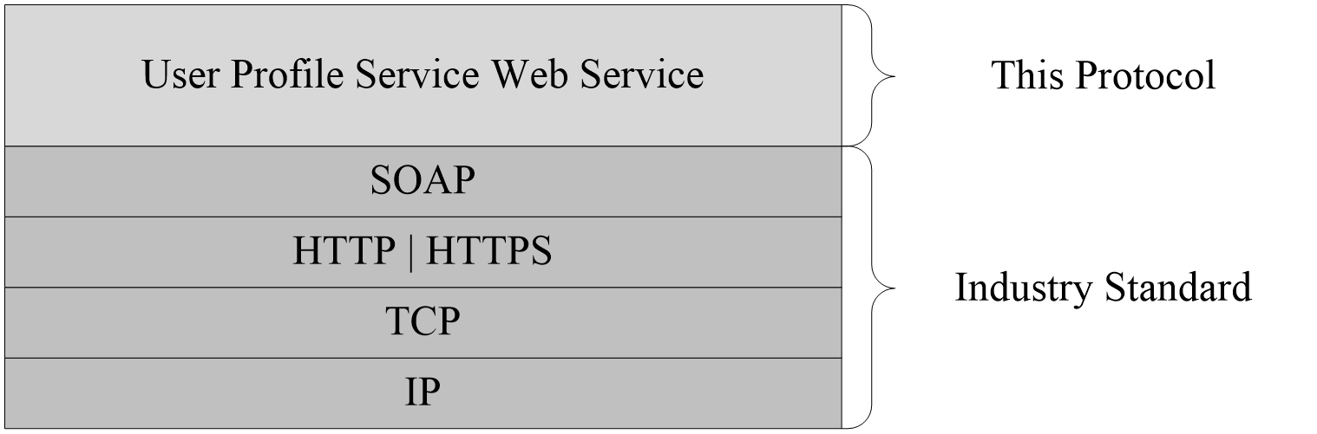
Figure 1: This protocol in relation to other protocols

Prerequisites/Preconditions
This protocol operates against a site that is identified by a URL that is known by protocol clients. The protocol server endpoint is formed by appending "_vti_bin/userprofileservice.asmx" to the URL of the site, for example http://www.contoso.com/Repository/_vti_bin/userprofileservice.asmx.
This protocol assumes that authentication has been performed by the underlying protocols.

Applicability Statement
This protocol is designed to work with up to 5 million user profiles. For each user profile, it supports up to 100 user profile properties.

Versioning and Capability Negotiation
This document covers versioning issues in the following areas:
- Supported Transports: This protocol uses multiple transports with SOAP as specified in section 2.1.

Vendor-Extensible Fields
None.

Standards Assignments
None.

Messages

Transport
Protocol servers MUST support SOAP over HTTP. Protocol servers SHOULD additionally support SOAP over HTTPS for securing communication with clients.
Protocol messages MUST be formatted as specified either in [SOAP1.1] section 4 or in [SOAP1.2-1/2007] section 5. Protocol server faults MUST be returned either by using HTTP Status Codes as specified in [RFC2616] section 10 or by using SOAP faults as specified either in [SOAP1.1] section 4.4 or in [SOAP1.2-1/2007] section 5.4.

Common Message Syntax
This section contains common definitions used by this protocol. The syntax of the definitions uses XML schema as defined in [XMLSCHEMA1] and [XMLSCHEMA2], and WSDL as defined in [WSDL].

Namespaces
This specification defines and references various XML namespaces using the mechanisms specified in [XMLNS]. Although this specification associates a specific XML namespace prefix for each XML namespace that is used, the choice of any particular XML namespace prefix is implementation-specific and not significant for interoperability.
Prefix | Namespace URI | Reference
s1 | http://microsoft.com/wsdl/types/
soap | http://schemas.xmlsoap.org/wsdl/soap/ | [SOAP1.1]
s | http://www.w3.org/2001/XMLSchema | [XMLSCHEMA1]  [XMLSCHEMA2]
tns | http://microsoft.com/webservices/SharePointPortalServer/UserProfileService
wsdl | http://schemas.xmlsoap.org/wsdl/ | [WSDL]

Messages
This specification does not define any common WSDL message definitions.

Elements
This specification does not define any common XML schema element definitions.

Complex Types
The following table summarizes the set of common XML schema complex type definitions defined by this specification. XML schema complex type definitions that are specific to a particular operation are described with the operation.
Complex type | Description
ArrayOfContactData | A set of ContactData (section 2.2.4.11) elements.
ArrayOfDouble | A set of double elements.
ArrayOfMembershipData | A set of MembershipData (section 2.2.4.13) elements.
ArrayOfOrganziationProfileData | A set of OrganizationProfileData (section 2.2.4.14) elements.
ArrayOfPinnedLinkData | A set of PinnedLinkData (section 2.2.4.15) elements.
ArrayOfPropertyData | A set of PropertyData (section 2.2.4.16) elements.
ArrayOfPropertyInfo | A set of PropertyInfo (section 2.2.4.17) elements.
ArrayOfQuickLinkData | A set of QuickLinkData (section 2.2.4.18) elements.
ArrayOfString | A set of string elements.
ArrayOfValueData | A set of ValueData (section 2.2.4.19) elements.
ContactData | Identifies a contact (2) of the user profile.
MemberGroupData | Identifies a member group.
MembershipData | Identifies a membership.
OrganizationProfileData | An organization.
PinnedLinkData | A pinned link.
PropertyData | A property of a user profile object.
PropertyInfo | Describes the attributes of a property.
QuickLinkData | A quick link.
ValueData | This type is one value for a given user profile property.

ArrayOfContactData
The ArrayOfContactData complex type contains a set of ContactData (section 2.2.4.11) elements.
<s:complexType name="ArrayOfContactData">
<s:sequence>
<s:element minOccurs="0" maxOccurs="unbounded" name="ContactData" nillable="true" type="tns:ContactData" />
</s:sequence>
</s:complexType>
ContactData: A single contact (2).

ArrayOfDouble
The ArrayOfDouble complex type contains a set of double elements.
<s:complexType name="ArrayOfDouble">
<s:sequence>
<s:element minOccurs="0" maxOccurs="unbounded" name="double" type="s:double" />
</s:sequence>
</s:complexType>
double: A single element in the array of doubles.

ArrayOfMembershipData
The ArrayOfMembershipData complex type contains a set of MembershipData (section 2.2.4.13) elements.
<s:complexType name="ArrayOfMembershipData">
<s:sequence>
<s:element minOccurs="0" maxOccurs="unbounded" name="MembershipData" nillable="true" type="tns:MembershipData" />
</s:sequence>
</s:complexType>
MembershipData: A single membership.

ArrayOfOrganizationProfileData
The ArrayOfOrganizationProfileData complex type contains a set of OrganizationProfileData (section 2.2.4.14) elements.
<s:complexType name="ArrayOfOrganizationProfileData">
<s:sequence>
<s:element minOccurs="0" maxOccurs="unbounded" name="OrganizationProfileData" nillable="true" type="tns:OrganizationProfileData" />
</s:sequence>
</s:complexType>
OrganizationProfileData: A single organization profile.

ArrayOfPinnedLinkData
The ArrayOfPinnedLinkData complex type contains a set of PinnedLinkData (section 2.2.4.15) elements.
<s:complexType name="ArrayOfPinnedLinkData">
<s:sequence>
<s:element minOccurs="0" maxOccurs="unbounded" name="PinnedLinkData" nillable="true" type="tns:PinnedLinkData" />
</s:sequence>
</s:complexType>
PinnedLinkData: A single pinned link.

ArrayOfPropertyData
The ArrayOfPropertyData complex type contains a set of PropertyData (section 2.2.4.16) elements.
<s:complexType name="ArrayOfPropertyData">
<s:sequence>
<s:element minOccurs="0" maxOccurs="unbounded" name="PropertyData" nillable="true" type="tns:PropertyData" />
</s:sequence>
</s:complexType>
PropertyData: A single property.

ArrayOfPropertyInfo
The ArrayOfPropertyInfo complex type contains a set of PropertyInfo (section 2.2.4.17) elements.
<s:complexType name="ArrayOfPropertyInfo">
<s:sequence>
<s:element minOccurs="0" maxOccurs="unbounded" name="PropertyInfo" nillable="true" type="tns:PropertyInfo" />
</s:sequence>
</s:complexType>
PropertyInfo: Used to represent schema information about a property.

ArrayOfQuickLinkData
The ArrayOfQuickLinkData complex type contains a set of QuickLinkData (section 2.2.4.18) elements.
<s:complexType name="ArrayOfQuickLinkData">
<s:sequence>
<s:element minOccurs="0" maxOccurs="unbounded" name="QuickLinkData" nillable="true" type="tns:QuickLinkData" />
</s:sequence>
</s:complexType>
QuickLinkData: A single quick link.

ArrayOfString
The ArrayOfString complex type is used to represent a set of strings.
<s:complexType name="ArrayOfString">
<s:sequence>
<s:element minOccurs="0" maxOccurs="unbounded" name="string" nillable="true" type="s:string" />
</s:sequence>
</s:complexType>
string: A single element in the array of strings.

ArrayOfValueData
The ArrayOfValueData complex type contains a set of ValueData (section 2.2.4.19) elements.
<s:complexType name="ArrayOfValueData">
<s:sequence>
<s:element minOccurs="0" maxOccurs="unbounded" name="ValueData" nillable="true" type="tns:ValueData" />
</s:sequence>
</s:complexType>
ValueData: Represents a single value.

ContactData
The ContactData complex type contains contact information about a user profile.
<s:complexType name="ContactData">
<s:sequence>
<s:element minOccurs="0" maxOccurs="1" name="AccountName" type="s:string" />
<s:element minOccurs="1" maxOccurs="1" name="Privacy" type="tns:Privacy" />
<s:element minOccurs="0" maxOccurs="1" name="Name" type="s:string" />
<s:element minOccurs="1" maxOccurs="1" name="IsInWorkGroup" type="s:boolean" />
<s:element minOccurs="0" maxOccurs="1" name="Group" type="s:string" />
<s:element minOccurs="0" maxOccurs="1" name="Email" type="s:string" />
<s:element minOccurs="0" maxOccurs="1" name="Title" type="s:string" />
<s:element minOccurs="0" maxOccurs="1" name="Url" type="s:string" />
<s:element minOccurs="1" maxOccurs="1" name="UserProfileID" type="s1:guid" />
<s:element minOccurs="1" maxOccurs="1" name="ID" type="s:long" />
</s:sequence>
</s:complexType>
AccountName: A string that specifies the login name of the user profile. This value MUST be less than or equal to 400 characters in length.
Privacy: The privacy level for the contact (2) association with the user profile. This MUST be a value in the Privacy (section 2.2.5.4) enumeration.
Name: A string that specifies the name of the user.
IsInWorkGroup: A Boolean value that specifies whether the user specified by this element belongs to the same workgroup as the associated user profile. If associated user profile is in the same workgroup as the user specified in this element the server MUST return true.
Group: A string that specifies the group (2) this contact (1) belongs to.
Email: A string that specifies the e-mail address for the user.
Title: A string that specifies the title for the user.
Url: The URL for the user.
UserProfileID: The GUID of the user.
ID: A long that specifies the unique identifier for the user.

MemberGroupData
The MemberGroupData complex type identifies a member group.
<s:complexType name="MemberGroupData">
<s:sequence>
<s:element minOccurs="1" maxOccurs="1" name="SourceInternal" type="s1:guid" />
<s:element minOccurs="0" maxOccurs="1" name="SourceReference" type="s:string" />
</s:sequence>
</s:complexType>
SourceInternal: A GUID that specifies the original source of members for the member group. If the original source was from a distribution list or site then the GUID MUST be one of the values listed in the following table. Otherwise the GUID MUST correspond to the user-defined GUID for that source.

GUID value | Description
A88B9DCB-5B82-41E4-8A19-17672F307B95 | The member group was originally populated from a distribution list.
8BB1220F-DE8B-4771-AC3A-0551242CF2BD | The member group was originally populated from a site.

SourceReference: A string that uniquely identifies the member group.

MembershipData
The MembershipData complex type represents a membership.
<s:complexType name="MembershipData">
<s:sequence>
<s:element minOccurs="1" maxOccurs="1" name="Source" type="tns:MembershipSource" />
<s:element minOccurs="0" maxOccurs="1" name="MemberGroup" type="tns:MemberGroupData" />
<s:element minOccurs="0" maxOccurs="1" name="Group" type="s:string" />
<s:element minOccurs="0" maxOccurs="1" name="DisplayName" type="s:string" />
<s:element minOccurs="1" maxOccurs="1" name="Privacy" type="tns:Privacy" />
<s:element minOccurs="0" maxOccurs="1" name="MailNickname" type="s:string" />
<s:element minOccurs="0" maxOccurs="1" name="Url" type="s:string" />
<s:element minOccurs="1" maxOccurs="1" name="ID" type="s:long" />
<s:element minOccurs="1" maxOccurs="1" name="MemberGroupID" type="s:long" />
</s:sequence>
</s:complexType>
Source: This value specifies the original source of members for the member group. It MUST be a value specified in MembershipSource (section 2.2.5.3).
MemberGroup: A MemberGroupData (section 2.2.4.12) type that identifies the member group involved in the membership.
Group: A string that specifies the group (2) of this membership. This value MUST be less than or equal to 50 characters in length.
DisplayName: A string that specifies the display name of the member group involved in the membership.
Privacy: Specifies the category of users who can view this membership. This MUST be a value in the Privacy (section 2.2.5.4) enumeration.
MailNickname: A string that specifies the e-mail alias of the member group involved in the membership.
Url: The URL of the member group involved in the membership.
ID: A long that uniquely identifies this membership.
MemberGroupID: A long that uniquely identifies the member group involved in the membership.

OrganizationProfileData
The OrganizationProfileData complex type represents an organization.
<s:complexType name="OrganizationProfileData">
<s:sequence>
<s:element minOccurs="0" maxOccurs="1" name="DisplayName" type="s:string" />
<s:element minOccurs="1" maxOccurs="1" name="RecordID" type="s:long" />
</s:sequence>
</s:complexType>

DisplayName: A string that specifies the display text for the organization.
RecordID: A long that uniquely identifies the organization.

PinnedLinkData
The PinnedLinkData complex type represents a pinned link.
<s:complexType name="PinnedLinkData">
<s:sequence>
<s:element minOccurs="0" maxOccurs="1" name="Name" type="s:string" />
<s:element minOccurs="0" maxOccurs="1" name="Url" type="s:string" />
<s:element minOccurs="1" maxOccurs="1" name="ID" type="s:long" />
</s:sequence>
</s:complexType>
Name: A string that specifies the display text for the pinned link.
Url: The URL of the pinned link.
ID: A long that uniquely identifies the pinned link.

PropertyData
The PropertyData complex type contains information about a user profile property.
<s:complexType name="PropertyData">
<s:sequence>
<s:element minOccurs="1" maxOccurs="1" name="IsPrivacyChanged" type="s:boolean" />
<s:element minOccurs="1" maxOccurs="1" name="IsValueChanged" type="s:boolean" />
<s:element minOccurs="0" maxOccurs="1" name="Name" type="s:string" />
<s:element minOccurs="1" maxOccurs="1" name="Privacy" type="tns:Privacy" />
<s:element minOccurs="0" maxOccurs="1" name="Values" type="tns:ArrayOfValueData" />
</s:sequence>
</s:complexType>
Name: A string that specifies the name of the user profile property.
Privacy: The privacy level of the user profile property. This MUST be a value in the Privacy (section 2.2.5.4) enumeration.
Values: A set of ValueData (section 2.2.4.19) elements.
IsPrivacyChanged: A Boolean value indicating whether or not the privacy value for this user profile property has changed. When a PropertyData element is returned from the protocol server, IsPrivacyChanged MUST be false.
IsValueChanged: A Boolean value indicating whether or not the values for this user profile property have changed. When a PropertyData element is returned from the protocol server, IsValueChanged MUST be false.

PropertyInfo
The PropertyInfo complex type is used to represent schema information about a property.
<s:complexType name="PropertyInfo">
<s:sequence>
<s:element minOccurs="0" maxOccurs="1" name="Name" type="s:string" />
<s:element minOccurs="0" maxOccurs="1" name="Description" type="s:string" />
<s:element minOccurs="0" maxOccurs="1" name="DisplayOrder" type="s:int" />
<s:element minOccurs="0" maxOccurs="1" name="MaximumShown" type="s:int" />
<s:element minOccurs="0" maxOccurs="1" name="IsAdminEditable" type="s:boolean" />
<s:element minOccurs="0" maxOccurs="1" name="IsSearchable" type="s:boolean" />
<s:element minOccurs="0" maxOccurs="1" name="IsSystem" type="s:boolean" />
<s:element minOccurs="0" maxOccurs="1" name="ManagedPropertyName" type="s:string" />
<s:element minOccurs="0" maxOccurs="1" name="DisplayName" type="s:string" />
<s:element minOccurs="0" maxOccurs="1" name="Type" type="s:string" />
<s:element minOccurs="1" maxOccurs="1" name="AllowPolicyOverride" type="s:boolean" />
<s:element minOccurs="1" maxOccurs="1" name="DefaultPrivacy" type="tns:Privacy" />
<s:element minOccurs="1" maxOccurs="1" name="IsAlias" type="s:boolean" />
<s:element minOccurs="1" maxOccurs="1" name="IsColleagueEventLog" type="s:boolean" />
<s:element minOccurs="1" maxOccurs="1" name="IsRequired" type="s:boolean" />
<s:element minOccurs="1" maxOccurs="1" name="IsUserEditable" type="s:boolean" />
<s:element minOccurs="1" maxOccurs="1" name="IsVisibleOnEditor" type="s:boolean" />
<s:element minOccurs="1" maxOccurs="1" name="IsVisibleOnViewer" type="s:boolean" />
<s:element minOccurs="1" maxOccurs="1" name="IsReplicable" type="s:boolean" />
<s:element minOccurs="1" maxOccurs="1" name="UserOverridePrivacy" type="s:boolean" />
<s:element minOccurs="1" maxOccurs="1" name="Length" type="s:int" />
<s:element minOccurs="1" maxOccurs="1" name="IsImported" type="s:boolean" />
<s:element minOccurs="1" maxOccurs="1" name="IsMultiValue" type="s:boolean" />
<s:element minOccurs="1" maxOccurs="1" name="ChoiceType" type="tns:ChoiceTypes" />
<s:element minOccurs="0" maxOccurs="1" name="TermSetId" nillable="true" type="s1:guid" />
</s:sequence>
</s:complexType>
Name: A string that specifies the name of the property.
Description: A string that specifies a description of the property.
DisplayOrder: An integer that specifies the index at which this property is normally displayed.
MaximumShown: An integer that specifies the maximum number of values shown for this property.
IsAdminEditable: A Boolean that if set to true specifies that this property can be edited by an administrator and is set to false otherwise.
IsSearchable: A Boolean that if set to true specifies that this property is searchable and is set to false otherwise.
IsSystem: A Boolean that if set to true specifies that this is a core system property and is set to false otherwise.
ManagedPropertyName: If specified, a string that is used in URL encodings when searching for other properties with the same value.
DisplayName: A string that specifies the display name of the property.Type: A string that specifies the value specifying the type of the user profile property.
AllowPolicyOverride: A Boolean that if set to true specifies that the site collection administrator is allowed to override the default policy setting assigned to the user profile privacy policy and is set to false otherwise.
DefaultPrivacy: A value indicating the default privacy setting of the property which MUST be a value listed in the Privacy (section 2.2.5.4) enumeration.
IsAlias: A Boolean that if set to true specifies that this property serves as an alias property of the user profile for user search purposes and is set to false otherwise.
IsColleagueEventLog: A Boolean that if set to true specifies that this property is displayed on the Colleague Tracker Web Part and is set to false otherwise
IsRequired: A Boolean that if set to true specifies that this property is required when saving its value to a user profile and is set to false otherwise.
IsUserEditable: A Boolean value that if set to true specifies that this property is editable and is set to false otherwise
IsVisibleOnEditor: A Boolean that if set to true specifies that this property is visible when a user edits his or her user profile from his or her profile site and is set to false otherwise.
IsVisibleOnViewer: A Boolean value that if set to true specifies this property is visible on the default profile site and is set to false otherwise.
IsReplicable: A Boolean value that if set to true specifies this property is replicable and is set to false otherwise.
UserOverridePrivacy: A Boolean that if set to true specifies that the system enables the user to override the default protection level assigned to the privacy policy and is set to false otherwise.
Length: An integer that specifies the maximum length of the value of the property.
IsImported: A Boolean value that if set to true specifies that this property is imported to the protocol server from an external data source and is set to false otherwise.
IsMultiValue: A Boolean that if set to true specifies that the property can have multiple values and is set to false otherwise.
ChoiceType: A ChoiceTypes (section 2.2.5.1) value which indicates the state of the property's list of choices.
TermSetID: If specified, a GUID that corresponds to a taxonomy term set that backs the value of the property.

QuickLinkData
The QuickLinkData complex type represents a quick link.
<s:complexType name="QuickLinkData">
<s:sequence>
<s:element minOccurs="0" maxOccurs="1" name="Name" type="s:string" />
<s:element minOccurs="0" maxOccurs="1" name="Group" type="s:string" />
<s:element minOccurs="1" maxOccurs="1" name="Privacy" type="tns:Privacy" />
<s:element minOccurs="0" maxOccurs="1" name="Url" type="s:string" />
<s:element minOccurs="1" maxOccurs="1" name="ID" type="s:long" />
</s:sequence>
</s:complexType>
Name: A string that specifies the display text for the quick link.
Group: A string that specifies the group (2) this quick link belongs to.
Privacy: Specifies the category of users who can view this quick link. This MUST be a value in the Privacy (section 2.2.5.4) enumeration.
Url: The URL of the quick link.
ID: A long that uniquely identifies the quick link.

ValueData
The ValueData complex type is used to represent a value for a given user profile property.
<s:complexType name="ValueData">
<s:sequence>
<s:element minOccurs="0" maxOccurs="1" name="Value" type="s:string" />
</s:sequence>
</s:complexType>
Value: A string element contains the value of a user profile property.

Simple Types
The following table summarizes the set of common XML schema simple type definitions defined by this specification. XML schema simple type definitions that are specific to a particular operation are described with the operation.
Simple type | Description
ChoiceTypes | Used to indicate the state of a list of choices for a property.
guid | A simple type used to represent a GUID.
MembershipSource | Specifies the source of a member group involved in a particular membership.
Privacy | Specifies the set of users who are allowed to access a protected resource.
SuggestionType | Specifies the type of suggestion (for example, keyword suggestion vs. colleague suggestion).

ChoiceTypes
The ChoiceTypes simple type is used to indicate the state of a list of choices for a property.
<s:simpleType name="ChoiceTypes">
<s:restriction base="s:string">
<s:enumeration value="Off"/>
<s:enumeration value="None"/>
<s:enumeration value="Open"/>
<s:enumeration value="Closed"/>
</s:restriction>
</s:simpleType>

Value | Meaning
Off | The property does not use a list of choices.
None | The property is not using a list of choices, but a list of choices can be added by a site collection administrator.
Open | The property is using a list of choices and users can add items to the list of choices.
Closed | The property uses a list of choices but users cannot edit the choices. A site collection administrator has full control over the choices for the property.

guid
The guid simple type is used to represent a GUID.
<s:simpleType name="guid">
<s:restriction base="s:string">
<s:pattern value="[0-9a-fA-F]{8}-[0-9a-fA-F]{4}-[0-9a-fA-F]{4}-[0-9a-fA-F]{4}-[0-9a-fA-F]{12}"/>
</s:restriction>
</s:simpleType>

MembershipSource
The MembershipSource simple type is an enumeration used to specify the source of a member group involved in a particular membership.
<s:simpleType name="MembershipSource">
<s:restriction base="s:string">
<s:enumeration value="DistributionList"/>
<s:enumeration value="SharePointSite"/>
<s:enumeration value="Other"/>
</s:restriction>
</s:simpleType>

Value | Meaning
DistributionList | The member group was originally populated from a distribution list.
SharePointSite | The member group was originally populated from a site.
Other | The member group was originally populated from a source external to a site server.

Privacy
The Privacy simple type specifies the set of users who are allowed to access a protected resource.
<s:simpleType name="Privacy">
<s:restriction base="s:string">
<s:enumeration value="Public"/>
<s:enumeration value="Contacts"/>
<s:enumeration value="Organization"/>
<s:enumeration value="Manager"/>
<s:enumeration value="Private"/>
<s:enumeration value="NotSet"/>
</s:restriction>
</s:simpleType>

Value | Meaning
Public | All users are allowed to access the resource.
Contacts | The only users allowed to access the resource are the owner of the resource and the owner's colleagues.
Organization | The only users allowed to access the resource are the owner of the resource and the owner's workgroup colleagues.
Manager | The only two users allowed to access the resource are the owner of the resource and the owner's manager.
Private | The only user allowed to access the resource is the owner of the resource.
NotSet | The security settings for the item have not been overridden by the user that created the resource. The settings as defined in the user profile policy are applied.

SuggestionType
The SuggestionType simple type is an enumeration that specifies the type of suggestion.
<s:simpleType name="SuggestionType">
<s:restriction base="s:string">
<s:enumeration value="Colleague" />
<s:enumeration value="Keyword" />
</s:restriction>
</s:simpleType>

Value | Meaning
Colleague | The Suggestion corresponds to a Colleague that is specified by a string with either an accountName or email value.
Keyword | The Suggestion corresponds to a keyword that is specified by a string.

Attributes
This specification does not define any common XML schema attribute definitions.

Groups
This specification does not define any common XML schema group definitions.

Attribute Groups
This specification does not define any common XML schema attribute group definitions.

Protocol Details
The client side of this protocol is simply a pass-through. That is, no additional timers or other state is required on the client side of this protocol. Calls made by the higher-layer protocol or application are passed directly to the transport, and the results returned by the transport are passed directly back to the higher-layer protocol or application.

Protocol Server Details

Abstract Data Model
This section describes a conceptual model of possible data organization that an implementation maintains to participate in this protocol. The described organization is provided to facilitate the explanation of how the protocol behaves. This document does not mandate that implementations adhere to this model as long as their external behavior is consistent with that described in this document.
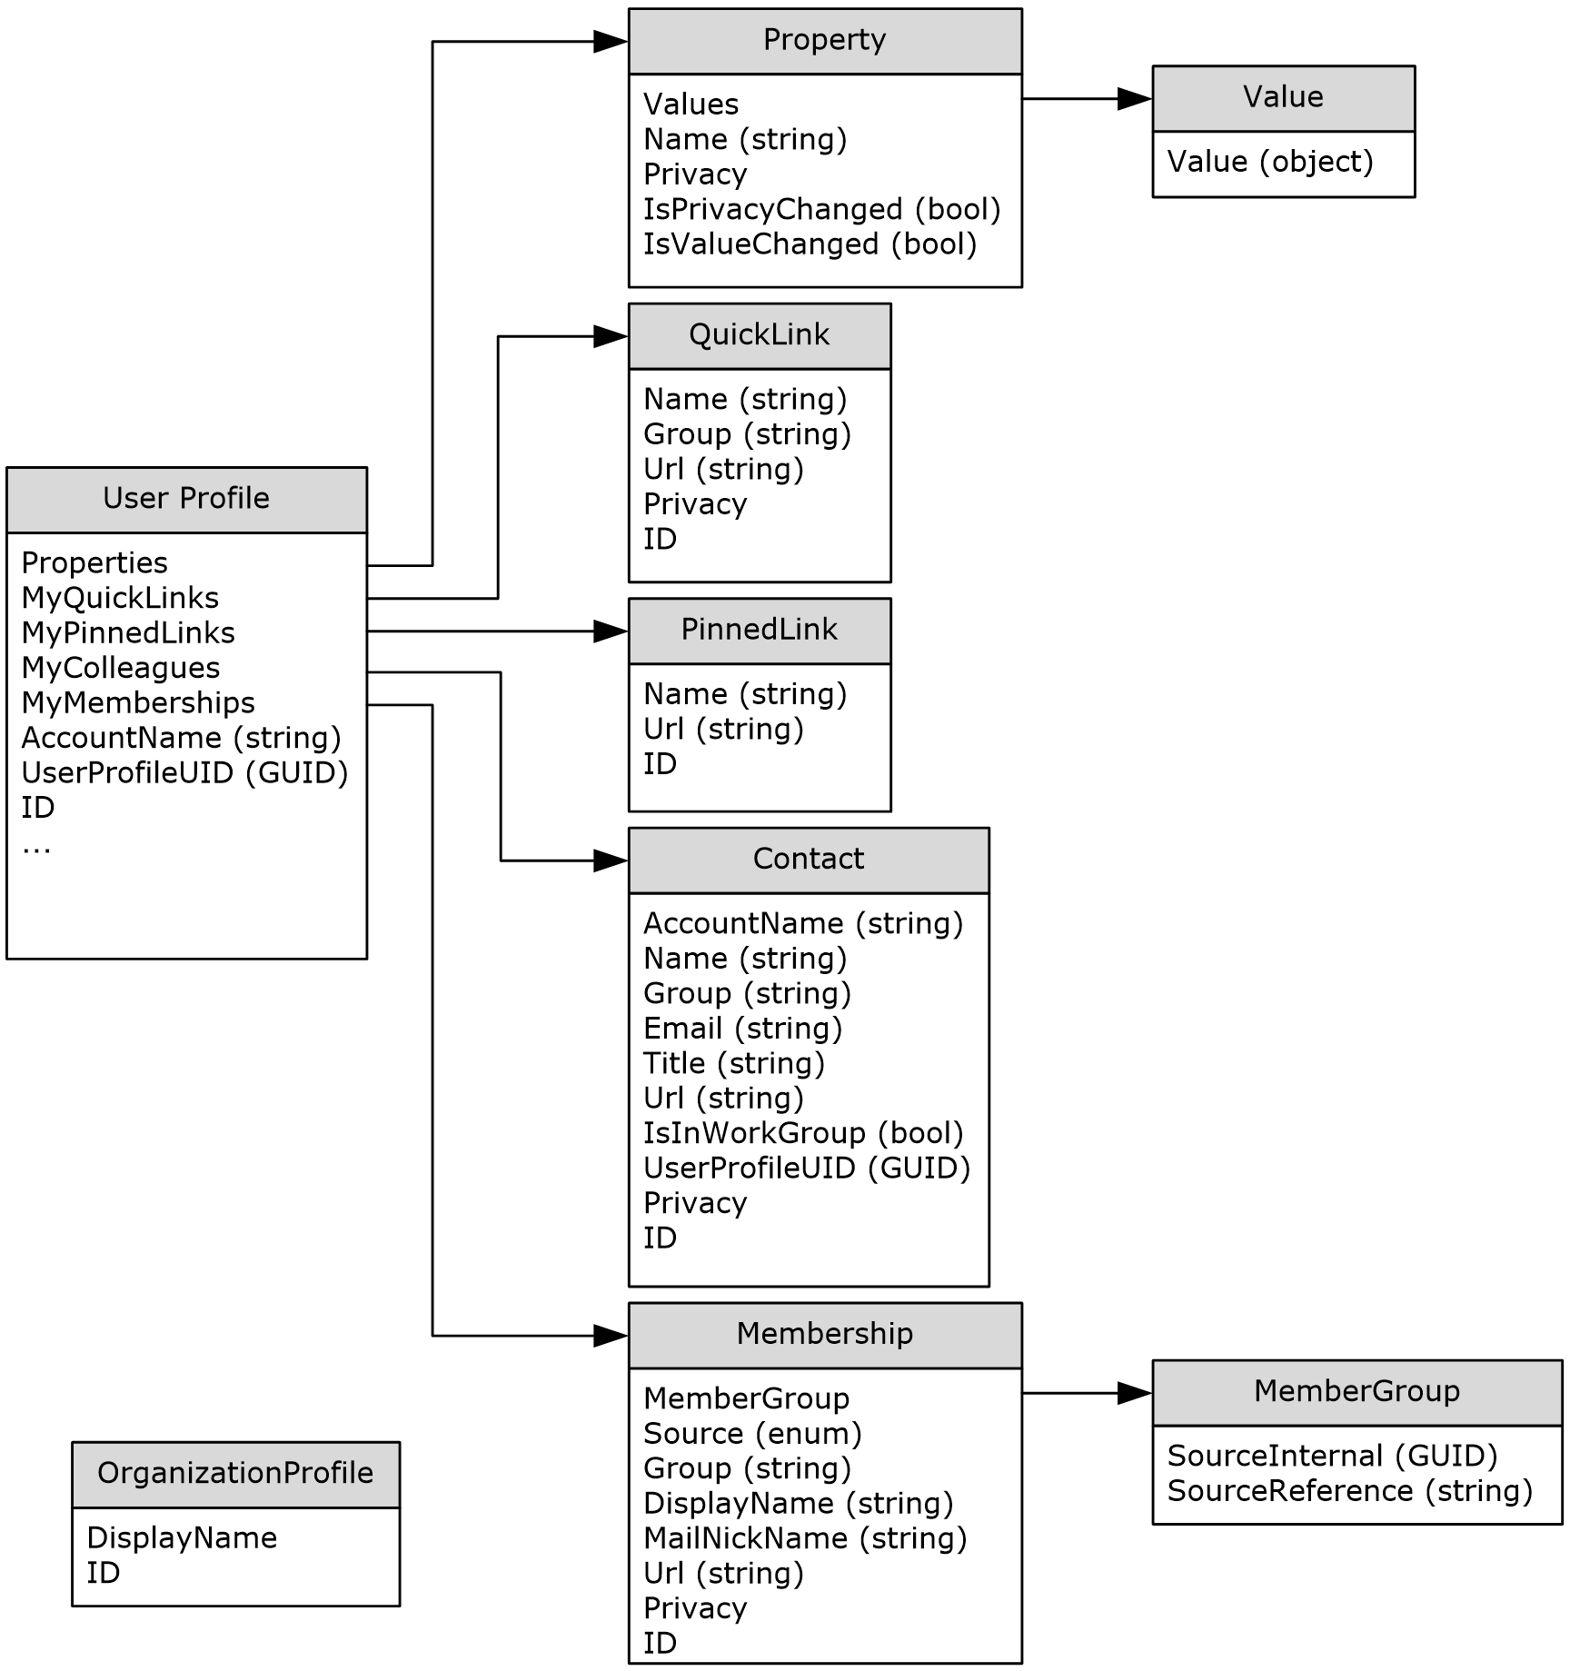
Figure 2: Protocol server abstract data model
In the previous figure, each table specifies a type of entity in the model. Each arrow specifies that one type of entity contains one or more references to another.
UserProfile Entity: An entity that corresponds to a user profile available on the protocol server. A UserProfile entity contains references to properties, quick links, pinned links, colleagues, and memberships. This entity can also contain various other pieces of data associated with the user.
Properties Field: References a collection of Property data model entities.
MyQuickLinks Field: References a collection of QuickLink data model entities.
MyPinnedLinks Field: References a collection of PinnedLink data model entities.
MyColleagues Field: References a collection of contact (2) data model entities.
MyMemberships Field: References a collection of Membership data model entities.
AccountName Field: A string value that serves as the login name for the account associated with this UserProfile entity.
UserProfileUID Field: A GUID value that uniquely identifies the user profile.
ID Field: A unique identifier that identifies the UserProfile entity.
Property Entity: An entity that corresponds to a property. A Property entity belongs to a UserProfile entity and represents a property of a user profile. A Property entity implements the concept of associating one or more values with a given property name.
Values Field: References a collection of Value data model entities. These entities serve as the values for this Property entity.
Name Field: A string value that serves as the name for this Property entity.
Privacy Field: An enumerated value corresponding to the privacy level for this Property entity. Conceptually, this Privacy value determines who has the rights to view this property.
IsPrivacyChanged Field: A Boolean value indicating whether or not the Privacy for this Property entity has changed. This can be used for caching to prevent excess data queries.
IsValueChanged Field: A Boolean value indicating whether or not the Values for this Property entity have changed. This can be used for caching to prevent excess data queries.
Value Entity: An entity that contains a value of a Property data model entity.
Value Field: An object that serves as the value for this Value entity.
QuickLink Entity: An entity that corresponds to a quick link, which is associated with a UserProfile data model entity.
Name Field: A string value that serves as the name for this QuickLink entity.
Group Field: A string value corresponding to the group (2) for this QuickLink entity.
Url Field: A string value corresponding to the URL for this QuickLink entity.
Privacy Field: An enumerated value corresponding to the privacy level for this QuickLink entity. Conceptually, this Privacy value determines who has the rights to view this quick link.
ID Field: A unique identifier that identifies the QuickLink entity.
PinnedLink Entity: An entity that corresponds to a pinned link, which is associated with a UserProfile data model entity.
Name Field: A string value that serves as the name for this PinnedLink entity.
Url Field: A string value corresponding to the URL for this PinnedLink entity.
ID Field: A unique identifier that identifies the PinnedLink entity.
Contact Entity: An entity that contains the necessary data to store contact (2) information for another user who is a colleague of the associated UserProfile data model entity. Conceptually, each contact (1) entity serves as a one-way link from the specified UserProfile entity to contact (1) .
AccountName Field: A string value corresponding to the AccountName of the colleague's UserProfile entity.
Name Field: A string value that serves as the name for this contact (1) entity.
Group Field: A string value corresponding to the group (1) for this contact (1) entity.
Email Field: A string value corresponding to the e-mail address for this contact (1) entity.
Title Field: A string value corresponding to the title for this contact (1) entity.
Url Field: A string value corresponding to the URL for this contact (1) entity.
IsInWorkGroup Field: A Boolean value indicating whether or not the colleague for this contact (1) entity is in the associated user profile's workgroup. If associated user profile is in the same workgroup as the colleague for this contact (1) entity the server MUST return true.
UserProfileUID Field: A GUID value that uniquely identifies the user profile of the colleague.
Privacy Field: An enumerated value corresponding to the privacy level for this contact (1) entity. Conceptually, this Privacy value determines who has the rights to view this colleague relationship.
ID Field: A unique identifier that identifies the contact (1) entity.
Membership Entity: An entity that contains the necessary data to store membership information. Conceptually, a Membership entity serves as a one-way link from a UserProfile entity to a MemberGroup entity.
MemberGroup Field: A reference to this Membership entity's MemberGroup data model entity.
Source Field: An enumerated value corresponding to the source of members for this Membership entity. Conceptually, this Source value indicates whether this membership is to a distribution list, site, or "other".
Group Field: A string value corresponding to the group (2) for this Membership entity.
DisplayName Field: A string value corresponding to the display name for this Membership entity.
MailNickName Field: A string value corresponding to the e-mail alias for this Membership entity.
Url Field: A string value corresponding to the URL for this Membership entity.
Privacy Field: An enumerated value corresponding to the privacy level for this contact (1) entity. Conceptually, this Privacy value determines who has the rights to view this membership relationship.
ID Field: A unique identifier that identifies the Membership entity.
MemberGroup Entity: An entity that represents a member group. Conceptually, this entity is a node for Membership entities to reference.
SourceInternal Field: A GUID value indicating the original source of members for the member group as specified in MemberGroupData (section 2.2.4.12).
SourceReference Field: A string that uniquely identifies the member group.

Timers
None.

Initialization
The following initialization steps MUST be performed:
- All abstract data model entities contain data MUST be retrieved from persistent storage at initialization time.
- Each operation within the protocol server MUST begin listening for requests at the respective URL addresses given in the message transport (as specified in section 2.1).

Message Processing Events and Sequencing Rules
The following table summarizes the list of WSDL operations as defined by this specification:
Operation | Description
AddColleague | Updates the specified user profile by adding a colleague association.
AddColleagueWithoutEmailNotification | Updates the specified user profile by adding a colleague association, but the server will not send any email notifications upon successful addition of a new colleague.
AddLink | Updates the specified user profile by adding a quick link.
AddMembership | Updates the specified user profile by adding a membership.
AddPinnedLink | Updates the specified user profile by adding a pinned link.
AddSuggestions<1> | Add a suggestion for the user profile of the current user.
CreateMemberGroup | Creates a new member group.
CreateUserProfileByAccountName | Creates a user profile for the specified user login name.
GetCommonColleagues | Retrieves the common colleagues between two user profiles.
GetCommonManager | Retrieves the lowest level common manager between two user profiles.
GetCommonMemberships | Retrieves the common memberships between two user profiles.
GetInCommon | Retrieves the common memberships, colleagues, and lowest level common manager between two user profiles.
GetProfileSchema<2> | Retrieves schema information about each of the profile properties defined.
GetProfileSchemaNameByAccountName<3> | Retrieves the name of the schema for the user profile of the specified user login name.
GetProfileSchemaNames<4> | Retrieves a list of profile schema names.
GetPropertyChoiceList | Retrieves a list of possible values for a property.
GetUserColleagues | Retrieves the colleagues associated with a user profile.
GetUserLinks | Retrieves the quick links associated with a user profile.
GetUserMemberships | Retrieves the memberships associated with a user profile.
GetUserOrganizations<5> | Retrieves the organizations associated with a user profile.
GetUserPinnedLinks | Retrieves the pinned links associated with a user profile.
GetUserProfileByGuid | Retrieve a user profile given the GUID of a user.
GetUserProfileByIndex | Retrieves a user profile given a unique identifier.
GetUserProfileByName | Retrieves a user profile given a login name.
GetUserProfileCount | Returns the number of user profiles stored by the protocol server.
GetUserProfileSchema | Retrieves schema information about each of the properties defined.
GetUserPropertyByAccountName<6> | Retrieves a user profile property given a user login name and property name.
ModifyUserPropertyByAccountName | Updates a set of properties for a user.
RemoveAllColleagues | Deletes all colleagues associated with a user profile.
RemoveAllLinks | Deletes all quick links associated with a user profile.
RemoveAllMemberships | Deletes all memberships associated with a user profile.
RemoveAllPinnedLinks | Deletes all pinned links associated with a user profile.
RemoveColleague | Deletes a colleague associated with a user profile.
RemoveLink | Deletes a quick link associated with a user profile.
RemoveMembership | Deletes a membership associated with a user profile.
RemovePinnedLink | Deletes a pinned link associated with a user profile.
UpdateColleaguePrivacy | Updates the privacy level of a colleague association.
UpdateLink | Updates a quick link for the specified user.
UpdateMembershipPrivacy | Updates the privacy level of a membership.
UpdatePinnedLink | Updates a pinned link for the specified user.

AddColleague
The AddColleague WSDL operation is used to update the specified user profile by adding a colleague association.
The operation of adding a colleague is unidirectional, meaning that when a colleague is added to the specified user, the user profile of the colleague will not be updated.
<wsdl:operation name="AddColleague">
<wsdl:input message="tns:AddColleagueSoapIn"/>
<wsdl:output message="tns:AddColleagueSoapOut"/>
</wsdl:operation>
The protocol client sends an AddColleagueSoapIn request WSDL message and the protocol server responds with an AddColleagueSoapOut response WSDL message.
If the user is not authorized to administer the user profile service and is not updating his or her own user profile, the protocol server MUST send a SOAP fault message.
Additionally, if the user does not have the Use Personalization Features permission, the protocol server MUST send a SOAP fault message. The Use Personalization Features permission is defined for users in the User Profile Service Application and governs the user’s access to view other’s profiles and view/edit their own profile.
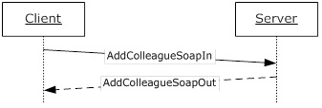
Figure 3: AddColleague operation
The AddColleagueWithoutEmailNotification WSDL operation behaves identically to the AddColleague WSDL operation, except that the server will not send any email notifications upon successful addition of a new colleague.

Messages
The following WSDL message definitions are specific to this operation.

AddColleagueSoapIn
The AddColleagueSoapIn message is the request WSDL message for the AddColleague WSDL operation.
The SOAP action value of the message is defined as:
http://microsoft.com/webservices/SharePointPortalServer/UserProfileService/AddColleague
The SOAP body contains an AddColleague element.

AddColleagueSoapOut
The AddColleagueSoapOut message is the response WSDL message for the AddColleague WSDL operation.
The SOAP body contains an AddColleagueResponse element.

Elements
The following XML schema element definitions are specific to this operation.

AddColleague
The AddColleague element is the body of the request WSDL message for the AddColleague WSDL operation.
<s:element name="AddColleague">
<s:complexType>
<s:sequence>
<s:element name="accountName" type="s:string" minOccurs="0" maxOccurs="1"/>
<s:element name="colleagueAccountName" type="s:string" minOccurs="0"
maxOccurs="1"/>
<s:element name="group" type="s:string" minOccurs="0" maxOccurs="1"/>
<s:element minOccurs="1" maxOccurs="1" name="privacy" type="tns:Privacy"/>
<s:element minOccurs="1" maxOccurs="1" name="isInWorkGroup" type="s:boolean"/>
</s:sequence>
</s:complexType>
</s:element>
accountName: A string that specifies the login name of the user profile to be updated. This value MUST be less than or equal to 400 characters in length. If this element is not specified or does not have a value, the protocol server MUST use the user profile of the current user. The protocol server MUST treat accountName in a case insensitive manner for retrieval of the user profile.
If accountName does not correspond to an existing user profile, the protocol server MUST send a SOAP fault message.
colleagueAccountName: A string that specifies the login name of the user profile of the colleague to be added to the user profile specified by accountName. This value MUST be less than or equal to 400 characters in length. If this element is not specified or does not have a value, the protocol server MUST use the user profile of the current user, and return a SOAP fault message if the current user does not have a user profile. The protocol server MUST treat colleagueAccountName in a case insensitive manner for retrieval of the user profile.
If colleagueAccountName does not correspond to an existing user profile, the protocol server MUST send a SOAP fault message.
The user specified by colleagueAccountName MUST NOT be the same as the user specified by accountName.
If the user specified by accountName and the user specified by colleagueAccountName are already colleagues, the protocol server MUST send a SOAP fault message.
If the accountName is not specified or does not have a value and the colleagueAccountName is not specified or does not have a value, the protocol server MUST send a SOAP fault message.
group: A string that refers to a group (2). This value MUST be less than or equal to 50 characters in length.
privacy: A value that MUST correspond to a Privacy (section 2.2.5.4) enumeration. It specifies the set of users who can view this colleague association. This value MUST NOT be "NotSet" as specified in Privacy (section 2.2.5.4). If this value is set to "NotSet" the server MUST send a SOAP fault message.
isInWorkGroup: A Boolean value which, when true, the protocol server MUST allow the user specified in colleagueAccountName to see user profile information that falls within the organization privacy level for the user specified by accountName.

AddColleagueResponse
The AddColleagueResponse element is the body of the response WSDL message for the AddColleague WSDL operation.
<s:element name="AddColleagueResponse">
<s:complexType>
<s:sequence>
<s:element name="AddColleagueResult" type="tns:ContactData" minOccurs="0"
maxOccurs="1"/>
</s:sequence>
</s:complexType>
</s:element>
AddColleagueResult: A ContactData (section 2.2.4.11) element that corresponds to the created colleague association.

AddColleagueWithoutEmailNotification
The AddColleagueWithoutEmailNotification WSDL operation is used to update the specified user profile by adding a colleague association.
The operation of adding a colleague is unidirectional, meaning that when a colleague is added to the specified user, the user profile of the colleague will not be updated.
<wsdl:operation name="AddColleagueWithoutEmailNotification">
<wsdl:input message="tns:AddColleagueWithoutEmailNotificationSoapIn" />
<wsdl:output message="tns:AddColleagueWithoutEmailNotificationSoapOut" />
</wsdl:operation>
The protocol client sends an AddColleagueWithoutEmailNotificationSoapIn request WSDL message and the protocol server responds with an AddColleagueWithoutEmailNotificationSoapOut response WSDL message.
If the user is not authorized to administer the user profile service and is not updating his or her own user profile, the protocol server MUST send a SOAP fault message.
Additionally, if the user does not have the Use Personalization Features permission, the protocol server MUST send a SOAP fault message. The Use Personalization Features permission is defined for users in the User Profile Service Application and governs the user’s access to view other’s profiles and view/edit their own profile.
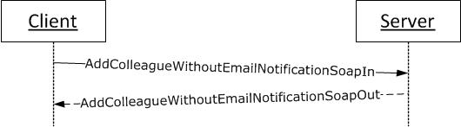
Figure 4: AddColleagueWithoutEmailNotification operation
The AddColleagueWithoutEmailNotification WSDL operation behaves identically to the AddColleague WSDL operation, except that the server will not send any email notifications upon successful addition of a new colleague.

Messages
The following WSDL message definitions are specific to this operation.

AddColleagueWithoutEmailNotificationSoapIn
The AddColleagueWithoutEmailNotificationSoapIn message is the request WSDL message for the AddColleagueWithoutEmailNotification WSDL operation.
The SOAP action value of the message is defined as:
http://microsoft.com/webservices/SharePointPortalServer/UserProfileService/ AddColleagueWithoutEmailNotification
The SOAP body contains an AddColleagueWithoutEmailNotification element.

AddColleagueWithoutEmailNotificationSoapOut
The AddColleagueWithoutEmailNotificationSoapOut message is the response WSDL message for the AddColleagueWithoutEmailNotification WSDL operation.
The SOAP body contains an AddColleagueWithoutEmailNotificationResponse element.

Elements
The following XML schema element definitions are specific to this operation.

AddColleagueWithoutEmailNotification
The AddColleagueWithoutEmailNotification element is the body of the request WSDL message for the AddColleagueWithoutEmailNotification WSDL operation.
<s:element name="AddColleagueWithoutEmailNotification">
<s:complexType>
<s:sequence>
<s:element name="accountName" type="s:string" minOccurs="0" maxOccurs="1"/>
<s:element name="colleagueAccountName" type="s:string" minOccurs="0"
maxOccurs="1"/>
<s:element name="group" type="s:string" minOccurs="0" maxOccurs="1"/>
<s:element minOccurs="1" maxOccurs="1" name="privacy" type="tns:Privacy"/>
<s:element minOccurs="1" maxOccurs="1" name="isInWorkGroup" type="s:boolean"/>
</s:sequence>
</s:complexType>
</s:element>
accountName: A string that specifies the login name of the user profile to be updated. This value MUST be less than or equal to 400 characters in length. If this element is not specified or does not have a value, the protocol server MUST use the user profile of the current user. The protocol server MUST treat accountName in a case insensitive manner for retrieval of the user profile.
If accountName does not correspond to an existing user profile, the protocol server MUST send a SOAP fault message.
colleagueAccountName: A string that specifies the login name of the user profile of the colleague to be added to the user profile specified by accountName. This value MUST be less than or equal to 400 characters in length. If this element is not specified or does not have a value, the protocol server MUST use the user profile of the current user, and return a SOAP fault message if the current user does not have a user profile. The protocol server MUST treat colleagueAccountName in a case insensitive manner for retrieval of the user profile.
If colleagueAccountName does not correspond to an existing user profile, the protocol server MUST send a SOAP fault message.
The user specified by colleagueAccountName MUST NOT be the same as the user specified by accountName.
If the user specified by accountName and the user specified by colleagueAccountName are already colleagues, the protocol server MUST send a SOAP fault message.
If the accountName is not specified or does not have a value and the colleagueAccountName is not specified or does not have a value, the protocol server MUST send a SOAP fault message.
group: A string that refers to a group (2). This value MUST be less than or equal to 50 characters in length.
privacy: A value that MUST correspond to a Privacy enumeration (section 2.2.5.4). It specifies the set of users who can view this colleague association. This value MUST NOT be "NotSet" as specified in Privacy (section 2.2.5.4). If this value is set to "NotSet" the server MUST send a SOAP fault message.
isInWorkGroup: A Boolean value which, when true, the protocol server MUST allow the user specified in colleagueAccountName to see user profile information that falls within the organization privacy level for the user specified by accountName.

AddColleagueWithoutEmailNotificationResponse
The AddColleagueWithoutEmailNotificationResponse element is the body of the response WSDL message for the AddColleagueWithoutEmailNotification WSDL operation.
<s:element name="AddColleagueWithoutEmailNotificationResponse">
<s:complexType>
<s:sequence>
<s:element name="AddColleagueWithoutEmailNotificationResult" type="tns:ContactData" minOccurs="0"
maxOccurs="1"/>
</s:sequence>
</s:complexType>
</s:element>
AddColleagueWithoutEmailNotificationResult: A ContactData element (section 2.2.4.11) that corresponds to the created colleague association.

AddLink
The AddLink WSDL operation is used to update the specified user profile by adding a quick link.
<wsdl:operation name="AddLink">
<wsdl:input message="tns:AddLinkSoapIn"/>
<wsdl:output message="tns:AddLinkSoapOut"/>
</wsdl:operation>
The protocol client sends an AddLinkSoapIn request WSDL message and the protocol server responds with an AddLinkSoapOut response WSDL message.
If the user is not authorized to administer the user profile service and is not updating his or her own user profile, the protocol server MUST send a SOAP fault message.
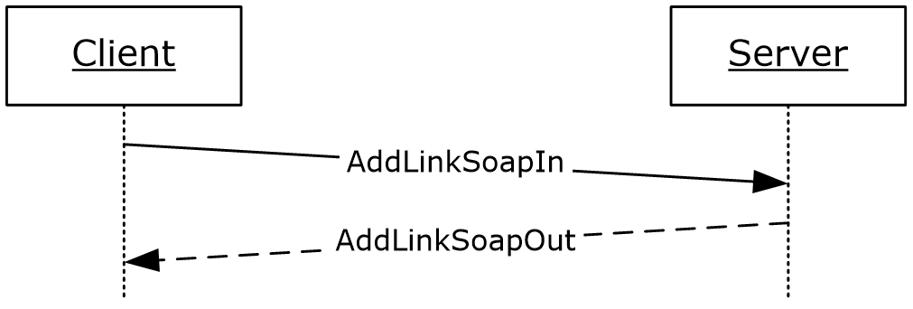
Figure 5: AddLink operation

Messages
The following WSDL message definitions are specific to this operation.

AddLinkSoapIn
The AddLinkSoapIn message is the request WSDL message for the AddLink WSDL operation.
The SOAP action value of the message is defined as:
http://microsoft.com/webservices/SharePointPortalServer/UserProfileService/AddLink
The SOAP body contains an AddLink element.

AddLinkSoapOut
The AddLinkSoapOut message is the response WSDL message for the AddLink WSDL operation.
The SOAP body contains an AddLinkResponse element.

Elements
The following XML schema element definitions are specific to this operation.

AddLink
The AddLink element is the body of the request WSDL message for the AddLink WSDL operation.
If there is another quick link association in the user profile referred to by accountName that has the same name, URL, and group (1) (all treated in a case insensitive manner), the protocol server MUST send a SOAP fault message.
<s:element name="AddLink">
<s:complexType>
<s:sequence>
<s:element name="accountName" type="s:string" minOccurs="0" maxOccurs="1"/>
<s:element minOccurs="0" maxOccurs="1" name="name" type="s:string"/>
<s:element minOccurs="0" maxOccurs="1" name="url" type="s:string"/>
<s:element minOccurs="0" maxOccurs="1" name="group" type="s:string"/>
<s:element minOccurs="1" maxOccurs="1" name="privacy" type="tns:Privacy"/>
</s:sequence>
</s:complexType>
</s:element>
accountName: A string that specifies the login name of the user profile to return the elements for. This value MUST be less than or equal to 400 characters in length. The protocol server MUST treat accountName in a case insensitive manner for retrieval of the user profile.
If accountName is not specified or does not have a value and there is not an existing user profile for the current user, then a new user profile MUST be created which represents the current user.
If accountName is not specified or does not have a value and there is an existing user profile for the current user, then the protocol server MUST return elements for that user profile.
If accountName is specified and does not match the login name of an existing user profile, the protocol server MUST send a SOAP fault message.
name: A string that specifies the display text for the new quick link. This value MUST be less than or equal to 50 characters.
url: The URL that the quick link refers to. This value MUST be less than or equal to 2048 characters and MUST be a properly formatted URL as specified in [RFC2396]. If the url is null or an empty string, the server MUST return a SOAP fault message.
group: A string that refers to a group (2). This value MUST be less than or equal to 50 characters.
privacy: This specifies the set of users who can view this quick link. The value MUST correspond to a value in the Privacy (section 2.2.5.4) enumeration. This value MUST NOT be "NotSet".

AddLinkResponse
The AddLinkResponse element is the body of the response WSDL message for the AddLink WSDL operation.
<s:element name="AddLinkResponse">
<s:complexType>
<s:sequence>
<s:element name="AddLinkResult" type="tns:QuickLinkData" minOccurs="0"
maxOccurs="1"/>
</s:sequence>
</s:complexType>
</s:element>
AddLinkResult: A QuickLinkData (section 2.2.4.18) element corresponding to the created object.

AddMembership
The AddMembership WSDL operation is used to update the specified user profile by adding a membership.
<wsdl:operation name="AddMembership">
<wsdl:input message="tns:AddMembershipSoapIn"/>
<wsdl:output message="tns:AddMembershipSoapOut"/>
</wsdl:operation>
The protocol client sends an AddMembershipSoapIn request WSDL message and the protocol server responds with an AddMembershipSoapOut response WSDL message.
If the user is not authorized to administer the user profile service and is not updating his or her own user profile, the protocol server MUST send a SOAP fault message.
Additionally, if the user does not have the Use Personalization Features permission, the protocol server MUST send a SOAP fault message.
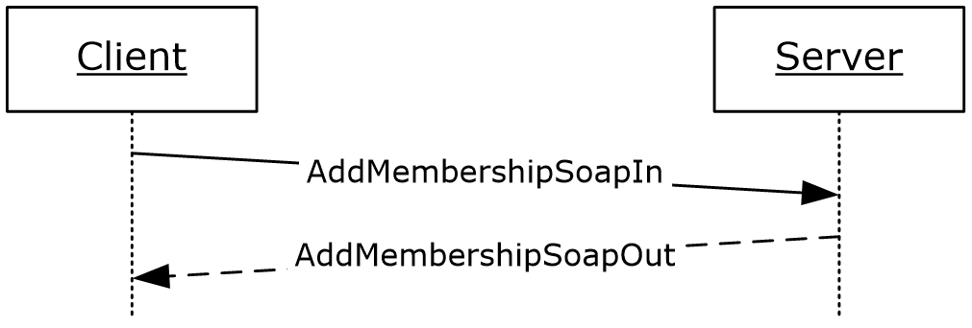
Figure 6: AddMembership operation

Messages
The following WSDL message definitions are specific to this operation.

AddMembershipSoapIn
The AddMembershipSoapIn message is the request WSDL message for the AddMembership WSDL operation.
The SOAP action value of the message is defined as:
http://microsoft.com/webservices/SharePointPortalServer/UserProfileService/AddMembership
The SOAP body contains an AddMembership element.

AddMembershipSoapOut
The AddMembershipSoapOut message is the response WSDL message for the AddMembership WSDL operation.
The SOAP body contains an AddMembershipResponse element.

Elements
The following XML schema element definitions are specific to this operation.

AddMembership
The AddMembership element is the body of the request WSDL message for the AddMembership WSDL operation.
<s:element name="AddMembership">
<s:complexType>
<s:sequence>
<s:element name="accountName" type="s:string" minOccurs="0" maxOccurs="1"/>
<s:element minOccurs="0" maxOccurs="1" name="membershipInfo" type="tns:MembershipData"/>
<s:element minOccurs="0" maxOccurs="1" name="group" type="s:string"/>
<s:element name="privacy" type="tns:Privacy"/>
</s:sequence>
</s:complexType>
</s:element>
accountName: A string that specifies the login name of the user profile to return the elements for. This value MUST be less than or equal to 400 characters in length. The protocol server MUST treat accountName in a case insensitive manner for retrieval of the user profile.
If accountName is not specified or does not have a value and there is not an existing user profile for the current user, then a new user profile MAY<7> be created which represents the current user.
If accountName is not specified or does not have a value and there is an existing user profile for the current user, then the protocol server MUST return elements for that user profile.
If accountName is specified and does not match the login name of an existing user profile, the protocol server MUST send a SOAP fault message.
membershipInfo: Identifies the member group of the membership that will be added to the user profile. The protocol server MUST only use the MemberGroup element of the MembershipData (section 2.2.4.13) element and MUST ignore all other elements.
If the membershipInfo element specified does not correspond to an existing member group, the protocol server MUST send a SOAP fault message.
If the user profile already contains a membership to this member group, the protocol server MUST send a SOAP fault message.
group: A string that refers to a group (2). This value MUST be less than or equal to 50 characters.
privacy: A value that MUST correspond to a value in the Privacy (section 2.2.5.4) enumeration. This value specifies the set of users who can view this membership. This value MUST NOT be "NotSet".

AddMembershipResponse
The AddMembershipResponse element is the body of the response WSDL message for the AddMembership WSDL operation.
<s:element name="AddMembershipResponse">
<s:complexType>
<s:sequence>
<s:element name="AddMembershipResult" type="tns:MembershipData" minOccurs="0" maxOccurs="1"/>
</s:sequence>
</s:complexType>
</s:element>
AddMembershipResult: A MembershipData (section 2.2.4.13) element corresponding to the created membership.

AddPinnedLink
The AddPinnedLink WSDL operation is used to update the specified user profile by adding a pinned link.

<wsdl:operation name="AddPinnedLink">
<wsdl:input message="tns:AddPinnedLinkSoapIn" />
<wsdl:output message="tns:AddPinnedLinkSoapOut" />
</wsdl:operation>
The protocol client sends an AddPinnedLinkSoapIn request WSDL message, and the protocol server responds with an AddPinnedLinkSoapOut response WSDL message.
If the user is not authorized to administer the user profile service and is not updating his or her own user profile, the protocol server MUST send a SOAP fault message.
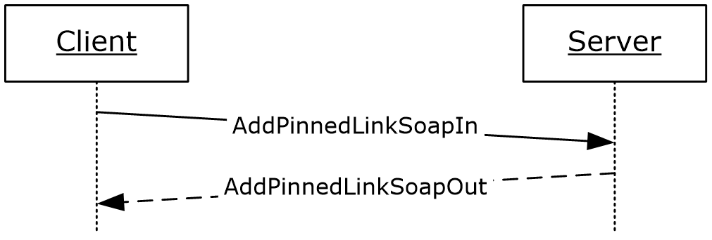
Figure 7: AddPinnedLink operation

Messages
The following WSDL message definitions are specific to this operation.

AddPinnedLinkSoapIn
The AddPinnedLinkSoapIn message is the request WSDL message for the AddPinnedLink WSDL operation.
The SOAP action value of the message is defined as:
http://microsoft.com/webservices/SharePointPortalServer/UserProfileService/AddPinnedLink
The SOAP body contains an AddPinnedLink element.

AddPinnedLinkSoapOut
The AddPinnedLinkSoapOut message is the response WSDL message for the AddPinnedLink WSDL operation.
The SOAP body contains an AddPinnedLinkResponse element.

Elements
The following XML schema element definitions are specific to this operation.

AddPinnedLink
The AddPinnedLink element is the body of the request WSDL message for the AddPinnedLink WSDL operation.
If a pinned link with the same URL already exists for the user profile associated with accountName, the protocol server MUST replace the existing pinned link's name with the name specified in this element.
<s:element name="AddPinnedLink">
<s:complexType>
<s:sequence>
<s:element name="accountName" type="s:string" minOccurs="0" maxOccurs="1"/>
<s:element minOccurs="0" maxOccurs="1" name="name" type="s:string"/>
<s:element minOccurs="0" maxOccurs="1" name="url" type="s:string"/>
</s:sequence>
</s:complexType>
</s:element>
accountName: A string that specifies the login name of the user profile to be updated. This value MUST be less than or equal to 400 characters in length. If this element is not specified or does not have a value, the protocol server MUST use the user profile of the current user, and return a SOAP fault message if the current user does not have a user profile. The protocol server MUST treat accountName in a case insensitive manner for retrieval of the user profile.
If the accountName does not correspond to an existing user profile, the protocol server MUST return a SOAP fault message.
name: A string that specifies the display text for the new pinned link. This value MUST be less than or equal to 50 characters.
url: The URL of the pinned link. This MUST be less than or equal to 2048 characters and MUST be a properly formatted URL as specified in [RFC2396]. If the url is null or an empty string, the server MUST return a SOAP fault message.

AddPinnedLinkResponse
The AddPinnedLinkResponse element is the body of the response WSDL message for the AddPinnedLink WSDL operation.
<s:element name="AddPinnedLinkResponse">
<s:complexType>
<s:sequence>
<s:element name="AddPinnedLinkResult" type="tns:PinnedLinkData" minOccurs="0"
maxOccurs="1"/>
</s:sequence>
</s:complexType>
</s:element>
AddPinnedLinkResult: A PinnedLinkData (section 2.2.4.15) element corresponding to the created pinned link.

AddSuggestions
The AddSuggestions WSDL operation is used to update the user profile of the current user with new suggestions of colleagues or keywords.
<wsdl:operation name="AddSuggestions">
<wsdl:input message="tns:AddSuggestionsSoapIn"/>
<wsdl:output message="tns:AddSuggestionsSoapOut"/>
</wsdl:operation>
The protocol client sends an AddSuggestionsSoapIn request WSDL message and the protocol server responds with an AddSuggestionsSoapOut response WSDL message.
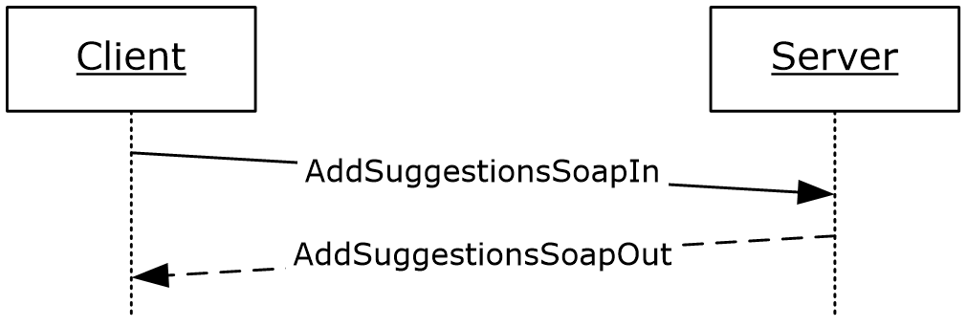
Figure 8: AddSuggestions operation

Messages
The following WSDL message definitions are specific to this operation.

AddSuggestionsSoapIn
The AddSuggestionsSoapIn message is the request WSDL message for the AddSuggestions WSDL operation.
The SOAP action value of the message is defined as:
http://microsoft.com/webservices/SharePointPortalServer/UserProfileService/AddSuggestions
The SOAP body contains an AddSuggestions element.

AddSuggestionsSoapOut
The AddSuggestionsSoapOut message is the response WSDL message for the AddSuggestions WSDL operation.
The SOAP body contains an AddSuggestionsResponse element.

Elements
The following XML schema element definitions are specific to this operation.

AddSuggestions
The AddSuggestions element is the body of the request WSDL message for the AddSuggestions WSDL operation.
<s:element name="AddSuggestions">
<s:complexType>
<s:sequence><s:element minOccurs="1" maxOccurs="1" name="type" type="tns:SuggestionType" />
<s:element minOccurs="0" maxOccurs="1" name="suggestions" type="tns:ArrayOfString" />
<s:element minOccurs="0" maxOccurs="1" name="weights" type="tns:ArrayOfDouble" /> </s:sequence>
</s:complexType>
</s:element>
SuggestionType: A SuggestionType (section 2.2.5.5) element that specifies the type of suggestions to be added to the user profile of the current user.
suggestions: An array of strings containing colleagues or keywords.
weights: An array of double values. suggestions are sorted in descending weights values.
suggestions and weights MUST be paired.
If SuggestionType is Colleague, suggestions MUST be either accountName or email. If SuggestionType is Keyword, suggestions MUST be keyword.

AddSuggestionsResponse
The AddSuggestionsResponse element is the body of the response WSDL message for the AddSuggestions WSDL operation.
<s:element name="AddSuggestionsResponse">
<s:complexType/>
</s:element>

CreateMemberGroup
The CreateMemberGroup WSDL operation is used to create a new member group.
<wsdl:operation name="CreateMemberGroup">
<wsdl:input message="tns:CreateMemberGroupSoapIn"/>
<wsdl:output message="tns:CreateMemberGroupSoapOut"/>
</wsdl:operation>
The protocol client sends a CreateMemberGroupSoapIn request WSDL message and the protocol server responds with a CreateMemberGroupSoapOut response WSDL message.
If the user is not authorized to administer the user profile service, the protocol server MUST send a SOAP fault message.
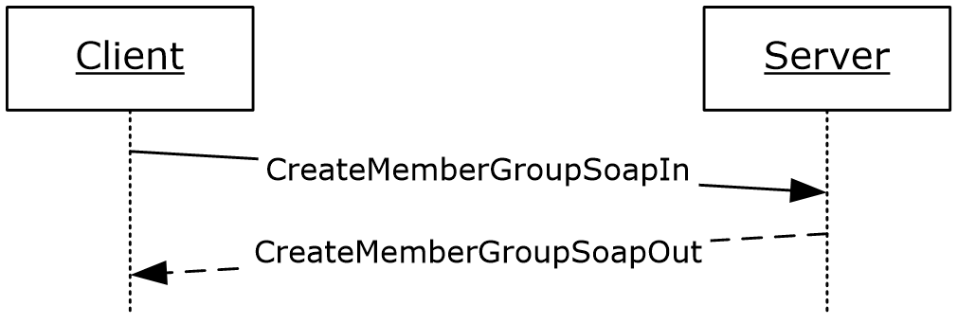
Figure 9: CreateMemberGroup operation

Messages
The following WSDL message definitions are specific to this operation.

CreateMemberGroupSoapIn
The CreateMemberGroupSoapIn message is the request WSDL message for the CreateMemberGroup WSDL operation.
The SOAP action value of the message is defined as:
http://microsoft.com/webservices/SharePointPortalServer/UserProfileService/CreateMemberGroup
The SOAP body contains a CreateMemberGroup element.

CreateMemberGroupSoapOut
The CreateMemberGroupSoapOut message is the response WSDL message for the CreateMemberGroup WSDL operation.
The SOAP body contains a CreateMemberGroupResponse element.

Elements
The following XML schema element definitions are specific to this operation.

CreateMemberGroup
The CreateMemberGroup element is the body of the request WSDL message for the CreateMemberGroup WSDL operation.
<s:element name="CreateMemberGroup">
<s:complexType>
<s:sequence>
<s:element minOccurs="0" maxOccurs="1" name="membershipInfo" type="tns:MembershipData"/>
</s:sequence>
</s:complexType>
</s:element>
membershipInfo: The information for the member group to be created. The protocol server MUST only use the MemberGroup, DisplayName, MailNickname, and Url elements of the MembershipData (section 2.2.4.13) element and MUST ignore all other elements. If DisplayName or MailNickname are null the server MUST send a SOAP fault message.
If the MemberGroupData (section 2.2.4.12) element of membershipInfo element corresponds to an existing member group on the protocol server, the protocol server MUST send a SOAP fault message.

CreateMemberGroupResponse
The CreateMemberGroupResponse element is the body of the response WSDL message for the CreateMemberGroup WSDL operation.
<s:element name="CreateMemberGroupResponse">
<s:complexType/>
</s:element>

CreateUserProfileByAccountName
The CreateUserProfileByAccountName WSDL operation is used to create a user profile for the specified user login name.
<wsdl:operation name="CreateUserProfileByAccountName">
<wsdl:input message="tns:CreateUserProfileByAccountNameSoapIn"/>
<wsdl:output message="tns:CreateUserProfileByAccountNameSoapOut"/>
</wsdl:operation>
The protocol client sends a CreateUserProfileByAccountNameSoapIn request WSDL message and the protocol server responds with a CreateUserProfileByAccountNameSoapOut response WSDL message.
If the user is not authorized to administer the user profile service and is not creating his or her own user profile, the protocol server MUST send a SOAP fault message.
Additionally, if the user does not have the Use Personalization Features permission, the protocol server MUST send a SOAP fault message.
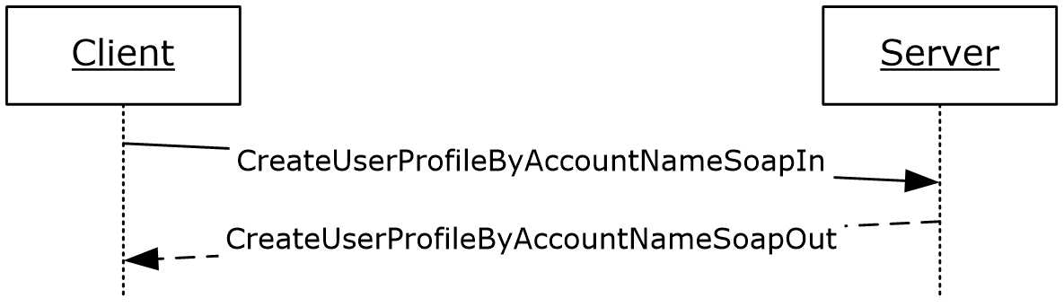
Figure 10: CreateUserProfileByAccountName operation

Messages
The following WSDL message definitions are specific to this operation.

CreateUserProfileByAccountNameSoapIn
The CreateUserProfileByAccountNameSoapIn message is the request WSDL message for the CreateUserProfileByAccountName WSDL operation.
The SOAP action value of the message is defined as:
http://microsoft.com/webservices/SharePointPortalServer/UserProfileService/CreateUserProfileByAccountName
The SOAP body contains a CreateUserProfileByAccountName element.

CreateUserProfileByAccountNameSoapOut
The CreateUserProfileByAccountNameSoapOut message is the response WSDL message for the CreateUserProfileByAccountName WSDL operation.
The SOAP body contains a CreateUserProfileByAccountNameResponse element.

Elements
The following XML schema element definitions are specific to this operation.

CreateUserProfileByAccountName
The CreateUserProfileByAccountName element is the body of the request WSDL message for the CreateUserProfileByAccountName WSDL operation.
<s:element name="CreateUserProfileByAccountName">
<s:complexType>
<s:sequence>
<s:element minOccurs="0" maxOccurs="1" name="accountName" type="s:string"/>
</s:sequence>
</s:complexType>
</s:element>
accountName: A string that specifies the login name of the user profile to be created. This value MUST be less than or equal to 400 characters in length and MUST be specified. The protocol server MUST treat accountName in a case insensitive manner for retrieval of the user profile.
If a user profile with the specified login name already exists, the protocol server MUST send a SOAP fault message.
If the login name is not found in the directory service (DS), the protocol server MUST send a SOAP fault message.

CreateUserProfileByAccountNameResponse
The CreateUserProfileByAccountNameResponse element is the body of the response WSDL message for the CreateUserProfileByAccountName WSDL operation.
<s:element name="CreateUserProfileByAccountNameResponse">
<s:complexType>
<s:sequence>
<s:element minOccurs="0" maxOccurs="1" name="CreateUserProfileByAccountNameResult" type="tns:ArrayOfPropertyData" />
</s:sequence>
</s:complexType>
</s:element>
CreateUserProfileByAccountNameResult: An ArrayOfPropertyData (section 2.2.4.6) element containing all property data for the newly created user profile.

GetCommonColleagues
The GetCommonColleagues WSDL operation is used to get the colleagues that are common to the specified user profile and the user profile of the current user.
<wsdl:operation name="GetCommonColleagues">
<wsdl:input message="tns:GetCommonColleaguesSoapIn"/>
<wsdl:output message="tns:GetCommonColleaguesSoapOut"/>
</wsdl:operation>
The protocol client sends a GetCommonColleaguesSoapIn request WSDL message and the protocol server responds with a GetCommonColleaguesSoapOut response WSDL message.
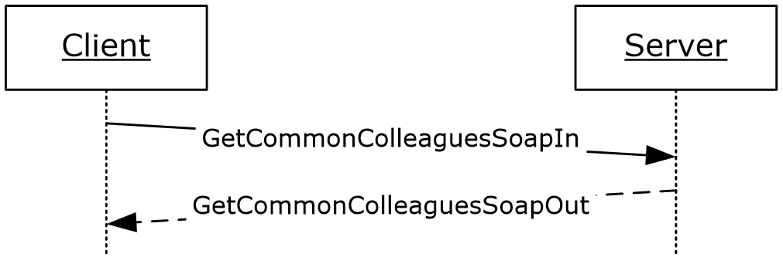
Figure 11: GetCommonColleagues operation

Messages
The following WSDL message definitions are specific to this operation.

GetCommonColleaguesSoapIn
The GetCommonColleaguesSoapIn message is the request WSDL message for the GetCommonColleagues WSDL operation.
The SOAP action value of the message is defined as:
http://microsoft.com/webservices/SharePointPortalServer/UserProfileService/GetCommonColleagues
The SOAP body contains a GetCommonColleagues element.

GetCommonColleaguesSoapOut
The GetCommonColleaguesSoapOut message is the response WSDL message for the GetCommonColleagues WSDL operation.
The SOAP body contains a GetCommonColleaguesResponse element.

Elements
The following XML schema element definitions are specific to this operation.

GetCommonColleagues
The GetCommonColleagues element is the body of the request WSDL message for the GetCommonColleagues WSDL operation.
<s:element name="GetCommonColleagues">
<s:complexType>
<s:sequence>
<s:element name="accountName" type="s:string" minOccurs="0" maxOccurs="1"/>
</s:sequence>
</s:complexType>
</s:element>
accountName: A string that specifies the login name of the user profile to be compared with. This value MUST be less than or equal to 400 characters in length. If this value matches the login name of the current user, the protocol server MUST return the colleagues for the user profile of the current user. If this element is not specified or does not have a value, AND a user profile for the current user exists, the protocol server MUST return the colleagues for the user profile of the current user. If this element is not specified or does not have a value, AND a user profile for the current user does not exist, the protocol server MUST create a user profile for the current user and return the colleagues for the user profile of the current user.. The protocol server MUST treat accountName in a case insensitive manner for retrieval of the user profile.
If the accountName does not correspond to an existing user profile, the protocol server MUST send a SOAP fault message.

GetCommonColleaguesResponse
The GetCommonColleaguesResponse element is the body of the response WSDL message for the GetCommonColleagues WSDL operation.
<s:element name="GetCommonColleaguesResponse">
<s:complexType>
<s:sequence>
<s:element name="GetCommonColleaguesResult" type="tns:ArrayOfContactData"
minOccurs="0" maxOccurs="1"/>
</s:sequence>
</s:complexType>
</s:element>
GetCommonColleaguesResult: A set of ContactData (section 2.2.4.11) elements corresponding to the common colleagues. The Privacy element of ContactData MUST be returned as "NotSet", the Group MUST be NULL, the ID MUST be zero, and IsInWorkGroup MUST be false.
The values returned MUST be filtered according to the privacy level.

GetCommonManager
The GetCommonManager WSDL operation is used to get the lowest level manager in common between the specified user profile and the user profile of the current user.
<wsdl:operation name="GetCommonManager">
<wsdl:input message="tns:GetCommonManagerSoapIn"/>
<wsdl:output message="tns:GetCommonManagerSoapOut"/>
</wsdl:operation>
The protocol client sends a GetCommonManagerSoapIn request WSDL message and the protocol server responds with a GetCommonManagerSoapOut response WSDL message.
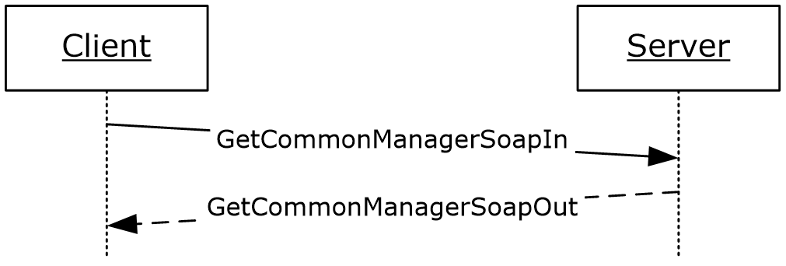
Figure 12: GetCommonManager operation

Messages
The following WSDL message definitions are specific to this operation.

GetCommonManagerSoapIn
The GetCommonManagerSoapIn message is the request WSDL message for the GetCommonManager WSDL operation.
The SOAP action value of the message is defined as:
http://microsoft.com/webservices/SharePointPortalServer/UserProfileService/GetCommonManager
The SOAP body contains a GetCommonManager element.

GetCommonManagerSoapOut
The GetCommonManagerSoapOut message is the response WSDL message for the GetCommonManager WSDL operation.
The SOAP body contains a GetCommonManagerResponse element.

Elements
The following XML schema element definitions are specific to this operation.

GetCommonManager
The GetCommonManager element is the body of the request WSDL message for the GetCommonManager WSDL operation.
<s:element name="GetCommonManager">
<s:complexType>
<s:sequence>
<s:element name="accountName" type="s:string" minOccurs="0" maxOccurs="1"/>
</s:sequence>
</s:complexType>
</s:element>
accountName: A string that specifies the login name of the user profile to be compared with. This value MUST be less than or equal to 400 characters in length. If this element is not specified or does not have a value, the protocol server MUST use the user profile of the current user, and return a SOAP fault message if the current user does not have a user profile. The protocol server MUST treat accountName in a case insensitive manner for retrieval of the user profile.
If the accountName does not correspond to an existing user profile, the protocol server MUST send a SOAP fault message.

GetCommonManagerResponse
The GetCommonManagerResponse element is the body of the response WSDL message for the GetCommonManager WSDL operation.
<s:element name="GetCommonManagerResponse">
<s:complexType>
<s:sequence>
<s:element name="GetCommonManagerResult" type="tns:ContactData" minOccurs="0"
maxOccurs="1"/>
</s:sequence>
</s:complexType>
</s:element>
GetCommonManagerResult: A ContactData (section 2.2.4.11)element corresponding to the common Manager property. The user specified by this element MUST NOT be the same user as the current user or as the user specified by AccountName.
If no common Manager can be found, the protocol server MUST send a SOAP fault message.

GetCommonMemberships
The GetCommonMemberships WSDL operation is used to get all of the membership properties in common between the specified user profile and the user profile of the current user.
<wsdl:operation name="GetCommonMemberships">
<wsdl:input message="tns:GetCommonMembershipsSoapIn"/>
<wsdl:output message="tns:GetCommonMembershipsSoapOut"/>
</wsdl:operation>
The protocol client sends a GetCommonMembershipsSoapIn request WSDL message and the protocol server responds with a GetCommonMembershipsSoapOut response WSDL message.
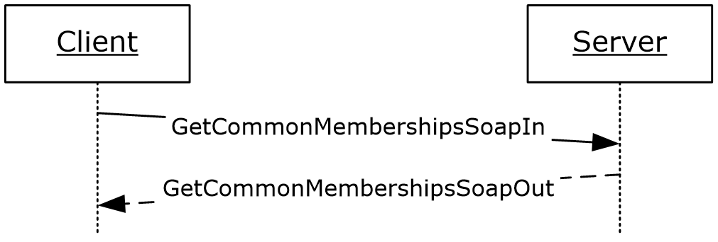
Figure 13: GetCommonMemberships operation

Messages
The following WSDL message definitions are specific to this operation.

GetCommonMembershipsSoapIn
The GetCommonMembershipsSoapIn message is the request WSDL message for the GetCommonMemberships WSDL operation.
The SOAP action value of the message is defined as:
http://microsoft.com/webservices/SharePointPortalServer/UserProfileService/GetCommonMemberships
The SOAP body contains a GetCommonMemberships element.

GetCommonMembershipsSoapOut
The GetCommonMembershipsSoapOut message is the response WSDL message for the GetCommonMemberships WSDL operation.
The SOAP body contains a GetCommonMembershipsResponse element.

Elements
The following XML schema element definitions are specific to this operation.

GetCommonMemberships
The GetCommonMemberships element is the body of the request WSDL message for the GetCommonMemberships WSDL operation.
<s:element name="GetCommonMemberships">
<s:complexType>
<s:sequence>
<s:element name="accountName" type="s:string" minOccurs="0" maxOccurs="1"/>
</s:sequence>
</s:complexType>
</s:element>
accountName: A string that specifies the login name of the user profile to be compared with. This value MUST be less than or equal to 400 characters in length. If this value matches the login name of the current user, the protocol server MUST return the memberships associated with user profile of the current user. If this element is not specified or does not have a value, AND a user profile for the current user exists, the protocol server MUST return the memberships associated with the user profile of the current user. If this element is not specified or does not have a value, AND a user profile for the current user does not exist, the protocol server MAY<8> create a user profile for the current user and return the memberships associated with the user profile of the current user. The protocol server MUST treat accountName in a case insensitive manner for retrieval of the user profile.
If the accountName does not correspond to an existing user profile, the protocol server MUST send a SOAP fault message.

GetCommonMembershipsResponse
The GetCommonMembershipsResponse element is the body of the response WSDL message for the GetCommonMemberships WSDL operation.
<s:element name="GetCommonMembershipsResponse">
<s:complexType>
<s:sequence>
<s:element name="GetCommonMembershipsResult" type="tns:ArrayOfMembershipData"
minOccurs="0" maxOccurs="1"/>
</s:sequence>
</s:complexType>
</s:element>
GetCommonMembershipsResult: A set of MembershipData (section 2.2.4.13) elements corresponding to the memberships that the users have in common. The Privacy element of MembershipData MUST be returned as "NotSet", the Group MUST be NULL and the ID MUST be "0".
The values returned MUST be filtered according to the privacy enumeration.

GetInCommon
The GetInCommon WSDL operation is used to get all common colleagues, all common memberships, and the lowest level common Manager property between the specified user profile and the user profile of the current user.
<wsdl:operation name="GetInCommon">
<wsdl:input message="tns:GetInCommonSoapIn"/>
<wsdl:output message="tns:GetInCommonSoapOut"/>
</wsdl:operation>
The protocol client sends a GetInCommonSoapIn request WSDL message and the protocol server responds with a GetInCommonSoapOut response WSDL message.
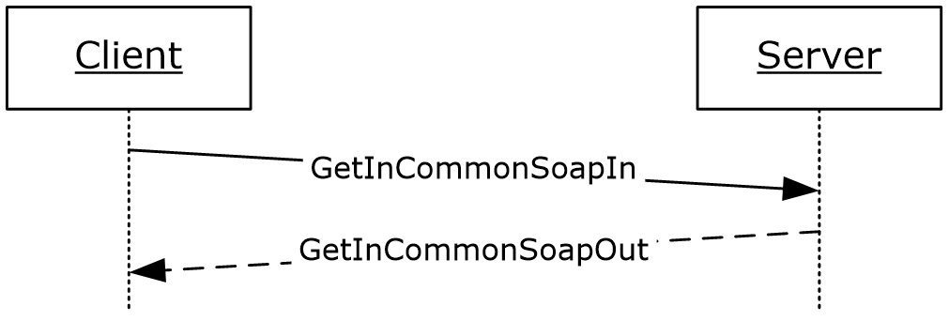
Figure 14: GetInCommon operation

Messages
The following WSDL message definitions are specific to this operation.

GetInCommonSoapIn
The GetInCommonSoapIn message is the request WSDL message for the GetInCommon WSDL operation.
The SOAP action value of the message is defined as:
http://microsoft.com/webservices/SharePointPortalServer/UserProfileService/GetInCommon
The SOAP body contains a GetInCommon element.

GetInCommonSoapOut
The GetInCommonSoapOut message is the response WSDL message for the GetInCommon WSDL operation.
The SOAP body contains a GetInCommonResponse element.

Elements
The following XML schema element definitions are specific to this operation.

GetInCommon
The GetInCommon element is the body of the request WSDL message for the GetInCommon WSDL operation.
<s:element name="GetInCommon">
<s:complexType>
<s:sequence>
<s:element name="accountName" type="s:string" minOccurs="0" maxOccurs="1"/>
</s:sequence>
</s:complexType>
</s:element>
accountName: A string that specifies the login name of the user profile to be compared with. This value MUST be less than or equal to 400 characters in length. The protocol server MUST treat accountName in a case insensitive manner for retrieval of the user profile.
If accountName is not specified or does not have a value and there is not an existing user profile for the current user, then a new user profile MUST be created which represents the current user.
If accountName is not specified or does not have a value and there is an existing user profile for the current user, then the protocol server MUST return elements for ONLY that user profile.
If accountName is specified and does not match the login name of an existing user profile, the protocol server MUST send a SOAP fault message.

GetInCommonResponse
The GetInCommonResponse element is the body of the response WSDL message for the GetInCommon WSDL operation.
<s:element name="GetInCommonResponse">
<s:complexType>
<s:sequence>
<s:element name="GetInCommonResult" type="tns:InCommonData" minOccurs="0"
maxOccurs="1"/>
</s:sequence>
</s:complexType>
</s:element>
GetInCommonResult: An InCommonData (section 3.1.4.12.3.1) element containing the colleague properties, membership properties, and manager property in common between the user profile of the current user and the specified user profile.
The values returned MUST be filtered according to the privacy level.
If no common Manager can be found, the protocol server MUST either send a SOAP fault or return ContactData with the Manager field set to null.<9>

Complex Types
The following XML schema complex type definitions are specific to this operation.

InCommonData
The InCommonData complex type is used to represent the returned common manager, colleagues, and memberships.
<s:complexType name="InCommonData">
<s:sequence>
<s:element name="Manager" type="tns:ContactData" minOccurs="0" maxOccurs="1"/>
<s:element name="Colleagues" type="tns:ArrayOfContactData" minOccurs="0"
maxOccurs="1"/>
<s:element name="Memberships" type="tns:ArrayOfMembershipData" minOccurs="0"
maxOccurs="1"/>
</s:sequence>
</s:complexType>
Manager: A ContactData (section 2.2.4.11) element corresponding to the common manager.
Colleagues: A set of ContactData (section 2.2.4.11) elements corresponding to the common colleague. The same Privacy element restrictions that apply to the GetCommonColleaguesResponse type (section 3.1.4.9.2.2) also apply to this data set.
Memberships: A set of MembershipData (section 2.2.4.13) elements corresponding to the common memberships.

GetProfileSchema
The GetProfileSchema WSDL operation is used to retrieve the list of properties associated with a particular user profile schema.
<wsdl:operation name="GetProfileSchema">
<wsdl:input message="tns:GetProfileSchemaSoapIn" />
<wsdl:output message="tns:GetProfileSchemaSoapOut" />
</wsdl:operation>
The protocol client sends a GetProfileSchemaSoapIn request WSDL message and the protocol server responds with a GetProfileSchemaSoapOut response WSDL message.
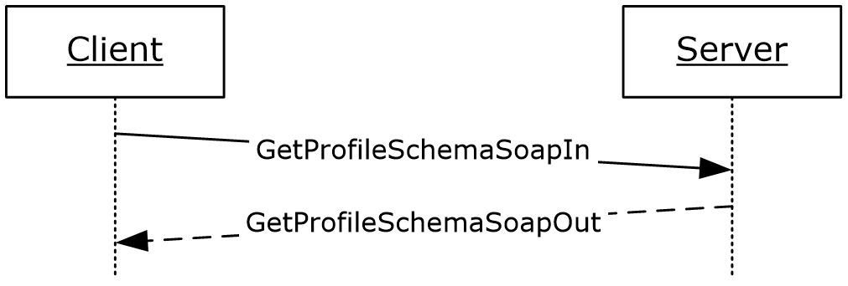
Figure 15: GetProfileSchema operation

Messages
The following WSDL message definitions are specific to this operation.

GetProfileSchemaSoapIn
The GetProfileSchemaSoapIn message is the request WSDL message for the GetProfileSchema WSDL operation.
The SOAP action value of the message is defined as:
http://microsoft.com/webservices/SharePointPortalServer/UserProfileService/GetProfileSchema
The SOAP body contains a GetProfileSchema element.

GetProfileSchemaSoapOut
The GetProfileSchemaSoapOut message is the response WSDL message for the GetProfileSchema WSDL operation.
The SOAP body contains a GetProfileSchemaResponse element.

Elements
The following XML schema element definitions are specific to this operation.

GetProfileSchema
The GetProfileSchema element is the body of the request WSDL message for the GetProfileSchema WSDL operation.
<s:element name="GetProfileSchema">
<s:complexType>
<s:sequence>
<s:element name="schemaName" type="s:string" minOccurs="0" maxOccurs="1"/>
</s:sequence>
</s:complexType>
</s:element>
schemaName: A string that specifies the profile schema name to retrieve the list of properties on. This value MUST be less than or equal to 400 characters in length. If this element is not specified or does not have a value, the protocol server MUST send a SOAP fault message. The protocol server MUST treat schemaName in a case insensitive manner for retrieval of the user profile.
If the schemaName does not correspond to an existing schema, the protocol server MUST send a SOAP fault message.

GetProfileSchemaResponse
The GetProfileSchemaResponse element is the body of the response WSDL message for the GetProfileSchema WSDL operation.
<s:element name="GetProfileSchemaResponse">
<s:complexType>
<s:sequence>
<s:element minOccurs="0" maxOccurs="1" name="GetProfileSchemaResult" type="tns:ArrayOfPropertyInfo"/>
</s:sequence>
</s:complexType>
</s:element>
GetProfileSchemaResult: The protocol server MUST return a set of PropertyInfo (section 2.2.4.17) items in the response WSDL message.

GetProfileSchemaNameByAccountName
The GetProfileSchemaNameByAccountName WSDL operation is used to retrieve the user profile schema name corresponding to the specified user.
<wsdl:operation name="GetProfileSchemaNameByAccountName">
<wsdl:input message="tns:GetProfileSchemaNameByAccountNameSoapIn"/>
<wsdl:output message="tns:GetProfileSchemaNameByAccountNameSoapOut"/>
</wsdl:operation>
The protocol client sends a GetProfileSchemaNameByAccountNameSoapIn request WSDL message and the protocol server responds with a GetProfileSchemaNameByAccountNameSoapOut response WSDL message.
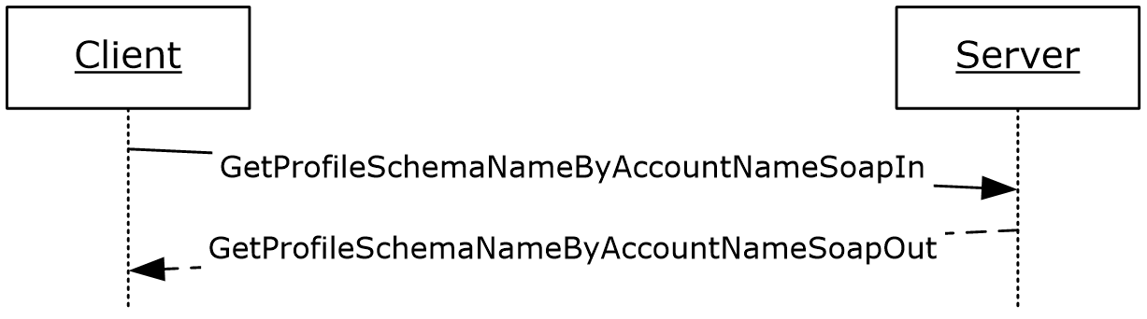
Figure 16: GetProfileSchemaNameByAccountName operation

Messages
The following WSDL message definitions are specific to this operation.

GetProfileSchemaNameByAccountNameSoapIn
The GetProfileSchemaNameByAccountNameSoapIn message is the request WSDL message for the GetProfileSchemaNameByAccountName WSDL operation.
The SOAP action value of the message is defined as:
http://microsoft.com/webservices/SharePointPortalServer/UserProfileService/GetProfileSchemaNameByAccountName
The SOAP body contains a GetProfileSchemaNameByAccountName element.

GetProfileSchemaNameByAccountNameSoapOut
The GetProfileSchemaNameByAccountNameSoapOut message is the response WSDL message for the GetProfileSchemaNameByAccountName WSDL operation.
The SOAP body contains a GetProfileSchemaNameByAccountNameResponse element.

Elements
The following XML schema element definitions are specific to this operation.

GetProfileSchemaNameByAccountName
The GetProfileSchemaNameByAccountName element is the body of the request WSDL message for the GetProfileSchemaNameByAccountName WSDL operation.
<s:element name="GetProfileSchemaNameByAccountName">
<s:complexType>
<s:sequence>
<s:element minOccurs="0" maxOccurs="1" name="accountName" type="s:string"/>
</s:sequence>
</s:complexType>
</s:element>
accountName: A string the specifies the login name of the user profile for which to return the name of the profile schema. This value MUST be less than or equal to 400 characters in length. The protocol server MUST treat accountName in a case insensitive manner for retrieval of the user profile.
If accountName is not specified or does not have a value and there is not an existing user profile for the current user, then a new user profile MUST be created which represents the current user and the protocol server MUST return the name of the profile schema corresponding to that user profile.
If accountName is not specified or does not have a value and there is an existing user profile for the current user, then the protocol server MUST return the name of the profile schema corresponding to the user profile of the current user.
If accountName is specified and does not match the login name of an existing user profile, the protocol server MUST send a SOAP fault message.

GetProfileSchemaNameByAccountNameResponse
The GetProfileSchemaNameByAccountNameResponse element if the body of the response WSDL message for the GetProfileSchemaNameByAccountName WSDL operation.
<s:element name="GetProfileSchemaNameByAccountNameResponse">
<s:complexType>
<s:sequence>
<s:element minOccurs="0" maxOccurs="1"
name="GetProfileSchemaNameByAccountNameResult" type="s:string"/>
</s:sequence>
</s:complexType>
</s:element>
GetProfileSchemaNameByAccountNameResult: A string that represents the name of the profile schema for the specified user.

GetProfileSchemaNames
The GetProfileSchemaNames WSDL operation is used to retrieve a list of profile schema names in the user profile.
<wsdl:operation name="GetProfileSchemaNames">
<wsdl:input message="tns:GetProfileSchemaNamesSoapIn"/>
<wsdl:output message="tns:GetProfileSchemaNamesSoapOut"/>
</wsdl:operation>
The protocol client sends a GetProfileSchemaNamesSoapIn request WSDL message and the protocol server responds with a GetProfileSchemaNamesSoapOut response WSDL message.
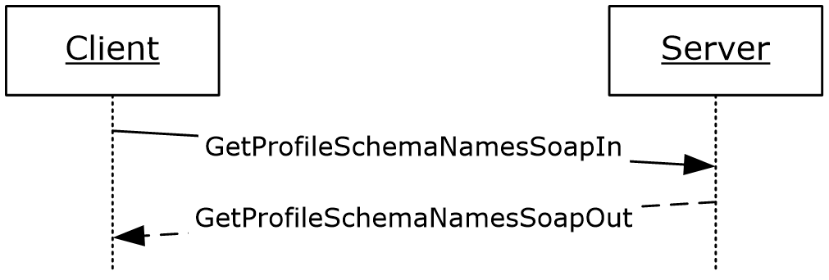
Figure 17: GetProfileSchemaNames operation

Messages
The following WSDL message definitions are specific to this operation.

GetProfileSchemaNamesSoapIn
The GetProfileSchemaNamesSoapIn message is the request WSDL message for the GetProfileSchemaNames WSDL operation.
The SOAP action value of the message is defined as:
http://microsoft.com/webservices/SharePointPortalServer/UserProfileService/GetProfileSchemaNames
The SOAP body contains a GetProfileSchemaNames element.

GetProfileSchemaNamesSoapOut
The GetProfileSchemaNamesSoapOut message is the response WSDL message for the GetProfileSchemaNames WSDL operation.
The SOAP body contains a GetProfileSchemaNamesResponse element.

Elements
The following XML schema element definitions are specific to this operation.

GetProfileSchemaNames
The GetProfileSchemaNames element is the body of the request WSDL message for the GetProfileSchemaNames WSDL operation.
<s:element name="GetProfileSchemaNames">
<s:complexType/>
</s:element>

GetProfileSchemaNamesResponse
The GetProfileSchemaNamesResponse element is the body of the response WSDL message for the GetProfileSchemaNames WSDL operation.
<s:element name="GetProfileSchemaNamesResponse">
<s:complexType>
<s:sequence>
<s:element minOccurs="0" maxOccurs="1" name="GetProfileSchemaNamesResult"
type="tns:ArrayOfString"/>
</s:sequence>
</s:complexType>
</s:element>
GetProfileSchemaNamesResult: An ArrayOfString (section 2.2.4.9) type. The protocol server MUST return the set of profile schema names.

GetPropertyChoiceList
The GetPropertyChoiceList WSDL operation is used to retrieve a list of possible values for a property.
<wsdl:operation name="GetPropertyChoiceList">
<wsdl:input message="tns:GetPropertyChoiceListSoapIn"/>
<wsdl:output message="tns:GetPropertyChoiceListSoapOut"/>
</wsdl:operation>
The protocol client sends a GetPropertyChoiceListSoapIn request WSDL message and the protocol server responds with a GetPropertyChoiceListSoapOut response WSDL message.
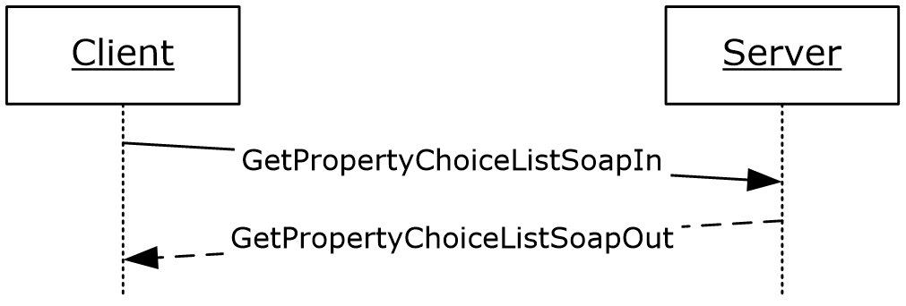
Figure 18: GetPropertyChoiceList operation

Messages
The following WSDL message definitions are specific to this operation.

GetPropertyChoiceListSoapIn
The GetPropertyChoiceListSoapIn message is the request WSDL message for GetPropertyChoiceList.
The SOAP action value of the message is defined as:
http://microsoft.com/webservices/SharePointPortalServer/UserProfileService/GetPropertyChoiceList
The SOAP body contains a GetPropertyChoiceList element.

GetPropertyChoiceListSoapOut
The GetPropertyChoiceListSoapOut message is the response WSDL message for GetPropertyChoiceList.
The SOAP body contains a GetPropertyChoiceListResponse element.

Elements
The following XML schema element definitions are specific to this operation.

GetPropertyChoiceList
The GetPropertyChoiceList element is the body of the request WSDL message for the GetPropertyChoiceList WSDL operation.
<s:element name="GetPropertyChoiceList">
<s:complexType>
<s:sequence>
<s:element name="propertyName" minOccurs="0" maxOccurs="1" type="s:string"/>
</s:sequence>
</s:complexType>
</s:element>
propertyName: A string that specifies the name of the property to get the list of choices for. The protocol server MUST trim excess whitespaces from propertyName before retrieving the list of choices. The protocol server MUST treat propertyName in a case insensitive manner for retrieval of the list.
If propertyName does not match an existing property on the server, the protocol server MUST return a SOAP fault. If the property is not available through web service<10>, the protocol server MUST return a SOAP fault. If the property does not have a choice list, the protocol server MUST return a SOAP fault.

GetPropertyChoiceListResponse
The GetPropertyChoiceListResponse element is the body of the response WSDL message for the GetPropertyChoiceList WSDL operation.
<s:element name="GetPropertyChoiceListResponse">
<s:complexType>
<s:sequence>
<s:element name="GetPropertyChoiceListResult" type="tns:ArrayOfString" minOccurs="0" maxOccurs="1"/>
</s:sequence>
</s:complexType>
</s:element>
GetPropertyChoiceListResult: An ArrayOfString (section 2.2.4.9) type. The protocol server MUST return the set of values for the given property.
If the property specified by propertyName does not have a list of choices, the protocol server MUST return a SOAP fault.

GetUserColleagues
The GetUserColleagues WSDL operation is used to get all the colleague properties associated with the specified user profile.
<wsdl:operation name="GetUserColleagues">
<wsdl:input message="tns:GetUserColleaguesSoapIn"/>
<wsdl:output message="tns:GetUserColleaguesSoapOut"/>
</wsdl:operation>
The protocol client sends a GetUserColleaguesSoapIn request WSDL message and the protocol server responds with a GetUserColleaguesSoapOut response WSDL message.
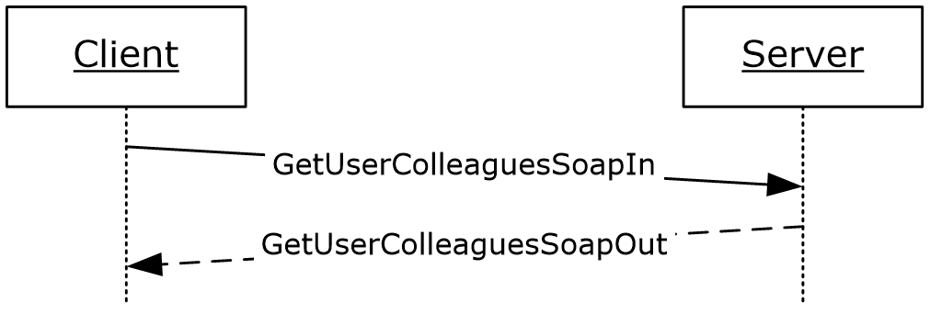
Figure 19: GetUserColleagues operation

Messages
The following WSDL message definitions are specific to this operation.

GetUserColleaguesSoapIn
The GetUserColleaguesSoapIn message is the request WSDL message for the GetUserColleagues WSDL operation.
The SOAP action value of the message is defined as:
http://microsoft.com/webservices/SharePointPortalServer/UserProfileService/GetUserColleagues
The SOAP body contains a GetUserColleagues element.

GetUserColleaguesSoapOut
The GetUserColleaguesSoapOut message is the response WSDL message for the GetUserColleagues WSDL operation.
The SOAP body contains a GetUserColleaguesResponse element.

Elements
The following XML schema element definitions are specific to this operation.

GetUserColleagues
The GetUserColleagues element is the body of the request WSDL message for the GetUserColleagues WSDL operation.
<s:element name="GetUserColleagues">
<s:complexType>
<s:sequence>
<s:element name="accountName" type="s:string" minOccurs="0" maxOccurs="1"/>
</s:sequence>
</s:complexType>
</s:element>
accountName: A string that specifies the login name of the user profile to return the elements for. This value MUST be less than or equal to 400 characters in length. The protocol server MUST treat accountName in a case insensitive manner for retrieval of the user profile.
If accountName is not specified or does not have a value and there is not an existing user profile for the current user, then a new user profile MUST be created which represents the current user and the protocol server MUST send a response that includes zero ContactData elements.
If accountName is not specified or does not have a value and there is an existing user profile for the current user, then the protocol server MUST return elements for that user profile.
If accountName is specified and does not match the login name of an existing user profile, the protocol server MUST send a SOAP fault message

GetUserColleaguesResponse
The GetUserColleaguesResponse element is the body of the response WSDL message for the GetUserColleagues WSDL operation.
<s:element name="GetUserColleaguesResponse">
<s:complexType>
<s:sequence>
<s:element name="GetUserColleaguesResult" type="tns:ArrayOfContactData"
minOccurs="0" maxOccurs="1"/>
</s:sequence>
</s:complexType>
</s:element>
GetUserColleaguesResult: A set of ContactData (section 2.2.4.11) elements corresponding to the colleagues of the specified user.
If the current user is not the same as the user specified by accountName, and the current user is not authorized to administer the user profile service, the server MUST return a SOAP fault message.
The protocol server MUST only return ContactData elements for colleagues the current user has permission to view as specified in section 2.2.5.4. The sole exception to this are SharePoint administrator(s) with user personalization permissions; they are permitted to access the data.
If the user specified by accountName does not have any colleagues, the response MUST contain zero ContactData elements.

GetUserLinks
The GetUserLinks WSDL operation is used to get the quick link properties associated with the specified user profile.
<wsdl:operation name="GetUserLinks">
<wsdl:input message="tns:GetUserLinksSoapIn"/>
<wsdl:output message="tns:GetUserLinksSoapOut"/>
</wsdl:operation>
The protocol client sends a GetUserLinksSoapIn request WSDL message and the protocol server responds with a GetUserLinksSoapOut response WSDL message.
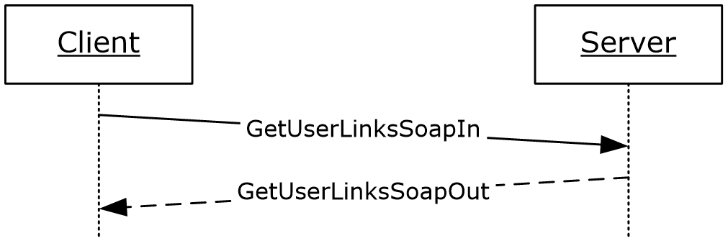
Figure 20: GetUserLinks operation

Messages
The following WSDL message definitions are specific to this operation.

GetUserLinksSoapIn
The GetUserLinksSoapIn message is the request WSDL message for the GetUserLinks WSDL operation.
The SOAP action value of the message is defined as:
http://microsoft.com/webservices/SharePointPortalServer/UserProfileService/GetUserLinks
The SOAP body contains a GetUserLinks element.

GetUserLinksSoapOut
The GetUserLinksSoapOut message is the response WSDL message for the GetUserLinks WSDL operation.
The SOAP body contains a GetUserLinksResponse element.

Elements
The following XML schema element definitions are specific to this operation.

GetUserLinks
The GetUserLinks element is the body of the request WSDL message for the GetUserLinks WSDL operation.
<s:element name="GetUserLinks">
<s:complexType>
<s:sequence>
<s:element name="accountName" type="s:string" minOccurs="0" maxOccurs="1"/>
</s:sequence>
</s:complexType>
</s:element>
accountName: A string that specifies the login name of the user profile to return the elements for. This value MUST be less than or equal to 400 characters in length. The protocol server MUST treat accountName in a case insensitive manner for retrieval of the user profile.
If accountName is not specified or does not have a value and there is not an existing user profile for the current user, then a new user profile MAY<11> be created which represents the current user and the protocol server MUST send a response that includes zero QuickLinkData elements.
If accountName is not specified or does not have a value and there is an existing user profile for the current user, then the protocol server MUST return the QuickLinkData elements corresponding to the quick link properties of the current user.
If accountName is specified and does not match the login name of an existing user profile, the protocol server MUST send a SOAP fault message

GetUserLinksResponse
The GetUserLinksResponse element is the body of the response WSDL message for the GetUserLinks WSDL operation.
<s:element name="GetUserLinksResponse">
<s:complexType>
<s:sequence>
<s:element name="GetUserLinksResult" type="tns:ArrayOfQuickLinkData"
minOccurs="0" maxOccurs="1"/>
</s:sequence>
</s:complexType>
</s:element>
GetUserLinksResult: A set of QuickLinkData (section 2.2.4.18) elements corresponding to the quick link properties of the specified user.
If the current user is not the same user specified by accountName, and the current user is not authorized to administer the user profile service, then the protocol server MUST return a SOAP fault message.
The protocol server MUST only return QuickLinkData elements for quick links the current user has permission to view as specified in section 2.2.5.4..
If the user specified by accountName does not have any quick links, the response MUST contain zero QuickLinkData elements.

GetUserMemberships
The GetUserMemberships WSDL operation is used to get the memberships associated with the specified user profile.
<wsdl:operation name="GetUserMemberships">
<wsdl:input message="tns:GetUserMembershipsSoapIn"/>
<wsdl:output message="tns:GetUserMembershipsSoapOut"/>
</wsdl:operation>
The protocol client sends a GetUserMembershipsSoapIn request WSDL message and the protocol server responds with a GetUserMembershipsSoapOut response WSDL message.
If the current user is not authorized to administer the user profile service and not requesting the profile of the current user, the protocol server MUST send a SOAP fault message.
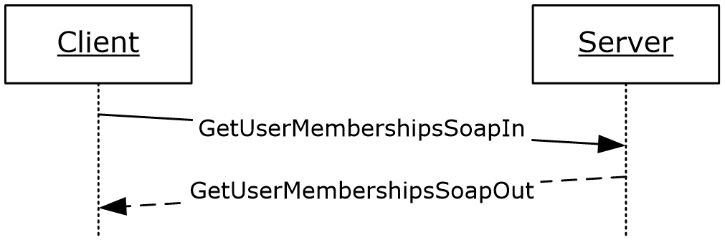
Figure 21: GetUserMemberships operation

Messages
The following WSDL message definitions are specific to this operation.

GetUserMembershipsSoapIn
The GetUserMembershipsSoapIn message is the request WSDL message for the GetUserMemberships WSDL operation.
The SOAP action value of the message is defined as:
http://microsoft.com/webservices/SharePointPortalServer/UserProfileService/GetUserMemberships
The SOAP body contains a GetUserMemberships element.

GetUserMembershipsSoapOut
The GetUserMembershipsSoapOut message is the response WSDL message for the GetUserMemberships WSDL operation.
The SOAP body contains a GetUserMembershipsResponse element.

Elements
The following XML schema element definitions are specific to this operation.

GetUserMemberships
The GetUserMemberships element is the body of the request WSDL message for the GetUserMemberships WSDL operation.
<s:element name="GetUserMemberships">
<s:complexType>
<s:sequence>
<s:element name="accountName" type="s:string" minOccurs="0" maxOccurs="1"/>
</s:sequence>
</s:complexType>
</s:element>
accountName: A string that specifies the login name of the user profile to return the elements for. This value MUST be less than or equal to 400 characters in length. The protocol server MUST treat accountName in a case insensitive manner for retrieval of the user profile.
If accountName is not specified or does not have a value and there is not an existing user profile for the current user, then a new user profile MAY<12> be created which represents the current user and the protocol server MUST send a response that includes zero MembershipData elements.
If accountName is not specified or does not have a value and there is an existing user profile for the current user, then the protocol server MUST return elements for that user profile.
If accountName is specified and does not match the login name of an existing user profile, the protocol server MUST send a SOAP fault message.

GetUserMembershipsResponse
The GetUserMembershipsResponse element is the body of the response WSDL message for the GetUserMemberships WSDL operation.
<s:element name="GetUserMembershipsResponse">
<s:complexType>
<s:sequence>
<s:element name="GetUserMembershipsResult" type="tns:ArrayOfMembershipData"
minOccurs="0" maxOccurs="1"/>
</s:sequence>
</s:complexType>
</s:element>
GetUserMembershipsResult: A set of MembershipData (section 2.2.4.13) elements corresponding to the specified user's membership properties.
If the current user is not the same user specified by accountName, and the current user is not authorized to administer the user profile service, then the protocol server MUST return a SOAP fault message.
The protocol server MUST only return MembershipData elements for memberships the current user has permission to view as specified in section 2.2.5.4.
If the user specified by accountName does not have any memberships, the response MUST contain zero MembershipData elements.

GetUserOrganizations
The GetUserOrganizations WSDL operation is used to get the organization properties associated with the specified user profile.
<wsdl:operation name="GetUserOrganizations">
<wsdl:input message="tns:GetUserOrganizationsSoapIn"/>
<wsdl:output message="tns:GetUserOrganizationsSoapOut"/>
</wsdl:operation>
The protocol client sends a GetUserOrganizationsSoapIn request WSDL message and the protocol server responds with a GetUserOrganizationsSoapOut response WSDL message.
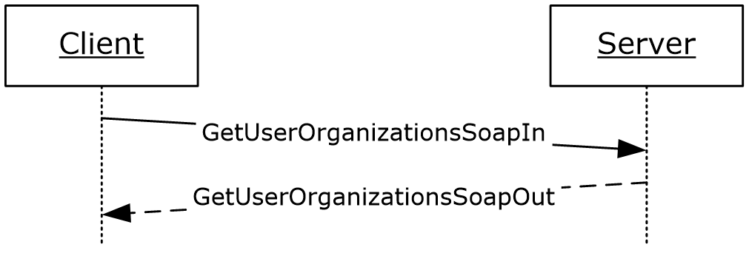
Figure 22: GetUserOrganizations operation

Messages
The following WSDL message definitions are specific to this operation.

GetUserOrganizationsSoapIn
The GetUserOrganizationsSoapIn message is the request WSDL message for the GetUserOrganizations WSDL operation.
The SOAP action value of the message is defined as:
http://microsoft.com/webservices/SharePointPortalServer/UserProfileService/GetUserOrganizations
The SOAP body contains a GetUserOrganizations element.

GetUserOrganizationsSoapOut
The GetUserOrganizationsSoapOut message is the response WSDL message for the GetUserOrganizations WSDL operation.
The SOAP body contains a GetUserOrganizationsResponse element.

Elements
The following XML schema element definitions are specific to this operation.

GetUserOrganizations
The GetUserOrganizations element is the body of the request WSDL message for the GetUserOrganizations WSDL operation.
<s:element name="GetUserOrganizations">
<s:complexType>
<s:sequence>
<s:element name="accountName" type="s:string" minOccurs="0" maxOccurs="1"/>
</s:sequence>
</s:complexType>
</s:element>
accountName: A string that specifies the login name of the user profile to return the elements for. This value MUST be less than or equal to 400 characters in length. The protocol server MUST treat accountName in a case insensitive manner for retrieval of the user profile.
If accountName is not specified or does not have a value and there is not an existing user profile for the current user, the protocol server MUST send a SOAP fault message.
If accountName is not specified or does not have a value and there is an existing user profile for the current user, then the protocol server MUST return elements for that user profile.
If accountName is specified and does not match the login name of an existing user profile, the protocol server MUST send a SOAP fault message.

GetUserOrganizationsResponse
The GetUserOrganizationsResponse element is the body of the response WSDL message for the GetUserOrganizations WSDL operation.
<s:element name="GetUserOrganizationsResponse">
<s:complexType>
<s:sequence>
<s:element name="GetUserOrganizationsResult" type="tns:ArrayOfOrganizationProfileData"
minOccurs="0" maxOccurs="1"/>
</s:sequence>
</s:complexType>
</s:element>
GetUserOrganizationsResult: A set of OrganizationProfileData (section 2.2.4.14) elements corresponding to the organizations of the specified user.
The protocol server MUST only return OrganizationProfileData elements for organizations the current user has permission to view. The protocol server determines the permission on each organization by checking the internal Privacy value for each as specified in section 2.2.5.4. However, these internally checked Privacy values are not returned as part of the response.
If the user specified by accountName does not have any organizations, the response MUST be an exception: "The object reference is not set to an instance of an object.".

GetUserPinnedLinks
The GetUserPinnedLinks WSDL operation is used to get the pinned links associated with the specified user profile.
<wsdl:operation name="GetUserPinnedLinks">
<wsdl:input message="tns:GetUserPinnedLinksSoapIn"/>
<wsdl:output message="tns:GetUserPinnedLinksSoapOut"/>
</wsdl:operation>
The protocol client sends a GetUserPinnedLinksSoapIn request WSDL message and the protocol server responds with a GetUserPinnedLinksSoapOut response WSDL message.
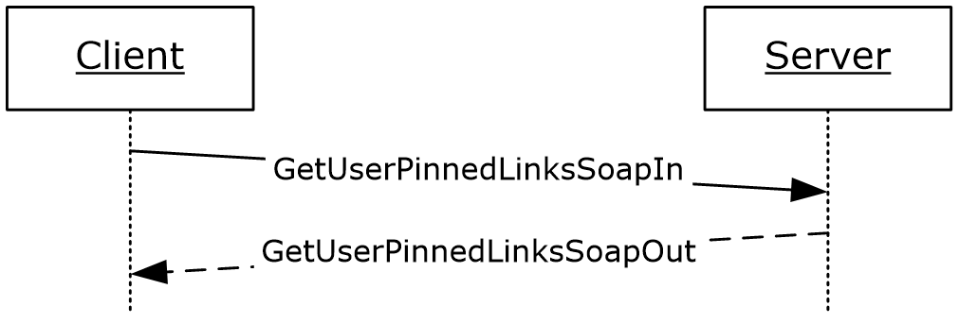
Figure 23: GetUserPinnedLinks operation

Messages
The following WSDL message definitions are specific to this operation.

GetUserPinnedLinksSoapIn
The GetUserPinnedLinksSoapIn message is the request WSDL message for the GetUserPinnedLinks WSDL operation.
The SOAP action value of the message is defined as:
http://microsoft.com/webservices/SharePointPortalServer/UserProfileService/GetUserPinnedLinks
The SOAP body contains a GetUserPinnedLinks element.

GetUserPinnedLinksSoapOut
The GetUserPinnedLinksSoapOut message is the response WSDL message for the GetUserPinnedLinks WSDL operation.
The SOAP body contains a GetUserPinnedLinksResponse element.

Elements
The following XML schema element definitions are specific to this operation.

GetUserPinnedLinks
The GetUserPinnedLinks element is the body of the request WSDL message for the GetUserPinnedLinks WSDL operation.
<s:element name="GetUserPinnedLinks">
<s:complexType>
<s:sequence>
<s:element name="accountName" type="s:string" minOccurs="0" maxOccurs="1"/>
</s:sequence>
</s:complexType>
</s:element>
accountName: A string that specifies the login name of the user profile to return the elements for. This value MUST be less than or equal to 400 characters in length. The protocol server MUST treat accountName in a case insensitive manner for retrieval of the user profile.
If accountName is not specified or does not have a value and there is not an existing user profile for the current user, then a new user profile MUST be created which represents the current user and the protocol server MUST send a response that includes zero PinnedLinkData elements.
If accountName is not specified or does not have a value and there is an existing user profile for the current user, then the protocol server MUST return elements for that user profile.
If accountName is specified and does not match the login name of an existing user profile, the protocol server MUST send a SOAP fault message.

GetUserPinnedLinksResponse
The GetUserPinnedLinksResponse element is the body of the response WSDL message for the GetUserPinnedLinks WSDL operation.
<s:element name="GetUserPinnedLinksResponse">
<s:complexType>
<s:sequence>
<s:element name="GetUserPinnedLinksResult" type="tns:ArrayOfPinnedLinkData"
minOccurs="0" maxOccurs="1"/>
</s:sequence>
</s:complexType>
</s:element>
GetUserPinnedLinksResult: A set of PinnedLinkData (section 2.2.4.15) elements corresponding to the pinned links for the specified user.
The protocol server MUST only return PinnedLinkData elements for the pinned links the current user has permission to view as specified in section 2.2.5.4. For this function ONLY, the Privacy level is assumed to be Private.
If the user specified by accountName does not have any pinned links, the response MUST contain zero PinnedLinkData elements.

GetUserProfileByGuid
The GetUserProfileByGuid WSDL operation is used to retrieve a user profile given the GUID of a user.
<wsdl:operation name="GetUserProfileByGuid">
<wsdl:input message="tns:GetUserProfileByGuidSoapIn"/>
<wsdl:output message="tns:GetUserProfileByGuidSoapOut"/>
</wsdl:operation>
The protocol client sends a GetUserProfileByGuidSoapIn request WSDL message and the protocol server responds with a GetUserProfileByGuidSoapOut response WSDL message.
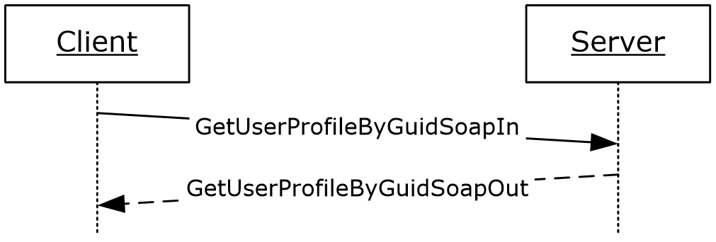
Figure 24: GetUserProfileByGuid operation

Messages
The following WSDL message definitions are specific to this operation.

GetUserProfileByGuidSoapIn
The GetUserProfileByGuidSoapIn message is the request WSDL message for the GetUserProfileByGuid WSDL operation.
The SOAP action value of the message is defined as:
http://microsoft.com/webservices/SharePointPortalServer/UserProfileService/GetUserProfileByGuid
The SOAP body contains a GetUserProfileByGuid element.

GetUserProfileByGuidSoapOut
The GetUserProfileByGuidSoapOut message is the response WSDL message from the GetUserProfileByGuid WSDL operation.
The SOAP body contains a GetUserProfileByGuidResponse element.

Elements
The following XML schema element definitions are specific to this operation.

GetUserProfileByGuid
The GetUserProfileByGuid element is the body of the request WSDL message for the GetUserProfileByGuid WSDL operation.
<s:element name="GetUserProfileByGuid">
<s:complexType>
<s:sequence>
<s:element name="guid" type="s1:guid"/>
</s:sequence>
</s:complexType>
</s:element>
guid: A guid type that specifies the GUID associated with the user for which to retrieve the user profile.
If the GUID does not exist indicating that it does not refer to an existing user, the protocol server MUST send a SOAP fault message.

GetUserProfileByGuidResponse
The GetUserProfileByGuidResponse element is the body of the response WSDL message for the GetUserProfileByGuid WSDL operation.
<s:element name="GetUserProfileByGuidResponse">
<s:complexType>
<s:sequence>
<s:element minOccurs="0" maxOccurs="1" name="GetUserProfileByGuidResult" type="tns:ArrayOfPropertyData"/>
</s:sequence>
</s:complexType>
</s:element>
GetUserProfileByGuidResult: A set of PropertyData (section 2.2.4.16) elements corresponding to the properties of the user specified by guid.
If the current user is not the same user specified by guid, and the current user is not authorized to administer the user profile service, then the protocol server MUST set the Privacy element of any PropertyData elements returned to "NotSet".
The protocol server MUST only return PropertyData elements for properties the current user has permission to view as specified in section 2.2.5.4.
If the user specified by guid does not have any properties, the response MUST contain zero PropertyData elements.

GetUserProfileByIndex
The GetUserProfileByIndex WSDL operation is used to retrieve a user profile given a unique identifier. This operation can be used to iterate through all of the existing user profiles.
<wsdl:operation name="GetUserProfileByIndex">
<wsdl:input message="tns:GetUserProfileByIndexSoapIn"/>
<wsdl:output message="tns:GetUserProfileByIndexSoapOut"/>
</wsdl:operation>
The protocol client sends a GetUserProfileByIndexSoapIn request WSDL message and the protocol server responds with a GetUserProfileByIndexSoapOut response WSDL message.
If the current user is not authorized to administer the user profile service and not requesting the profile of the current user, the protocol server MUST send a SOAP fault message.
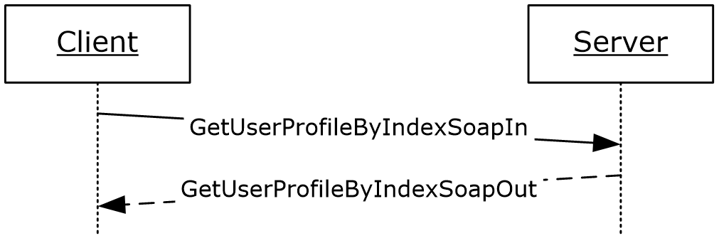
Figure 25: GetUserProfileByIndex operation

Messages
The following WSDL message definitions are specific to this operation.

GetUserProfileByIndexSoapIn
The GetUserProfileByIndexSoapIn message is the request WSDL message for the GetUserProfileByIndex WSDL operation.
The SOAP action value of the message is defined as:
http://microsoft.com/webservices/SharePointPortalServer/UserProfileService/GetUserProfileByIndex
The SOAP body contains a GetUserProfileByIndex element.

GetUserProfileByIndexSoapOut
The GetUserProfileByIndexSoapOut message is the response WSDL message for the GetUserProfileByIndex WSDL operation.
The SOAP body contains a GetUserProfileByIndexResponse element.

Elements
The following XML schema element definitions are specific to this operation.

GetUserProfileByIndex
The GetUserProfileByIndex element is the body of the request WSDL message for the GetUserProfileByIndex WSDL operation.
<s:element name="GetUserProfileByIndex">
<s:complexType>
<s:sequence>
<s:element name="index" type="s:int"/>
</s:sequence>
</s:complexType>
</s:element>
index: An int type that specifies which user profile is returned. The protocol server MUST return the user profile whose index matches the smallest user profile index that is greater than index.
If index is greater than the indices of all existing user profiles, the protocol server MUST return a GetUserProfileByIndexResult element, in which NextValue is set to -1 and all other fields are null.

GetUserProfileByIndexResponse
The GetUserProfileByIndexResponse element is the body of the response WSDL message for the GetUserProfileByIndex WSDL operation.
<s:element name="GetUserProfileByIndexResponse">
<s:complexType>
<s:sequence>
<s:element name="GetUserProfileByIndexResult"
type="tns:GetUserProfileByIndexResult" minOccurs="0" maxOccurs="1"/>
</s:sequence>
</s:complexType>
</s:element>
GetUserProfileByIndexResult: A complex type that represents the data of a user profile (section 3.1.4.23.3.1) as retrieved by the GetUserProfileByIndex WSDL operation (section 3.1.4.23.2.1)
The protocol server MUST return a GetUserProfileByIndexResult (section 3.1.4.23.3.1) in the response WSDL message as long as it is not returning a SOAP fault.

Complex Types
The following XML schema complex type definitions are specific to this operation.

GetUserProfileByIndexResult
The GetUserProfileByIndexResult complex type is used to represent the returned user profile data.
<s:complexType name="GetUserProfileByIndexResult">
<s:sequence>
<s:element name="NextValue" type="s:string" minOccurs="0" maxOccurs="1"/>
<s:element name="UserProfile" type="tns:ArrayOfPropertyData" minOccurs="0"
maxOccurs="1"/>
<s:element name="Colleagues" type="tns:ArrayOfContactData" minOccurs="0"
maxOccurs="1"/>
<s:element name="QuickLinks" type="tns:ArrayOfQuickLinkData" minOccurs="0"
maxOccurs="1"/>
<s:element name="PinnedLinks" type="tns:ArrayOfPinnedLinkData" minOccurs="0"
maxOccurs="1"/>
<s:element name="Memberships" type="tns:ArrayOfMembershipData" minOccurs="0"
maxOccurs="1"/>
</s:sequence>
</s:complexType>
NextValue: A string that specifies the user profile index of the next user profile that is greater than index. This value MUST uniquely identify another user profile object, or be set to -1 if no such object exists. The value inside the string is an integer of the same type as that accepted by GetUserProfileByIndexResult.
UserProfile: A set of PropertyData (section 2.2.4.16) elements corresponding to the properties of the specified user.
Colleagues: A set of ContactData (section 2.2.4.11) elements corresponding to the colleague properties of the specified user.
QuickLinks: A set of QuickLinkData (section 2.2.4.18) elements corresponding to the quick link properties of the specified user.
PinnedLinks: A set of PinnedLinkData (section 2.2.4.15) elements corresponding to the pinned links of the specified user.
Memberships: A set of MembershipData (section 2.2.4.13) elements corresponding to the memberships of the specified user.
If the current user is not the same as the user retrieved through GetUserProfileByIndex using index, and the current user is not authorized to administer the user profile service, the server must return a SOAP fault message.
The protocol server MUST only return elements for properties the current user has permission to view as specified in section 2.2.5.4.

GetUserProfileByName
The GetUserProfileByName WSDL operation is used to retrieve a user profile given a login name.
<wsdl:operation name="GetUserProfileByName">
<wsdl:input message="tns:GetUserProfileByNameSoapIn"/>
<wsdl:output message="tns:GetUserProfileByNameSoapOut"/>
</wsdl:operation>
The protocol client sends a GetUserProfileByNameSoapIn request WSDL message and the protocol server responds with a GetUserProfileByNameSoapOut response WSDL message.
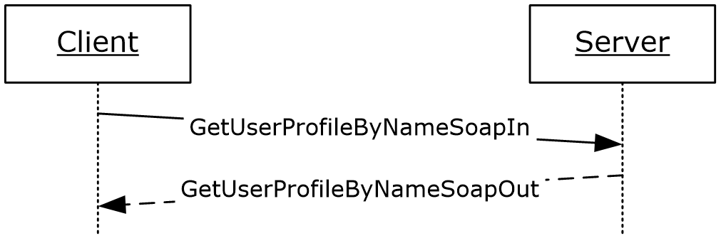
Figure 26: GetUserProfileByName operation

Messages
The following WSDL message definitions are specific to this operation.

GetUserProfileByNameSoapIn
The GetUserProfileByNameSoapIn message is the request WSDL message for the GetUserProfileByName WSDL operation.
The SOAP action value of the message is defined as:
http://microsoft.com/webservices/SharePointPortalServer/UserProfileService/GetUserProfileByName
The SOAP body contains a GetUserProfileByName element.

GetUserProfileByNameSoapOut
The GetUserProfileByNameSoapOut message is the response WSDL message for the GetUserProfileByName WSDL operation.
The SOAP body contains a GetUserProfileByNameResponse element.

Elements
The following XML schema element definitions are specific to this operation.

GetUserProfileByName
The GetUserProfileByName element is the body of the request WSDL message for the GetUserProfileByName WSDL operation.

<s:element name="GetUserProfileByName">
<s:complexType>
<s:sequence>
<s:element name="accountName" minOccurs="0" maxOccurs="1" type="s:string"/>
</s:sequence>
</s:complexType>
</s:element>
accountName: A string that specifies the login name of the user profile to return the elements for. This value MUST be less than or equal to 400 characters in length. The protocol server MUST treat accountName in a case insensitive manner for retrieval of the user profile.
If accountName is an empty string or NULL, and there is not an existing user profile for the current user, then a new user profile MUST be created which represents the user and the protocol server MUST return that user profile.
If accountName is an empty string or NULL, and there is an existing user profile for the current user, then the user profile for the current user MUST be returned from the server.
If accountName is specified and does not match the login name of an existing user profile, the protocol server MUST send a SOAP fault message.

GetUserProfileByNameResponse
The GetUserProfileByNameResponse element is the body of the response WSDL message for the GetUserProfileByName WSDL operation.
<s:element name="GetUserProfileByNameResponse">
<s:complexType>
<s:sequence>
<s:element minOccurs="0" maxOccurs="1" name="GetUserProfileByNameResult" type="tns:ArrayOfPropertyData"/>
</s:sequence>
</s:complexType>
</s:element>
GetUserProfileByNameResult: A set of PropertyData (section 2.2.4.16) elements corresponding to the properties of the user specified by accountName.
If the current user is not the same user specified by accountName, and the current user is not authorized to administer the user profile service, then the protocol server MUST set the Privacy element of any PropertyData elements returned to "NotSet".
The protocol server MUST only return PropertyData elements for properties the current user has permission to view as specified in section 2.2.5.4.
If the user specified by accountName does not have any properties, the response MUST contain zero PropertyData elements.

GetUserProfileCount
The GetUserProfileCount WSDL operation is used return the number of user profiles stored by the protocol server.
<wsdl:operation name="GetUserProfileCount">
<wsdl:input message="tns:GetUserProfileCountSoapIn"/>
<wsdl:output message="tns:GetUserProfileCountSoapOut"/>
</wsdl:operation>
The protocol client sends a GetUserProfileCountSoapIn request WSDL message and the protocol server responds with a GetUserProfileCountSoapOut response WSDL message.
If the user is not authorized to administer the user profile service, the protocol server MUST send a SOAP fault message.
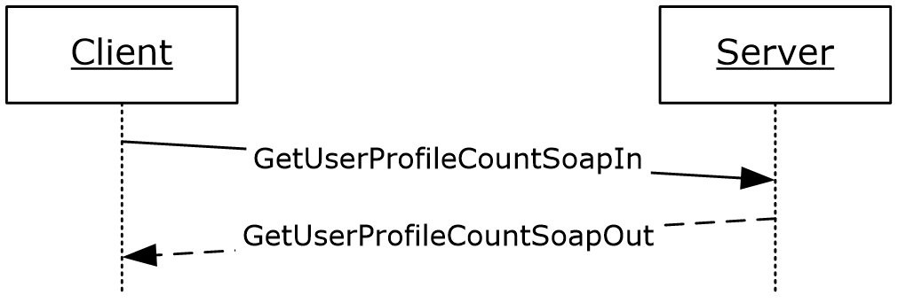
Figure 27: GetUserProfileCount operation

Messages
The following WSDL message definitions are specific to this operation.

GetUserProfileCountSoapIn
The GetUserProfileCountSoapIn message is the request WSDL message for the GetUserProfileCount WSDL operation.
The SOAP action value of the message is defined as:
http://microsoft.com/webservices/SharePointPortalServer/UserProfileService/GetUserProfileCount
The SOAP body contains a GetUserProfileCount element.

GetUserProfileCountSoapOut
The GetUserProfileCountSoapOut message is the response WSDL message for the GetUserProfileCount WSDL operation.
The SOAP body contains a GetUserProfileCountResponse element.

Elements
The following XML schema element definitions are specific to this operation.

GetUserProfileCount
The GetUserProfileCount element is the body of the request WSDL message for the GetUserProfileCount WSDL operation.
<s:element name="GetUserProfileCount">
<s:complexType/>
</s:element>

GetUserProfileCountResponse
The GetUserProfileCountResponse element is the body of the response WSDL message for the GetUserProfileCount WSDL operation.
<s:element name="GetUserProfileCountResponse">
<s:complexType>
<s:sequence>
<s:element minOccurs="1" maxOccurs="1" name="GetUserProfileCountResult" type="s:long" /> </s:sequence>
</s:complexType>
</s:element>
GetUserProfileCountResult: A long type that specifies the number of user profiles on the host server.

GetUserProfileSchema
The GetUserProfileSchema WSDL operation is used to retrieve schema information about each of the defined properties.
<wsdl:operation name="GetUserProfileSchema">
<wsdl:input message="tns:GetUserProfileSchemaSoapIn"/>
<wsdl:output message="tns:GetUserProfileSchemaSoapOut"/>
</wsdl:operation>
The protocol client sends a GetUserProfileSchemaSoapIn request WSDL message and the protocol server responds with a GetUserProfileSchemaSoapOut response WSDL message.
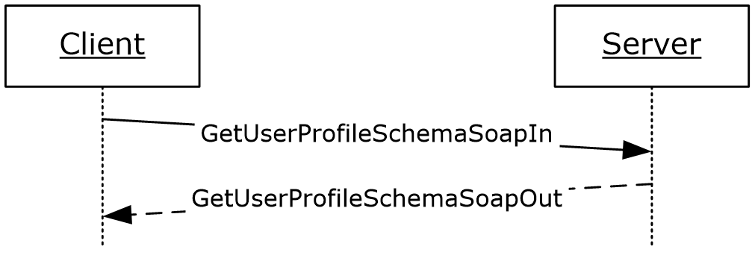
Figure 28: GetUserProfileSchema operation

Messages
The following WSDL message definitions are specific to this operation.

GetUserProfileSchemaSoapIn
The GetUserProfileSchemaSoapIn message is the request WSDL message for the GetUserProfileSchema WSDL operation.
The SOAP action value of the message is defined as:
http://microsoft.com/webservices/SharePointPortalServer/UserProfileService/GetUserProfileSchema
The SOAP body contains a GetUserProfileSchema element.

GetUserProfileSchemaSoapOut
The GetUserProfileSchemaSoapOut message is the response WSDL message for the GetUserProfileSchema WSDL operation.
The SOAP body contains a GetUserProfileSchemaResponse element.

Elements
The following XML schema element definitions are specific to this operation.

GetUserProfileSchema
The GetUserProfileSchema element is the body of the request WSDL message for the GetUserProfileSchema WSDL operation.
<s:element name="GetUserProfileSchema">
<s:complexType/>
</s:element>

GetUserProfileSchemaResponse
The GetUserProfileSchemaResponse element is the body of the response WSDL message for the GetUserProfileSchema WSDL operation.
<s:element name="GetUserProfileSchemaResponse">
<s:complexType>
<s:sequence>
<s:element minOccurs="0" maxOccurs="1" name="GetUserProfileSchemaResult" type="tns:ArrayOfPropertyInfo" />
</s:sequence>
</s:complexType>
</s:element>
GetUserProfileSchemaResult: A set of PropertyInfo (section 2.2.4.17) elements that is a listing of the properties of a user profile and of the attributes of each property.

GetUserPropertyByAccountName
The GetUserPropertyByAccountName WSDL operation is used to get the value of a specific property for the specified user.
<wsdl:operation name="GetUserPropertyByAccountName">
<wsdl:input message="tns:GetUserPropertyByAccountNameSoapIn"/>
<wsdl:output message="tns:GetUserPropertyByAccountNameSoapOut"/>
</wsdl:operation>
The protocol client sends a GetUserPropertyByAccountNameSoapIn request WSDL message and the protocol server responds with a GetUserPropertyByAccountNameSoapIn response WSDL message.
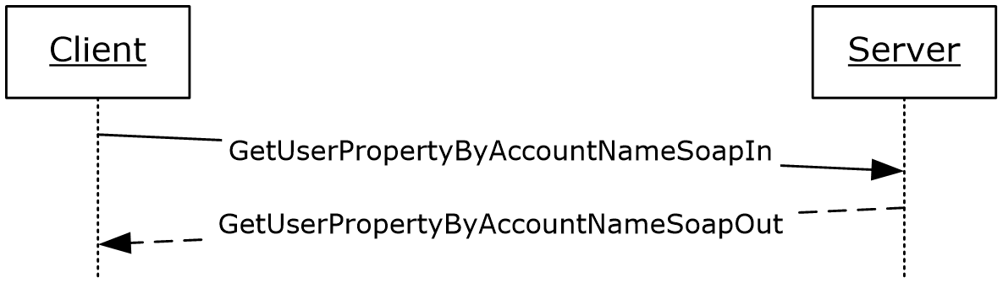
Figure 29: GetUserPropertyByAccountName operation

Messages
The following WSDL message definitions are specific to this operation.

GetUserPropertyByAccountNameSoapIn
The GetUserPropertyByAccountNameSoapIn message is the request WSDL message for the GetUserPropertyByAccountName WSDL operation.
The SOAP action value of the message is defined as:
http://microsoft.com/webservices/SharePointPortalServer/UserProfileService/GetUserPropertyByAccountName
The SOAP body contains a GetUserPropertyByAccountName element.

GetUserPropertyByAccountNameSoapOut
The GetUserPropertyByAccountNameSoapOut message is the response WSDL message for the GetUserPropertyByAccountName WSDL operation.
The SOAP body contains a GetUserPropertyByAccountNameResponse element.

Elements
The following XML schema element definitions are specific to this operation.

GetUserPropertyByAccountName
The GetUserPropertyByAccountName element is the body of the request WSDL message for the GetUserPropertyByAccountName WSDL operation.
<s:element name="GetUserPropertyByAccountName">
<s:complexType>
<s:sequence>
<s:element minOccurs="0" maxOccurs="1" name="accountName" type="s:string" /> <s:element minOccurs="0" maxOccurs="1" name="propertyName" type="s:string" />
</s:sequence>
</s:complexType>
</s:element>
accountName: A string that specifies the login name of the user profile for which to get the property. This value MUST be less than or equal to 400 characters in length. The protocol server MUST treat accountName in a case insensitive manner for retrieval of the user profile.
If accountName is not specified or does not have a value and there is not an existing user profile for the current user, then a new user profile MUST be created which represents the user and the protocol server MUST use that user profile to get the property.
If accountName is not specified or does not have a value and there is an existing user profile for the current user, then the protocol server MUST use that user profile to get the property.
If accountName is specified and does not match the login name of an existing user profile, the protocol server MUST send a SOAP fault message.
propertyName: A string that specifies the name of an element that belongs to the PropertyData (section 2.2.4.16) complex type.
If PropertyData does not have a property name specified by propertyName, the protocol server MUST send a SOAP fault message.

GetUserPropertyByAccountNameResponse
The GetUserPropertyByAccountNameResponse element is the body of the response WSDL message for the GetUserPropertyByAccountName WSDL operation.
<s:element name="GetUserPropertyByAccountNameResponse">
<s:complexType>
<s:sequence>
<s:element minOccurs="0" maxOccurs="1" name="GetUserPropertyByAccountNameResult" type="tns:PropertyData" />
</s:sequence>
</s:complexType>
</s:element>
GetUserPropertyByAccountNameResult: A PropertyData element containing the specified user profile property of the user with the specified login name.
If the current user is not the same user specified by accountName, and the current user is not authorized to administer the user profile service, then the protocol server MUST send a SOAP fault message.
The protocol server MUST only return a PropertyData element for a property that the current user has permission to view as specified in section 2.2.5.4.
If propertyName is not specified or does not have a value, the response MUST contain zero PropertyData elements.

ModifyUserPropertyByAccountName
The ModifyUserPropertyByAccountName WSDL operation is used to modify a set of properties for the specified user.
<wsdl:operation name="ModifyUserPropertyByAccountName">
<wsdl:input message="tns:ModifyUserPropertyByAccountNameSoapIn"/>
<wsdl:output message="tns:ModifyUserPropertyByAccountNameSoapOut"/>
</wsdl:operation>
The protocol client sends a ModifyUserPropertyByAccountNameSoapIn request WSDL message and the protocol server responds with a ModifyUserPropertyByAccountNameSoapOut response WSDL message.
If the user is not authorized to administer the user profile service and is not updating his or her own user profile, the protocol server MUST send a SOAP fault message.
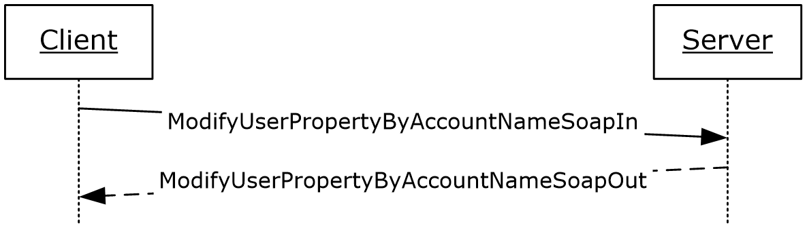
Figure 30: ModifyUserPropertyByAccountName operation

Messages
The following WSDL message definitions are specific to this operation.

ModifyUserPropertyByAccountNameSoapIn
The ModifyUserPropertyByAccountNameSoapIn message is the request WSDL message for the ModifyUserPropertyByAccountName WSDL operation.
The SOAP action value of the message is defined as:
http://microsoft.com/webservices/SharePointPortalServer/UserProfileService/ModifyUserPropertyByAccountName
The SOAP body contains a ModifyUserPropertyByAccountName element.

ModifyUserPropertyByAccountNameSoapOut
The ModifyUserPropertyByAccountNameSoapOut message is the response WSDL message for the ModifyUserPropertyByAccountName WSDL operation.
The SOAP body contains a ModifyUserPropertyByAccountNameResponse element.

Elements
The following XML schema element definitions are specific to this operation.

ModifyUserPropertyByAccountName
The ModifyUserPropertyByAccountName element updates a set of PropertyData (section 2.2.4.16) elements for the specified user.
<s:element name="ModifyUserPropertyByAccountName">
<s:complexType>
<s:sequence>
<s:element name="accountName" type="s:string" minOccurs="0" maxOccurs="1"/>
<s:element name="newData" type="tns:ArrayOfPropertyData" minOccurs="0"
maxOccurs="1"/>
</s:sequence>
</s:complexType>
</s:element>
accountName: A string that specifies the login name of the user profile to return the elements for. This value MUST be less than or equal to 400 characters in length. The protocol server MUST treat accountName in a case insensitive manner for retrieval of the user profile.
If accountName is not specified or does not have a value and there is not an existing user profile for the current user, then a new user profile MAY<13> be created which represents the current user.
If accountName is not specified or does not have a value and there is an existing user profile for the current user, then the protocol server MUST return elements for that user profile.
If accountName is specified and does not match the login name of an existing user profile, the protocol server MUST send a SOAP fault message.
newData: A set of PropertyData (section 2.2.4.16) elements that contain the properties to modify.
If a PropertyData element with the name "UserProfile_GUID" is passed in with a GUID that matches a user, and accountName is NULL or an empty string, then that user MUST be modified. If the GUID does not match an existing user, the protocol server MUST send a SOAP fault message.
Additionally, for the properties specified by newData, if the property is not editable, then the property MUST NOT be updated. For properties that are only editable by users authorized to administer the user profile service, the current user MUST be authorized to administer the user profile service to update the property.

ModifyUserPropertyByAccountNameResponse
The ModifyUserPropertyByAccountNameResponse element is the body of the response WSDL message for the ModifyUserPropertyByAccountName WSDL operation.
<s:element name="ModifyUserPropertyByAccountNameResponse">
<s:complexType/>
</s:element>

RemoveAllColleagues
The RemoveAllColleagues WSDL operation is used to update the specified user profile by deleting all colleague associations present in the user profile.
<wsdl:operation name="RemoveAllColleagues">
<wsdl:input message="tns:RemoveAllColleaguesSoapIn"/>
<wsdl:output message="tns:RemoveAllColleaguesSoapOut"/>
</wsdl:operation>
The protocol client sends a RemoveAllColleaguesSoapIn request WSDL message and the protocol server responds with a RemoveAllColleaguesSoapOut response WSDL message.
If the user is not authorized to administer the user profile service and is not updating his or her own user profile, the protocol server MUST send a SOAP fault message.
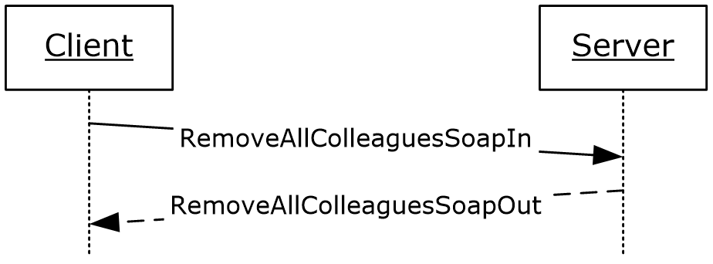
Figure 31: RemoveAllColleagues operation

Messages
The following WSDL message definitions are specific to this operation.

RemoveAllColleaguesSoapIn
The RemoveAllColleaguesSoapIn message is the request WSDL message for the RemoveAllColleagues WSDL operation.
The SOAP action value of the message is defined as:
http://microsoft.com/webservices/SharePointPortalServer/UserProfileService/RemoveAllColleagues
The SOAP body contains a RemoveAllColleagues element.

RemoveAllColleaguesSoapOut
The RemoveAllColleaguesSoapOut message is the response WSDL message for the RemoveAllColleagues WSDL operation.
The SOAP body contains a RemoveAllColleaguesResponse element.

Elements
The following XML schema element definitions are specific to this operation.

RemoveAllColleagues
The RemoveAllColleagues element is the body of the request WSDL message for the RemoveAllColleagues WSDL operation.
<s:element name="RemoveAllColleagues">
<s:complexType>
<s:sequence>
<s:element name="accountName" type="s:string" minOccurs="0" maxOccurs="1"/>
</s:sequence>
</s:complexType>
</s:element>
accountName: A string that specifies the login name of the user profile to be updated. This value MUST be less than or equal to 400 characters in length. If this element is not specified or does not have a value, the protocol server MUST use the user profile of the current user, and return a SOAP fault message if the current user does not have a user profile. The protocol server MUST treat accountName in a case insensitive manner for retrieval of the user profile.
If accountName does not correspond to an existing user profile, the protocol server MUST send a SOAP fault message.

RemoveAllColleaguesResponse
The RemoveAllColleaguesResponse element is the body of the response WSDL message for the RemoveAllColleagues WSDL operation.
<s:element name="RemoveAllColleaguesResponse">
<s:complexType/>
</s:element>

RemoveAllLinks
The RemoveAllLinks WSDL operation is used to update the specified user profile by deleting all quick link properties present in the user profile of the specified user.
<wsdl:operation name="RemoveAllLinks">
<wsdl:input message="tns:RemoveAllLinksSoapIn"/>
<wsdl:output message="tns:RemoveAllLinksSoapOut"/>
</wsdl:operation>
The protocol client sends a RemoveAllLinksSoapIn request WSDL message and the protocol server responds with a RemoveAllLinksSoapOut response WSDL message.
If the user is not authorized to administer the user profile service and is not updating his or her own user profile, the protocol server MUST send a SOAP fault message.
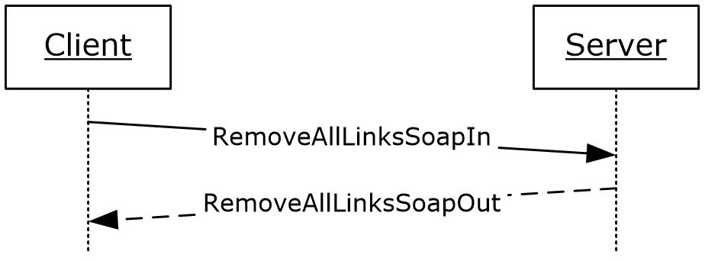
Figure 32: RemoveAllLinks operation

Messages
The following WSDL message definitions are specific to this operation.

RemoveAllLinksSoapIn
The RemoveAllLinksSoapIn message is the request WSDL message for the RemoveAllLinks WSDL operation.
The SOAP action value of the message is defined as:
http://microsoft.com/webservices/SharePointPortalServer/UserProfileService/RemoveAllLinks
The SOAP body contains a RemoveAllLinks element.

RemoveAllLinksSoapOut
The RemoveAllLinksSoapOut message is the response WSDL message for the RemoveAllLinks WSDL operation.
The SOAP body contains a RemoveAllLinksResponse element.

Elements
The following XML schema element definitions are specific to this operation.

RemoveAllLinks
The RemoveAllLinks element is the body of the request WSDL message for the RemoveAllLinks WSDL operation.
<s:element name="RemoveAllLinks">
<s:complexType>
<s:sequence>
<s:element name="accountName" type="s:string" minOccurs="0" maxOccurs="1"/>
</s:sequence>
</s:complexType>
</s:element>
accountName: A string that specifies the login name of the user profile to be updated. This value MUST be less than or equal to 400 characters in length. If this element is not specified or does not have a value, the protocol server MUST use the user profile of the current user, and return a SOAP fault message if the current user does not have a user profile. The protocol server MUST treat accountName in a case insensitive manner for retrieval of the user profile.
If accountName does not correspond to an existing user profile, the protocol server MUST send a SOAP fault message.

RemoveAllLinksResponse
The RemoveAllLinksResponse element is the body of the response WSDL message for the RemoveAllLinks WSDL operation.
<s:element name="RemoveAllLinksResponse">
<s:complexType/>
</s:element>

RemoveAllMemberships
The RemoveAllMemberships WSDL operation is used to update the specified user profile by deleting all memberships present in the user profile.
<wsdl:operation name="RemoveAllMemberships">
<wsdl:input message="tns:RemoveAllMembershipsSoapIn"/>
<wsdl:output message="tns:RemoveAllMembershipsSoapOut"/>
</wsdl:operation>
The protocol client sends a RemoveAllMembershipsSoapIn request WSDL message and the protocol server responds with a RemoveAllMembershipsSoapOut response WSDL message.
If the user is not authorized to administer the user profile service, the protocol server MUST send a SOAP fault message.
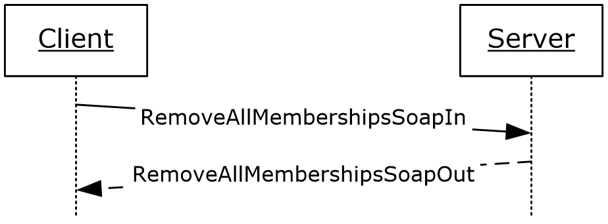
Figure 33: RemoveAllMemberships operation

Messages
The following WSDL message definitions are specific to this operation.

RemoveAllMembershipsSoapIn
The RemoveAllMembershipsSoapIn message is the request WSDL message for the RemoveAllMemberships WSDL operation.
The SOAP action value of the message is defined as:
http://microsoft.com/webservices/SharePointPortalServer/UserProfileService/RemoveAllMemberships
The SOAP body contains a RemoveAllMemberships element.

RemoveAllMembershipsSoapOut
The RemoveAllMembershipsSoapOut message is the response WSDL message for the RemoveAllMemberships WSDL operation.
The SOAP body contains a RemoveAllMembershipsResponse element.

Elements
The following XML schema element definitions are specific to this operation.

RemoveAllMemberships
The RemoveAllMemberships element is the body of the request WSDL message for the RemoveAllMemberships WSDL operation.
<s:element name="RemoveAllMemberships">
<s:complexType>
<s:sequence>
<s:element name="accountName" type="s:string" minOccurs="0" maxOccurs="1"/>
</s:sequence>
</s:complexType>
</s:element>
accountName: A string that specifies the login name of the user profile to be updated. This value MUST be less than or equal to 400 characters in length. If this element is not specified or does not have a value, the protocol server MUST use the user profile of the current user, and return a SOAP fault message if the current user does not have a user profile. The protocol server MUST treat accountName in a case insensitive manner for retrieval of the user profile.
If accountName does not correspond to an existing user profile, the protocol server MUST send a SOAP fault message. For memberships, only administrators or profile owner can add or delete items.

RemoveAllMembershipsResponse
The RemoveAllMembershipsResponse element is the body of the response WSDL message for the RemoveAllMemberships WSDL operation.
<s:element name="RemoveAllMembershipsResponse">
<s:complexType/>
</s:element>

RemoveAllPinnedLinks
The RemoveAllPinnedLinks WSDL operation is used to update the specified user profile by deleting all pinned link properties present in the user profile.
<wsdl:operation name="RemoveAllPinnedLinks">
<wsdl:input message="tns:RemoveAllPinnedLinksSoapIn"/>
<wsdl:output message="tns:RemoveAllPinnedLinksSoapOut"/>
</wsdl:operation>
The protocol client sends a RemoveAllPinnedLinksSoapIn request WSDL message and the protocol server responds with a RemoveAllPinnedLinksSoapOut response WSDL message.
If the user is not authorized to administer the user profile service and is not updating his or her own user profile, the protocol server MUST send a SOAP fault message.
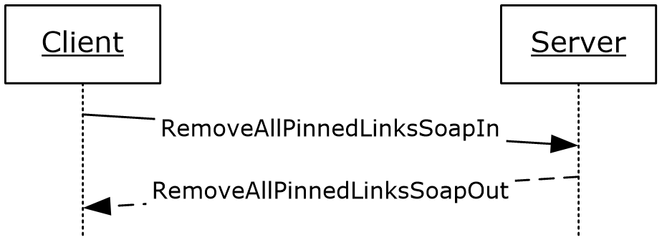
Figure 34: RemoveAllPinnedLinks operation

Messages
The following WSDL message definitions are specific to this operation.

RemoveAllPinnedLinksSoapIn
The RemoveAllPinnedLinksSoapIn message is the request WSDL message for the RemoveAllPinnedLinks WSDL operation.
The SOAP action value of the message is defined as:
http://microsoft.com/webservices/SharePointPortalServer/UserProfileService/RemoveAllPinnedLinks
The SOAP body contains a RemoveAllPinnedLinks element.

RemoveAllPinnedLinksSoapOut
The RemoveAllPinnedLinksSoapOut message is the response WSDL message for the RemoveAllPinnedLinks WSDL operation.
The SOAP body contains a RemoveAllPinnedLinksResponse element.

Elements
The following XML schema element definitions are specific to this operation.

RemoveAllPinnedLinks
The RemoveAllPinnedLinks element is the body of the request WSDL message for the RemoveAllPinnedLinks WSDL operation.
<s:element name="RemoveAllPinnedLinks">
<s:complexType>
<s:sequence>
<s:element name="accountName" type="s:string" minOccurs="0" maxOccurs="1"/>
</s:sequence>
</s:complexType>
</s:element>
accountName: A string that specifies the login name of the user profile to be updated. This value MUST be less than or equal to 400 characters in length. The protocol server MUST treat accountName in a case insensitive manner for retrieval of the user profile.
If accountName is not specified or does not have a value and there is not an existing user profile for the current user, then a new user profile MAY<14> be created which represents the current user and the protocol server MUST update that user profile.
If accountName is not specified or does not have a value and there is an existing user profile for the current user, then the protocol server MUST update that user profile.
If accountName is specified and does not match the login name of an existing user profile, then the protocol server MUST send a SOAP fault message.

RemoveAllPinnedLinksResponse
The RemoveAllPinnedLinksResponse element is the body of the response WSDL message for the RemoveAllPinnedLinks WSDL operation.
<s:element name="RemoveAllPinnedLinksResponse">
<s:complexType/>
</s:element>

RemoveColleague
The RemoveColleague WSDL operation is used to update the specified user profile by deleting a specified colleague property association currently present in the user profile.
The operation of removing a colleague is unidirectional, meaning that when a colleague of the specified user is removed, the user profile information of the colleague being removed is not changed.
<wsdl:operation name="RemoveColleague">
<wsdl:input message="tns:RemoveColleagueSoapIn"/>
<wsdl:output message="tns:RemoveColleagueSoapOut"/>
</wsdl:operation>
The protocol client sends a RemoveColleagueSoapIn request WSDL message and the protocol server responds with a RemoveColleagueSoapOut response WSDL message.
If the user is not authorized to administer the user profile service and is not updating his or her own user profile, the protocol server MUST send a SOAP fault message.
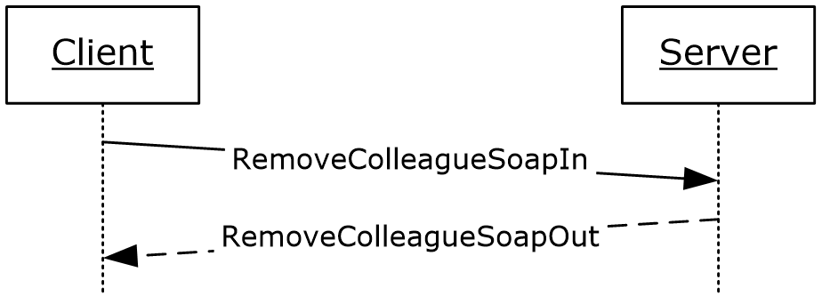
Figure 35: RemoveColleague operation

Messages
The following WSDL message definitions are specific to this operation.

RemoveColleagueSoapIn
The RemoveColleagueSoapIn message is the request WSDL message for the RemoveColleague WSDL operation.
The SOAP action value of the message is defined as:
http://microsoft.com/webservices/SharePointPortalServer/UserProfileService/RemoveColleague
The SOAP body contains a RemoveColleague element.

RemoveColleagueSoapOut
The RemoveColleagueSoapOut message is the response WSDL message for the RemoveColleague WSDL operation.
The SOAP body contains a RemoveColleagueResponse element.

Elements
The following XML schema element definitions are specific to this operation.

RemoveColleague
The RemoveColleague element is the body of the request WSDL message for the RemoveColleague WSDL operation.
<s:element name="RemoveColleague">
<s:complexType>
<s:sequence>
<s:element name="accountName" type="s:string" minOccurs="0" maxOccurs="1"/>
<s:element name="colleagueAccountName" type="s:string" minOccurs="0"
maxOccurs="1"/>
</s:sequence>
</s:complexType>
</s:element>
accountName: A string that specifies the login name of the user profile to be updated. This value MUST be less than or equal to 400 characters in length. If this element is not specified or does not have a value, the protocol server MUST use the user profile of the current user, and return a SOAP fault message if the current user does not have a user profile. The protocol server MUST treat accountName in a case insensitive manner for retrieval of the user profile.
If accountName does not correspond to an existing user profile, the protocol server MUST send a SOAP fault message.
colleagueAccountName: A string that specifies the login name of the user profile of the colleague to be disassociated from the user profile specified in accountName. If this element does not have a value or is not specified, the protocol server MUST use the user profile of the current user. The protocol server MUST treat colleagueAccountName in a case insensitive manner for retrieval of the user profile.
If colleagueAccountName does not correspond to an existing user profile or the user profile specified by colleagueAccountName does not refer to a currently associated colleague, the protocol server MUST send a SOAP fault message.

RemoveColleagueResponse
The RemoveColleagueResponse element is the body of the response WSDL message for the RemoveColleague WSDL operation.
<s:element name="RemoveColleagueResponse">
<s:complexType/>
</s:element>

RemoveLink
The RemoveLink WSDL operation is used to update the specified user profile by deleting a specified quick link property present in the user profile.
<wsdl:operation name="RemoveLink">
<wsdl:input message="tns:RemoveLinkSoapIn"/>
<wsdl:output message="tns:RemoveLinkSoapOut"/>
</wsdl:operation>
The protocol client sends a RemoveLinkSoapIn request WSDL message and the protocol server responds with a RemoveLinkSoapOut response WSDL message.
If the user is not authorized to administer the user profile service and is not updating his or her own user profile, the protocol server MUST send a SOAP fault message.
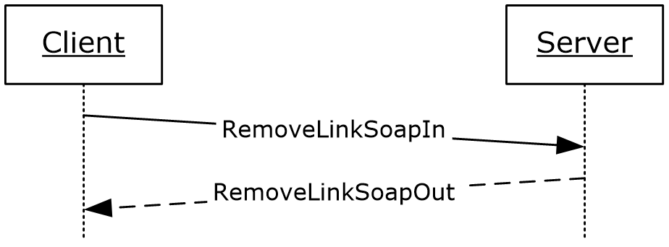
Figure 36: RemoveLink operation

Messages
The following WSDL message definitions are specific to this operation.

RemoveLinkSoapIn
The RemoveLinkSoapIn message is the request WSDL message for the RemoveLink WSDL operation.
The SOAP action value of the message is defined as:
http://microsoft.com/webservices/SharePointPortalServer/UserProfileService/RemoveLink
The SOAP body contains a RemoveLink element.

RemoveLinkSoapOut
The RemoveLinkSoapOut message is the response WSDL message for the RemoveLink WSDL operation.
The SOAP body contains a RemoveLinkResponse element.

Elements
The following XML schema element definitions are specific to this operation.

RemoveLink
The RemoveLink element is the body of the request WSDL message for the RemoveLink WSDL operation.
<s:element name="RemoveLink">
<s:complexType>
<s:sequence>
<s:element name="accountName" type="s:string" minOccurs="0" maxOccurs="1"/>
<s:element name="id" type="s:int" minOccurs="1" maxOccurs="1"/>
</s:sequence>
</s:complexType>
</s:element>
accountName: A string that specifies the login name of the user profile to be updated. This value MUST be less than or equal to 400 characters in length. If this element is not specified or does not have a value, the protocol server MUST use the user profile of the current user, and return a SOAP fault message if the current user does not have a user profile. The protocol server MUST treat accountName in a case insensitive manner for retrieval of the user profile.
If accountName does not correspond to an existing user profile, the protocol server MUST send a SOAP fault message.
id: An int that specifies the unique identifier of the quick link to be removed.
If this identifier does not refer to a quick link currently present in the user profile, the protocol server MUST send a SOAP fault message.

RemoveLinkResponse
The RemoveLinkResponse element is the body of the response WSDL message for the RemoveLink WSDL operation.
<s:element name="RemoveLinkResponse">
<s:complexType/>
</s:element>

RemoveMembership
The RemoveMembership WSDL operation is used to update the specified user profile by deleting a specified membership present in the user profile.
<wsdl:operation name="RemoveMembership">
<wsdl:input message="tns:RemoveMembershipSoapIn"/>
<wsdl:output message="tns:RemoveMembershipSoapOut"/>
</wsdl:operation>
The protocol client sends a RemoveMembershipSoapIn request WSDL message and the protocol server responds with a RemoveMembershipSoapOut response WSDL message.
If the user is not authorized to administer the user profile service, the protocol server MUST send a SOAP fault message.
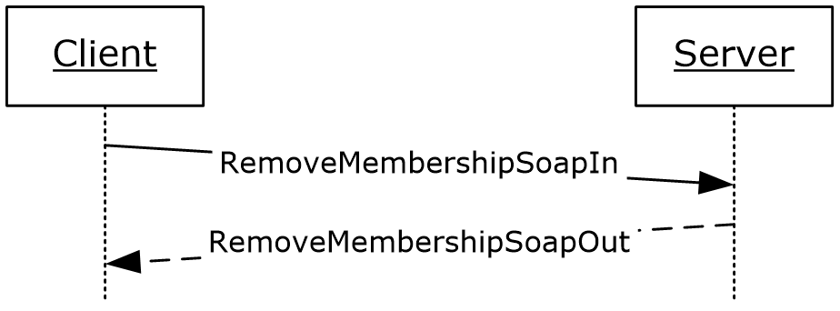
Figure 37: RemoveMembership operation

Messages
The following WSDL message definitions are specific to this operation.

RemoveMembershipSoapIn
The RemoveMembershipSoapIn message is the request WSDL message for the RemoveMembership WSDL operation.
The SOAP action value of the message is defined as:
http://microsoft.com/webservices/SharePointPortalServer/UserProfileService/RemoveMembership
The SOAP body contains a RemoveMembership element.

RemoveMembershipSoapOut
The RemoveMembershipSoapOut message is the response WSDL message for the RemoveMembership WSDL operation.
The SOAP body contains a RemoveMembershipResponse element.

Elements
The following XML schema element definitions are specific to this operation.

RemoveMembership
The RemoveMembership element is the body of the request WSDL message for the RemoveMembership WSDL operation.
<s:element name="RemoveMembership">
<s:complexType>
<s:sequence>
<s:element name="accountName" type="s:string" minOccurs="0" maxOccurs="1"/>
<s:element name="sourceInternal" type="s1:guid" minOccurs="1" maxOccurs="1"/>
<s:element name="sourceReference" type="s:string" minOccurs="0" maxOccurs="1"/>
</s:sequence>
</s:complexType>
</s:element>
accountName: A string that specifies the login name of the user profile to be updated. This value MUST be less than or equal to 400 characters in length. If this element is not specified or does not have a value, the protocol server MUST use the user profile of the current user, and return a SOAP fault message if the current user does not have a user profile. The protocol server MUST treat accountName in a case insensitive manner for retrieval of the user profile.
If accountName does not correspond to an existing user profile, the protocol server MUST send a SOAP fault message.
sourceInternal: A guid type that specifies the original source of members for the member group. The GUID MUST be one of the following values:

Value | Description
A88B9DCB-5B82-41E4-8A19-17672F307B95 | The member group was originally populated from a distribution list.
8BB1220F-DE8B-4771-AC3A-0551242CF2BD | The member group was originally populated from a site.

sourceReference: A string that uniquely identifies the member group to be removed.
If there is not an existing membership with the same sourceInternal and sourceReference values in the user profile specified by accountName, the protocol server MUST send a SOAP fault message.

RemoveMembershipResponse
The RemoveMembershipResponse element is the body of the response WSDL message for the RemoveMembership WSDL operation.
<s:element name="RemoveMembershipResponse">
<s:complexType/>
</s:element>

RemovePinnedLink
The RemovePinnedLink WSDL operation is used to update the specified user profile by deleting a specified pinned link present in the user profile.
<wsdl:operation name="RemovePinnedLink">
<wsdl:input message="tns:RemovePinnedLinkSoapIn"/>
<wsdl:output message="tns:RemovePinnedLinkSoapOut"/>
</wsdl:operation>
The protocol client sends a RemovePinnedLinkSoapIn request WSDL message and the protocol server responds with a RemovePinnedLinkSoapOut response WSDL message.
If the user is not authorized to administer the user profile service and is not updating his or her own user profile, the protocol server MUST send a SOAP fault message.
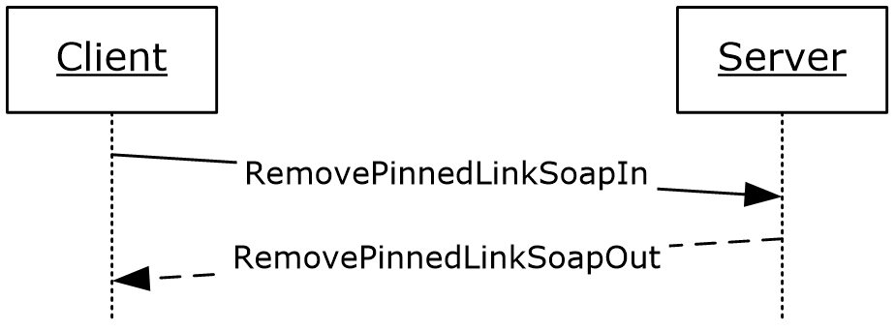
Figure 38: RemovePinnedLink operation

Messages
The following WSDL message definitions are specific to this operation.

RemovePinnedLinkSoapIn
The RemovePinnedLinkSoapIn message is the request WSDL message for the RemovePinnedLink WSDL operation.
The SOAP action value of the message is defined as:
http://microsoft.com/webservices/SharePointPortalServer/UserProfileService/RemovePinnedLink
The SOAP body contains a RemovePinnedLink element.

RemovePinnedLinkSoapOut
The RemovePinnedLinkSoapOut message is the response WSDL message for the RemovePinnedLink WSDL operation.
The SOAP body contains a RemovePinnedLinkResponse element.

Elements
The following XML schema element definitions are specific to this operation.

RemovePinnedLink
The RemovePinnedLink element is the body of the request WSDL message for the RemovePinnedLink WSDL operation.
<s:element name="RemovePinnedLink">
<s:complexType>
<s:sequence>
<s:element name="accountName" type="s:string" minOccurs="0" maxOccurs="1"/>
<s:element name="id" type="s:int" minOccurs="1" maxOccurs="1"/>
</s:sequence>
</s:complexType>
</s:element>
accountName: A string that specifies the login name of the user profile to be updated. This value MUST be less than or equal to 400 characters in length. The protocol server MUST treat accountName in a case insensitive manner for retrieval of the user profile.
If accountName is not specified or does not have a value and there is not an existing user profile for the current user, then a new user profile MAY<15> be created which represents the current user and the protocol server MUST send a SOAP fault message.
If accountName is not specified or does not have a value and there is an existing user profile for the current user, then the protocol server MUST update that user profile.
If accountName is specified and does not match the login name of an existing user profile, the protocol server MUST send a SOAP fault message.
id: An int that specifies the unique identifier for the pinned link to be removed.
If id does not refer to a pinned link currently present in the user profile, the protocol server MUST send a SOAP fault message.

RemovePinnedLinkResponse
The RemovePinnedLinkResponse element is the body of the response WSDL message for the RemovePinnedLink WSDL operation.
<s:element name="RemovePinnedLinkResponse">
<s:complexType/>
</s:element>

UpdateColleaguePrivacy
The UpdateColleaguePrivacy WSDL operation is used to update the specified user profile by updating the privacy level of a colleague association.
<wsdl:operation name="UpdateColleaguePrivacy">
<wsdl:input message="tns:UpdateColleaguePrivacySoapIn"/>
<wsdl:output message="tns:UpdateColleaguePrivacySoapOut"/>
</wsdl:operation>
The protocol client sends an UpdateColleaguePrivacySoapIn request WSDL message and the protocol server responds with an UpdateColleaguePrivacySoapOut response WSDL message.
If the current user is not authorized to administer the user profile service or is not updating his or her own user profile, the protocol server MUST send a SOAP fault message.
Additionally, if the user does not have the Use Personalization Features permission, the protocol server MUST send a SOAP fault message.
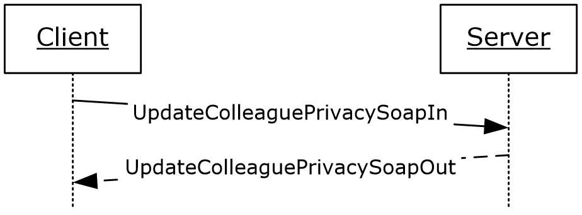
Figure 39: UpdateColleaguePrivacy operation

Messages
The following WSDL message definitions are specific to this operation.

UpdateColleaguePrivacySoapIn
The UpdateColleaguePrivacySoapIn message is the request WSDL message for the UpdateColleaguePrivacy WSDL operation.
The SOAP action value of the message is defined as:
http://microsoft.com/webservices/SharePointPortalServer/UserProfileService/UpdateColleaguePrivacy
The SOAP body contains an UpdateColleaguePrivacy element.

UpdateColleaguePrivacySoapOut
The UpdateColleaguePrivacySoapOut message is the response WSDL message for the UpdateColleaguePrivacy WSDL operation.
The SOAP body contains an UpdateColleaguePrivacyResponse element.

Elements
The following XML schema element definitions are specific to this operation.

UpdateColleaguePrivacy
The UpdateColleaguePrivacy element is the body of the request WSDL message for the UpdateColleaguePrivacy WSDL operation.
<s:element name="UpdateColleaguePrivacy">
<s:complexType>
<s:sequence>
<s:element minOccurs="0" maxOccurs="1" name="accountName" type="s:string" />
<s:element minOccurs="0" maxOccurs="1" name="colleagueAccountName" type="s:string" />
<s:element minOccurs="1" maxOccurs="1" name="newPrivacy" type="tns:Privacy" />
</s:sequence>
</s:complexType>
</s:element>
accountName: A string that specifies the login name of the user profile to be updated. This value MUST be less than or equal to 400 characters in length. The protocol server MUST treat accountName in a case insensitive manner for retrieval of the user profile.
If accountName is not specified or does not have a value and there is not an existing user profile for the current user, then a new user profile MAY<16> be created which represents the current user and the protocol server MUST update that user profile.
If accountName is not specified or does not have a value and there is an existing user profile for the current user, then the protocol server MUST update that user profile.
If accountName is specified and does not match the login name of an existing user profile, then the protocol server MUST send a SOAP fault message.
colleagueAccountName: A string that specifies the login name of the user profile of the colleague to be updated. This string MUST be less than or equal to 400 characters in length. If this element is not specified or does not have a value, the protocol server MUST use the user profile of the current user. The user specified by colleagueAccountName MUST NOT be the same as the user specified by accountName; otherwise the protocol server MUST send a SOAP fault message. The protocol server MUST treat colleagueAccountName in a case insensitive manner for retrieval of the user profile.
If colleagueAccountName is not specified or does not have a value and there is not an existing user profile for the current user, then a new user profile MUST be created which represents the current user and the protocol server MUST send a SOAP fault message.
If colleagueAccountName is not specified or does not have a value and there is an existing user profile for the current user, then the protocol server MUST send a SOAP fault message.
If colleagueAccountName is specified and does not match the login name of an existing user profile, then the protocol server MUST send a SOAP fault message.
If colleagueAccountName is specified and does match the login name of an existing user profile but that user profile is not a colleague of the user with the user profile specified by accountName, the protocol server MUST send a SOAP fault message.
newPrivacy: A value that MUST correspond to a value in the Privacy (section 2.2.5.4) enumeration. If the current privacy level is not set to NotSet, this value MUST NOT be set to NotSet. If this value is set to "NotSet" when the current privacy level is not set to NotSet the server MUST return a SOAP fault message. This is the updated privacy level that will be assigned to the specified colleague relationship.

UpdateColleaguePrivacyResponse
The UpdateColleaguePrivacyResponse element is the body of the response WSDL message for the UpdateColleaguePrivacy WSDL operation.
<s:element name="UpdateColleaguePrivacyResponse">
<s:complexType/>
</s:element>

UpdateLink
The UpdateLink WSDL operation is used to update a quick link for the specified user.
<wsdl:operation name="UpdateLink">
<wsdl:input message="tns:UpdateLinkSoapIn"/>
<wsdl:output message="tns:UpdateLinkSoapOut"/>
</wsdl:operation>
The protocol client sends an UpdateLinkSoapIn request WSDL message and the protocol server responds with an UpdateLinkSoapOut response WSDL message.
If the user is not authorized to administer the user profile service and is not updating his or her own user profile, the protocol server MUST send a SOAP fault message.
Additionally, if the user does not have the Use Personalization Features permission, the protocol server MUST send a SOAP fault message.
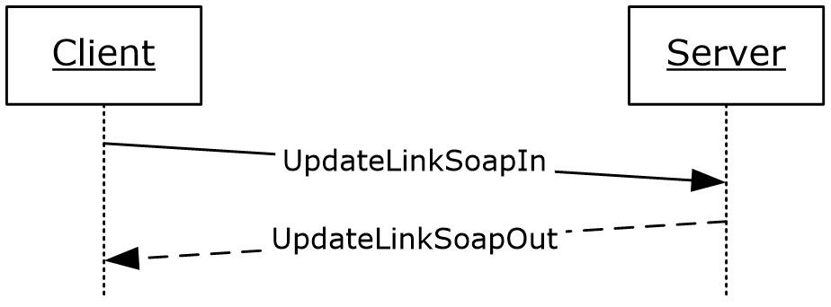
Figure 40: UpdateLink operation

Messages
The following WSDL message definitions are specific to this operation.

UpdateLinkSoapIn
The UpdateLinkSoapIn message is the request WSDL message for the UpdateLink WSDL operation.
The SOAP action value of the message is defined as:
http://microsoft.com/webservices/SharePointPortalServer/UserProfileService/UpdateLink
The SOAP body contains an UpdateLink element.

UpdateLinkSoapOut
The UpdateLinkSoapOut message is the response WSDL message for the UpdateLink WSDL operation.
The SOAP body contains an UpdateLinkResponse element.

Elements
The following XML schema element definitions are specific to this operation.

UpdateLink
The UpdateLink element is the body of the request WSDL message for the UpdateLink WSDL operation.
<s:element name="UpdateLink">
<s:complexType>
<s:sequence>
<s:element minOccurs="0" maxOccurs="1" name="accountName" type="s:string" />
<s:element minOccurs="0" maxOccurs="1" name="data" type="tns:QuickLinkData" />
</s:sequence>
</s:complexType>
</s:element>
accountName: A string that specifies the login name of the user profile to be updated. This value MUST be less than or equal to 400 characters in length. The protocol server MUST treat accountName in a case insensitive manner for retrieval of the user profile.
If accountName is not specified or does not have a value and there is not an existing user profile for the current user, then a new user profile MAY<17> be created which represents the user and the protocol server MUST update that user profile.
If accountName is not specified or does not have a value and there is an existing user profile for the current user, then the protocol server MUST update that user profile.
If accountName is specified and does not match the login name of an existing user profile, the protocol server MUST send a SOAP fault message.
data: The QuickLinkData (section 2.2.4.18) to be updated.
If the identifier of data does not match the identifier of an existing quick link, the protocol server MUST send a SOAP fault message.

UpdateLinkResponse
The UpdateLinkResponse element is the body of the response WSDL message for the UpdateLink WSDL operation.
<s:element name="UpdateLinkResponse">
<s:complexType/>
</s:element>

UpdateMembershipPrivacy
The UpdateMembershipPrivacy WSDL operation is used to update the specified user profile by updating the privacy level of a membership.
<wsdl:operation name="UpdateMembershipPrivacy">
<wsdl:input message="tns:UpdateMembershipPrivacySoapIn"/>
<wsdl:output message="tns:UpdateMembershipPrivacySoapOut"/>
</wsdl:operation>
The protocol client sends an UpdateMembershipPrivacySoapIn request WSDL message and the protocol server responds with an UpdateMembershipPrivacySoapOut response WSDL message.
If the current user is not authorized to administer the user profile service or is not updating his or her own user profile, the protocol server MUST send a SOAP fault message.
Additionally, if the user does not have the Use Personalization Features permission, the protocol server MUST send a SOAP fault message.
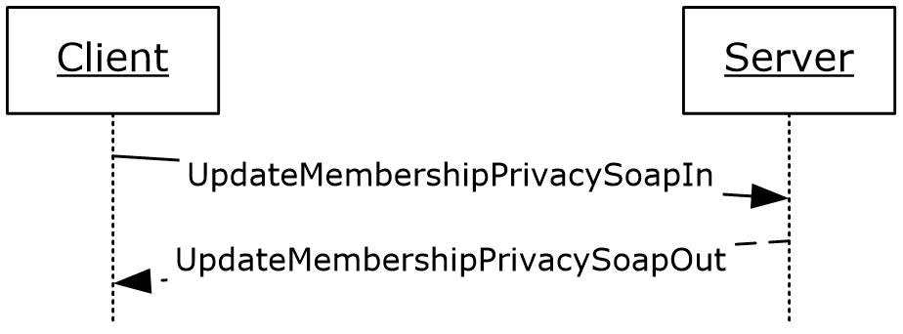
Figure 41: UpdateMembershipPrivacy operation

Messages
The following WSDL message definitions are specific to this operation.

UpdateMembershipPrivacySoapIn
The UpdateMembershipPrivacySoapIn message is the request WSDL message for the UpdateMembershipPrivacy WSDL operation.
The SOAP action value of the message is defined as:
http://microsoft.com/webservices/SharePointPortalServer/UserProfileService/UpdateMembershipPrivacy
The SOAP body contains an UpdateMembershipPrivacy element.

UpdateMembershipPrivacySoapOut
The UpdateMembershipPrivacySoapOut message is the response WSDL message for the UpdateMembershipPrivacy WSDL operation.
The SOAP body contains an UpdateMembershipPrivacyResponse element.

Elements
The following XML schema element definitions are specific to this operation.

UpdateMembershipPrivacy
The UpdateMembershipPrivacy element is the body of the request WSDL message for the UpdateMembershipPrivacy WSDL operation.
<s:element name="UpdateMembershipPrivacy">
<s:complexType>
<s:sequence>
<s:element minOccurs="0" maxOccurs="1" name="accountName" type="s:string" />
<s:element minOccurs="1" maxOccurs="1" name="sourceInternal" type="s1:guid" />
<s:element minOccurs="0" maxOccurs="1" name="sourceReference" type="s:string" />
<s:element minOccurs="1" maxOccurs="1" name="newPrivacy" type="tns:Privacy" />
</s:sequence>
</s:complexType>
</s:element>
accountName: A string that specifies the login name of the user profile to be updated. This value MUST be less than or equal to 400 characters in length. The protocol server MUST treat accountName in a case insensitive manner for retrieval of the user profile.
If accountName is not specified or does not have a value and there is not an existing user profile for the current user, then a new user profile MUST be created which represents the user and the protocol server MUST update that user profile.
If accountName is not specified or does not have a value and there is an existing user profile for the current user, then the protocol server MUST update that user profile.
If accountName is specified and does not match the login name of an existing user profile, the protocol server MUST send a SOAP fault message.
sourceInternal: A guid type that specifies the original source of members for the member group. The GUID MUST be one of the following values:

Value | Description
A88B9DCB-5B82-41E4-8A19-17672F307B95 | The member group was originally populated from a distribution list.
8BB1220F-DE8B-4771-AC3A-0551242CF2BD | The member group was originally populated from a SharePoint site.

sourceReference: A string that uniquely identifies the member group. This element is used to determine the specific membership to be updated.
If the specified sourceInternal and sourceReference values don't match an existing membership for the user specified by accountName, the protocol server MUST send a SOAP fault message.
If the member group does not exist, the server MUST return a SOAP fault message.
If the member group exists, but does not include the user specified by accountName, the server MUST return a SOAP fault message.
newPrivacy: A value that MUST correspond to a Privacy (section 2.2.5.4) enumeration. This value MUST NOT be NotSet. If this value is set to NotSet the server MUST return a SOAP fault message. This is the updated privacy level that will be assigned to the specified membership.

UpdateMembershipPrivacyResponse
The UpdateMembershipPrivacyResponse element is the body of the response WSDL message for the UpdateMembershipPrivacy WSDL operation.
<s:element name="UpdateMembershipPrivacyResponse">
<s:complexType/>
</s:element>

UpdatePinnedLink
The UpdatePinnedLink WSDL operation is used to update a pinned link for the specified user.
<wsdl:operation name="UpdatePinnedLink">
<wsdl:input message="tns:UpdatePinnedLinkSoapIn"/>
<wsdl:output message="tns:UpdatePinnedLinkSoapOut"/>
</wsdl:operation>
The protocol client sends an UpdatePinnedLinkSoapIn request WSDL message and the protocol server responds with an UpdatePinnedLinkSoapOut response WSDL message.
If the user is not authorized to administer the user profile service and is not updating his or her own user profile, the protocol server MUST send a SOAP fault message.
Additionally, if the user does not have the Use Personalization Features permission, the protocol server MUST send a SOAP fault message.
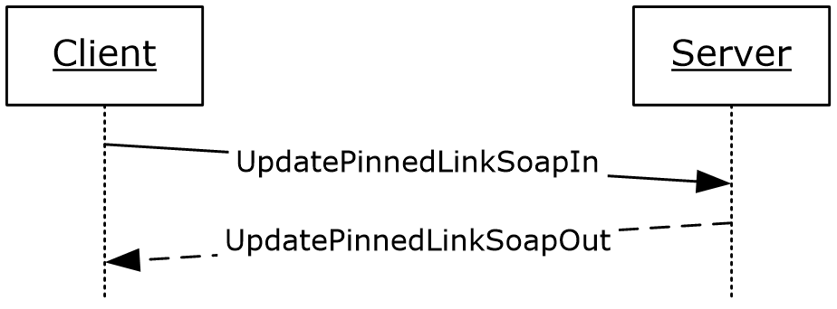
Figure 42: UpdatePinnedLink operation

Messages
The following WSDL message definitions are specific to this operation.

UpdatePinnedLinkSoapIn
The UpdatePinnedLinkSoapIn message is the request WSDL message for the UpdatePinnedLink WSDL operation.
The SOAP action value of the message is defined as:
http://microsoft.com/webservices/SharePointPortalServer/UserProfileService/UpdatePinnedLink
The SOAP body contains an UpdatePinnedLink element.

UpdatePinnedLinkSoapOut
The UpdatePinnedLinkSoapOut message is the response WSDL message for the UpdatePinnedLink WSDL operation.
The SOAP body contains an UpdatePinnedLinkResponse element.

Elements
The following XML schema element definitions are specific to this operation.

UpdatePinnedLink
The UpdatePinnedLink element is the body of the request WSDL message for the UpdatePinnedLink WSDL operation.
<s:element name="UpdatePinnedLink">
<s:complexType>
<s:sequence>
<s:element minOccurs="0" maxOccurs="1" name="accountName" type="s:string" />
<s:element minOccurs="0" maxOccurs="1" name="data" type="tns:PinnedLinkData" />
</s:sequence>
</s:complexType>
</s:element>
accountName: A string that specifies the login name of the user profile to be updated. This value MUST be less than or equal to 400 characters in length. The protocol server MUST treat accountName in a case insensitive manner for retrieval of the user profile.
If accountName is not specified or does not have a value and there is not an existing user profile for the current user, then a new user profile MUST be created which represents the user and the protocol server MUST update that user profile.
If accountName is not specified or does not have a value and there is an existing user profile for the current user, then the protocol server MUST update that user profile.
If accountName is specified and does not match the login name of an existing user profile, the protocol server MUST send a SOAP fault message.
data: The PinnedLinkData (section 2.2.4.15) to be updated.
If the identifier of data does not match the identifier of an existing pinned link, the protocol server MUST send a SOAP fault message.

UpdatePinnedLinkResponse
The UpdatePinnedLinkResponse element is the body of the response WSDL message for the UpdatePinnedLink WSDL operation.
<s:element name="UpdatePinnedLinkResponse">
<s:complexType/>
</s:element>

Timer Events
None.

Other Local Events
None.

Protocol Examples
The following sections show examples of protocol requests and responses for various scenarios around the user profile web service.

Create User Profile Example
This section demonstrates how to create a user profile using a known account name. The appropriate request is demonstrated and the expected feedback is also shown.

Create the Profile
This protocol can be used to create user profiles. The protocol client calls CreateUserProfileByAccountName with the name of a specified user. CreateUserProfileByAccountName will return a set of the properties it created with the default values.

Request
The following request message is constructed:
<?xml version="1.0" encoding="utf-8"?>
<soap:Envelope
xmlns:xsi="http://www.w3.org/2001/XMLSchema-instance"
xmlns:xsd="http://www.w3.org/2001/XMLSchema"
xmlns:soap="http://schemas.xmlsoap.org/soap/envelope/">
<soap:Body>

<CreateUserProfileByAccountName
xmlns="http://microsoft.com/webservices/SharePointPortalServer/UserProfileService">
<accountName>Contoso\Weber</accountName>
</CreateUserProfileByAccountName>

</soap:Body>
</soap:Envelope>

Response
Assuming there are only two properties defined for a user profile, Name and Address, the following response message is returned:
<?xml version="1.0" encoding="utf-8"?>
<soap:Envelope xmlns:xsi="http://www.w3.org/2001/XMLSchema-instance" xmlns:xsd="http://www.w3.org/2001/XMLSchema" xmlns:soap="http://schemas.xmlsoap.org/soap/envelope/">
<soap:Body>
<CreateUserProfileByAccountNameResponse xmlns="http://microsoft.com/webservices/SharePointPortalServer/UserProfileService">
<CreateUserProfileByAccountNameResult>
<PropertyData>
<IsPrivacyChanged>False</IsPrivacyChanged>
<IsValueChanged>False</IsValueChanged>
<Name>Name</Name>
<Privacy>NotSet</Privacy>
<Values>
<ValueData>
<Value xsi:type="xsd:string">Martin Weber</Value>
</ValueData>
</Values>
</PropertyData>
<PropertyData>
<IsPrivacyChanged>False</IsPrivacyChanged>
<IsValueChanged>False</IsValueChanged>
<Name>Address</Name>
<Privacy>NotSet</Privacy>
<Values>
<ValueData>
<Value xsi:type="xsd:string"></Value>
</ValueData>
</Values>
</PropertyData>
</CreateUserProfileByAccountNameResult>
</CreateUserProfileByAccountNameResponse>
</soap:Body>
</soap:Envelope>

Commonalities Example
This example demonstrates how to separately determine the common manager, common memberships and common colleagues between two valid user accounts. Then the example will show how to use the GetInCommon method to determine all three commonalities at once.

GetCommonManager
The protocol client can retrieve the common manager between two users. The GetCommonManager WSDL operation will retrieve the common manager of the current user and a specified user.

Request
The following request message is constructed:
<?xml version="1.0" encoding="utf-8"?>
<soap:Envelope xmlns:xsi="http://www.w3.org/2001/XMLSchema-instance" xmlns:xsd="http://www.w3.org/2001/XMLSchema" xmlns:soap="http://schemas.xmlsoap.org/soap/envelope/">
<soap:Body>
<GetCommonManager xmlns="http://microsoft.com/webservices/SharePointPortalServer/UserProfileService">
<accountName>Contoso\Weber</accountName>
</GetCommonManager>
</soap:Body>
</soap:Envelope>

Response
The protocol server returns the following response message:
<?xml version="1.0" encoding="utf-8"?>
<soap:Envelope xmlns:xsi="http://www.w3.org/2001/XMLSchema-instance" xmlns:xsd="http://www.w3.org/2001/XMLSchema" xmlns:soap="http://schemas.xmlsoap.org/soap/envelope/">
<soap:Body>
<GetCommonManagerResponse xmlns="http://microsoft.com/webservices/SharePointPortalServer/UserProfileService">
<GetCommonManagerResult>
<AccountName>Contoso\Corets</AccountName>
<Privacy>NotSet</Privacy>
<Name>Eva Corets</Name>
<IsInWorkGroup>false</IsInWorkGroup>
<Email>Eva@contoso.com</Email>
<Title>Manager</Title>
<Url>http://www.example.com/mysite/Person.aspx?accountname=Jane.Doe</Url>
<UserProfileID>25fa36d0-964e-48ea-8568-304bc1847f32</UserProfileID>
<ID>0</ID>
</GetCommonManagerResult>
</GetCommonManagerResponse>
</soap:Body>
</soap:Envelope>

GetCommonMemberships
The protocol client retrieves the common memberships between two users. The GetCommonMemberships WSDL operation retrieves the common memberships of the current user and a specified user. In this example, assume that the currently logged on user and Martin Weber both have the memberships "Some Group" and "Another Group".

Request
The following request message is constructed:
<?xml version="1.0" encoding="utf-8"?>
<soap:Envelope xmlns:xsi="http://www.w3.org/2001/XMLSchema-instance" xmlns:xsd="http://www.w3.org/2001/XMLSchema" xmlns:soap="http://schemas.xmlsoap.org/soap/envelope/">
<soap:Body>
<GetCommonMemberships xmlns="http://microsoft.com/webservices/SharePointPortalServer/UserProfileService">
<accountName>Contoso\Weber</accountName>
</GetCommonMemberships>
</soap:Body>
</soap:Envelope>

Response
The protocol server returns the following response message:
<?xml version="1.0" encoding="utf-8"?>
<soap:Envelope xmlns:xsi="http://www.w3.org/2001/XMLSchema-instance" xmlns:xsd="http://www.w3.org/2001/XMLSchema" xmlns:soap="http://schemas.xmlsoap.org/soap/envelope/">
<soap:Body>
<GetCommonMembershipsResponse xmlns="http://microsoft.com/webservices/SharePointPortalServer/UserProfileService">
<GetCommonMembershipsResult>
<MembershipData>
<Source>DistributionList</Source>
<MemberGroup>
<SourceInternal>25fa36d0-964e-48ea-8568-304bc1847f37</SourceInternal>
<SourceReference>string</SourceReference>
</MemberGroup>
<DisplayName>Some Group</DisplayName>
<Privacy>NotSet</Privacy>
<MailNickname>Some Group</MailNickname>
<Url>mailto:somegroup@contoso.com</Url>
<ID>1</ID>
<MemberGroupID>1</MemberGroupID>
</MembershipData>
<MembershipData>
<Source>DistributionList</Source>
<MemberGroup>
<SourceInternal>25fa36d0-964e-48ea-8568-304bc1847f33</SourceInternal>
<SourceReference>string</SourceReference>
</MemberGroup>
<DisplayName>Another Group</DisplayName>
<Privacy>Contacts</Privacy>
<MailNickname>Another Group</MailNickname>
<Url>mailto:anothergroup@contoso.com</Url>
<ID>4</ID>
<MemberGroupID>5</MemberGroupID>
</MembershipData>
</GetCommonMembershipsResult>
</GetCommonMembershipsResponse>
</soap:Body>
</soap:Envelope>

GetCommonColleagues
A protocol client retrieves the common colleagues between two users. The GetCommonColleagues WSDL operation will retrieve the common colleagues of the current user and a specified user. In this example assume the current user and Martin Weber are both colleagues with Cassie Hicks and John Glen."

Request
The following request message is constructed:
<?xml version="1.0" encoding="utf-8"?>
<soap:Envelope xmlns:xsi="http://www.w3.org/2001/XMLSchema-instance" xmlns:xsd="http://www.w3.org/2001/XMLSchema" xmlns:soap="http://schemas.xmlsoap.org/soap/envelope/">
<soap:Body>
<GetCommonColleagues xmlns="http://microsoft.com/webservices/SharePointPortalServer/UserProfileService">
<accountName>Contoso\Weber</accountName>
</GetCommonColleagues>
</soap:Body>
</soap:Envelope>

Response
The protocol server returns the following response message:
<?xml version="1.0" encoding="utf-8"?>
<soap:Envelope xmlns:xsi="http://www.w3.org/2001/XMLSchema-instance" xmlns:xsd="http://www.w3.org/2001/XMLSchema" xmlns:soap="http://schemas.xmlsoap.org/soap/envelope/">
<soap:Body>
<GetCommonColleaguesResponse xmlns="http://microsoft.com/webservices/SharePointPortalServer/UserProfileService">
<GetCommonColleaguesResult>
<ContactData>
<AccountName>Contoso\Hicks</AccountName>
<Privacy>NotSet</Privacy>
<Name>Cassie Hicks</Name>
<IsInWorkGroup>false</IsInWorkGroup>
<Email>Hicks@contoso.com</Email>
<Title>Developer</Title>
<Url>http://www.conotoso.com/mysite/Person.aspx?accountname=Contoso\Hicks</Url>
<UserProfileID>25fa36d0-964e-48ea-8568-304bc1847f39</UserProfileID>
<ID>0</ID>
</ContactData>
<ContactData>
<AccountName>Contoso\Glen</AccountName>
<Privacy>NotSet</Privacy>
<Name>John Glen</Name>
<IsInWorkGroup>false</IsInWorkGroup>
<Email>Glen@contoso.com</Email>
<Title>Tester</Title>
<Url>http://www.conotoso.com/mysite/Person.aspx?accountname=Contoso\Glen</Url>
<UserProfileID>25fa36d0-964e-48ea-8568-304bc1847f3a</UserProfileID>
<ID>0</ID>
</ContactData>
</GetCommonColleaguesResult>
</GetCommonColleaguesResponse>
</soap:Body>
</soap:Envelope>

GetInCommon
A protocol client retrieves the set of common manager, memberships and colleagues between the current user and another user. The protocol client could call the GetCommonManager, GetCommonMemberships, and GetCommonColleagues WSDL operations or it could call the GetInCommon WSDL operation to retrieve similar data for all three in the set at once.

Request
The following request message is constructed:
<?xml version="1.0" encoding="utf-8"?>
<soap:Envelope xmlns:xsi="http://www.w3.org/2001/XMLSchema-instance" xmlns:xsd="http://www.w3.org/2001/XMLSchema" xmlns:soap="http://schemas.xmlsoap.org/soap/envelope/">
<soap:Body>
<GetInCommon xmlns="http://microsoft.com/webservices/SharePointPortalServer/UserProfileService">
<accountName>Contoso\Weber</accountName>
</GetInCommon>
</soap:Body>
</soap:Envelope>

Response
The protocol server returns the following response message:
<?xml version="1.0" encoding="utf-8"?>
<soap:Envelope xmlns:xsi="http://www.w3.org/2001/XMLSchema-instance" xmlns:xsd="http://www.w3.org/2001/XMLSchema" xmlns:soap="http://schemas.xmlsoap.org/soap/envelope/">
<soap:Body>
<GetInCommonResponse xmlns="http://microsoft.com/webservices/SharePointPortalServer/UserProfileService">
<GetInCommonResult>
<Manager>
<AccountName>Contoso\Corets</AccountName>
<Privacy>NotSet</Privacy>
<Name>Eva Corets</Name>
<IsInWorkGroup>false</IsInWorkGroup>
<Email>Eva@contoso.com</Email>
<Title>Manager</Title>
<Url>http://www.conotoso.com/mysite/Person.aspx?accountname=Contoso\Corets</Url>
<UserProfileID>25fa36d0-964e-48ea-8568-304bc1847f32</UserProfileID>
<ID>0</ID>
</Manager>
<Colleagues>
<ContactData>
<AccountName>Contoso\Hicks</AccountName>
<Privacy>NotSet</Privacy>
<Name>Cassie Hicks</Name>
<IsInWorkGroup>false</IsInWorkGroup>
<Email>Hicks@contoso.com</Email>
<Title>Developer</Title>
<Url>http://www.conotoso.com/mysite/Person.aspx?accountname=Contoso\Hicks</Url>
<UserProfileID>25fa36d0-964e-48ea-8568-304bc1847f39</UserProfileID>
<ID>0</ID>
</ContactData>
<ContactData>
<AccountName>Contoso\Glen</AccountName>
<Privacy>NotSet</Privacy>
<Name>John Glen</Name>
<IsInWorkGroup>false</IsInWorkGroup>
<Email>Glen@contoso.com</Email>
<Title>Tester</Title>
<Url>http://www.conotoso.com/mysite/Person.aspx?accountname=Contoso\Glen</Url>
<UserProfileID>25fa36d0-964e-48ea-8568-304bc1847f3a</UserProfileID>
<ID>0</ID>
</ContactData>
</Colleagues>
<Memberships>
<MembershipData>
<Source>DistributionList</Source>
<MemberGroup>
<SourceInternal>25fa36d0-964e-48ea-8568-304bc1847f37</SourceInternal>
<SourceReference>string</SourceReference>
</MemberGroup>
<DisplayName>Some Group</DisplayName>
<Privacy>NotSet</Privacy>
<MailNickname>Some Group</MailNickname>
<Url>mailto:somegroup@contoso.com</Url>
<ID>1</ID>
<MemberGroupID>1</MemberGroupID>
</MembershipData>
<MembershipData>
<Source>DistributionList</Source>
<MemberGroup>
<SourceInternal>25fa36d0-964e-48ea-8568-304bc1847f33</SourceInternal>
<SourceReference>string</SourceReference>
</MemberGroup>
<DisplayName>Another Group</DisplayName>
<Privacy>Contacts</Privacy>
<MailNickname>Another Group</MailNickname>
<Url>mailto:anothergroup@contoso</Url>
<ID>4</ID>
<MemberGroupID>5</MemberGroupID>
</MembershipData>
</Memberships>
</GetInCommonResult>
</GetInCommonResponse>
</soap:Body>
</soap:Envelope>

GetUserProfile Example
This example demonstrates a common method for retrieving a user profile if the name of the user is known. The first step demonstrated is the use of the GetUserProfileSchema WSDL operation so that the client can understand the format of the profile. Second, the GetUserProfileByName WSDL operation is demonstrated. A request message for a single user profile is sent to the server, and then a GetUserProfileByNameResponse message, matching the schema retrieved is returned, which contain the user profile data. Error scenarios are not addressed.

Retrieve Profile Definition
A user profile is a set of properties that can change. For a protocol client to understand the information retrieved from the GetUserProfileByName WSDL operation, it first calls the GetUserProfileSchema WSDL operation.

Obtain the Schema
When a protocol client interacts with user profiles, it calls the GetUserProfileSchema WSDL operation to obtain a list of the various properties in the profile.

Request
The following request message is constructed:
<?xml version="1.0" encoding="utf-8"?>
<soap:Envelope xmlns:xsi="http://www.w3.org/2001/XMLSchema-instance" xmlns:xsd="http://www.w3.org/2001/XMLSchema" xmlns:soap="http://schemas.xmlsoap.org/soap/envelope/">
<soap:Body>
<GetUserProfileSchema xmlns="http://microsoft.com/webservices/SharePointPortalServer/UserProfileService" />
</soap:Body>
</soap:Envelope>

Response
Assume that there are only two properties defined for a user profile. The protocol server responds with the following response message:
<?xml version="1.0" encoding="utf-8"?>
<soap:Envelope xmlns:xsi="http://www.w3.org/2001/XMLSchema-instance" xmlns:xsd="http://www.w3.org/2001/XMLSchema" xmlns:soap="http://schemas.xmlsoap.org/soap/envelope/">
<soap:Body>
<GetUserProfileSchemaResponse xmlns="http://microsoft.com/webservices/SharePointPortalServer/UserProfileService">
<GetUserProfileSchemaResult>
<PropertyInfo>
<Name>Name</Name>
<DisplayOrder>1</DisplayOrder> <MaximumShown>1</MaximumShown>
<IsAdminEditable>True</IsAdminEditable> <IsSearchable>True</IsSearchable> <IsSystem>True</IsSystem>
<DisplayName>Name</DisplayName>
<Type>String</Type>
<AllowPolicyOverride>False</AllowPolicyOverride>
<DefaultPrivacy>NotSet</DefaultPrivacy>
<IsAlias>False</IsAlias>
<IsColleagueEventLog>False</IsColleagueEventLog>
<IsRequired>True</IsRequired>
<IsUserEditable>True</IsUserEditable>
<IsVisibleOnEditor>True</IsVisibleOnEditor>
<IsVisibleOnViewer>True</IsVisibleOnViewer>
<IsReplicable>True</IsReplicable>
<UserOverridePrivacy>False</UserOverridePrivacy>
<Length>400</Length>
<IsImported>True</IsImported>
<IsMultiValue>False</IsMultiValue>
<ChoiceType>None</ChoiceType> <TermSetId>FC2C18F4-832B-4b87-87C5-D0D60E9AEFD1</TermSetId>
</PropertyInfo>
<PropertyInfo>
<Name>Address</Name> <DisplayOrder>2</DisplayOrder> <MaximumShown>1</MaximumShown>
<IsAdminEditable>True</IsAdminEditable> <IsSearchable>True</IsSearchable> <IsSystem>True</IsSystem>
<DisplayName>User's Address</DisplayName>
<Type>String</Type>
<AllowPolicyOverride>False</AllowPolicyOverride>
<DefaultPrivacy>NotSet</DefaultPrivacy>
<IsAlias>False</IsAlias>
<IsColleagueEventLog>False</IsColleagueEventLog>
<IsRequired>True</IsRequired>
<IsUserEditable>True</IsUserEditable>
<IsVisibleOnEditor>True</IsVisibleOnEditor>
<IsVisibleOnViewer>True</IsVisibleOnViewer>
<IsReplicable>True</IsReplicable>
<UserOverridePrivacy>False</UserOverridePrivacy>
<Length>1000</Length>
<IsImported>True</IsImported>
<IsMultiValue>False</IsMultiValue>
<ChoiceType>None</ChoiceType> <TermSetId>FC60F505-297D-4d6a-B7BE-0EFF215F17C6</TermSetId>
</PropertyInfo>
</GetUserProfileSchemaResult>
</GetUserProfileSchemaResponse>
</soap:Body>
</soap:Envelope>

Obtain the Profile of the Specified User
Now that the schema is known, the protocol client can call the GetUserProfileByName WSDL operation for the user profile of Martin Weber.

Request
The following request message is constructed:
<?xml version="1.0" encoding="utf-8"?>
<soap:Envelope xmlns:xsi="http://www.w3.org/2001/XMLSchema-instance" xmlns:xsd="http://www.w3.org/2001/XMLSchema" xmlns:soap="http://schemas.xmlsoap.org/soap/envelope/">
<soap:Body>
<GetUserProfileByName xmlns="http://microsoft.com/webservices/SharePointPortalServer/UserProfileService">
<AccountName>Contoso\Weber</AccountName>
</GetUserProfileByName>
</soap:Body>
</soap:Envelope>

Response
The protocol server returns the following response message:
<?xml version="1.0" encoding="utf-8"?>
<soap:Envelope xmlns:xsi="http://www.w3.org/2001/XMLSchema-instance" xmlns:xsd="http://www.w3.org/2001/XMLSchema" xmlns:soap="http://schemas.xmlsoap.org/soap/envelope/">
<soap:Body>
<GetUserProfileByNameResponse xmlns="http://microsoft.com/webservices/SharePointPortalServer/UserProfileService">
<GetUserProfileByNameResult>
<PropertyData>
<IsPrivacyChanged>False</IsPrivacyChanged>
<IsValueChanged>False</IsValueChanged>
<Name>Name</Name>
<Privacy>NotSet</Privacy>
<Values>
<ValueData>
<Value xsi:type="xsd:string">Martin Weber</Value>
</ValueData>
</Values>
</PropertyData>
<PropertyData>
<IsPrivacyChanged>False</IsPrivacyChanged>
<IsValueChanged>False</IsValueChanged>
<Name>Address</Name>
<Privacy>NotSet</Privacy>
<Values>
<ValueData>
<Value xsi:type="xsd:string">100 Somewhere Street</Value>
</ValueData>
</Values>
</PropertyData>
</GetUserProfileByNameResult>
</GetUserProfileByNameResponse>
</soap:Body>
</soap:Envelope>

GetUserProfileByIndex Example
In this example, the mechanism for enumerating all user profiles using the GetUserProfileByIndex WSDL operation (section 3.1.4.23) is demonstrated. Two request messages for user profiles are made in sequential order starting with the first (index 0). The server then returns the first and then the second responses in the form of GetUserProfileByIndexResponse, which contain the user profile data.

Enumerate Users
To retrieve all of the user profiles in the system, the GetUserProfileByIndex WSDL operation can be used. The GetUserProfileByIndex WSDL operation will allow the protocol client to pass in the index of the user profile to obtain, and it will return information about that user profile and the index of the next user profile if such a user profile exists.

Obtain User Profiles
A protocol client calls the GetUserProfileByIndex WSDL operation with an index of zero to begin. The result will have a parameter called NextValue that will indicate the index of the next user profile or -1 if there are no more user profiles. In this manner a protocol client can enumerate all of the user profiles in the system.

Request
The following request message is for the first user profile:
<?xml version="1.0" encoding="utf-8"?>
<soap:Envelope xmlns:xsi="http://www.w3.org/2001/XMLSchema-instance" xmlns:xsd="http://www.w3.org/2001/XMLSchema" xmlns:soap="http://schemas.xmlsoap.org/soap/envelope/">
<soap:Body>
<GetUserProfileByIndex xmlns="http://microsoft.com/webservices/SharePointPortalServer/UserProfileService">
<index>0</index>
</GetUserProfileByIndex>
</soap:Body>
</soap:Envelope>
The following request message is for the next user profile (assuming there is more than one user profile):
<?xml version="1.0" encoding="utf-8"?>
<soap:Envelope xmlns:xsi="http://www.w3.org/2001/XMLSchema-instance" xmlns:xsd="http://www.w3.org/2001/XMLSchema" xmlns:soap="http://schemas.xmlsoap.org/soap/envelope/">
<soap:Body>
<GetUserProfileByIndex xmlns="http://microsoft.com/webservices/SharePointPortalServer/UserProfileService">
<index>1</index>
</GetUserProfileByIndex>
</soap:Body>
</soap:Envelope>

Response
The protocol server returns the following response message for the first user profile:
<?xml version="1.0" encoding="utf-8"?>
<soap:Envelope xmlns:xsi="http://www.w3.org/2001/XMLSchema-instance" xmlns:xsd="http://www.w3.org/2001/XMLSchema" xmlns:soap="http://schemas.xmlsoap.org/soap/envelope/">
<soap:Body>
<GetUserProfileByIndexResponse xmlns="http://microsoft.com/webservices/SharePointPortalServer/UserProfileService">
<GetUserProfileByIndexResult>
<NextValue>1</NextValue>
<UserProfile>
<PropertyData>
<IsPrivacyChanged>False</IsPrivacyChanged>
<IsValueChanged>False</IsValueChanged>
<Name>Name</Name>
<Privacy>NotSet</Privacy>
<Values>
<ValueData>
<Value xsi:type="xsd:string">Martin Weber</Value>
</ValueData>
</Values>
</PropertyData>
<PropertyData>
<IsPrivacyChanged>False</IsPrivacyChanged>
<IsValueChanged>False</IsValueChanged>
<Name>SomeOtherProperty</Name>
<Privacy>NotSet</Privacy>
<Values>
<ValueData>
<Value xsi:type="xsd:string">SomeOtherValue</Value>
</ValueData>
</Values>
</PropertyData>
</UserProfile>
<Colleagues>
<ContactData>
<AccountName>Contoso\Hicks</AccountName>
<Privacy>NotSet</Privacy>
<Name>Cassie Hicks</Name>
<IsInWorkGroup>false</IsInWorkGroup>
<Email>Kim@contoso.com</Email>
<Title>Developer</Title>
<Url></Url>
<UserProfileID>guid</UserProfileID>
<ID></ID>
</ContactData>
<ContactData>
<AccountName>Contoso\Glen</AccountName>
<Privacy>NotSet</Privacy>
<Name>John Glen</Name>
<IsInWorkGroup>false</IsInWorkGroup>
<Email>Glen@contoso.com</Email>
<Title>Tester</Title>
<Url></Url>
<UserProfileID>guid</UserProfileID>
<ID></ID>
</ContactData>
</Colleagues>
<QuickLinks>
<QuickLinkData>
<Name>A Person</Name>
<Group>A group</Group>
<Privacy>NotSet</Privacy>
<Url>http://contoso/APerson</Url>
<ID>1</ID>
</QuickLinkData>
<QuickLinkData>
<Name>Another Person</Name>
<Group>A group</Group>
<Privacy>NotSet</Privacy>
<Url>http://contoso/AnotherPerson</Url>
<ID>2</ID>
</QuickLinkData>
</QuickLinks>
<PinnedLinks>
<PinnedLinkData>
<Name>Some Person</Name>
<Url>http://contoso/SomePerson</Url>
<ID>3</ID>
</PinnedLinkData>
<PinnedLinkData>
<Name>Some Other Person</Name>
<Url>http://contoso/SomeOtherPerson</Url>
<ID>4</ID>
</PinnedLinkData>
</PinnedLinks>
<Memberships>
<MembershipData>
<Source>SharePointSite</Source>
<MemberGroup>
<SourceInternal>8BB1220F-DE8B-4771-AC3A-0551242CF2BD</SourceInternal>
<SourceReference>string</SourceReference>
</MemberGroup>
<Group>A group</Group>
<DisplayName>A group</DisplayName>
<Privacy>NotSet</Privacy>
<MailNickname>AGroup</MailNickname>
<Url></Url>
<ID>10</ID>
<MemberGroupID>1</MemberGroupID>
</MembershipData>
<MembershipData>
<Source>DistributionList</Source>
<MemberGroup>
<SourceInternal>A88B9DCB-5B82-41E4-8A19-17672F307B95</SourceInternal>
<SourceReference>string</SourceReference>
</MemberGroup>
<Group>Another group</Group>
<DisplayName>Another group</DisplayName>
<Privacy>NotSet</Privacy>
<MailNickname>AnotherGroup</MailNickname>
<Url></Url>
<ID>11</ID>
<MemberGroupID>1</MemberGroupID>
</MembershipData>
</Memberships>
</GetUserProfileByIndexResult>
</GetUserProfileByIndexResponse>
</soap:Body>
</soap:Envelope>
Taking note of the NextValue field in the response shown previously, it is not -1; thus, the second response message returned is for the second user profile:
<?xml version="1.0" encoding="utf-8"?>
<soap:Envelope xmlns:xsi="http://www.w3.org/2001/XMLSchema-instance" xmlns:xsd="http://www.w3.org/2001/XMLSchema" xmlns:soap="http://schemas.xmlsoap.org/soap/envelope/">
<soap:Body>
<GetUserProfileByIndexResponse xmlns="http://microsoft.com/webservices/SharePointPortalServer/UserProfileService">
<GetUserProfileByIndexResult>
<NextValue>3</NextValue>
<UserProfile>
<PropertyData>
<IsPrivacyChanged>False</IsPrivacyChanged>
<IsValueChanged>False</IsValueChanged>
<Name>Name2</Name>
<Privacy>NotSet</Privacy>
<Values>
<ValueData>
<Value xsi:type="xsd:string">Eva Corets</Value>
</ValueData>
</Values>
</PropertyData>
<PropertyData>
<IsPrivacyChanged>False</IsPrivacyChanged>
<IsValueChanged>False</IsValueChanged>
<Name>PropA</Name>
<Privacy>NotSet</Privacy>
<Values>
<ValueData>
<Value xsi:type="xsd:string">SomeOtherValue</Value>
</ValueData>
</Values>
</PropertyData>
</UserProfile>
<Colleagues>
<ContactData>
<AccountName>Contoso\Counts</AccountName>
<Privacy>NotSet</Privacy>
<Name>Robin Counts</Name>
<IsInWorkGroup>false</IsInWorkGroup>
<Email>Counts@contoso.com</Email>
<Title>Developer</Title>
<Url></Url>
<UserProfileID>2C3B6339-3352-47e3-8C91-1EF42934D68C</UserProfileID>
<ID></ID>
</ContactData>
</Colleagues>
<QuickLinks>
<QuickLinkData>
<Name>PersonABC</Name>
<Group>GroupABC</Group>
<Privacy>NotSet</Privacy>
<Url>http://contoso/PersonABC</Url>
<ID>1</ID>
</QuickLinkData>
<QuickLinkData>
<Name>Another Person</Name>
<Group>A group</Group>
<Privacy>NotSet</Privacy>
<Url>http://contoso/AnotherPerson</Url>
<ID>2</ID>
</QuickLinkData>
</QuickLinks>
<PinnedLinks>
<PinnedLinkData>
<Name>Person Somebody</Name>
<Url>http://contoso/PersonSomebody</Url>
<ID>3</ID>
</PinnedLinkData>
<PinnedLinkData>
<Name>Some Other Person</Name>
<Url>http://contoso/SomeOtherPerson</Url>
<ID>4</ID>
</PinnedLinkData>
</PinnedLinks>
<Memberships>
<MembershipData>
<Source>SharePointSite</Source>
<MemberGroup>
<SourceInternal>8BB1220F-DE8B-4771-AC3A-0551242CF2BD</SourceInternal>
<SourceReference>string</SourceReference>
</MemberGroup>
<Group>A group</Group>
<DisplayName>A group</DisplayName>
<Privacy>NotSet</Privacy>
<MailNickname>AGroup</MailNickname>
<Url></Url>
<ID>10</ID>
<MemberGroupID>1</MemberGroupID>
</MembershipData>
<MembershipData>
<Source>DistributionList</Source>
<MemberGroup>
<SourceInternal>A88B9DCB-5B82-41E4-8A19-17672F307B95</SourceInternal>
<SourceReference>string</SourceReference>
</MemberGroup>
<Group>Another group</Group>
<DisplayName>Another group</DisplayName>
<Privacy>NotSet</Privacy>
<MailNickname>AnotherGroup</MailNickname>
<Url></Url>
<ID>11</ID>
<MemberGroupID>1</MemberGroupID>
</MembershipData>
</Memberships>
</GetUserProfileByIndexResult>
</GetUserProfileByIndexResponse>
</soap:Body>
</soap:Envelope>

Memberships
This example shows how to synchronize the memberships of two users by copying memberships from the second to the first and deleting any on the first which the second does not have. The appropriate request messages and response messages are demonstrated.

Example Data
In these synchronization examples, the data begins organized in the following arrangement:
The user profile store contains two user profiles (P1, P2) representing two different directory accounts:
- P1 – Martin Weber
- P2 – Cassie Hicks
There are three member groups:
- MG1 – Marketing
- MG2 – Shipping
- MG3 – Content Management
The users have the following memberships:
- P1 – Martin Weber
  - MG1 - Marketing
  - MG3 - Content Management
  - MG4 - Sales
- P2 – Cassie Hicks
  - MG2 – Shipping
  - MG3 – Content Management

Synchronize Two Users
Assume that a site collection administrator requests to write a small application to copy memberships associated with one user to another user. The application will also remove any memberships that the second user does not have. For the data described previously , the application will copy P2's memberships to P1 using the following steps:
- Obtain memberships for both users.
- Add any memberships that exist in P2 to P1.
- Remove any memberships that exist in P1 that do not exist in P2.

Obtain Memberships
The GetUserMemberships WSDL operation will return a set of MembershipData items for the requested user. Assume that the user is authorized to administer the user profile service so that the calls complete successfully. To get the MembershipData set, the GetUserMemberships WSDL operation is called twice; once with the first user (P1 – Martin Weber) and again with the second user (P2 – Cassie Hicks).

Requests
The following request message for Martin Weber is constructed:
<?xml version="1.0" encoding="utf-8"?>
<soap:Envelope xmlns:xsi="http://www.w3.org/2001/XMLSchema-instance" xmlns:xsd="http://www.w3.org/2001/XMLSchema" xmlns:soap="http://schemas.xmlsoap.org/soap/envelope/">
<soap:Body>
<GetUserMemberships xmlns="http://microsoft.com/webservices/SharePointPortalServer/UserProfileService">
<accountName>Contoso\Weber</accountName>
</GetUserMemberships>
</soap:Body>
</soap:Envelope>
The following request for Cassie Hicks is constructed:
<?xml version="1.0" encoding="utf-8"?>
<soap:Envelope xmlns:xsi="http://www.w3.org/2001/XMLSchema-instance" xmlns:xsd="http://www.w3.org/2001/XMLSchema" xmlns:soap="http://schemas.xmlsoap.org/soap/envelope/">
<soap:Body>
<GetUserMemberships xmlns="http://microsoft.com/webservices/SharePointPortalServer/UserProfileService">
<accountName>Contoso\Hicks</accountName>
</GetUserMemberships>
</soap:Body>
</soap:Envelope>

Responses
The protocol server returns the following response for Martin Weber:
<?xml version="1.0" encoding="utf-8"?>
<soap:Envelope xmlns:xsi="http://www.w3.org/2001/XMLSchema-instance" xmlns:xsd="http://www.w3.org/2001/XMLSchema" xmlns:soap="http://schemas.xmlsoap.org/soap/envelope/">
<soap:Body>
<GetUserMembershipsResponse xmlns="http://microsoft.com/webservices/SharePointPortalServer/UserProfileService">
<GetUserMembershipsResult>
<MembershipData>
<Source>SharePointSite</Source>
<MemberGroup>
<SourceInternal>8BB1220F-DE8B-4771-AC3A-0551242CF2BD</SourceInternal>
<SourceReference>string</SourceReference>
</MemberGroup>
<Group>Marketing</Group>
<DisplayName>Marketing</DisplayName>
<Privacy>Public</Privacy>
<MailNickname>Marketing</MailNickname>
<Url></Url>
<ID>1</ID>
<MemberGroupID>1</MemberGroupID>
</MembershipData>
<MembershipData>
<Source> DistributionList</Source>
<MemberGroup>
<SourceInternal> A88B9DCB-5B82-41E4-8A19-17672F307B95</SourceInternal>
<SourceReference>string</SourceReference>
</MemberGroup>
<Group>Content Management</Group>
<DisplayName>Content Management</DisplayName>
<Privacy>Public</Privacy>
<MailNickname>Content Management</MailNickname>
<Url></Url>
<ID>2</ID>
<MemberGroupID>2</MemberGroupID>
</MembershipData>
</GetUserMembershipsResult>
</GetUserMembershipsResponse>
</soap:Body>
</soap:Envelope>
The protocol server returns the following response for Cassie Hicks:
<?xml version="1.0" encoding="utf-8"?>
<soap:Envelope xmlns:xsi="http://www.w3.org/2001/XMLSchema-instance" xmlns:xsd="http://www.w3.org/2001/XMLSchema" xmlns:soap="http://schemas.xmlsoap.org/soap/envelope/">
<soap:Body>
<GetUserMembershipsResponse xmlns="http://microsoft.com/webservices/SharePointPortalServer/UserProfileService">
<GetUserMembershipsResult>
<MembershipData>
<Source>SharePointSite</Source>
<MemberGroup>
<SourceInternal>8BB1220F-DE8B-4771-AC3A-0551242CF2BD</SourceInternal>
<SourceReference>string</SourceReference>
</MemberGroup>
<Group>Shipping</Group>
<DisplayName>Shipping</DisplayName>
<Privacy>Public</Privacy>
<MailNickname>Shipping</MailNickname>
<Url></Url>
<ID>3</ID>
<MemberGroupID>3</MemberGroupID>
</MembershipData>
<MembershipData>
<Source>DistributionList</Source>
<MemberGroup>
<SourceInternal>A88B9DCB-5B82-41E4-8A19-17672F307B95</SourceInternal>
<SourceReference>string</SourceReference>
</MemberGroup>
<Group>Content Management</Group>
<DisplayName>Content Management</DisplayName>
<Privacy>Public </Privacy>
<MailNickname>Content Management</MailNickname>
<Url></Url>
<ID>2</ID>
<MemberGroupID>2</MemberGroupID>
</MembershipData>
</GetUserMembershipsResult>
</GetUserMembershipsResponse>
</soap:Body>
</soap:Envelope>

Adding Memberships to P1 – Martin Weber
Now that the protocol client has two arrays of memberships, it can iterate through the second (P2 – Cassie Hicks) to find memberships that do not exist in P1 – Martin Weber. Once it finds a membership that does not exist, it calls the AddMembership WSDL operation. In this example, the protocol client will only find one such membership and thus call AddMembership only once: only MG2 – Shipping does not exist in P1's memberships. The AddMembership WSDL operation takes four parameters:
- accountName: Set to the name of P1 – Martin Weber, for this scenario.
- membershipInfo: Set to the MembershipData object acquired in section 4.5.2.1.2 by obtaining memberships.
- group: Set to the group defined on the MembershipData object that will be added.
- privacy: Set to the privacy level defined on the MembershipData object that will be added.
Note that the group and privacy parameters could be set to other values depending on the scenario.

Requests
The following request message is constructed:
<?xml version="1.0" encoding="utf-8"?>
<soap:Envelope xmlns:xsi="http://www.w3.org/2001/XMLSchema-instance" xmlns:xsd="http://www.w3.org/2001/XMLSchema" xmlns:soap="http://schemas.xmlsoap.org/soap/envelope/">
<soap:Body>
<AddMembership xmlns="http://microsoft.com/webservices/SharePointPortalServer/UserProfileService">
<accountName>Contoso\Weber</accountName>
<membershipInfo>
<Source>SharePointSite</Source>
<MemberGroup>
<SourceInternal>8BB1220F-DE8B-4771-AC3A-0551242CF2BD</SourceInternal>
<SourceReference>string</SourceReference>
</MemberGroup>
<Group>Shipping</Group>
<DisplayName>Shipping</DisplayName>
<Privacy>Public</Privacy>
<MailNickname>Shipping</MailNickname>
<Url>http://www.contoso.com/Shipping</Url>
<ID>3</ID>
<MemberGroupID>3</MemberGroupID>
</membershipInfo>
<group>Shipping</group>
<privacy>Public</privacy>
</AddMembership>
</soap:Body>
</soap:Envelope>

Responses
The protocol server returns the following response message:
<?xml version="1.0" encoding="utf-8"?>
<soap:Envelope xmlns:xsi="http://www.w3.org/2001/XMLSchema-instance" xmlns:xsd="http://www.w3.org/2001/XMLSchema" xmlns:soap="http://schemas.xmlsoap.org/soap/envelope/">
<soap:Body>
<AddMembershipResponse xmlns="http://microsoft.com/webservices/SharePointPortalServer/UserProfileService">
<AddMembershipResult>
<Source>SharePointSite</Source>
<MemberGroup>
<SourceInternal>8BB1220F-DE8B-4771-AC3A-0551242CF2BD</SourceInternal>
<SourceReference>string</SourceReference>
</MemberGroup>
<Group>Shipping</Group>
<DisplayName>Shipping</DisplayName>
<Privacy>Public</Privacy>
<MailNickname>Shipping</MailNickname>
<Url>http://www.contoso.com/Shipping</Url>
<ID>3</ID>
<MemberGroupID>3</MemberGroupID>
</AddMembershipResult>
</AddMembershipResponse>
</soap:Body>
</soap:Envelope>

Deleting Memberships from P1 – Martin Weber
With another simple iteration the application can determine that MG1 – Marketing and MG4 – Sales needs to be removed from P1- Martin Weber. To remove these memberships the application will call the RemoveMembership WSDL operation with the following parameters:
- accountName: Set to the account name, which is P1 – Martin Weber.
- sourceInternal: Set to the value obtained from the MemberGroupData (section 2.2.4.12) element which is part of the MembershipData (2.2.4.13) element.
- sourceReference: Set to the value obtained from the MemberGroupData element which is part of the MembershipData element.
When removing MG1 – Marketing, the application will call the RemoveMembership WSDL operation once with the data relevant to MG1 – Marketing.

Requests
The following request message is constructed:
<?xml version="1.0" encoding="utf-8"?>
<soap:Envelope xmlns:xsi="http://www.w3.org/2001/XMLSchema-instance" xmlns:xsd="http://www.w3.org/2001/XMLSchema" xmlns:soap="http://schemas.xmlsoap.org/soap/envelope/">
<soap:Body>
<RemoveMembership xmlns="http://microsoft.com/webservices/SharePointPortalServer/UserProfileService">
<accountName>Contoso\Weber</accountName>
<sourceInternal>8BB1220F-DE8B-4771-AC3A-0551242CF2BD</sourceInternal>
<sourceReference>Insert string here </sourceReference>
</RemoveMembership>
</soap:Body>
</soap:Envelope>

Responses
The protocol server returns the following response message:
<?xml version="1.0" encoding="utf-8"?>
<soap:Envelope xmlns:xsi="http://www.w3.org/2001/XMLSchema-instance" xmlns:xsd="http://www.w3.org/2001/XMLSchema" xmlns:soap="http://schemas.xmlsoap.org/soap/envelope/">
<soap:Body>
<RemoveMembershipResponse xmlns="http://microsoft.com/webservices/SharePointPortalServer/UserProfileService" />
</soap:Body>
</soap:Envelope>

Security

Security Considerations for Implementers
None.

Index of Security Parameters
None.

Appendix A: Full WSDL
For ease of implementation, the full WSDL is provided as follows.

<?xml version="1.0" encoding="utf-8" ?>
<wsdl:definitions xmlns:s="http://www.w3.org/2001/XMLSchema" xmlns:tns="http://microsoft.com/webservices/SharePointPortalServer/UserProfileService" xmlns:soap12="http://schemas.xmlsoap.org/wsdl/soap12/" xmlns:mime="http://schemas.xmlsoap.org/wsdl/mime/" xmlns:s1="http://microsoft.com/wsdl/types/" xmlns:soapenc="http://schemas.xmlsoap.org/soap/encoding/" xmlns:soap="http://schemas.xmlsoap.org/wsdl/soap/" xmlns:tm="http://microsoft.com/wsdl/mime/textMatching/" xmlns:http="http://schemas.xmlsoap.org/wsdl/http/" targetNamespace="http://microsoft.com/webservices/SharePointPortalServer/UserProfileService" xmlns:wsdl="http://schemas.xmlsoap.org/wsdl/">
<wsdl:documentation xmlns:wsdl="http://schemas.xmlsoap.org/wsdl/">User Profile Service</wsdl:documentation>
<wsdl:types>
<s:schema elementFormDefault="qualified" targetNamespace="http://microsoft.com/webservices/SharePointPortalServer/UserProfileService">
<s:import namespace="http://microsoft.com/wsdl/types/" />
<s:element name="GetUserProfileByIndex">
<s:complexType>
<s:sequence>
<s:element minOccurs="1" maxOccurs="1" name="index" type="s:int" />
</s:sequence>
</s:complexType>
</s:element>
<s:element name="GetUserProfileByIndexResponse">
<s:complexType>
<s:sequence>
<s:element minOccurs="0" maxOccurs="1" name="GetUserProfileByIndexResult" type="tns:GetUserProfileByIndexResult" />
</s:sequence>
</s:complexType>
</s:element>
<s:complexType name="GetUserProfileByIndexResult">
<s:sequence>
<s:element minOccurs="0" maxOccurs="1" name="NextValue" type="s:string" />
<s:element minOccurs="0" maxOccurs="1" name="UserProfile" type="tns:ArrayOfPropertyData" />
<s:element minOccurs="0" maxOccurs="1" name="Colleagues" type="tns:ArrayOfContactData" />
<s:element minOccurs="0" maxOccurs="1" name="QuickLinks" type="tns:ArrayOfQuickLinkData" />
<s:element minOccurs="0" maxOccurs="1" name="PinnedLinks" type="tns:ArrayOfPinnedLinkData" />
<s:element minOccurs="0" maxOccurs="1" name="Memberships" type="tns:ArrayOfMembershipData" />
</s:sequence>
</s:complexType>
<s:complexType name="ArrayOfPropertyData">
<s:sequence>
<s:element minOccurs="0" maxOccurs="unbounded" name="PropertyData" nillable="true" type="tns:PropertyData" />
</s:sequence>
</s:complexType>
<s:complexType name="PropertyData">
<s:sequence>
<s:element minOccurs="1" maxOccurs="1" name="IsPrivacyChanged" type="s:boolean" />
<s:element minOccurs="1" maxOccurs="1" name="IsValueChanged" type="s:boolean" />
<s:element minOccurs="0" maxOccurs="1" name="Name" type="s:string" />
<s:element minOccurs="1" maxOccurs="1" name="Privacy" type="tns:Privacy" />
<s:element minOccurs="0" maxOccurs="1" name="Values" type="tns:ArrayOfValueData" />
</s:sequence>
</s:complexType>
<s:simpleType name="Privacy">
<s:restriction base="s:string">
<s:enumeration value="Public" />
<s:enumeration value="Contacts" />
<s:enumeration value="Organization" />
<s:enumeration value="Manager" />
<s:enumeration value="Private" />
<s:enumeration value="NotSet" />
</s:restriction>
</s:simpleType>
<s:complexType name="ArrayOfValueData">
<s:sequence>
<s:element minOccurs="0" maxOccurs="unbounded" name="ValueData" nillable="true" type="tns:ValueData" />
</s:sequence>
</s:complexType>
<s:complexType name="ValueData">
<s:sequence>
<s:element minOccurs="0" maxOccurs="1" name="Value" type="s:string" />
</s:sequence>
</s:complexType>
<s:complexType name="ArrayOfContactData">
<s:sequence>
<s:element minOccurs="0" maxOccurs="unbounded" name="ContactData" nillable="true" type="tns:ContactData" />
</s:sequence>
</s:complexType>
<s:complexType name="ContactData">
<s:sequence>
<s:element minOccurs="0" maxOccurs="1" name="AccountName" type="s:string" />
<s:element minOccurs="1" maxOccurs="1" name="Privacy" type="tns:Privacy" />
<s:element minOccurs="0" maxOccurs="1" name="Name" type="s:string" />
<s:element minOccurs="1" maxOccurs="1" name="IsInWorkGroup" type="s:boolean" />
<s:element minOccurs="0" maxOccurs="1" name="Group" type="s:string" />
<s:element minOccurs="0" maxOccurs="1" name="Email" type="s:string" />
<s:element minOccurs="0" maxOccurs="1" name="Title" type="s:string" />
<s:element minOccurs="0" maxOccurs="1" name="Url" type="s:string" />
<s:element minOccurs="1" maxOccurs="1" name="UserProfileID" type="s1:guid" />
<s:element minOccurs="1" maxOccurs="1" name="ID" type="s:long" />
</s:sequence>
</s:complexType>
<s:complexType name="ArrayOfQuickLinkData">
<s:sequence>
<s:element minOccurs="0" maxOccurs="unbounded" name="QuickLinkData" nillable="true" type="tns:QuickLinkData" />
</s:sequence>
</s:complexType>
<s:complexType name="QuickLinkData">
<s:sequence>
<s:element minOccurs="0" maxOccurs="1" name="Name" type="s:string" />
<s:element minOccurs="0" maxOccurs="1" name="Group" type="s:string" />
<s:element minOccurs="1" maxOccurs="1" name="Privacy" type="tns:Privacy" />
<s:element minOccurs="0" maxOccurs="1" name="Url" type="s:string" />
<s:element minOccurs="1" maxOccurs="1" name="ID" type="s:long" />
</s:sequence>
</s:complexType>
<s:complexType name="ArrayOfPinnedLinkData">
<s:sequence>
<s:element minOccurs="0" maxOccurs="unbounded" name="PinnedLinkData" nillable="true" type="tns:PinnedLinkData" />
</s:sequence>
</s:complexType>
<s:complexType name="PinnedLinkData">
<s:sequence>
<s:element minOccurs="0" maxOccurs="1" name="Name" type="s:string" />
<s:element minOccurs="0" maxOccurs="1" name="Url" type="s:string" />
<s:element minOccurs="1" maxOccurs="1" name="ID" type="s:long" />
</s:sequence>
</s:complexType>
<s:complexType name="ArrayOfMembershipData">
<s:sequence>
<s:element minOccurs="0" maxOccurs="unbounded" name="MembershipData" nillable="true" type="tns:MembershipData" />
</s:sequence>
</s:complexType>
<s:complexType name="MembershipData">
<s:sequence>
<s:element minOccurs="1" maxOccurs="1" name="Source" type="tns:MembershipSource" />
<s:element minOccurs="0" maxOccurs="1" name="MemberGroup" type="tns:MemberGroupData" />
<s:element minOccurs="0" maxOccurs="1" name="Group" type="s:string" />
<s:element minOccurs="0" maxOccurs="1" name="DisplayName" type="s:string" />
<s:element minOccurs="1" maxOccurs="1" name="Privacy" type="tns:Privacy" />
<s:element minOccurs="0" maxOccurs="1" name="MailNickname" type="s:string" />
<s:element minOccurs="0" maxOccurs="1" name="Url" type="s:string" />
<s:element minOccurs="1" maxOccurs="1" name="ID" type="s:long" />
<s:element minOccurs="1" maxOccurs="1" name="MemberGroupID" type="s:long" />
</s:sequence>
</s:complexType>
<s:simpleType name="MembershipSource">
<s:restriction base="s:string">
<s:enumeration value="DistributionList" />
<s:enumeration value="SharePointSite" />
<s:enumeration value="Other" />
</s:restriction>
</s:simpleType>
<s:complexType name="MemberGroupData">
<s:sequence>
<s:element minOccurs="1" maxOccurs="1" name="SourceInternal" type="s1:guid" />
<s:element minOccurs="0" maxOccurs="1" name="SourceReference" type="s:string" />
</s:sequence>
</s:complexType>
<s:complexType name="SPTimeZone">
<s:sequence>
<s:element minOccurs="1" maxOccurs="1" name="ID" type="s:unsignedShort" />
</s:sequence>
</s:complexType>
<s:element name="CreateUserProfileByAccountName">
<s:complexType>
<s:sequence>
<s:element minOccurs="0" maxOccurs="1" name="accountName" type="s:string" />
</s:sequence>
</s:complexType>
</s:element>
<s:element name="CreateUserProfileByAccountNameResponse">
<s:complexType>
<s:sequence>
<s:element minOccurs="0" maxOccurs="1" name="CreateUserProfileByAccountNameResult" type="tns:ArrayOfPropertyData" />
</s:sequence>
</s:complexType>
</s:element>
<s:element name="GetUserProfileByName">
<s:complexType>
<s:sequence>
<s:element minOccurs="0" maxOccurs="1" name="accountName" type="s:string" />
</s:sequence>
</s:complexType>
</s:element>
<s:element name="GetUserProfileByNameResponse">
<s:complexType>
<s:sequence>
<s:element minOccurs="0" maxOccurs="1" name="GetUserProfileByNameResult" type="tns:ArrayOfPropertyData" />
</s:sequence>
</s:complexType>
</s:element>
<s:element name="GetUserProfileByGuid">
<s:complexType>
<s:sequence>
<s:element minOccurs="1" maxOccurs="1" name="guid" type="s1:guid" />
</s:sequence>
</s:complexType>
</s:element>
<s:element name="GetUserProfileByGuidResponse">
<s:complexType>
<s:sequence>
<s:element minOccurs="0" maxOccurs="1" name="GetUserProfileByGuidResult" type="tns:ArrayOfPropertyData" />
</s:sequence>
</s:complexType>
</s:element>
<s:element name="GetUserProfileSchema">
<s:complexType />
</s:element>
<s:complexType name="PropertyInfo">
<s:sequence>
<s:element minOccurs="0" maxOccurs="1" name="Name" type="s:string" />
<s:element minOccurs="0" maxOccurs="1" name="Description" type="s:string" />
<s:element minOccurs="0" maxOccurs="1" name="DisplayOrder" type="s:int" />
<s:element minOccurs="0" maxOccurs="1" name="MaximumShown" type="s:int" />
<s:element minOccurs="0" maxOccurs="1" name="IsAdminEditable" type="s:boolean" />
<s:element minOccurs="0" maxOccurs="1" name="IsSearchable" type="s:boolean" />
<s:element minOccurs="0" maxOccurs="1" name="IsSystem" type="s:boolean" />
<s:element minOccurs="0" maxOccurs="1" name="ManagedPropertyName" type="s:string" />
<s:element minOccurs="0" maxOccurs="1" name="DisplayName" type="s:string" />
<s:element minOccurs="0" maxOccurs="1" name="Type" type="s:string" />
<s:element minOccurs="1" maxOccurs="1" name="AllowPolicyOverride" type="s:boolean" />
<s:element minOccurs="1" maxOccurs="1" name="DefaultPrivacy" type="tns:Privacy" />
<s:element minOccurs="1" maxOccurs="1" name="IsAlias" type="s:boolean" />
<s:element minOccurs="1" maxOccurs="1" name="IsColleagueEventLog" type="s:boolean" />
<s:element minOccurs="1" maxOccurs="1" name="IsRequired" type="s:boolean" />
<s:element minOccurs="1" maxOccurs="1" name="IsUserEditable" type="s:boolean" />
<s:element minOccurs="1" maxOccurs="1" name="IsVisibleOnEditor" type="s:boolean" />
<s:element minOccurs="1" maxOccurs="1" name="IsVisibleOnViewer" type="s:boolean" />
<s:element minOccurs="1" maxOccurs="1" name="IsReplicable" type="s:boolean" />
<s:element minOccurs="1" maxOccurs="1" name="UserOverridePrivacy" type="s:boolean" />
<s:element minOccurs="1" maxOccurs="1" name="Length" type="s:int" />
<s:element minOccurs="1" maxOccurs="1" name="IsImported" type="s:boolean" />
<s:element minOccurs="1" maxOccurs="1" name="IsMultiValue" type="s:boolean" />
<s:element minOccurs="1" maxOccurs="1" name="ChoiceType" type="tns:ChoiceTypes" />
<s:element minOccurs="0" maxOccurs="1" name="TermSetId" nillable="true" type="s1:guid" />
</s:sequence>
</s:complexType>
<s:simpleType name="ChoiceTypes">
<s:restriction base="s:string">
<s:enumeration value="Off" />
<s:enumeration value="None" />
<s:enumeration value="Open" />
<s:enumeration value="Closed" />
</s:restriction>
</s:simpleType>
<s:complexType name="ArrayOfPropertyInfo">
<s:sequence>
<s:element minOccurs="0" maxOccurs="unbounded" name="PropertyInfo" nillable="true" type="tns:PropertyInfo" />
</s:sequence>
</s:complexType>
<s:element name="GetUserProfileSchemaResponse">
<s:complexType>
<s:sequence>
<s:element minOccurs="0" maxOccurs="1" name="GetUserProfileSchemaResult" type="tns:ArrayOfPropertyInfo" />
</s:sequence>
</s:complexType>
</s:element>
<s:element name="GetProfileSchemaNameByAccountName">
<s:complexType>
<s:sequence>
<s:element minOccurs="0" maxOccurs="1" name="accountName" type="s:string" />
</s:sequence>
</s:complexType>
</s:element>
<s:element name="GetProfileSchemaNameByAccountNameResponse">
<s:complexType>
<s:sequence>
<s:element minOccurs="0" maxOccurs="1" name="GetProfileSchemaNameByAccountNameResult" type="s:string" />
</s:sequence>
</s:complexType>
</s:element>
<s:element name="GetPropertyChoiceList">
<s:complexType>
<s:sequence>
<s:element minOccurs="0" maxOccurs="1" name="propertyName" type="s:string" />
</s:sequence>
</s:complexType>
</s:element>
<s:complexType name="ArrayOfString">
<s:sequence>
<s:element minOccurs="0" maxOccurs="unbounded" name="string" nillable="true" type="s:string" />
</s:sequence>
</s:complexType>
<s:element name="GetPropertyChoiceListResponse">
<s:complexType>
<s:sequence>
<s:element minOccurs="0" maxOccurs="1" name="GetPropertyChoiceListResult" type="tns:ArrayOfString" />
</s:sequence>
</s:complexType>
</s:element>
<s:element name="ModifyUserPropertyByAccountName">
<s:complexType>
<s:sequence>
<s:element minOccurs="0" maxOccurs="1" name="accountName" type="s:string" />
<s:element minOccurs="0" maxOccurs="1" name="newData" type="tns:ArrayOfPropertyData" />
</s:sequence>
</s:complexType>
</s:element>
<s:element name="ModifyUserPropertyByAccountNameResponse">
<s:complexType />
</s:element>
<s:element name="GetUserPropertyByAccountName">
<s:complexType>
<s:sequence>
<s:element minOccurs="0" maxOccurs="1" name="accountName" type="s:string" />
<s:element minOccurs="0" maxOccurs="1" name="propertyName" type="s:string" />
</s:sequence>
</s:complexType>
</s:element>
<s:element name="GetUserPropertyByAccountNameResponse">
<s:complexType>
<s:sequence>
<s:element minOccurs="0" maxOccurs="1" name="GetUserPropertyByAccountNameResult" type="tns:PropertyData" />
</s:sequence>
</s:complexType>
</s:element>
<s:element name="CreateMemberGroup">
<s:complexType>
<s:sequence>
<s:element minOccurs="0" maxOccurs="1" name="membershipInfo" type="tns:MembershipData" />
</s:sequence>
</s:complexType>
</s:element>
<s:element name="CreateMemberGroupResponse">
<s:complexType />
</s:element>
<s:element name="AddMembership">
<s:complexType>
<s:sequence>
<s:element minOccurs="0" maxOccurs="1" name="accountName" type="s:string" />
<s:element minOccurs="0" maxOccurs="1" name="membershipInfo" type="tns:MembershipData" />
<s:element minOccurs="0" maxOccurs="1" name="group" type="s:string" />
<s:element minOccurs="1" maxOccurs="1" name="privacy" type="tns:Privacy" />
</s:sequence>
</s:complexType>
</s:element>
<s:element name="AddMembershipResponse">
<s:complexType>
<s:sequence>
<s:element minOccurs="0" maxOccurs="1" name="AddMembershipResult" type="tns:MembershipData" />
</s:sequence>
</s:complexType>
</s:element>
<s:element name="RemoveMembership">
<s:complexType>
<s:sequence>
<s:element minOccurs="0" maxOccurs="1" name="accountName" type="s:string" />
<s:element minOccurs="1" maxOccurs="1" name="sourceInternal" type="s1:guid" />
<s:element minOccurs="0" maxOccurs="1" name="sourceReference" type="s:string" />
</s:sequence>
</s:complexType>
</s:element>
<s:element name="RemoveMembershipResponse">
<s:complexType />
</s:element>
<s:element name="UpdateMembershipPrivacy">
<s:complexType>
<s:sequence>
<s:element minOccurs="0" maxOccurs="1" name="accountName" type="s:string" />
<s:element minOccurs="1" maxOccurs="1" name="sourceInternal" type="s1:guid" />
<s:element minOccurs="0" maxOccurs="1" name="sourceReference" type="s:string" />
<s:element minOccurs="1" maxOccurs="1" name="newPrivacy" type="tns:Privacy" />
</s:sequence>
</s:complexType>
</s:element>
<s:element name="UpdateMembershipPrivacyResponse">
<s:complexType />
</s:element>
<s:element name="GetUserMemberships">
<s:complexType>
<s:sequence>
<s:element minOccurs="0" maxOccurs="1" name="accountName" type="s:string" />
</s:sequence>
</s:complexType>
</s:element>
<s:element name="GetUserMembershipsResponse">
<s:complexType>
<s:sequence>
<s:element minOccurs="0" maxOccurs="1" name="GetUserMembershipsResult" type="tns:ArrayOfMembershipData" />
</s:sequence>
</s:complexType>
</s:element>
<s:element name="GetUserOrganizations">
<s:complexType>
<s:sequence>
<s:element minOccurs="0" maxOccurs="1" name="accountName" type="s:string" />
</s:sequence>
</s:complexType>
</s:element>
<s:complexType name="OrganizationProfileData">
<s:sequence>
<s:element minOccurs="0" maxOccurs="1" name="DisplayName" type="s:string" />
<s:element minOccurs="1" maxOccurs="1" name="RecordID" type="s:long" />
</s:sequence>
</s:complexType>
<s:complexType name="ArrayOfOrganizationProfileData">
<s:sequence>
<s:element minOccurs="0" maxOccurs="unbounded" name="OrganizationProfileData" nillable="true" type="tns:OrganizationProfileData" />
</s:sequence>
</s:complexType>
<s:element name="GetUserOrganizationsResponse">
<s:complexType>
<s:sequence>
<s:element minOccurs="0" maxOccurs="1" name="GetUserOrganizationsResult" type="tns:ArrayOfOrganizationProfileData" />
</s:sequence>
</s:complexType>
</s:element>
<s:element name="GetUserColleagues">
<s:complexType>
<s:sequence>
<s:element minOccurs="0" maxOccurs="1" name="accountName" type="s:string" />
</s:sequence>
</s:complexType>
</s:element>
<s:element name="GetUserColleaguesResponse">
<s:complexType>
<s:sequence>
<s:element minOccurs="0" maxOccurs="1" name="GetUserColleaguesResult" type="tns:ArrayOfContactData" />
</s:sequence>
</s:complexType>
</s:element>
<s:element name="GetUserLinks">
<s:complexType>
<s:sequence>
<s:element minOccurs="0" maxOccurs="1" name="accountName" type="s:string" />
</s:sequence>
</s:complexType>
</s:element>
<s:element name="GetUserLinksResponse">
<s:complexType>
<s:sequence>
<s:element minOccurs="0" maxOccurs="1" name="GetUserLinksResult" type="tns:ArrayOfQuickLinkData" />
</s:sequence>
</s:complexType>
</s:element>
<s:element name="GetUserPinnedLinks">
<s:complexType>
<s:sequence>
<s:element minOccurs="0" maxOccurs="1" name="accountName" type="s:string" />
</s:sequence>
</s:complexType>
</s:element>
<s:element name="GetUserPinnedLinksResponse">
<s:complexType>
<s:sequence>
<s:element minOccurs="0" maxOccurs="1" name="GetUserPinnedLinksResult" type="tns:ArrayOfPinnedLinkData" />
</s:sequence>
</s:complexType>
</s:element>
<s:element name="GetInCommon">
<s:complexType>
<s:sequence>
<s:element minOccurs="0" maxOccurs="1" name="accountName" type="s:string" />
</s:sequence>
</s:complexType>
</s:element>
<s:complexType name="InCommonData">
<s:sequence>
<s:element minOccurs="0" maxOccurs="1" name="Manager" type="tns:ContactData" />
<s:element minOccurs="0" maxOccurs="1" name="Colleagues" type="tns:ArrayOfContactData" />
<s:element minOccurs="0" maxOccurs="1" name="Memberships" type="tns:ArrayOfMembershipData" />
</s:sequence>
</s:complexType>
<s:element name="GetInCommonResponse">
<s:complexType>
<s:sequence>
<s:element minOccurs="0" maxOccurs="1" name="GetInCommonResult" type="tns:InCommonData" />
</s:sequence>
</s:complexType>
</s:element>
<s:element name="GetCommonManager">
<s:complexType>
<s:sequence>
<s:element minOccurs="0" maxOccurs="1" name="accountName" type="s:string" />
</s:sequence>
</s:complexType>
</s:element>
<s:element name="GetCommonManagerResponse">
<s:complexType>
<s:sequence>
<s:element minOccurs="0" maxOccurs="1" name="GetCommonManagerResult" type="tns:ContactData" />
</s:sequence>
</s:complexType>
</s:element>
<s:element name="GetCommonColleagues">
<s:complexType>
<s:sequence>
<s:element minOccurs="0" maxOccurs="1" name="accountName" type="s:string" />
</s:sequence>
</s:complexType>
</s:element>
<s:element name="GetCommonColleaguesResponse">
<s:complexType>
<s:sequence>
<s:element minOccurs="0" maxOccurs="1" name="GetCommonColleaguesResult" type="tns:ArrayOfContactData" />
</s:sequence>
</s:complexType>
</s:element>
<s:element name="GetCommonMemberships">
<s:complexType>
<s:sequence>
<s:element minOccurs="0" maxOccurs="1" name="accountName" type="s:string" />
</s:sequence>
</s:complexType>
</s:element>
<s:element name="GetCommonMembershipsResponse">
<s:complexType>
<s:sequence>
<s:element minOccurs="0" maxOccurs="1" name="GetCommonMembershipsResult" type="tns:ArrayOfMembershipData" />
</s:sequence>
</s:complexType>
</s:element>
<s:element name="AddColleague">
<s:complexType>
<s:sequence>
<s:element minOccurs="0" maxOccurs="1" name="accountName" type="s:string" />
<s:element minOccurs="0" maxOccurs="1" name="colleagueAccountName" type="s:string" />
<s:element minOccurs="0" maxOccurs="1" name="group" type="s:string" />
<s:element minOccurs="1" maxOccurs="1" name="privacy" type="tns:Privacy" />
<s:element minOccurs="1" maxOccurs="1" name="isInWorkGroup" type="s:boolean" />
</s:sequence>
</s:complexType>
</s:element>
<s:element name="AddColleagueResponse">
<s:complexType>
<s:sequence>
<s:element minOccurs="0" maxOccurs="1" name="AddColleagueResult" type="tns:ContactData" />
</s:sequence>
</s:complexType>
</s:element>
<s:element name="AddColleagueWithoutEmailNotification">
<s:complexType>
<s:sequence>
<s:element minOccurs="0" maxOccurs="1" name="accountName" type="s:string" />
<s:element minOccurs="0" maxOccurs="1" name="colleagueAccountName" type="s:string" />
<s:element minOccurs="0" maxOccurs="1" name="group" type="s:string" />
<s:element minOccurs="1" maxOccurs="1" name="privacy" type="tns:Privacy" />
<s:element minOccurs="1" maxOccurs="1" name="isInWorkGroup" type="s:boolean" />
</s:sequence>
</s:complexType>
</s:element>
<s:element name="AddColleagueWithoutEmailNotificationResponse">
<s:complexType>
<s:sequence>
<s:element minOccurs="0" maxOccurs="1" name="AddColleagueWithoutEmailNotificationResult" type="tns:ContactData" />
</s:sequence>
</s:complexType>
</s:element>
<s:element name="RemoveColleague">
<s:complexType>
<s:sequence>
<s:element minOccurs="0" maxOccurs="1" name="accountName" type="s:string" />
<s:element minOccurs="0" maxOccurs="1" name="colleagueAccountName" type="s:string" />
</s:sequence>
</s:complexType>
</s:element>
<s:element name="RemoveColleagueResponse">
<s:complexType />
</s:element>
<s:element name="UpdateColleaguePrivacy">
<s:complexType>
<s:sequence>
<s:element minOccurs="0" maxOccurs="1" name="accountName" type="s:string" />
<s:element minOccurs="0" maxOccurs="1" name="colleagueAccountName" type="s:string" />
<s:element minOccurs="1" maxOccurs="1" name="newPrivacy" type="tns:Privacy" />
</s:sequence>
</s:complexType>
</s:element>
<s:element name="UpdateColleaguePrivacyResponse">
<s:complexType />
</s:element>
<s:element name="AddPinnedLink">
<s:complexType>
<s:sequence>
<s:element minOccurs="0" maxOccurs="1" name="accountName" type="s:string" />
<s:element minOccurs="0" maxOccurs="1" name="name" type="s:string" />
<s:element minOccurs="0" maxOccurs="1" name="url" type="s:string" />
</s:sequence>
</s:complexType>
</s:element>
<s:element name="AddPinnedLinkResponse">
<s:complexType>
<s:sequence>
<s:element minOccurs="0" maxOccurs="1" name="AddPinnedLinkResult" type="tns:PinnedLinkData" />
</s:sequence>
</s:complexType>
</s:element>
<s:element name="UpdatePinnedLink">
<s:complexType>
<s:sequence>
<s:element minOccurs="0" maxOccurs="1" name="accountName" type="s:string" />
<s:element minOccurs="0" maxOccurs="1" name="data" type="tns:PinnedLinkData" />
</s:sequence>
</s:complexType>
</s:element>
<s:element name="UpdatePinnedLinkResponse">
<s:complexType />
</s:element>
<s:element name="RemovePinnedLink">
<s:complexType>
<s:sequence>
<s:element minOccurs="0" maxOccurs="1" name="accountName" type="s:string" />
<s:element minOccurs="1" maxOccurs="1" name="id" type="s:int" />
</s:sequence>
</s:complexType>
</s:element>
<s:element name="RemovePinnedLinkResponse">
<s:complexType />
</s:element>
<s:element name="AddLink">
<s:complexType>
<s:sequence>
<s:element minOccurs="0" maxOccurs="1" name="accountName" type="s:string" />
<s:element minOccurs="0" maxOccurs="1" name="name" type="s:string" />
<s:element minOccurs="0" maxOccurs="1" name="url" type="s:string" />
<s:element minOccurs="0" maxOccurs="1" name="group" type="s:string" />
<s:element minOccurs="1" maxOccurs="1" name="privacy" type="tns:Privacy" />
</s:sequence>
</s:complexType>
</s:element>
<s:element name="AddLinkResponse">
<s:complexType>
<s:sequence>
<s:element minOccurs="0" maxOccurs="1" name="AddLinkResult" type="tns:QuickLinkData" />
</s:sequence>
</s:complexType>
</s:element>
<s:element name="UpdateLink">
<s:complexType>
<s:sequence>
<s:element minOccurs="0" maxOccurs="1" name="accountName" type="s:string" />
<s:element minOccurs="0" maxOccurs="1" name="data" type="tns:QuickLinkData" />
</s:sequence>
</s:complexType>
</s:element>
<s:element name="UpdateLinkResponse">
<s:complexType />
</s:element>
<s:element name="RemoveLink">
<s:complexType>
<s:sequence>
<s:element minOccurs="0" maxOccurs="1" name="accountName" type="s:string" />
<s:element minOccurs="1" maxOccurs="1" name="id" type="s:int" />
</s:sequence>
</s:complexType>
</s:element>
<s:element name="RemoveLinkResponse">
<s:complexType />
</s:element>
<s:element name="RemoveAllLinks">
<s:complexType>
<s:sequence>
<s:element minOccurs="0" maxOccurs="1" name="accountName" type="s:string" />
</s:sequence>
</s:complexType>
</s:element>
<s:element name="RemoveAllLinksResponse">
<s:complexType />
</s:element>
<s:element name="RemoveAllPinnedLinks">
<s:complexType>
<s:sequence>
<s:element minOccurs="0" maxOccurs="1" name="accountName" type="s:string" />
</s:sequence>
</s:complexType>
</s:element>
<s:element name="RemoveAllPinnedLinksResponse">
<s:complexType />
</s:element>
<s:element name="RemoveAllColleagues">
<s:complexType>
<s:sequence>
<s:element minOccurs="0" maxOccurs="1" name="accountName" type="s:string" />
</s:sequence>
</s:complexType>
</s:element>
<s:element name="RemoveAllColleaguesResponse">
<s:complexType />
</s:element>
<s:element name="RemoveAllMemberships">
<s:complexType>
<s:sequence>
<s:element minOccurs="0" maxOccurs="1" name="accountName" type="s:string" />
</s:sequence>
</s:complexType>
</s:element>
<s:element name="RemoveAllMembershipsResponse">
<s:complexType />
</s:element>
<s:element name="GetUserProfileCount">
<s:complexType />
</s:element>
<s:element name="GetUserProfileCountResponse">
<s:complexType>
<s:sequence>
<s:element minOccurs="1" maxOccurs="1" name="GetUserProfileCountResult" type="s:long" />
</s:sequence>
</s:complexType>
</s:element>
<s:element name="AddSuggestions">
<s:complexType>
<s:sequence>
<s:element minOccurs="1" maxOccurs="1" name="type" type="tns:SuggestionType" />
<s:element minOccurs="0" maxOccurs="1" name="suggestions" type="tns:ArrayOfString" />
<s:element minOccurs="0" maxOccurs="1" name="weights" type="tns:ArrayOfDouble" />
</s:sequence>
</s:complexType>
</s:element>
<s:simpleType name="SuggestionType">
<s:restriction base="s:string">
<s:enumeration value="Colleague" />
<s:enumeration value="Keyword" />
</s:restriction>
</s:simpleType>
<s:complexType name="ArrayOfDouble">
<s:sequence>
<s:element minOccurs="0" maxOccurs="unbounded" name="double" type="s:double" />
</s:sequence>
</s:complexType>
<s:element name="AddSuggestionsResponse">
<s:complexType />
</s:element>
<s:element name="GetProfileSchemaNames">
<s:complexType />
</s:element>
<s:element name="GetProfileSchemaNamesResponse">
<s:complexType>
<s:sequence>
<s:element minOccurs="0" maxOccurs="1" name="GetProfileSchemaNamesResult" type="tns:ArrayOfString" />
</s:sequence>
</s:complexType>
</s:element>
<s:element name="GetProfileSchema">
<s:complexType>
<s:sequence>
<s:element minOccurs="0" maxOccurs="1" name="schemaName" type="s:string" />
</s:sequence>
</s:complexType>
</s:element>
<s:element name="GetProfileSchemaResponse">
<s:complexType>
<s:sequence>
<s:element minOccurs="0" maxOccurs="1" name="GetProfileSchemaResult" type="tns:ArrayOfPropertyInfo" />
</s:sequence>
</s:complexType>
</s:element>
</s:schema>
<s:schema elementFormDefault="qualified" targetNamespace="http://microsoft.com/wsdl/types/">
<s:simpleType name="guid">
<s:restriction base="s:string">
<s:pattern value="[0-9a-fA-F]{8}-[0-9a-fA-F]{4}-[0-9a-fA-F]{4}-[0-9a-fA-F]{4}-[0-9a-fA-F]{12}" />
</s:restriction>
</s:simpleType>
</s:schema>
</wsdl:types>
<wsdl:message name="GetUserProfileByIndexSoapIn">
<wsdl:part name="parameters" element="tns:GetUserProfileByIndex" />
</wsdl:message>
<wsdl:message name="GetUserProfileByIndexSoapOut">
<wsdl:part name="parameters" element="tns:GetUserProfileByIndexResponse" />
</wsdl:message>
<wsdl:message name="CreateUserProfileByAccountNameSoapIn">
<wsdl:part name="parameters" element="tns:CreateUserProfileByAccountName" />
</wsdl:message>
<wsdl:message name="CreateUserProfileByAccountNameSoapOut">
<wsdl:part name="parameters" element="tns:CreateUserProfileByAccountNameResponse" />
</wsdl:message>
<wsdl:message name="GetUserProfileByNameSoapIn">
<wsdl:part name="parameters" element="tns:GetUserProfileByName" />
</wsdl:message>
<wsdl:message name="GetUserProfileByNameSoapOut">
<wsdl:part name="parameters" element="tns:GetUserProfileByNameResponse" />
</wsdl:message>
<wsdl:message name="GetUserProfileByGuidSoapIn">
<wsdl:part name="parameters" element="tns:GetUserProfileByGuid" />
</wsdl:message>
<wsdl:message name="GetUserProfileByGuidSoapOut">
<wsdl:part name="parameters" element="tns:GetUserProfileByGuidResponse" />
</wsdl:message>
<wsdl:message name="GetUserProfileSchemaSoapIn">
<wsdl:part name="parameters" element="tns:GetUserProfileSchema" />
</wsdl:message>
<wsdl:message name="GetUserProfileSchemaSoapOut">
<wsdl:part name="parameters" element="tns:GetUserProfileSchemaResponse" />
</wsdl:message>
<wsdl:message name="GetProfileSchemaNameByAccountNameSoapIn">
<wsdl:part name="parameters" element="tns:GetProfileSchemaNameByAccountName" />
</wsdl:message>
<wsdl:message name="GetProfileSchemaNameByAccountNameSoapOut">
<wsdl:part name="parameters" element="tns:GetProfileSchemaNameByAccountNameResponse" />
</wsdl:message>
<wsdl:message name="GetPropertyChoiceListSoapIn">
<wsdl:part name="parameters" element="tns:GetPropertyChoiceList" />
</wsdl:message>
<wsdl:message name="GetPropertyChoiceListSoapOut">
<wsdl:part name="parameters" element="tns:GetPropertyChoiceListResponse" />
</wsdl:message>
<wsdl:message name="ModifyUserPropertyByAccountNameSoapIn">
<wsdl:part name="parameters" element="tns:ModifyUserPropertyByAccountName" />
</wsdl:message>
<wsdl:message name="ModifyUserPropertyByAccountNameSoapOut">
<wsdl:part name="parameters" element="tns:ModifyUserPropertyByAccountNameResponse" />
</wsdl:message>
<wsdl:message name="GetUserPropertyByAccountNameSoapIn">
<wsdl:part name="parameters" element="tns:GetUserPropertyByAccountName" />
</wsdl:message>
<wsdl:message name="GetUserPropertyByAccountNameSoapOut">
<wsdl:part name="parameters" element="tns:GetUserPropertyByAccountNameResponse" />
</wsdl:message>
<wsdl:message name="CreateMemberGroupSoapIn">
<wsdl:part name="parameters" element="tns:CreateMemberGroup" />
</wsdl:message>
<wsdl:message name="CreateMemberGroupSoapOut">
<wsdl:part name="parameters" element="tns:CreateMemberGroupResponse" />
</wsdl:message>
<wsdl:message name="AddMembershipSoapIn">
<wsdl:part name="parameters" element="tns:AddMembership" />
</wsdl:message>
<wsdl:message name="AddMembershipSoapOut">
<wsdl:part name="parameters" element="tns:AddMembershipResponse" />
</wsdl:message>
<wsdl:message name="RemoveMembershipSoapIn">
<wsdl:part name="parameters" element="tns:RemoveMembership" />
</wsdl:message>
<wsdl:message name="RemoveMembershipSoapOut">
<wsdl:part name="parameters" element="tns:RemoveMembershipResponse" />
</wsdl:message>
<wsdl:message name="UpdateMembershipPrivacySoapIn">
<wsdl:part name="parameters" element="tns:UpdateMembershipPrivacy" />
</wsdl:message>
<wsdl:message name="UpdateMembershipPrivacySoapOut">
<wsdl:part name="parameters" element="tns:UpdateMembershipPrivacyResponse" />
</wsdl:message>
<wsdl:message name="GetUserMembershipsSoapIn">
<wsdl:part name="parameters" element="tns:GetUserMemberships" />
</wsdl:message>
<wsdl:message name="GetUserMembershipsSoapOut">
<wsdl:part name="parameters" element="tns:GetUserMembershipsResponse" />
</wsdl:message>
<wsdl:message name="GetUserOrganizationsSoapIn">
<wsdl:part name="parameters" element="tns:GetUserOrganizations" />
</wsdl:message>
<wsdl:message name="GetUserOrganizationsSoapOut">
<wsdl:part name="parameters" element="tns:GetUserOrganizationsResponse" />
</wsdl:message>
<wsdl:message name="GetUserColleaguesSoapIn">
<wsdl:part name="parameters" element="tns:GetUserColleagues" />
</wsdl:message>
<wsdl:message name="GetUserColleaguesSoapOut">
<wsdl:part name="parameters" element="tns:GetUserColleaguesResponse" />
</wsdl:message>
<wsdl:message name="GetUserLinksSoapIn">
<wsdl:part name="parameters" element="tns:GetUserLinks" />
</wsdl:message>
<wsdl:message name="GetUserLinksSoapOut">
<wsdl:part name="parameters" element="tns:GetUserLinksResponse" />
</wsdl:message>
<wsdl:message name="GetUserPinnedLinksSoapIn">
<wsdl:part name="parameters" element="tns:GetUserPinnedLinks" />
</wsdl:message>
<wsdl:message name="GetUserPinnedLinksSoapOut">
<wsdl:part name="parameters" element="tns:GetUserPinnedLinksResponse" />
</wsdl:message>
<wsdl:message name="GetInCommonSoapIn">
<wsdl:part name="parameters" element="tns:GetInCommon" />
</wsdl:message>
<wsdl:message name="GetInCommonSoapOut">
<wsdl:part name="parameters" element="tns:GetInCommonResponse" />
</wsdl:message>
<wsdl:message name="GetCommonManagerSoapIn">
<wsdl:part name="parameters" element="tns:GetCommonManager" />
</wsdl:message>
<wsdl:message name="GetCommonManagerSoapOut">
<wsdl:part name="parameters" element="tns:GetCommonManagerResponse" />
</wsdl:message>
<wsdl:message name="GetCommonColleaguesSoapIn">
<wsdl:part name="parameters" element="tns:GetCommonColleagues" />
</wsdl:message>
<wsdl:message name="GetCommonColleaguesSoapOut">
<wsdl:part name="parameters" element="tns:GetCommonColleaguesResponse" />
</wsdl:message>
<wsdl:message name="GetCommonMembershipsSoapIn">
<wsdl:part name="parameters" element="tns:GetCommonMemberships" />
</wsdl:message>
<wsdl:message name="GetCommonMembershipsSoapOut">
<wsdl:part name="parameters" element="tns:GetCommonMembershipsResponse" />
</wsdl:message>
<wsdl:message name="AddColleagueSoapIn">
<wsdl:part name="parameters" element="tns:AddColleague" />
</wsdl:message>
<wsdl:message name="AddColleagueSoapOut">
<wsdl:part name="parameters" element="tns:AddColleagueResponse" />
</wsdl:message>
<wsdl:message name="AddColleagueWithoutEmailNotificationSoapIn">
<wsdl:part name="parameters" element="tns:AddColleagueWithoutEmailNotification" />
</wsdl:message>
<wsdl:message name="AddColleagueWithoutEmailNotificationSoapOut">
<wsdl:part name="parameters" element="tns:AddColleagueWithoutEmailNotificationResponse" />
</wsdl:message>
<wsdl:message name="RemoveColleagueSoapIn">
<wsdl:part name="parameters" element="tns:RemoveColleague" />
</wsdl:message>
<wsdl:message name="RemoveColleagueSoapOut">
<wsdl:part name="parameters" element="tns:RemoveColleagueResponse" />
</wsdl:message>
<wsdl:message name="UpdateColleaguePrivacySoapIn">
<wsdl:part name="parameters" element="tns:UpdateColleaguePrivacy" />
</wsdl:message>
<wsdl:message name="UpdateColleaguePrivacySoapOut">
<wsdl:part name="parameters" element="tns:UpdateColleaguePrivacyResponse" />
</wsdl:message>
<wsdl:message name="AddPinnedLinkSoapIn">
<wsdl:part name="parameters" element="tns:AddPinnedLink" />
</wsdl:message>
<wsdl:message name="AddPinnedLinkSoapOut">
<wsdl:part name="parameters" element="tns:AddPinnedLinkResponse" />
</wsdl:message>
<wsdl:message name="UpdatePinnedLinkSoapIn">
<wsdl:part name="parameters" element="tns:UpdatePinnedLink" />
</wsdl:message>
<wsdl:message name="UpdatePinnedLinkSoapOut">
<wsdl:part name="parameters" element="tns:UpdatePinnedLinkResponse" />
</wsdl:message>
<wsdl:message name="RemovePinnedLinkSoapIn">
<wsdl:part name="parameters" element="tns:RemovePinnedLink" />
</wsdl:message>
<wsdl:message name="RemovePinnedLinkSoapOut">
<wsdl:part name="parameters" element="tns:RemovePinnedLinkResponse" />
</wsdl:message>
<wsdl:message name="AddLinkSoapIn">
<wsdl:part name="parameters" element="tns:AddLink" />
</wsdl:message>
<wsdl:message name="AddLinkSoapOut">
<wsdl:part name="parameters" element="tns:AddLinkResponse" />
</wsdl:message>
<wsdl:message name="UpdateLinkSoapIn">
<wsdl:part name="parameters" element="tns:UpdateLink" />
</wsdl:message>
<wsdl:message name="UpdateLinkSoapOut">
<wsdl:part name="parameters" element="tns:UpdateLinkResponse" />
</wsdl:message>
<wsdl:message name="RemoveLinkSoapIn">
<wsdl:part name="parameters" element="tns:RemoveLink" />
</wsdl:message>
<wsdl:message name="RemoveLinkSoapOut">
<wsdl:part name="parameters" element="tns:RemoveLinkResponse" />
</wsdl:message>
<wsdl:message name="RemoveAllLinksSoapIn">
<wsdl:part name="parameters" element="tns:RemoveAllLinks" />
</wsdl:message>
<wsdl:message name="RemoveAllLinksSoapOut">
<wsdl:part name="parameters" element="tns:RemoveAllLinksResponse" />
</wsdl:message>
<wsdl:message name="RemoveAllPinnedLinksSoapIn">
<wsdl:part name="parameters" element="tns:RemoveAllPinnedLinks" />
</wsdl:message>
<wsdl:message name="RemoveAllPinnedLinksSoapOut">
<wsdl:part name="parameters" element="tns:RemoveAllPinnedLinksResponse" />
</wsdl:message>
<wsdl:message name="RemoveAllColleaguesSoapIn">
<wsdl:part name="parameters" element="tns:RemoveAllColleagues" />
</wsdl:message>
<wsdl:message name="RemoveAllColleaguesSoapOut">
<wsdl:part name="parameters" element="tns:RemoveAllColleaguesResponse" />
</wsdl:message>
<wsdl:message name="RemoveAllMembershipsSoapIn">
<wsdl:part name="parameters" element="tns:RemoveAllMemberships" />
</wsdl:message>
<wsdl:message name="RemoveAllMembershipsSoapOut">
<wsdl:part name="parameters" element="tns:RemoveAllMembershipsResponse" />
</wsdl:message>
<wsdl:message name="GetUserProfileCountSoapIn">
<wsdl:part name="parameters" element="tns:GetUserProfileCount" />
</wsdl:message>
<wsdl:message name="GetUserProfileCountSoapOut">
<wsdl:part name="parameters" element="tns:GetUserProfileCountResponse" />
</wsdl:message>
<wsdl:message name="AddSuggestionsSoapIn">
<wsdl:part name="parameters" element="tns:AddSuggestions" />
</wsdl:message>
<wsdl:message name="AddSuggestionsSoapOut">
<wsdl:part name="parameters" element="tns:AddSuggestionsResponse" />
</wsdl:message>
<wsdl:message name="GetProfileSchemaNamesSoapIn">
<wsdl:part name="parameters" element="tns:GetProfileSchemaNames" />
</wsdl:message>
<wsdl:message name="GetProfileSchemaNamesSoapOut">
<wsdl:part name="parameters" element="tns:GetProfileSchemaNamesResponse" />
</wsdl:message>
<wsdl:message name="GetProfileSchemaSoapIn">
<wsdl:part name="parameters" element="tns:GetProfileSchema" />
</wsdl:message>
<wsdl:message name="GetProfileSchemaSoapOut">
<wsdl:part name="parameters" element="tns:GetProfileSchemaResponse" />
</wsdl:message>
<wsdl:portType name="UserProfileServiceSoap">
<wsdl:operation name="GetUserProfileByIndex">
<wsdl:input message="tns:GetUserProfileByIndexSoapIn" />
<wsdl:output message="tns:GetUserProfileByIndexSoapOut" />
</wsdl:operation>
<wsdl:operation name="CreateUserProfileByAccountName">
<wsdl:input message="tns:CreateUserProfileByAccountNameSoapIn" />
<wsdl:output message="tns:CreateUserProfileByAccountNameSoapOut" />
</wsdl:operation>
<wsdl:operation name="GetUserProfileByName">
<wsdl:input message="tns:GetUserProfileByNameSoapIn" />
<wsdl:output message="tns:GetUserProfileByNameSoapOut" />
</wsdl:operation>
<wsdl:operation name="GetUserProfileByGuid">
<wsdl:input message="tns:GetUserProfileByGuidSoapIn" />
<wsdl:output message="tns:GetUserProfileByGuidSoapOut" />
</wsdl:operation>
<wsdl:operation name="GetUserProfileSchema">
<wsdl:input message="tns:GetUserProfileSchemaSoapIn" />
<wsdl:output message="tns:GetUserProfileSchemaSoapOut" />
</wsdl:operation>
<wsdl:operation name="GetProfileSchemaNameByAccountName">
<wsdl:input message="tns:GetProfileSchemaNameByAccountNameSoapIn" />
<wsdl:output message="tns:GetProfileSchemaNameByAccountNameSoapOut" />
</wsdl:operation>
<wsdl:operation name="GetPropertyChoiceList">
<wsdl:input message="tns:GetPropertyChoiceListSoapIn" />
<wsdl:output message="tns:GetPropertyChoiceListSoapOut" />
</wsdl:operation>
<wsdl:operation name="ModifyUserPropertyByAccountName">
<wsdl:input message="tns:ModifyUserPropertyByAccountNameSoapIn" />
<wsdl:output message="tns:ModifyUserPropertyByAccountNameSoapOut" />
</wsdl:operation>
<wsdl:operation name="GetUserPropertyByAccountName">
<wsdl:input message="tns:GetUserPropertyByAccountNameSoapIn" />
<wsdl:output message="tns:GetUserPropertyByAccountNameSoapOut" />
</wsdl:operation>
<wsdl:operation name="CreateMemberGroup">
<wsdl:input message="tns:CreateMemberGroupSoapIn" />
<wsdl:output message="tns:CreateMemberGroupSoapOut" />
</wsdl:operation>
<wsdl:operation name="AddMembership">
<wsdl:input message="tns:AddMembershipSoapIn" />
<wsdl:output message="tns:AddMembershipSoapOut" />
</wsdl:operation>
<wsdl:operation name="RemoveMembership">
<wsdl:input message="tns:RemoveMembershipSoapIn" />
<wsdl:output message="tns:RemoveMembershipSoapOut" />
</wsdl:operation>
<wsdl:operation name="UpdateMembershipPrivacy">
<wsdl:input message="tns:UpdateMembershipPrivacySoapIn" />
<wsdl:output message="tns:UpdateMembershipPrivacySoapOut" />
</wsdl:operation>
<wsdl:operation name="GetUserMemberships">
<wsdl:input message="tns:GetUserMembershipsSoapIn" />
<wsdl:output message="tns:GetUserMembershipsSoapOut" />
</wsdl:operation>
<wsdl:operation name="GetUserOrganizations">
<wsdl:input message="tns:GetUserOrganizationsSoapIn" />
<wsdl:output message="tns:GetUserOrganizationsSoapOut" />
</wsdl:operation>
<wsdl:operation name="GetUserColleagues">
<wsdl:input message="tns:GetUserColleaguesSoapIn" />
<wsdl:output message="tns:GetUserColleaguesSoapOut" />
</wsdl:operation>
<wsdl:operation name="GetUserLinks">
<wsdl:input message="tns:GetUserLinksSoapIn" />
<wsdl:output message="tns:GetUserLinksSoapOut" />
</wsdl:operation>
<wsdl:operation name="GetUserPinnedLinks">
<wsdl:input message="tns:GetUserPinnedLinksSoapIn" />
<wsdl:output message="tns:GetUserPinnedLinksSoapOut" />
</wsdl:operation>
<wsdl:operation name="GetInCommon">
<wsdl:input message="tns:GetInCommonSoapIn" />
<wsdl:output message="tns:GetInCommonSoapOut" />
</wsdl:operation>
<wsdl:operation name="GetCommonManager">
<wsdl:input message="tns:GetCommonManagerSoapIn" />
<wsdl:output message="tns:GetCommonManagerSoapOut" />
</wsdl:operation>
<wsdl:operation name="GetCommonColleagues">
<wsdl:input message="tns:GetCommonColleaguesSoapIn" />
<wsdl:output message="tns:GetCommonColleaguesSoapOut" />
</wsdl:operation>
<wsdl:operation name="GetCommonMemberships">
<wsdl:input message="tns:GetCommonMembershipsSoapIn" />
<wsdl:output message="tns:GetCommonMembershipsSoapOut" />
</wsdl:operation>
<wsdl:operation name="AddColleague">
<wsdl:input message="tns:AddColleagueSoapIn" />
<wsdl:output message="tns:AddColleagueSoapOut" />
</wsdl:operation>
<wsdl:operation name="AddColleagueWithoutEmailNotification">
<wsdl:input message="tns:AddColleagueWithoutEmailNotificationSoapIn" />
<wsdl:output message="tns:AddColleagueWithoutEmailNotificationSoapOut" />
</wsdl:operation>
<wsdl:operation name="RemoveColleague">
<wsdl:input message="tns:RemoveColleagueSoapIn" />
<wsdl:output message="tns:RemoveColleagueSoapOut" />
</wsdl:operation>
<wsdl:operation name="UpdateColleaguePrivacy">
<wsdl:input message="tns:UpdateColleaguePrivacySoapIn" />
<wsdl:output message="tns:UpdateColleaguePrivacySoapOut" />
</wsdl:operation>
<wsdl:operation name="AddPinnedLink">
<wsdl:input message="tns:AddPinnedLinkSoapIn" />
<wsdl:output message="tns:AddPinnedLinkSoapOut" />
</wsdl:operation>
<wsdl:operation name="UpdatePinnedLink">
<wsdl:input message="tns:UpdatePinnedLinkSoapIn" />
<wsdl:output message="tns:UpdatePinnedLinkSoapOut" />
</wsdl:operation>
<wsdl:operation name="RemovePinnedLink">
<wsdl:input message="tns:RemovePinnedLinkSoapIn" />
<wsdl:output message="tns:RemovePinnedLinkSoapOut" />
</wsdl:operation>
<wsdl:operation name="AddLink">
<wsdl:input message="tns:AddLinkSoapIn" />
<wsdl:output message="tns:AddLinkSoapOut" />
</wsdl:operation>
<wsdl:operation name="UpdateLink">
<wsdl:input message="tns:UpdateLinkSoapIn" />
<wsdl:output message="tns:UpdateLinkSoapOut" />
</wsdl:operation>
<wsdl:operation name="RemoveLink">
<wsdl:input message="tns:RemoveLinkSoapIn" />
<wsdl:output message="tns:RemoveLinkSoapOut" />
</wsdl:operation>
<wsdl:operation name="RemoveAllLinks">
<wsdl:input message="tns:RemoveAllLinksSoapIn" />
<wsdl:output message="tns:RemoveAllLinksSoapOut" />
</wsdl:operation>
<wsdl:operation name="RemoveAllPinnedLinks">
<wsdl:input message="tns:RemoveAllPinnedLinksSoapIn" />
<wsdl:output message="tns:RemoveAllPinnedLinksSoapOut" />
</wsdl:operation>
<wsdl:operation name="RemoveAllColleagues">
<wsdl:input message="tns:RemoveAllColleaguesSoapIn" />
<wsdl:output message="tns:RemoveAllColleaguesSoapOut" />
</wsdl:operation>
<wsdl:operation name="RemoveAllMemberships">
<wsdl:input message="tns:RemoveAllMembershipsSoapIn" />
<wsdl:output message="tns:RemoveAllMembershipsSoapOut" />
</wsdl:operation>
<wsdl:operation name="GetUserProfileCount">
<wsdl:input message="tns:GetUserProfileCountSoapIn" />
<wsdl:output message="tns:GetUserProfileCountSoapOut" />
</wsdl:operation>
<wsdl:operation name="AddSuggestions">
<wsdl:input message="tns:AddSuggestionsSoapIn" />
<wsdl:output message="tns:AddSuggestionsSoapOut" />
</wsdl:operation>
<wsdl:operation name="GetProfileSchemaNames">
<wsdl:input message="tns:GetProfileSchemaNamesSoapIn" />
<wsdl:output message="tns:GetProfileSchemaNamesSoapOut" />
</wsdl:operation>
<wsdl:operation name="GetProfileSchema">
<wsdl:input message="tns:GetProfileSchemaSoapIn" />
<wsdl:output message="tns:GetProfileSchemaSoapOut" />
</wsdl:operation>
</wsdl:portType>
<wsdl:binding name="UserProfileServiceSoap" type="tns:UserProfileServiceSoap">
<soap:binding transport="http://schemas.xmlsoap.org/soap/http" />
<wsdl:operation name="GetUserProfileByIndex">
<soap:operation soapAction="http://microsoft.com/webservices/SharePointPortalServer/UserProfileService/GetUserProfileByIndex" style="document" />
<wsdl:input>
<soap:body use="literal" />
</wsdl:input>
<wsdl:output>
<soap:body use="literal" />
</wsdl:output>
</wsdl:operation>
<wsdl:operation name="CreateUserProfileByAccountName">
<soap:operation soapAction="http://microsoft.com/webservices/SharePointPortalServer/UserProfileService/CreateUserProfileByAccountName" style="document" />
<wsdl:input>
<soap:body use="literal" />
</wsdl:input>
<wsdl:output>
<soap:body use="literal" />
</wsdl:output>
</wsdl:operation>
<wsdl:operation name="GetUserProfileByName">
<soap:operation soapAction="http://microsoft.com/webservices/SharePointPortalServer/UserProfileService/GetUserProfileByName" style="document" />
<wsdl:input>
<soap:body use="literal" />
</wsdl:input>
<wsdl:output>
<soap:body use="literal" />
</wsdl:output>
</wsdl:operation>
<wsdl:operation name="GetUserProfileByGuid">
<soap:operation soapAction="http://microsoft.com/webservices/SharePointPortalServer/UserProfileService/GetUserProfileByGuid" style="document" />
<wsdl:input>
<soap:body use="literal" />
</wsdl:input>
<wsdl:output>
<soap:body use="literal" />
</wsdl:output>
</wsdl:operation>
<wsdl:operation name="GetUserProfileSchema">
<soap:operation soapAction="http://microsoft.com/webservices/SharePointPortalServer/UserProfileService/GetUserProfileSchema" style="document" />
<wsdl:input>
<soap:body use="literal" />
</wsdl:input>
<wsdl:output>
<soap:body use="literal" />
</wsdl:output>
</wsdl:operation>
<wsdl:operation name="GetProfileSchemaNameByAccountName">
<soap:operation soapAction="http://microsoft.com/webservices/SharePointPortalServer/UserProfileService/GetProfileSchemaNameByAccountName" style="document" />
<wsdl:input>
<soap:body use="literal" />
</wsdl:input>
<wsdl:output>
<soap:body use="literal" />
</wsdl:output>
</wsdl:operation>
<wsdl:operation name="GetPropertyChoiceList">
<soap:operation soapAction="http://microsoft.com/webservices/SharePointPortalServer/UserProfileService/GetPropertyChoiceList" style="document" />
<wsdl:input>
<soap:body use="literal" />
</wsdl:input>
<wsdl:output>
<soap:body use="literal" />
</wsdl:output>
</wsdl:operation>
<wsdl:operation name="ModifyUserPropertyByAccountName">
<soap:operation soapAction="http://microsoft.com/webservices/SharePointPortalServer/UserProfileService/ModifyUserPropertyByAccountName" style="document" />
<wsdl:input>
<soap:body use="literal" />
</wsdl:input>
<wsdl:output>
<soap:body use="literal" />
</wsdl:output>
</wsdl:operation>
<wsdl:operation name="GetUserPropertyByAccountName">
<soap:operation soapAction="http://microsoft.com/webservices/SharePointPortalServer/UserProfileService/GetUserPropertyByAccountName" style="document" />
<wsdl:input>
<soap:body use="literal" />
</wsdl:input>
<wsdl:output>
<soap:body use="literal" />
</wsdl:output>
</wsdl:operation>
<wsdl:operation name="CreateMemberGroup">
<soap:operation soapAction="http://microsoft.com/webservices/SharePointPortalServer/UserProfileService/CreateMemberGroup" style="document" />
<wsdl:input>
<soap:body use="literal" />
</wsdl:input>
<wsdl:output>
<soap:body use="literal" />
</wsdl:output>
</wsdl:operation>
<wsdl:operation name="AddMembership">
<soap:operation soapAction="http://microsoft.com/webservices/SharePointPortalServer/UserProfileService/AddMembership" style="document" />
<wsdl:input>
<soap:body use="literal" />
</wsdl:input>
<wsdl:output>
<soap:body use="literal" />
</wsdl:output>
</wsdl:operation>
<wsdl:operation name="RemoveMembership">
<soap:operation soapAction="http://microsoft.com/webservices/SharePointPortalServer/UserProfileService/RemoveMembership" style="document" />
<wsdl:input>
<soap:body use="literal" />
</wsdl:input>
<wsdl:output>
<soap:body use="literal" />
</wsdl:output>
</wsdl:operation>
<wsdl:operation name="UpdateMembershipPrivacy">
<soap:operation soapAction="http://microsoft.com/webservices/SharePointPortalServer/UserProfileService/UpdateMembershipPrivacy" style="document" />
<wsdl:input>
<soap:body use="literal" />
</wsdl:input>
<wsdl:output>
<soap:body use="literal" />
</wsdl:output>
</wsdl:operation>
<wsdl:operation name="GetUserMemberships">
<soap:operation soapAction="http://microsoft.com/webservices/SharePointPortalServer/UserProfileService/GetUserMemberships" style="document" />
<wsdl:input>
<soap:body use="literal" />
</wsdl:input>
<wsdl:output>
<soap:body use="literal" />
</wsdl:output>
</wsdl:operation>
<wsdl:operation name="GetUserOrganizations">
<soap:operation soapAction="http://microsoft.com/webservices/SharePointPortalServer/UserProfileService/GetUserOrganizations" style="document" />
<wsdl:input>
<soap:body use="literal" />
</wsdl:input>
<wsdl:output>
<soap:body use="literal" />
</wsdl:output>
</wsdl:operation>
<wsdl:operation name="GetUserColleagues">
<soap:operation soapAction="http://microsoft.com/webservices/SharePointPortalServer/UserProfileService/GetUserColleagues" style="document" />
<wsdl:input>
<soap:body use="literal" />
</wsdl:input>
<wsdl:output>
<soap:body use="literal" />
</wsdl:output>
</wsdl:operation>
<wsdl:operation name="GetUserLinks">
<soap:operation soapAction="http://microsoft.com/webservices/SharePointPortalServer/UserProfileService/GetUserLinks" style="document" />
<wsdl:input>
<soap:body use="literal" />
</wsdl:input>
<wsdl:output>
<soap:body use="literal" />
</wsdl:output>
</wsdl:operation>
<wsdl:operation name="GetUserPinnedLinks">
<soap:operation soapAction="http://microsoft.com/webservices/SharePointPortalServer/UserProfileService/GetUserPinnedLinks" style="document" />
<wsdl:input>
<soap:body use="literal" />
</wsdl:input>
<wsdl:output>
<soap:body use="literal" />
</wsdl:output>
</wsdl:operation>
<wsdl:operation name="GetInCommon">
<soap:operation soapAction="http://microsoft.com/webservices/SharePointPortalServer/UserProfileService/GetInCommon" style="document" />
<wsdl:input>
<soap:body use="literal" />
</wsdl:input>
<wsdl:output>
<soap:body use="literal" />
</wsdl:output>
</wsdl:operation>
<wsdl:operation name="GetCommonManager">
<soap:operation soapAction="http://microsoft.com/webservices/SharePointPortalServer/UserProfileService/GetCommonManager" style="document" />
<wsdl:input>
<soap:body use="literal" />
</wsdl:input>
<wsdl:output>
<soap:body use="literal" />
</wsdl:output>
</wsdl:operation>
<wsdl:operation name="GetCommonColleagues">
<soap:operation soapAction="http://microsoft.com/webservices/SharePointPortalServer/UserProfileService/GetCommonColleagues" style="document" />
<wsdl:input>
<soap:body use="literal" />
</wsdl:input>
<wsdl:output>
<soap:body use="literal" />
</wsdl:output>
</wsdl:operation>
<wsdl:operation name="GetCommonMemberships">
<soap:operation soapAction="http://microsoft.com/webservices/SharePointPortalServer/UserProfileService/GetCommonMemberships" style="document" />
<wsdl:input>
<soap:body use="literal" />
</wsdl:input>
<wsdl:output>
<soap:body use="literal" />
</wsdl:output>
</wsdl:operation>
<wsdl:operation name="AddColleague">
<soap:operation soapAction="http://microsoft.com/webservices/SharePointPortalServer/UserProfileService/AddColleague" style="document" />
<wsdl:input>
<soap:body use="literal" />
</wsdl:input>
<wsdl:output>
<soap:body use="literal" />
</wsdl:output>
</wsdl:operation>
<wsdl:operation name="AddColleagueWithoutEmailNotification">
<soap:operation soapAction="http://microsoft.com/webservices/SharePointPortalServer/UserProfileService/AddColleagueWithoutEmailNotification" style="document" />
<wsdl:input>
<soap:body use="literal" />
</wsdl:input>
<wsdl:output>
<soap:body use="literal" />
</wsdl:output>
</wsdl:operation>
<wsdl:operation name="RemoveColleague">
<soap:operation soapAction="http://microsoft.com/webservices/SharePointPortalServer/UserProfileService/RemoveColleague" style="document" />
<wsdl:input>
<soap:body use="literal" />
</wsdl:input>
<wsdl:output>
<soap:body use="literal" />
</wsdl:output>
</wsdl:operation>
<wsdl:operation name="UpdateColleaguePrivacy">
<soap:operation soapAction="http://microsoft.com/webservices/SharePointPortalServer/UserProfileService/UpdateColleaguePrivacy" style="document" />
<wsdl:input>
<soap:body use="literal" />
</wsdl:input>
<wsdl:output>
<soap:body use="literal" />
</wsdl:output>
</wsdl:operation>
<wsdl:operation name="AddPinnedLink">
<soap:operation soapAction="http://microsoft.com/webservices/SharePointPortalServer/UserProfileService/AddPinnedLink" style="document" />
<wsdl:input>
<soap:body use="literal" />
</wsdl:input>
<wsdl:output>
<soap:body use="literal" />
</wsdl:output>
</wsdl:operation>
<wsdl:operation name="UpdatePinnedLink">
<soap:operation soapAction="http://microsoft.com/webservices/SharePointPortalServer/UserProfileService/UpdatePinnedLink" style="document" />
<wsdl:input>
<soap:body use="literal" />
</wsdl:input>
<wsdl:output>
<soap:body use="literal" />
</wsdl:output>
</wsdl:operation>
<wsdl:operation name="RemovePinnedLink">
<soap:operation soapAction="http://microsoft.com/webservices/SharePointPortalServer/UserProfileService/RemovePinnedLink" style="document" />
<wsdl:input>
<soap:body use="literal" />
</wsdl:input>
<wsdl:output>
<soap:body use="literal" />
</wsdl:output>
</wsdl:operation>
<wsdl:operation name="AddLink">
<soap:operation soapAction="http://microsoft.com/webservices/SharePointPortalServer/UserProfileService/AddLink" style="document" />
<wsdl:input>
<soap:body use="literal" />
</wsdl:input>
<wsdl:output>
<soap:body use="literal" />
</wsdl:output>
</wsdl:operation>
<wsdl:operation name="UpdateLink">
<soap:operation soapAction="http://microsoft.com/webservices/SharePointPortalServer/UserProfileService/UpdateLink" style="document" />
<wsdl:input>
<soap:body use="literal" />
</wsdl:input>
<wsdl:output>
<soap:body use="literal" />
</wsdl:output>
</wsdl:operation>
<wsdl:operation name="RemoveLink">
<soap:operation soapAction="http://microsoft.com/webservices/SharePointPortalServer/UserProfileService/RemoveLink" style="document" />
<wsdl:input>
<soap:body use="literal" />
</wsdl:input>
<wsdl:output>
<soap:body use="literal" />
</wsdl:output>
</wsdl:operation>
<wsdl:operation name="RemoveAllLinks">
<soap:operation soapAction="http://microsoft.com/webservices/SharePointPortalServer/UserProfileService/RemoveAllLinks" style="document" />
<wsdl:input>
<soap:body use="literal" />
</wsdl:input>
<wsdl:output>
<soap:body use="literal" />
</wsdl:output>
</wsdl:operation>
<wsdl:operation name="RemoveAllPinnedLinks">
<soap:operation soapAction="http://microsoft.com/webservices/SharePointPortalServer/UserProfileService/RemoveAllPinnedLinks" style="document" />
<wsdl:input>
<soap:body use="literal" />
</wsdl:input>
<wsdl:output>
<soap:body use="literal" />
</wsdl:output>
</wsdl:operation>
<wsdl:operation name="RemoveAllColleagues">
<soap:operation soapAction="http://microsoft.com/webservices/SharePointPortalServer/UserProfileService/RemoveAllColleagues" style="document" />
<wsdl:input>
<soap:body use="literal" />
</wsdl:input>
<wsdl:output>
<soap:body use="literal" />
</wsdl:output>
</wsdl:operation>
<wsdl:operation name="RemoveAllMemberships">
<soap:operation soapAction="http://microsoft.com/webservices/SharePointPortalServer/UserProfileService/RemoveAllMemberships" style="document" />
<wsdl:input>
<soap:body use="literal" />
</wsdl:input>
<wsdl:output>
<soap:body use="literal" />
</wsdl:output>
</wsdl:operation>
<wsdl:operation name="GetUserProfileCount">
<soap:operation soapAction="http://microsoft.com/webservices/SharePointPortalServer/UserProfileService/GetUserProfileCount" style="document" />
<wsdl:input>
<soap:body use="literal" />
</wsdl:input>
<wsdl:output>
<soap:body use="literal" />
</wsdl:output>
</wsdl:operation>
<wsdl:operation name="AddSuggestions">
<soap:operation soapAction="http://microsoft.com/webservices/SharePointPortalServer/UserProfileService/AddSuggestions" style="document" />
<wsdl:input>
<soap:body use="literal" />
</wsdl:input>
<wsdl:output>
<soap:body use="literal" />
</wsdl:output>
</wsdl:operation>
<wsdl:operation name="GetProfileSchemaNames">
<soap:operation soapAction="http://microsoft.com/webservices/SharePointPortalServer/UserProfileService/GetProfileSchemaNames" style="document" />
<wsdl:input>
<soap:body use="literal" />
</wsdl:input>
<wsdl:output>
<soap:body use="literal" />
</wsdl:output>
</wsdl:operation>
<wsdl:operation name="GetProfileSchema">
<soap:operation soapAction="http://microsoft.com/webservices/SharePointPortalServer/UserProfileService/GetProfileSchema" style="document" />
<wsdl:input>
<soap:body use="literal" />
</wsdl:input>
<wsdl:output>
<soap:body use="literal" />
</wsdl:output>
</wsdl:operation>
</wsdl:binding>
<wsdl:binding name="UserProfileServiceSoap12" type="tns:UserProfileServiceSoap">
<soap12:binding transport="http://schemas.xmlsoap.org/soap/http" />
<wsdl:operation name="GetUserProfileByIndex">
<soap12:operation soapAction="http://microsoft.com/webservices/SharePointPortalServer/UserProfileService/GetUserProfileByIndex" style="document" />
<wsdl:input>
<soap12:body use="literal" />
</wsdl:input>
<wsdl:output>
<soap12:body use="literal" />
</wsdl:output>
</wsdl:operation>
<wsdl:operation name="CreateUserProfileByAccountName">
<soap12:operation soapAction="http://microsoft.com/webservices/SharePointPortalServer/UserProfileService/CreateUserProfileByAccountName" style="document" />
<wsdl:input>
<soap12:body use="literal" />
</wsdl:input>
<wsdl:output>
<soap12:body use="literal" />
</wsdl:output>
</wsdl:operation>
<wsdl:operation name="GetUserProfileByName">
<soap12:operation soapAction="http://microsoft.com/webservices/SharePointPortalServer/UserProfileService/GetUserProfileByName" style="document" />
<wsdl:input>
<soap12:body use="literal" />
</wsdl:input>
<wsdl:output>
<soap12:body use="literal" />
</wsdl:output>
</wsdl:operation>
<wsdl:operation name="GetUserProfileByGuid">
<soap12:operation soapAction="http://microsoft.com/webservices/SharePointPortalServer/UserProfileService/GetUserProfileByGuid" style="document" />
<wsdl:input>
<soap12:body use="literal" />
</wsdl:input>
<wsdl:output>
<soap12:body use="literal" />
</wsdl:output>
</wsdl:operation>
<wsdl:operation name="GetUserProfileSchema">
<soap12:operation soapAction="http://microsoft.com/webservices/SharePointPortalServer/UserProfileService/GetUserProfileSchema" style="document" />
<wsdl:input>
<soap12:body use="literal" />
</wsdl:input>
<wsdl:output>
<soap12:body use="literal" />
</wsdl:output>
</wsdl:operation>
<wsdl:operation name="GetProfileSchemaNameByAccountName">
<soap12:operation soapAction="http://microsoft.com/webservices/SharePointPortalServer/UserProfileService/GetProfileSchemaNameByAccountName" style="document" />
<wsdl:input>
<soap12:body use="literal" />
</wsdl:input>
<wsdl:output>
<soap12:body use="literal" />
</wsdl:output>
</wsdl:operation>
<wsdl:operation name="GetPropertyChoiceList">
<soap12:operation soapAction="http://microsoft.com/webservices/SharePointPortalServer/UserProfileService/GetPropertyChoiceList" style="document" />
<wsdl:input>
<soap12:body use="literal" />
</wsdl:input>
<wsdl:output>
<soap12:body use="literal" />
</wsdl:output>
</wsdl:operation>
<wsdl:operation name="ModifyUserPropertyByAccountName">
<soap12:operation soapAction="http://microsoft.com/webservices/SharePointPortalServer/UserProfileService/ModifyUserPropertyByAccountName" style="document" />
<wsdl:input>
<soap12:body use="literal" />
</wsdl:input>
<wsdl:output>
<soap12:body use="literal" />
</wsdl:output>
</wsdl:operation>
<wsdl:operation name="GetUserPropertyByAccountName">
<soap12:operation soapAction="http://microsoft.com/webservices/SharePointPortalServer/UserProfileService/GetUserPropertyByAccountName" style="document" />
<wsdl:input>
<soap12:body use="literal" />
</wsdl:input>
<wsdl:output>
<soap12:body use="literal" />
</wsdl:output>
</wsdl:operation>
<wsdl:operation name="CreateMemberGroup">
<soap12:operation soapAction="http://microsoft.com/webservices/SharePointPortalServer/UserProfileService/CreateMemberGroup" style="document" />
<wsdl:input>
<soap12:body use="literal" />
</wsdl:input>
<wsdl:output>
<soap12:body use="literal" />
</wsdl:output>
</wsdl:operation>
<wsdl:operation name="AddMembership">
<soap12:operation soapAction="http://microsoft.com/webservices/SharePointPortalServer/UserProfileService/AddMembership" style="document" />
<wsdl:input>
<soap12:body use="literal" />
</wsdl:input>
<wsdl:output>
<soap12:body use="literal" />
</wsdl:output>
</wsdl:operation>
<wsdl:operation name="RemoveMembership">
<soap12:operation soapAction="http://microsoft.com/webservices/SharePointPortalServer/UserProfileService/RemoveMembership" style="document" />
<wsdl:input>
<soap12:body use="literal" />
</wsdl:input>
<wsdl:output>
<soap12:body use="literal" />
</wsdl:output>
</wsdl:operation>
<wsdl:operation name="UpdateMembershipPrivacy">
<soap12:operation soapAction="http://microsoft.com/webservices/SharePointPortalServer/UserProfileService/UpdateMembershipPrivacy" style="document" />
<wsdl:input>
<soap12:body use="literal" />
</wsdl:input>
<wsdl:output>
<soap12:body use="literal" />
</wsdl:output>
</wsdl:operation>
<wsdl:operation name="GetUserMemberships">
<soap12:operation soapAction="http://microsoft.com/webservices/SharePointPortalServer/UserProfileService/GetUserMemberships" style="document" />
<wsdl:input>
<soap12:body use="literal" />
</wsdl:input>
<wsdl:output>
<soap12:body use="literal" />
</wsdl:output>
</wsdl:operation>
<wsdl:operation name="GetUserOrganizations">
<soap12:operation soapAction="http://microsoft.com/webservices/SharePointPortalServer/UserProfileService/GetUserOrganizations" style="document" />
<wsdl:input>
<soap12:body use="literal" />
</wsdl:input>
<wsdl:output>
<soap12:body use="literal" />
</wsdl:output>
</wsdl:operation>
<wsdl:operation name="GetUserColleagues">
<soap12:operation soapAction="http://microsoft.com/webservices/SharePointPortalServer/UserProfileService/GetUserColleagues" style="document" />
<wsdl:input>
<soap12:body use="literal" />
</wsdl:input>
<wsdl:output>
<soap12:body use="literal" />
</wsdl:output>
</wsdl:operation>
<wsdl:operation name="GetUserLinks">
<soap12:operation soapAction="http://microsoft.com/webservices/SharePointPortalServer/UserProfileService/GetUserLinks" style="document" />
<wsdl:input>
<soap12:body use="literal" />
</wsdl:input>
<wsdl:output>
<soap12:body use="literal" />
</wsdl:output>
</wsdl:operation>
<wsdl:operation name="GetUserPinnedLinks">
<soap12:operation soapAction="http://microsoft.com/webservices/SharePointPortalServer/UserProfileService/GetUserPinnedLinks" style="document" />
<wsdl:input>
<soap12:body use="literal" />
</wsdl:input>
<wsdl:output>
<soap12:body use="literal" />
</wsdl:output>
</wsdl:operation>
<wsdl:operation name="GetInCommon">
<soap12:operation soapAction="http://microsoft.com/webservices/SharePointPortalServer/UserProfileService/GetInCommon" style="document" />
<wsdl:input>
<soap12:body use="literal" />
</wsdl:input>
<wsdl:output>
<soap12:body use="literal" />
</wsdl:output>
</wsdl:operation>
<wsdl:operation name="GetCommonManager">
<soap12:operation soapAction="http://microsoft.com/webservices/SharePointPortalServer/UserProfileService/GetCommonManager" style="document" />
<wsdl:input>
<soap12:body use="literal" />
</wsdl:input>
<wsdl:output>
<soap12:body use="literal" />
</wsdl:output>
</wsdl:operation>
<wsdl:operation name="GetCommonColleagues">
<soap12:operation soapAction="http://microsoft.com/webservices/SharePointPortalServer/UserProfileService/GetCommonColleagues" style="document" />
<wsdl:input>
<soap12:body use="literal" />
</wsdl:input>
<wsdl:output>
<soap12:body use="literal" />
</wsdl:output>
</wsdl:operation>
<wsdl:operation name="GetCommonMemberships">
<soap12:operation soapAction="http://microsoft.com/webservices/SharePointPortalServer/UserProfileService/GetCommonMemberships" style="document" />
<wsdl:input>
<soap12:body use="literal" />
</wsdl:input>
<wsdl:output>
<soap12:body use="literal" />
</wsdl:output>
</wsdl:operation>
<wsdl:operation name="AddColleague">
<soap12:operation soapAction="http://microsoft.com/webservices/SharePointPortalServer/UserProfileService/AddColleague" style="document" />
<wsdl:input>
<soap12:body use="literal" />
</wsdl:input>
<wsdl:output>
<soap12:body use="literal" />
</wsdl:output>
</wsdl:operation>
<wsdl:operation name="AddColleagueWithoutEmailNotification">
<soap12:operation soapAction="http://microsoft.com/webservices/SharePointPortalServer/UserProfileService/AddColleagueWithoutEmailNotification" style="document" />
<wsdl:input>
<soap12:body use="literal" />
</wsdl:input>
<wsdl:output>
<soap12:body use="literal" />
</wsdl:output>
</wsdl:operation>
<wsdl:operation name="RemoveColleague">
<soap12:operation soapAction="http://microsoft.com/webservices/SharePointPortalServer/UserProfileService/RemoveColleague" style="document" />
<wsdl:input>
<soap12:body use="literal" />
</wsdl:input>
<wsdl:output>
<soap12:body use="literal" />
</wsdl:output>
</wsdl:operation>
<wsdl:operation name="UpdateColleaguePrivacy">
<soap12:operation soapAction="http://microsoft.com/webservices/SharePointPortalServer/UserProfileService/UpdateColleaguePrivacy" style="document" />
<wsdl:input>
<soap12:body use="literal" />
</wsdl:input>
<wsdl:output>
<soap12:body use="literal" />
</wsdl:output>
</wsdl:operation>
<wsdl:operation name="AddPinnedLink">
<soap12:operation soapAction="http://microsoft.com/webservices/SharePointPortalServer/UserProfileService/AddPinnedLink" style="document" />
<wsdl:input>
<soap12:body use="literal" />
</wsdl:input>
<wsdl:output>
<soap12:body use="literal" />
</wsdl:output>
</wsdl:operation>
<wsdl:operation name="UpdatePinnedLink">
<soap12:operation soapAction="http://microsoft.com/webservices/SharePointPortalServer/UserProfileService/UpdatePinnedLink" style="document" />
<wsdl:input>
<soap12:body use="literal" />
</wsdl:input>
<wsdl:output>
<soap12:body use="literal" />
</wsdl:output>
</wsdl:operation>
<wsdl:operation name="RemovePinnedLink">
<soap12:operation soapAction="http://microsoft.com/webservices/SharePointPortalServer/UserProfileService/RemovePinnedLink" style="document" />
<wsdl:input>
<soap12:body use="literal" />
</wsdl:input>
<wsdl:output>
<soap12:body use="literal" />
</wsdl:output>
</wsdl:operation>
<wsdl:operation name="AddLink">
<soap12:operation soapAction="http://microsoft.com/webservices/SharePointPortalServer/UserProfileService/AddLink" style="document" />
<wsdl:input>
<soap12:body use="literal" />
</wsdl:input>
<wsdl:output>
<soap12:body use="literal" />
</wsdl:output>
</wsdl:operation>
<wsdl:operation name="UpdateLink">
<soap12:operation soapAction="http://microsoft.com/webservices/SharePointPortalServer/UserProfileService/UpdateLink" style="document" />
<wsdl:input>
<soap12:body use="literal" />
</wsdl:input>
<wsdl:output>
<soap12:body use="literal" />
</wsdl:output>
</wsdl:operation>
<wsdl:operation name="RemoveLink">
<soap12:operation soapAction="http://microsoft.com/webservices/SharePointPortalServer/UserProfileService/RemoveLink" style="document" />
<wsdl:input>
<soap12:body use="literal" />
</wsdl:input>
<wsdl:output>
<soap12:body use="literal" />
</wsdl:output>
</wsdl:operation>
<wsdl:operation name="RemoveAllLinks">
<soap12:operation soapAction="http://microsoft.com/webservices/SharePointPortalServer/UserProfileService/RemoveAllLinks" style="document" />
<wsdl:input>
<soap12:body use="literal" />
</wsdl:input>
<wsdl:output>
<soap12:body use="literal" />
</wsdl:output>
</wsdl:operation>
<wsdl:operation name="RemoveAllPinnedLinks">
<soap12:operation soapAction="http://microsoft.com/webservices/SharePointPortalServer/UserProfileService/RemoveAllPinnedLinks" style="document" />
<wsdl:input>
<soap12:body use="literal" />
</wsdl:input>
<wsdl:output>
<soap12:body use="literal" />
</wsdl:output>
</wsdl:operation>
<wsdl:operation name="RemoveAllColleagues">
<soap12:operation soapAction="http://microsoft.com/webservices/SharePointPortalServer/UserProfileService/RemoveAllColleagues" style="document" />
<wsdl:input>
<soap12:body use="literal" />
</wsdl:input>
<wsdl:output>
<soap12:body use="literal" />
</wsdl:output>
</wsdl:operation>
<wsdl:operation name="RemoveAllMemberships">
<soap12:operation soapAction="http://microsoft.com/webservices/SharePointPortalServer/UserProfileService/RemoveAllMemberships" style="document" />
<wsdl:input>
<soap12:body use="literal" />
</wsdl:input>
<wsdl:output>
<soap12:body use="literal" />
</wsdl:output>
</wsdl:operation>
<wsdl:operation name="GetUserProfileCount">
<soap12:operation soapAction="http://microsoft.com/webservices/SharePointPortalServer/UserProfileService/GetUserProfileCount" style="document" />
<wsdl:input>
<soap12:body use="literal" />
</wsdl:input>
<wsdl:output>
<soap12:body use="literal" />
</wsdl:output>
</wsdl:operation>
<wsdl:operation name="AddSuggestions">
<soap12:operation soapAction="http://microsoft.com/webservices/SharePointPortalServer/UserProfileService/AddSuggestions" style="document" />
<wsdl:input>
<soap12:body use="literal" />
</wsdl:input>
<wsdl:output>
<soap12:body use="literal" />
</wsdl:output>
</wsdl:operation>
<wsdl:operation name="GetProfileSchemaNames">
<soap12:operation soapAction="http://microsoft.com/webservices/SharePointPortalServer/UserProfileService/GetProfileSchemaNames" style="document" />
<wsdl:input>
<soap12:body use="literal" />
</wsdl:input>
<wsdl:output>
<soap12:body use="literal" />
</wsdl:output>
</wsdl:operation>
<wsdl:operation name="GetProfileSchema">
<soap12:operation soapAction="http://microsoft.com/webservices/SharePointPortalServer/UserProfileService/GetProfileSchema" style="document" />
<wsdl:input>
<soap12:body use="literal" />
</wsdl:input>
<wsdl:output>
<soap12:body use="literal" />
</wsdl:output>
</wsdl:operation>
</wsdl:binding>
</wsdl:definitions>

Appendix B: Product Behavior
The information in this specification is applicable to the following Microsoft products or supplemental software. References to product versions include updates to those products.
- Microsoft Office Communicator 2007
- Microsoft Lync 2010
- Microsoft Lync Client 2013/Skype for Business
- The 2007 Microsoft Office system
- Microsoft Office 2010 suites
- Microsoft Office 2013
- Microsoft Office SharePoint Designer 2007
- Microsoft SharePoint Designer 2013
- Microsoft Office SharePoint Server 2007
- Microsoft SharePoint Server 2010
- Microsoft SharePoint Server 2013
- Microsoft SharePoint Workspace 2010
- Microsoft Office Visio 2007
- Microsoft Visio 2010
- Microsoft Visio 2013
- Microsoft Office 2016
- Microsoft Visio 2016
- Microsoft SharePoint Server 2016
- Microsoft Office 2019
- Microsoft SharePoint Server 2019
- Microsoft Visio 2019
- Microsoft Office 2021
- Microsoft Visio 2021
- Microsoft SharePoint Server Subscription Edition
- Microsoft Skype for Business 2021
- Microsoft Office 2024 Preview
- Microsoft Visio 2024 Preview
Exceptions, if any, are noted in this section. If an update version, service pack or Knowledge Base (KB) number appears with a product name, the behavior changed in that update. The new behavior also applies to subsequent updates unless otherwise specified. If a product edition appears with the product version, behavior is different in that product edition.
Unless otherwise specified, any statement of optional behavior in this specification that is prescribed using the terms "SHOULD" or "SHOULD NOT" implies product behavior in accordance with the SHOULD or SHOULD NOT prescription. Unless otherwise specified, the term "MAY" implies that the product does not follow the prescription.
<1> Section 3.1.4: Section 3.1.4: AddSuggestions is not supported in Office SharePoint Server 2007.
<2> Section 3.1.4: Section 3.1.4: GetProfileSchema is not supported in Office SharePoint Server 2007.
<3> Section 3.1.4: Section 3.1.4: GetProfileSchemaNameByAccountName is not supported in Office SharePoint Server 2007.
<4> Section 3.1.4: Section 3.1.4: GetProfileSchemaNames is not supported in Office SharePoint Server 2007.
<5> Section 3.1.4: Section 3.1.4: GetUserOrganizations is not supported in Office SharePoint Server 2007.
<6> Section 3.1.4: Section 3.1.4: GetUserPropertyByAccountName is not supported in Office SharePoint Server 2007.
<7> Section 3.1.4.4.2.1: SharePoint Server 2010 does not create a new user profile when accountName is null or the empty string.
<8> Section 3.1.4.11.2.1: SharePoint Server 2010 does not create a new user profile when accountName is null or the empty string.
<9> Section 3.1.4.12.2.2: Office SharePoint Server 2007 sends a SOAP fault in this case, SharePoint Server 2010 returns a ContactData with Manager set to null.
<10> Section 3.1.4.16.2.1: In SharePoint Server 2010 and Office SharePoint Server 2007, a property can be unavailable through the web service for reasons such as, but not limited to: property is binary, property is managed by AD, property is a section. The reason is not specified by the web service.
<11> Section 3.1.4.18.2.1: SharePoint Server 2010 does not create a new user profile when accountName is the empty string.
<12> Section 3.1.4.19.2.1: SharePoint Server 2010 does not create a new user profile when accountName is the empty string.
<13> Section 3.1.4.28.2.1: SharePoint Server 2010 does not create a new user profile when accountName is null.
<14> Section 3.1.4.32.2.1: SharePoint Server 2010 does not create a new user profile when accountName is null or the empty string.
<15> Section 3.1.4.36.2.1: SharePoint Server 2010 does not create a new user profile when accountName is null or the empty string.
<16> Section 3.1.4.37.2.1: SharePoint Server 2010 does not create a new user profile when accountName is null or the empty string.
<17> Section 3.1.4.38.2.1: SharePoint Server 2010 does not create a new user profile when accountName is null or the empty string.

Change Tracking
This section identifies changes that were made to this document since the last release. Changes are classified as Major, Minor, or None.
The revision class Major means that the technical content in the document was significantly revised. Major changes affect protocol interoperability or implementation. Examples of major changes are:
- A document revision that incorporates changes to interoperability requirements.
- A document revision that captures changes to protocol functionality.
The revision class Minor means that the meaning of the technical content was clarified. Minor changes do not affect protocol interoperability or implementation. Examples of minor changes are updates to clarify ambiguity at the sentence, paragraph, or table level.
The revision class None means that no new technical changes were introduced. Minor editorial and formatting changes may have been made, but the relevant technical content is identical to the last released version.
The changes made to this document are listed in the following table. For more information, please contact dochelp@microsoft.com.
Section | Description | Revision class
7 Appendix B: Product Behavior | Updated list of supported products. | Major

Index
A

Abstract data model
server 29
Add memberships example 119
Applicability 15
ArrayOfContactData complex type 17
ArrayOfDouble complex type 17
ArrayOfMembershipData complex type 18
ArrayOfOrganizationProfileData complex type 18
ArrayOfPinnedLinkData complex type 18
ArrayOfPropertyData complex type 18
ArrayOfPropertyInfo complex type 19
ArrayOfQuickLinkData complex type 19
ArrayOfString complex type 19
ArrayOfValueData complex type 19
Attribute groups 28
Attributes 28

C

Capability negotiation 15
Change tracking 162
ChoiceTypes simple type 25
Client
overview 29
Commonalities example 105
Complex types 16
ArrayOfContactData 17
ArrayOfDouble 17
ArrayOfMembershipData 18
ArrayOfOrganizationProfileData 18
ArrayOfPinnedLinkData 18
ArrayOfPropertyData 18
ArrayOfPropertyInfo 19
ArrayOfQuickLinkData 19
ArrayOfString 19
ArrayOfValueData 19
ContactData 20
MemberGroupData 20
MembershipData 21
OrganizationProfileData 22
PinnedLinkData 22
PropertyData 22
PropertyInfo 23
QuickLinkData 24
ValueData 25
ContactData complex type 20
Create the profile example 104
Create user profile example 104

D

Data model - abstract
server 29
Delete memberships example 120

E

Enumerate users example 112
Events
local - server 103
timer - server 103
Examples
add memberships 119
commonalities 105
create the profile 104
create user profile 104
delete memberships 120
enumerate users 112
GetCommonColleagues 107
GetCommonManager 105
GetCommonMemberships 106
GetInCommon 108
GetUserProfile 109
GetUserProfileByIndex 112
memberships (section 4.5 116, section 4.5.1 116)
obtain memberships 117
obtain the first user 112
obtain the profile of the specified user 111
obtain the schema 110
retrieve profile definition 110
synchronize two users 117

F

Fields - vendor-extensible 15
Full WSDL 123

G

GetCommonColleagues example 107
GetCommonManager example 105
GetCommonMemberships example 106
GetInCommon example 108
GetUserProfile example 109
GetUserProfileByIndex example 112
Glossary 11
Groups 28
guid simple type 26

I

Implementer - security considerations 122
Index of security parameters 122
Informative references 14
Initialization
server 32
Introduction 11

L

Local events
server 103

M

MemberGroupData complex type 20
MembershipData complex type 21
Memberships example (section 4.5 116, section 4.5.1 116)
MembershipSource simple type 26
Message processing
server 33
Messages
ArrayOfContactData complex type 17
ArrayOfDouble complex type 17
ArrayOfMembershipData complex type 18
ArrayOfOrganizationProfileData complex type 18
ArrayOfPinnedLinkData complex type 18
ArrayOfPropertyData complex type 18
ArrayOfPropertyInfo complex type 19
ArrayOfQuickLinkData complex type 19
ArrayOfString complex type 19
ArrayOfValueData complex type 19
attribute groups 28
attributes 28
ChoiceTypes simple type 25
complex types 16
ContactData complex type 20
elements 16
enumerated 16
groups 28
guid simple type 26
MemberGroupData complex type 20
MembershipData complex type 21
MembershipSource simple type 26
namespaces 16
OrganizationProfileData complex type 22
PinnedLinkData complex type 22
Privacy simple type 27
PropertyData complex type 22
PropertyInfo complex type 23
QuickLinkData complex type 24
simple types 25
SuggestionType simple type 27
syntax 16
transport 16
ValueData complex type 25

N

Namespaces 16
Normative references 13

O

Obtain memberships example 117
Obtain the first user example 112
Obtain the profile of the specified user example 111
Obtain the schema example 110
Operations
AddColleague 34
AddColleagueWithoutEmailNotification 37
AddLink 39
AddMembership 41
AddPinnedLink 42
AddSuggestions 44
CreateMemberGroup 46
CreateUserProfileByAccountName 47
GetCommonColleagues 49
GetCommonManager 50
GetCommonMemberships 52
GetInCommon 54
GetProfileSchema 56
GetProfileSchemaNameByAccountName 57
GetProfileSchemaNames 59
GetPropertyChoiceList 60
GetUserColleagues 62
GetUserLinks 64
GetUserMemberships 65
GetUserOrganizations 67
GetUserPinnedLinks 69
GetUserProfileByGuid 71
GetUserProfileByIndex 72
GetUserProfileByName 75
GetUserProfileCount 77
GetUserProfileSchema 78
GetUserPropertyByAccountName 79
ModifyUserPropertyByAccountName 81
RemoveAllColleagues 83
RemoveAllLinks 84
RemoveAllMemberships 86
RemoveAllPinnedLinks 87
RemoveColleague 89
RemoveLink 90
RemoveMembership 92
RemovePinnedLink 94
UpdateColleaguePrivacy 95
UpdateLink 97
UpdateMembershipPrivacy 99
UpdatePinnedLink 101
OrganizationProfileData complex type 22
Overview (synopsis) 14

P

Parameters - security index 122
PinnedLinkData complex type 22
Preconditions 15
Prerequisites 15
Privacy simple type 27
Product behavior 160
PropertyData complex type 22
PropertyInfo complex type 23
Protocol Details
overview 29

Q

QuickLinkData complex type 24

R

References 13
informative 14
normative 13
Relationship to other protocols 14
Retrieve profile definition example 110

S

Security
implementer considerations 122
parameter index 122
Sequencing rules
server 33
Server
abstract data model 29
AddColleague operation 34
AddColleagueWithoutEmailNotification operation 37
AddLink operation 39
AddMembership operation 41
AddPinnedLink operation 42
AddSuggestions operation 44
CreateMemberGroup operation 46
CreateUserProfileByAccountName operation 47
GetCommonColleagues operation 49
GetCommonManager operation 50
GetCommonMemberships operation 52
GetInCommon operation 54
GetProfileSchema operation 56
GetProfileSchemaNameByAccountName operation 57
GetProfileSchemaNames operation 59
GetPropertyChoiceList operation 60
GetUserColleagues operation 62
GetUserLinks operation 64
GetUserMemberships operation 65
GetUserOrganizations operation 67
GetUserPinnedLinks operation 69
GetUserProfileByGuid operation 71
GetUserProfileByIndex operation 72
GetUserProfileByName operation 75
GetUserProfileCount operation 77
GetUserProfileSchema operation 78
GetUserPropertyByAccountName operation 79
initialization 32
local events 103
message processing 33
ModifyUserPropertyByAccountName operation 81
overview 29
RemoveAllColleagues operation 83
RemoveAllLinks operation 84
RemoveAllMemberships operation 86
RemoveAllPinnedLinks operation 87
RemoveColleague operation 89
RemoveLink operation 90
RemoveMembership operation 92
RemovePinnedLink operation 94
sequencing rules 33
timer events 103
timers 32
UpdateColleaguePrivacy operation 95
UpdateLink operation 97
UpdateMembershipPrivacy operation 99
UpdatePinnedLink operation 101
Simple types 25
ChoiceTypes 25
guid 26
MembershipSource 26
Privacy 27
SuggestionType 27
Standards assignments 15
SuggestionType simple type 27
Synchronize two users example 117
Syntax
messages - overview 16

T

Timer events
server 103
Timers
server 32
Tracking changes 162
Transport 16
Types
complex 16
simple 25

V

ValueData complex type 25
Vendor-extensible fields 15
Versioning 15

W

WSDL 123

