[MS-TURNBWM]:
Traversal using Relay NAT (TURN) Bandwidth Management Extensions

Intellectual Property Rights Notice for Open Specifications Documentation
- Technical Documentation. Microsoft publishes Open Specifications documentation (“this documentation”) for protocols, file formats, data portability, computer languages, and standards support. Additionally, overview documents cover inter-protocol relationships and interactions.
- Copyrights. This documentation is covered by Microsoft copyrights. Regardless of any other terms that are contained in the terms of use for the Microsoft website that hosts this documentation, you can make copies of it in order to develop implementations of the technologies that are described in this documentation and can distribute portions of it in your implementations that use these technologies or in your documentation as necessary to properly document the implementation. You can also distribute in your implementation, with or without modification, any schemas, IDLs, or code samples that are included in the documentation. This permission also applies to any documents that are referenced in the Open Specifications documentation.
- No Trade Secrets. Microsoft does not claim any trade secret rights in this documentation.
- Patents. Microsoft has patents that might cover your implementations of the technologies described in the Open Specifications documentation. Neither this notice nor Microsoft's delivery of this documentation grants any licenses under those patents or any other Microsoft patents. However, a given Open Specifications document might be covered by the Microsoft Open Specifications Promise or the Microsoft Community Promise. If you would prefer a written license, or if the technologies described in this documentation are not covered by the Open Specifications Promise or Community Promise, as applicable, patent licenses are available by contacting iplg@microsoft.com.
- License Programs. To see all of the protocols in scope under a specific license program and the associated patents, visit the Patent Map.
- Trademarks. The names of companies and products contained in this documentation might be covered by trademarks or similar intellectual property rights. This notice does not grant any licenses under those rights. For a list of Microsoft trademarks, visit www.microsoft.com/trademarks.
- Fictitious Names. The example companies, organizations, products, domain names, email addresses, logos, people, places, and events that are depicted in this documentation are fictitious. No association with any real company, organization, product, domain name, email address, logo, person, place, or event is intended or should be inferred.
Reservation of Rights. All other rights are reserved, and this notice does not grant any rights other than as specifically described above, whether by implication, estoppel, or otherwise.
Tools. The Open Specifications documentation does not require the use of Microsoft programming tools or programming environments in order for you to develop an implementation. If you have access to Microsoft programming tools and environments, you are free to take advantage of them. Certain Open Specifications documents are intended for use in conjunction with publicly available standards specifications and network programming art and, as such, assume that the reader either is familiar with the aforementioned material or has immediate access to it.
Support. For questions and support, please contact dochelp@microsoft.com.
Revision Summary
Date | Revision History | Revision Class | Comments
3/31/2010 | 0.1 | Major | Initial Availability
4/30/2010 | 0.2 | Editorial | Revised and edited the technical content
6/7/2010 | 0.3 | Editorial | Revised and edited the technical content
6/29/2010 | 0.4 | Editorial | Changed language and formatting in the technical content.
7/23/2010 | 0.4 | None | No changes to the meaning, language, or formatting of the technical content.
9/27/2010 | 1.0 | Major | Significantly changed the technical content.
11/15/2010 | 1.0 | None | No changes to the meaning, language, or formatting of the technical content.
12/17/2010 | 1.0 | None | No changes to the meaning, language, or formatting of the technical content.
3/18/2011 | 1.0 | None | No changes to the meaning, language, or formatting of the technical content.
6/10/2011 | 1.0 | None | No changes to the meaning, language, or formatting of the technical content.
1/20/2012 | 2.0 | Major | Significantly changed the technical content.
4/11/2012 | 2.0 | None | No changes to the meaning, language, or formatting of the technical content.
7/16/2012 | 2.0 | None | No changes to the meaning, language, or formatting of the technical content.
10/8/2012 | 2.0.1 | Editorial | Changed language and formatting in the technical content.
2/11/2013 | 2.0.1 | None | No changes to the meaning, language, or formatting of the technical content.
7/30/2013 | 2.0.1 | None | No changes to the meaning, language, or formatting of the technical content.
11/18/2013 | 2.0.1 | None | No changes to the meaning, language, or formatting of the technical content.
2/10/2014 | 2.0.1 | None | No changes to the meaning, language, or formatting of the technical content.
4/30/2014 | 2.1 | Minor | Clarified the meaning of the technical content.
7/31/2014 | 2.1 | None | No changes to the meaning, language, or formatting of the technical content.
10/30/2014 | 2.1 | None | No changes to the meaning, language, or formatting of the technical content.
3/30/2015 | 3.0 | Major | Significantly changed the technical content.
9/4/2015 | 3.0 | None | No changes to the meaning, language, or formatting of the technical content.
7/15/2016 | 3.0 | None | No changes to the meaning, language, or formatting of the technical content.
9/14/2016 | 3.0 | None | No changes to the meaning, language, or formatting of the technical content.
4/27/2018 | 4.0 | Major | Significantly changed the technical content.
7/24/2018 | 5.0 | Major | Significantly changed the technical content.
8/28/2018 | 6.0 | Major | Significantly changed the technical content.
8/17/2021 | 7.0 | Major | Significantly changed the technical content.
Table of Contents
1 Introduction 6
1.1 Glossary 6
1.2 References 7
1.2.1 Normative References 7
1.2.2 Informative References 8
1.3 Overview 8
1.4 Relationship to Other Protocols 11
1.5 Prerequisites/Preconditions 12
1.6 Applicability Statement 12
1.7 Versioning and Capability Negotiation 12
1.8 Vendor-Extensible Fields 12
1.9 Standards Assignments 12
2 Messages 13
2.1 Transport 13
2.2 Message Syntax 13
2.2.1 Bandwidth Admission Control Message 13
2.2.2 Bandwidth Reservation Identifier 13
2.2.3 Bandwidth Reservation Amount 14
2.2.4 Remote Site Address 15
2.2.5 Remote Relay Site Address 16
2.2.6 Local Site Address 17
2.2.7 Local Relay Site Address 18
2.2.8 Remote Site Address Response 19
2.2.9 Remote Relay Site Address Response 20
2.2.10 Local Site Address Response 21
2.2.11 Local Relay Site Address Response 22
2.2.12 SIP Dialog Identifier 22
2.2.13 SIP Call Identifier 23
2.2.14 Location Profile 23
3 Protocol Details 25
3.1 Common Details 25
3.1.1 Abstract Data Model 25
3.1.2 Timers 25
3.1.3 Initialization 25
3.1.4 Higher-Layer Triggered Events 25
3.1.5 Message Processing Events and Sequencing Rules 25
3.1.6 Timer Events 25
3.1.7 Other Local Events 25
3.2 Client Details 25
3.2.1 Abstract Data Model 25
3.2.2 Timers 25
3.2.3 Initialization 26
3.2.4 Higher-Layer Triggered Events 26
3.2.4.1 Checking for Bandwidth Admission Control 26
3.2.4.2 Committing a Bandwidth Reservation 26
3.2.4.3 Updating a Bandwidth Reservation 27
3.2.5 Message Processing Events and Sequencing Rules 27
3.2.5.1 Receiving a Bandwidth Admission Control Check Response Message 28
3.2.5.2 Receiving a Bandwidth Admission Control Commit Response Message 28
3.2.5.3 Receiving a Bandwidth Admission Control Update Response Message 29
3.2.6 Timer Events 29
3.2.7 Other Local Events 29
3.3 Server Details 29
3.3.1 Abstract Data Model 29
3.3.2 Timers 29
3.3.3 Initialization 30
3.3.4 Higher-Layer Triggered Events 30
3.3.5 Message Processing Events and Sequencing Rules 30
3.3.5.1 Receiving a Bandwidth Admission Control Check Request Message 30
3.3.5.2 Receiving a Bandwidth Admission Control Commit Request Message 31
3.3.5.3 Receiving a Bandwidth Admission Control Update Request Message 32
3.3.6 Timer Events 33
3.3.7 Other Local Events 33
4 Protocol Examples 34
4.1 Two TURN Clients Connecting Using SIP 34
4.2 Bandwidth Admission Control Message Flow with Sufficient Bandwidth 34
4.3 Bandwidth Admission Control Message Flow with Insufficient Bandwidth 38
4.4 Bandwidth Admission Control Message Flow with PSTN Gateways 40
5 Security 43
5.1 Security Considerations for Implementers 43
5.2 Index of Security Parameters 43
6 Appendix A: Product Behavior 44
7 Change Tracking 46
8 Index 47

Introduction
This document specifies the Traversal Using Relay NAT (TURN) Bandwidth Management Extensions, which are extensions to the Traversal Using Relay NAT (TURN) protocol, as described in [MS-TURN]. The extensions defined in this document provide support for controlling access to network bandwidth.
Sections 1.5, 1.8, 1.9, 2, and 3 of this specification are normative. All other sections and examples in this specification are informative.

Glossary
This document uses the following terms:
200 OK: A response to indicate that the request has succeeded.
call: A communication between peers that is configured for a multimedia conversation.
connectivity check: A Simple Traversal of UDP through NAT (STUN) binding request that is sent to validate connectivity between the local and remote candidates in a candidate pair.
dialog: A peer-to-peer Session Initiation Protocol (SIP) relationship that exists between two user agents and persists for a period of time. A dialog is established by SIP messages, such as a 2xx response to an INVITE request, and is identified by a call identifier, a local tag, and a remote tag.
federation: The ability of a server deployment to interoperate with other servers that were deployed by other enterprises.
Internet Protocol version 4 (IPv4): An Internet protocol that has 32-bit source and destination addresses. IPv4 is the predecessor of IPv6.
Internet Protocol version 6 (IPv6): A revised version of the Internet Protocol (IP) designed to address growth on the Internet. Improvements include a 128-bit IP address size, expanded routing capabilities, and support for authentication and privacy.
INVITE: A Session Initiation Protocol (SIP) method that is used to invite a user or a service to participate in a session.
public switched telephone network (PSTN): Public switched telephone network is the voice-oriented public switched telephone network. It is circuit-switched, as opposed to the packet-switched networks.
server: A replicating machine that sends replicated files to a partner (client). The term "server" refers to the machine acting in response to requests from partners that want to receive replicated files.
Session Description Protocol (SDP): A protocol that is used for session announcement, session invitation, and other forms of multimedia session initiation. For more information see [MS-SDP] and [RFC3264].
Session Initiation Protocol (SIP): An application-layer control (signaling) protocol for creating, modifying, and terminating sessions with one or more participants. SIP is defined in [RFC3261].
Simple Traversal of UDP through NAT (STUN): A protocol that enables applications to discover the presence of and types of network address translations (NATs) and firewalls that exist between those applications and the Internet.
SIP message: The data that is exchanged between Session Initiation Protocol (SIP) elements as part of the protocol. An SIP message is either a request or a response.
Transmission Control Protocol (TCP): A protocol used with the Internet Protocol (IP) to send data in the form of message units between computers over the Internet. TCP handles keeping track of the individual units of data (called packets) that a message is divided into for efficient routing through the Internet.
transport address: A 3-tuple that consists of a port, an IPv4 or IPV6 address, and a transport protocol of User Datagram Protocol (UDP) or Transmission Control Protocol (TCP).
Traversal Using Relay NAT (TURN): A protocol that is used to allocate a public IP address and port on a globally reachable server for the purpose of relaying media from one endpoint to another endpoint.
TURN client: An endpoint that generates Traversal Using Relay NAT (TURN) request messages.
TURN server: An endpoint that receives Traversal Using Relay NAT (TURN) request messages and sends TURN response messages. The protocol server acts as a data relay, receiving data on the public address that is allocated to a protocol client and forwarding that data to the client.
type-length-value (TLV): A method of organizing data that involves a Type code (16-bit), a specified length of a Value field (16-bit), and the data in the Value field (variable).
User Datagram Protocol (UDP): The connectionless protocol within TCP/IP that corresponds to the transport layer in the ISO/OSI reference model.
MAY, SHOULD, MUST, SHOULD NOT, MUST NOT: These terms (in all caps) are used as defined in [RFC2119]. All statements of optional behavior use either MAY, SHOULD, or SHOULD NOT.

References
Links to a document in the Microsoft Open Specifications library point to the correct section in the most recently published version of the referenced document. However, because individual documents in the library are not updated at the same time, the section numbers in the documents may not match. You can confirm the correct section numbering by checking the Errata.

Normative References
We conduct frequent surveys of the normative references to assure their continued availability. If you have any issue with finding a normative reference, please contact dochelp@microsoft.com. We will assist you in finding the relevant information.
[IETFDRAFT-STUN-02] Rosenberg, J., Huitema, C., and Mahy, R., "Simple Traversal of UDP Through Network Address Translators (NAT) (STUN)", draft-ietf-behave-rfc3489bis-02, July 2005, http://tools.ietf.org/html/draft-ietf-behave-rfc3489bis-02
[IETFDRAFT-TURN-08] Rosenberg, J., Mahy, R., and Huitema, C., "Traversal Using Relay NAT (TURN)", draft-rosenberg-midcom-turn-08, September 2005, http://tools.ietf.org/html/draft-rosenberg-midcom-turn-08
[MS-TURN] Microsoft Corporation, "Traversal Using Relay NAT (TURN) Extensions".
[RFC2119] Bradner, S., "Key words for use in RFCs to Indicate Requirement Levels", BCP 14, RFC 2119, March 1997, http://www.rfc-editor.org/rfc/rfc2119.txt

Informative References
[RFC3261] Rosenberg, J., Schulzrinne, H., Camarillo, G., Johnston, A., Peterson, J., Sparks, R., Handley, M., and Schooler, E., "SIP: Session Initiation Protocol", RFC 3261, June 2002, http://www.ietf.org/rfc/rfc3261.txt
[RFC4566] Handley, M., Jacobson, V., and Perkins, C., "SDP: Session Description Protocol", RFC 4566, July 2006, http://www.ietf.org/rfc/rfc4566.txt

Overview
Managing and controlling the utilization of network bandwidth is important for an enterprise to reduce cost and to ensure quality of service for applications using network resources. Media communication traffic has the potential to over-use the available bandwidth on network links unless the utilization is closely monitored and bandwidth policy restrictions are actively enforced. Even if the bandwidth utilization is known, enforcing the bandwidth policy can be difficult because the clients involved in the media session could be dispersed across the enterprise and can be in different geographical or network regions.
This protocol is a proprietary extension to the Traversal Using Relay NAT (TURN) protocol, as described in [MS-TURN], which provides support for controlling access to network bandwidth. This extension uses the optional attribute space of the Simple Traversal of UDP through NAT (STUN) protocol to define new attributes that a TURN client can use to check for the availability of, and reserve, network bandwidth to be used for the transport of its media streams.
A typical deployment supported by this extension where a client is communicating with a peer over a bandwidth managed network link is shown in the following diagram.
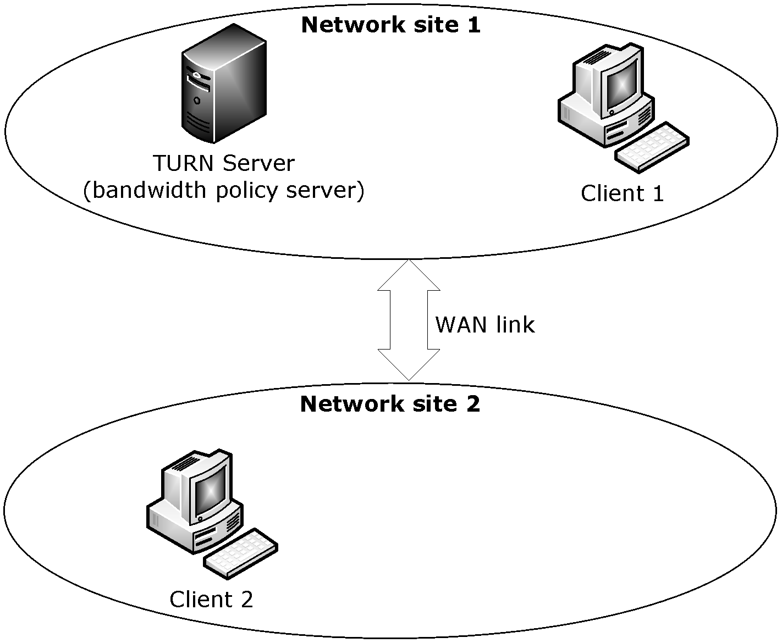
Figure 1: Client communicating with peer
The preceding diagram shows two clients in two different network sites where a network site is made up of a collection of Internet Protocol version 4 (IPv4) subnets. Network Site1 might be a corporation’s home office while Network Site2 is a regional branch office. Network Site2 connects back to the home office over a WAN Link which has limited bandwidth capacity. These network sites and WAN Link make up the bandwidth admission control network topology.
The TURN client named Client1 in Network Site1 is attempting to communicate with the TURN client named Client2 in Network Site2. Client1 allocates a public transport address from its TURN server. It then uses a signaling protocol, such as the Session Initiation Protocol (SIP), to communicate its local transport address and relay allocated transport address, which is the transport address allocated by the TURN server, to Client2.
When Client2 receives Client1’s media transport addresses, it attempts to allocate a public transport address from its TURN server. As part of the allocation attempt, Client2 checks for bandwidth availability across the WAN link. To check for bandwidth availability, Client2 includes the following attributes in its Allocate Request message, as described in [MS-TURN]:
- A Bandwidth Admission Control Message attribute, as specified in section 2.2.1, with a value of "Reservation Check".
- A Bandwidth Reservation Amount attribute, as specified in section 2.2.3, with values that cover the bandwidth range required for the media stream.
- A Remote Site Address attribute, as specified in section 2.2.4, containing the transport address of Client1.
- A Remote Relay Site Address attribute, as specified in section 2.2.5, containing the transport address allocated by Client1’s TURN server.
- A Local Site Address attribute, as specified in section 2.2.6, containing the local transport address of Client2.
- A MS-Service Quality attribute, as specified in [MS-TURN] section 2.2.2.22, containing the type and service quality of the media stream.
The TURN server implementing these extensions uses the transport addresses from the Reservation Check, along with the transport address that it allocates on behalf of Client2, to identify the network location of the two clients and their respective TURN servers in the bandwidth admission control network topology. Once it has the network locations of the clients and the TURN servers, it identifies the following network paths; Client1 to Client1 TURN server, Client2 to Client2 TURN server, Client1 to Client2. The server checks the policy and available bandwidth for each of these network paths to see if the Reservation Check can be satisfied.
When the server finishes checking the network paths, it responds to Client2 with an Allocate Response message, as described in [MS-TURN], that includes the following attributes:
- A Bandwidth Admission Control Message attribute, as specified in section 2.2.1, with a value of "Reservation Check".
- A Remote Site Address Response attribute, as specified in section 2.2.8, containing flags indicating the results of the bandwidth policy check along with the bandwidth range available to be used by the transport address that was included in the Remote Site Address attribute, as specified in section 2.2.4, of the Reservation Check request.
- A Remote Relay Site Address Response attribute, as specified in section 2.2.9, containing flags indicating the results of the bandwidth policy check along with the maximum bandwidth available to be used by the transport address that was included in the Remote Relay Site Address attribute, as specified in section 2.2.5, of the Reservation Check request.
- A Local Site Address Response attribute, as specified in section 2.2.10, containing flags indicating the results of the bandwidth policy check along with the maximum bandwidth available to be used by the transport address that was included in the Local Site Address attribute, as specified in section 2.2.6, of the Reservation Check request.
- A Local Relay Site Address Response attribute, as specified in section 2.2.11, containing flags indicating the results of the bandwidth policy check along with the maximum bandwidth available to be used by the transport address that was allocated by the TURN server as a result of the Allocate Request message.
Client2 can now use any of the transport addresses that were marked as valid by the server to run connectivity checks to Client1. If none of the transport addresses were marked valid, Client2 fails the connection attempt for lack of network bandwidth resources. When Client2 finishes connectivity checks, it notifies the server of the transport addresses it is using for the media stream. Client2 does this notification by including the following attributes in another Allocate Request message:
- A Bandwidth Admission Control Message attribute, as specified in section 2.2.1, with a value of "Reservation Commit".
- A Bandwidth Reservation Amount attribute, as specified in section 2.2.3, with values that identify the bandwidth to be used for the media stream.
- A Remote Site Address attribute, as specified in section 2.2.4, containing the transport address of Client1.
- If Client1 is using the transport address allocated by its TURN server, a Remote Relay Site Address attribute, as specified in section 2.2.5, is included with the public transport address allocated by Client1’s TURN server.
- A Local Site Address attribute, as specified in section 2.2.6, containing the transport address of Client2.
- If Client2 is using the transport address allocated by its TURN server, a Local Relay Site Address attribute, as specified in section 2.2.7, is included with the public transport address allocated by Client2’s TURN server.
When the server receives the Reservation Commit message from Client2, it uses the site address attributes included in the message to locate the network sites used by clients. Once it has the network locations of the clients, it identifies the network paths that will be used for this reservation and commits the bandwidth amount of the reservation against the network paths. This reduces the amount of bandwidth that is available for future calls over these network paths. After completing the bandwidth reservation, the server replies to the client letting it know that the bandwidth has been reserved for the media stream. It sends this reply in an Allocate Response message and includes the following attributes:
- A Bandwidth Admission Control Message attribute, as specified in section 2.2.1, with a value of "Reservation Commit".
- A Bandwidth Reservation Identifier attribute, as specified in section 2.2.2, with a value that identifies the reservation with the server (2). This identifier is used in all subsequent update/change, cancellation, and bandwidth update messages dealing with the reservation.
After Client2 has committed a bandwidth reservation with the server, it can attempt to increase or decrease the amount of bandwidth it has reserved for the media stream by sending a reservation update request to the server. The client notifies the server of this update request by sending another authenticated Allocate Request message:
- A Bandwidth Admission Control Message attribute, as specified in section 2.2.1, with a value of "Reservation Update".
- A Bandwidth Reservation Identifier attribute, as specified in section 2.2.2, with the reservation id value returned by the server in response to the Reservation Commit message.
- A Bandwidth Reservation Amount attribute, as specified in section 2.2.3, with values that identify the bandwidth to be used for the media stream.
When the server receives the Reservation Update message from Client2, it uses the reservation id to identify the existing bandwidth reservation and the network paths involved in the reservation. The server can update the reservation with the new values requested by the client, increasing or decreasing the bandwidth as requested. After completing the bandwidth reservation update, the server replies to the client letting it know the amount of bandwidth that has been reserved for the media stream. It sends this reply in an Allocate Response message and includes the following attributes:
- A Bandwidth Admission Control Message attribute, as specified in section 2.2.1, with a value of "Reservation Update".
- A Bandwidth Reservation Identifier attribute, as specified in section 2.2.2, with a value that identifies the reservation with the server (2).
- A Bandwidth Reservation Amount attribute, as specified in section 2.2.3, with values that identify the bandwidth that is reserved for the media stream.
The basic message flow for a scenario that uses SIP for signaling is shown in the following diagram.
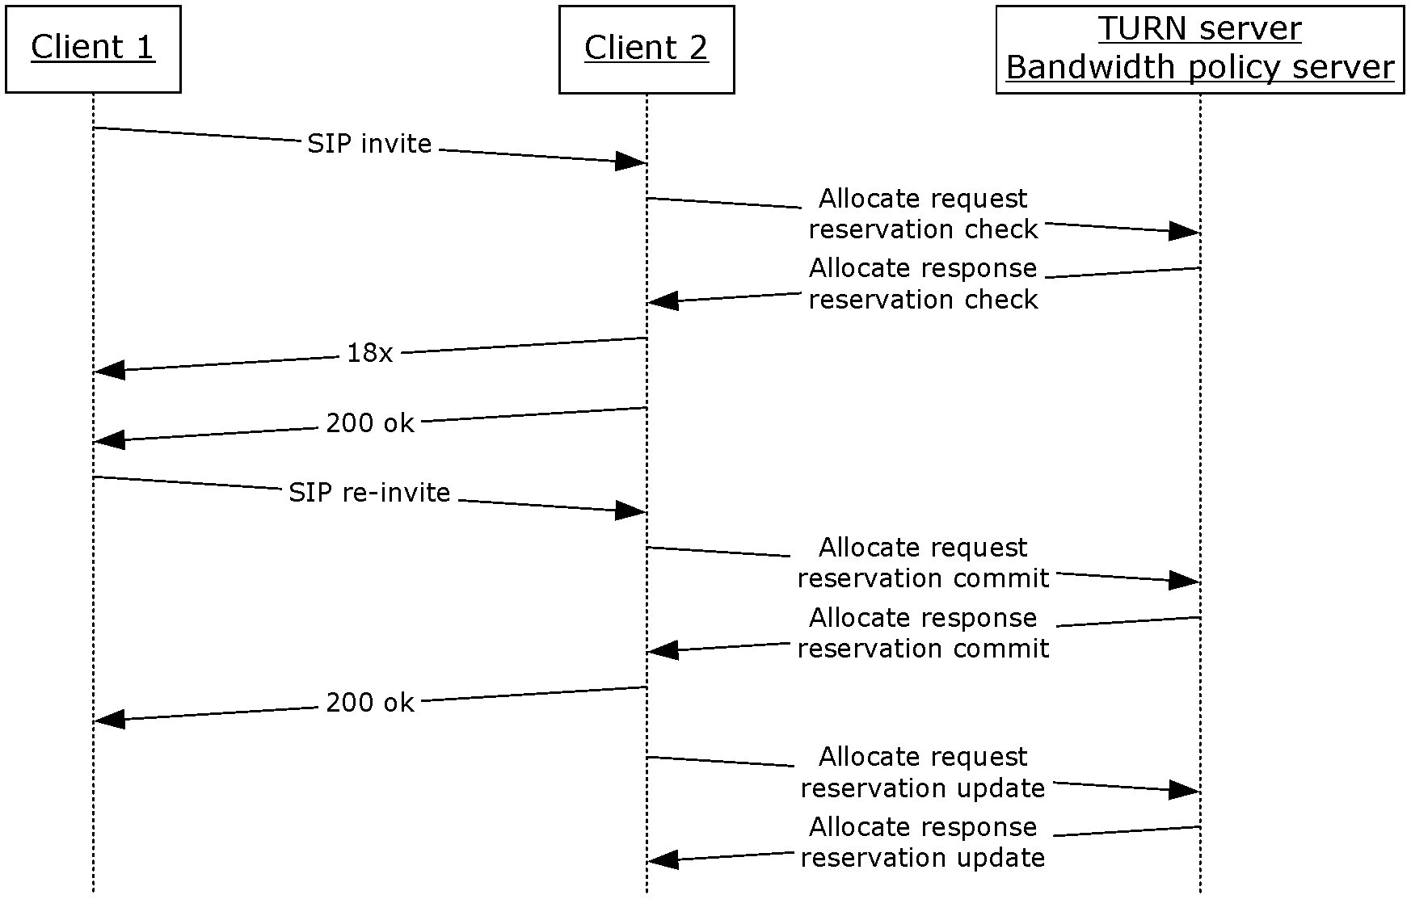
Figure 2: SIP signaling message flow

Relationship to Other Protocols
This protocol integrates with and extends the TURN protocol described in [MS-TURN].

Prerequisites/Preconditions
This protocol assumes the prerequisites/preconditions described in [MS-TURN] section 1.5.
This protocol requires that the TURN client authenticate with the TURN server.
This protocol requires that the TURN clients be able to communicate through a signaling protocol, such as SIP, to exchange transport addresses that identify the client’s site address and relay site address.
This protocol requires that the TURN server be configured with appropriate network topology information. This information includes network subnets that are used to identify network sites, along with bandwidth policy for any network links used to connect the network sites. The bandwidth policy information includes configured bandwidth availability for various media stream modalities on the network link used to connect the network sites.

Applicability Statement
This protocol is designed to provide a mechanism for TURN clients that are communicating with a bandwidth policy aware TURN server to check for the availability of, and reserve, bandwidth for transmission of a media stream.

Versioning and Capability Negotiation
This protocol does not have any versioning or capability negotiation beyond that described in [MS-TURN] section 1.7.

Vendor-Extensible Fields
None.

Standards Assignments
This protocol uses the standard User Datagram Protocol (UDP) and Transmission Control Protocol (TCP) ports from [MS-TURN] section 1.9.

Messages

Transport
This protocol does not change the transport requirements of the TURN protocol, as specified in [MS-TURN] section 2.1.

Message Syntax
All Bandwidth Admission Control message attributes are type-length-value (TLV) encoded, as specified in [MS-TURN] section 2.2.2.

Bandwidth Admission Control Message
The Bandwidth Admission Control Message attribute MUST be included in all Allocate Request/Response message exchanges between a client and a server when a bandwidth admission control action is required. The supported bandwidth admission control actions are:
- Reservation Check, which is used to check bandwidth availability between a client and its peer.
- Reservation Commit, which is used to commit a bandwidth reservation between a client and its peer.
- Reservation Update, which is used to update and refresh an already committed bandwidth reservation.
0 | 1 | 2 | 3 | 4 | 5 | 6 | 7 | 8 | 9 | 1  0 | 1 | 2 | 3 | 4 | 5 | 6 | 7 | 8 | 9 | 2  0 | 1 | 2 | 3 | 4 | 5 | 6 | 7 | 8 | 9 | 3  0 | 1
Attribute Type |  |  |  |  |  |  |  |  |  |  |  |  |  |  |  | Attribute Length
Reserved |  |  |  |  |  |  |  |  |  |  |  |  |  |  |  | Message Type
Attribute Type (2 bytes): The TURN attributes are specified in [IETFDRAFT-STUN-02] section 10.2 and [IETFDRAFT-TURN-08] section 9.2. Set to "0x8056".
Attribute Length (2 bytes): Length of the following fields. Set to "0x0004".
Reserved (2 bytes): These bits MUST be set to zero on send and ignored on receive.
Message Type (2 bytes): The bandwidth admission control action that the client is requesting. The message types are defined as follows. All other message types are reserved for future use.
- Reservation Check (0x0000): Used by the client to request a bandwidth reservation check.
- Reservation Commit (0x0001): Used by the client to commit a bandwidth reservation.
- Reservation Update (0x0002): Used by the client to update and refresh an already-committed bandwidth reservation.

Bandwidth Reservation Identifier
The Bandwidth Reservation Identifier attribute is returned by the server in response to a Reservation Commit message. This attribute MUST be used in all subsequent Reservation Commit and Reservation Update messages sent by the client to the server for this reservation, and MUST include the value assigned by the server in the response to the original Reservation Commit message.
0 | 1 | 2 | 3 | 4 | 5 | 6 | 7 | 8 | 9 | 1  0 | 1 | 2 | 3 | 4 | 5 | 6 | 7 | 8 | 9 | 2  0 | 1 | 2 | 3 | 4 | 5 | 6 | 7 | 8 | 9 | 3  0 | 1
Attribute Type |  |  |  |  |  |  |  |  |  |  |  |  |  |  |  | Attribute Length
Reservation Id (16 bytes)
...
...
Attribute Type (2 bytes): The TURN attributes are specified in [IETFDRAFT-STUN-02] section 10.2 and [IETFDRAFT-TURN-08] section 9.2. Set to "0x8057".
Attribute Length (2 bytes): Length of the Reservation Id field. Set to "0x0010".
Reservation Id (16 bytes): A bandwidth admission control reservation identifier. This field is assigned by the server in response to a client’s Reservation Commit message. Once assigned, it is used by the client to identify the bandwidth reservation in all subsequent messages sent to the server. If the server is not managing the network resources involved in the connection, it MUST return a Reservation Id consisting of all zeros in response to a Reservation Commit. If the client is not using the TURN session for any other purposes, such as data transport, it MUST disconnect the session when it receives a Reservation Id of all zeros.

Bandwidth Reservation Amount
The Bandwidth Reservation Amount attribute is used by the client to indicate the amount of bandwidth that the Bandwidth Admission Control Message is requesting. This attribute MUST be included in all Reservation Check request messages and Reservation Commit messages. It MUST be included in a Reservation Update message that requests a change in the bandwidth reservation amount.
When the client includes this attribute as part of a Reservation Check request message, the bandwidth values MUST identify the bandwidth range (minimum and maximum) for the client’s media stream.
When the client includes this attribute as part of a Reservation Commit message, the bandwidth values MUST be set to the bandwidth that the client expects to use for the media stream. The server MUST commit the bandwidth reservation for the maximum amounts indicated in the attribute.
When the client includes this attribute as part of a Reservation Update message, the bandwidth values can be less than, greater than, or equal to the committed bandwidth reservation value. If the client is using a Reservation Update to ask for an increase in the bandwidth reservation, and the server is not able to honor the increase it MUST deny the Reservation Update. If the client sends a Reservation Update with the bandwidth values set to zero, the server treats the message as a cancellation of the reservation and releases the bandwidth committed to the reservation. If the server is not being used to relay the media stream and the reservation is released, the server MUST disconnect the TURN session. When the server includes this attribute in the response to a Reservation Update, the bandwidth values specify the amount of bandwidth that the server (2) has reserved for the client’s media stream.
0 | 1 | 2 | 3 | 4 | 5 | 6 | 7 | 8 | 9 | 1  0 | 1 | 2 | 3 | 4 | 5 | 6 | 7 | 8 | 9 | 2  0 | 1 | 2 | 3 | 4 | 5 | 6 | 7 | 8 | 9 | 3  0 | 1
Attribute Type |  |  |  |  |  |  |  |  |  |  |  |  |  |  |  | Attribute Length
Minimum Send Bandwidth
Maximum Send Bandwidth
Minimum Receive Bandwidth
Maximum Receive Bandwidth
Attribute Type (2 bytes): The TURN attributes are specified in [IETFDRAFT-STUN-02] section 10.2 and [IETFDRAFT-TURN-08] section 9.2. Set to "0x8058".
Attribute Length (2 bytes): Length of the following fields. Set to "0x0010".
Minimum Send Bandwidth (4 bytes): The minimum bandwidth requirements, in kilobits per second, for the client’s outbound media stream.
Maximum Send Bandwidth (4 bytes): The maximum bandwidth requirements, in kilobits per second, for the client’s outbound media stream.
Minimum Receive Bandwidth (4 bytes): The minimum bandwidth requirements, in kilobits per second, for the client’s inbound media stream.
Maximum Receive Bandwidth (4 bytes): The maximum bandwidth requirements, in kilobits per second, for the client’s inbound media stream.

Remote Site Address
The Remote Site Address attribute contains the transport address that the remote client is using to contact its TURN server. This address maps the client into the bandwidth admission control network topology, and is used to identify the network site in which the remote client resides. There is an assumption that a client is in a single network site. In other words, if the client has multiple IP addresses, only one address from the client is needed to identify the client’s network site. This attribute MUST be included by the client in all Reservation Check and Reservation Commit request messages.
0 | 1 | 2 | 3 | 4 | 5 | 6 | 7 | 8 | 9 | 1  0 | 1 | 2 | 3 | 4 | 5 | 6 | 7 | 8 | 9 | 2  0 | 1 | 2 | 3 | 4 | 5 | 6 | 7 | 8 | 9 | 3  0 | 1
Attribute Type |  |  |  |  |  |  |  |  |  |  |  |  |  |  |  | Attribute Length
Reserved |  |  |  |  |  |  |  | Family |  |  |  |  |  |  |  | X-Port
X-IP Address
Attribute Type (2 bytes): The TURN attributes are specified in [IETFDRAFT-STUN-02] section 10.2 and [IETFDRAFT-TURN-08] section 9.2. Set to "0x8059".
Attribute Length (2 bytes): Length of the following fields. Set to "0x0008" (8) for an IPv4 address or "0x0014" (20) for an IPv6 address.<1>
Reserved (1 byte): These bits MUST be set to zero on send and ignored on receive.
Family (1 byte): The address family of the IP Address. It MUST have the value "0x01" for an IPv4 address or "0x02" for an IPv6 address.<2> If the value is anything other than 0x01 or 0x02, the attribute MUST be silently ignored.
X-Port (2 bytes): The port is a network byte ordered representation of the IP port. This value is created from the exclusive-or of the source port with the most significant 16 bits of the Transaction ID specified in [MS-TURN] section 2.2.1. If the port was 0x1122 (network byte order) and the most significant 16 bits of the Transaction ID (specified in [MS-TURN] section 2.2.1) was 0x4455 (network byte order), the resulting X-Port is "0x1122 ^ 0x4455 = 0x5577".
X-IP Address (4 or 16 bytes): The client’s IPv4 or IPv6 address.<3>
If the address family is IPv4 (Family is set to "0x01"), this is the client’s network byte ordered 32-bit (4 byte) IPv4 address. This value is created from the exclusive-or of the IP address with the most significant 32 bits of the Transaction ID specified in [MS-TURN] section 2.2.1. If the IPv4 address was 0x11223344 and the most significant 32 bits of the Transaction ID (specified in [MS-TURN] section 2.2.1) was 0xaabbccdd, the resulting X-IP Address is "0x11223344 ^ 0xaabbccdd = 0xbb99ff99".
If the address family is IPv6 (Family is set to "0x02"), this is the client’s network byte ordered 128-bit (16 byte) IPv6 address.<4> This value is created from the exclusive-or of the IP address with the 128 bits of the Transaction Id specified in [MS-TURN] section 2.2.1. If the IPv6 address was 0x20010DB8112233445566778899AABBCC and the 128-bit Transaction ID (specified in [MS-TURN] section 2.2.1) was 0x112233445566778899AABBCCDDEEFF00, the resulting X-IP Address is "0x20010DB8112233445566778899AABBCC ^ 0x112233445566778899AABBCCDDEEFF00 = 0x31233EFC444444CCCCCCCC44444444CC ".

Remote Relay Site Address
The Remote Relay Site Address attribute contains the IP address that the remote client received from an Allocate Request from its TURN server. This address maps the TURN server into the bandwidth admission control network topology, and is used to identify the network site that the TURN server is in.
If the remote client has allocated a transport address from its TURN server, it MUST include this attribute in the Reservation Check.
If the remote client uses the relay transport address for the media stream, this attribute MUST be included in the Reservation Commit request message. If the remote client does not use the relay transport address for the media stream, it MUST NOT include this attribute in the Reservation Commit request message.
0 | 1 | 2 | 3 | 4 | 5 | 6 | 7 | 8 | 9 | 1  0 | 1 | 2 | 3 | 4 | 5 | 6 | 7 | 8 | 9 | 2  0 | 1 | 2 | 3 | 4 | 5 | 6 | 7 | 8 | 9 | 3  0 | 1
Attribute Type |  |  |  |  |  |  |  |  |  |  |  |  |  |  |  | Attribute Length
Reserved |  |  |  |  |  |  |  | Family |  |  |  |  |  |  |  | X-Port
X-IP Address
Attribute Type (2 bytes): The TURN attributes are specified in [IETFDRAFT-STUN-02] section 10.2 and [IETFDRAFT-TURN-08] section 9.2. Set to "0x805A".
Attribute Length (2 bytes): Length of the following fields. Set to "0x0008" (8) for an IPv4 address or "0x0014" (20) for an IPv6 address.<5>
Reserved (1 byte): These bits MUST be set to zero on send and ignored on receive.
Family (1 byte): The address family of the IP Address. It MUST have the value "0x01" for an IPv4 address or "0x02" for an IPv6 address.<6> If the value is anything other than 0x01 or 0x02, the attribute MUST be silently ignored.
X-Port (2 bytes): The port is a network byte ordered representation of the IP port. This value is created from the exclusive-or of the source port with the most significant 16 bits of the Transaction ID specified in [MS-TURN] section 2.2.1. If the port was 0x1122 (network byte order) and the most significant 16 bits of the Transaction ID (specified in [MS-TURN] section 2.2.1) was 0x4455 (network byte order), the resulting X-Port is "0x1122 ^ 0x4455 = 0x5577".
X-IP Address (4 or 16 bytes): The client’s IPv4 or IPv6 address.<7>
If the address family is IPv4 (Family is set to "0x01") this is the client’s network byte ordered 32-bit (4 byte) IPv4 address. This value is created from the exclusive-or of the IP address with the most significant 32 bits of the Transaction ID specified in [MS-TURN] section 2.2.1. If the IPv4 address was 0x11223344 and the most significant 32 bits of the Transaction ID (specified in [MS-TURN] section 2.2.1) was 0xaabbccdd, the resulting X-IP Address is "0x11223344 ^ 0xaabbccdd = 0xbb99ff99".
If the address family is IPv6 (Family is set to "0x02") this is the client’s network byte ordered 128-bit (16 byte) IPv6 address.<8> This value is created from the exclusive-or of the IP address with the 128 bits of the Transaction Id specified in [MS-TURN] section 2.2.1. If the IPv6 address was 0x20010DB8112233445566778899AABBCC and the 128bit Transaction ID (specified in [MS-TURN] section 2.2.1) was 0x112233445566778899AABBCCDDEEFF00, the resulting X-IP Address is "0x20010DB8112233445566778899AABBCC ^ 0x112233445566778899AABBCCDDEEFF00 = 0x31233EFC444444CCCCCCCC44444444CC ".

Local Site Address
The Local Site Address attribute contains the IP address that the client is using to contact its TURN server. This address maps the client into the bandwidth admission control network topology, and is used to identify the network site that the client is in. There is an assumption that a client is in a single network site. In other words, if the client has multiple IP addresses, only one address from the client is needed to identify the client’s network site. This attribute MUST be included by the client in all Reservation Check and Reservation Commit request messages.
0 | 1 | 2 | 3 | 4 | 5 | 6 | 7 | 8 | 9 | 1  0 | 1 | 2 | 3 | 4 | 5 | 6 | 7 | 8 | 9 | 2  0 | 1 | 2 | 3 | 4 | 5 | 6 | 7 | 8 | 9 | 3  0 | 1
Attribute Type |  |  |  |  |  |  |  |  |  |  |  |  |  |  |  | Attribute Length
Reserved |  |  |  |  |  |  |  | Family |  |  |  |  |  |  |  | X-Port
X-IP Address
Attribute Type (2 bytes): The TURN attributes are specified in [IETFDRAFT-STUN-02] section 10.2 and [IETFDRAFT-TURN-08] section 9.2. Set to "0x805B".
Attribute Length (2 bytes): Length of the following fields. Set to "0x0008" (8) for an IPv4 address or "0x0014" (20) for an IPv6 address.<9>
Reserved (1 byte): These bits MUST be set to zero on send and ignored on receive.
Family (1 byte): The address family of the IP Address. It MUST have the value "0x01" for an IPv4 address or "0x02" for an IPv6 address.<10> If the value is anything other than 0x01 or 0x02, the attribute MUST be silently ignored.
X-Port (2 bytes): The port is a network byte ordered representation of the IP port. This value is created from the exclusive-or of the source port with the most significant 16 bits of the Transaction ID specified in [MS-TURN] section 2.2.1. If the port was 0x1122 (network byte order) and the most significant 16 bits of the Transaction ID (specified in [MS-TURN] section 2.2.1) was 0x4455 (network byte order), the resulting X-Port is "0x1122 ^ 0x4455 = 0x5577".
X-IP Address (4 or 16 bytes): The client’s IPv4 or IPv6 address.<11>
If the address family is IPv4 (Family is set to "0x01") this is the client’s network byte ordered 32-bit (4 byte) IPv4 address. This value is created from the exclusive-or of the IP address with the most significant 32 bits of the Transaction ID specified in [MS-TURN] section 2.2.1. If the IPv4 address was 0x11223344 and the most significant 32 bits of the Transaction ID (specified in [MS-TURN] section 2.2.1) was 0xaabbccdd, the resulting X-IP Address is "0x11223344 ^ 0xaabbccdd = 0xbb99ff99".
If the address family is IPv6 (Family is set to "0x02") this is the client’s network byte ordered 128-bit (16 byte) IPv6 address.<12> This value is created from the exclusive-or of the IP address with the 128 bits of the Transaction Id specified in [MS-TURN] section 2.2.1. If the IPv6 address was 0x20010DB8112233445566778899AABBCC and the 128bit Transaction ID (specified in [MS-TURN] section 2.2.1) was 0x112233445566778899AABBCCDDEEFF00, the resulting X-IP Address is "0x20010DB8112233445566778899AABBCC ^ 0x112233445566778899AABBCCDDEEFF00 = 0x31233EFC444444CCCCCCCC44444444CC ".

Local Relay Site Address
The Local Relay Site Address attribute contains the IP address that the local client received from its TURN server. This address maps the TURN server into the bandwidth admission control network topology, and is used to identify the network site that the TURN server is in.
If the local client has previously allocated a transport address from its TURN server, it MUST include this attribute in the Reservation Check message. If the local client is attempting to allocate a transport address from its TURN server as part of the Allocate Request message carrying the Reservation Check, the client MUST NOT include this attribute.
If the local client uses the relay transport address for the media stream, this attribute MUST be included in the Reservation Commit request message. If the local client does not use the relay transport address for the media stream, it MUST NOT include this attribute in the Reservation Commit request message.
0 | 1 | 2 | 3 | 4 | 5 | 6 | 7 | 8 | 9 | 1  0 | 1 | 2 | 3 | 4 | 5 | 6 | 7 | 8 | 9 | 2  0 | 1 | 2 | 3 | 4 | 5 | 6 | 7 | 8 | 9 | 3  0 | 1
Attribute Type |  |  |  |  |  |  |  |  |  |  |  |  |  |  |  | Attribute Length
Reserved |  |  |  |  |  |  |  | Family |  |  |  |  |  |  |  | X-Port
X-IP Address
Attribute Type (2 bytes): The TURN attributes are specified in [IETFDRAFT-STUN-02] section 10.2 and [IETFDRAFT-TURN-08] section 9.2. Set to "0x805C".
Attribute Length (2 bytes): Length of the following fields. Set to "0x0008" (8) for an IPv4 address or "0x0014" (20) for an IPv6 address.<13>
Reserved (1 byte): These bits MUST be set to zero on send and ignored on receive.
Family (1 byte): The address family of the IP Address. It MUST have the value "0x01" for an IPv4 address or "0x02" for an IPv6 address.<14> If the value is anything other than 0x01 or 0x02, the attribute MUST be silently ignored.
X-Port (2 bytes): The port is a network byte ordered representation of the IP port. This value is created from the exclusive-or of the source port with the most significant 16 bits of the Transaction ID specified in [MS-TURN] section 2.2.1. If the port was 0x1122 (network byte order) and the most significant 16 bits of the Transaction ID (specified in [MS-TURN] section 2.2.1) was 0x4455 (network byte order), the resulting X-Port is "0x1122 ^ 0x4455 = 0x5577".
X-IP Address (4 or 16 bytes): The client’s IPv4 or IPv6 address.<15>
If the address family is IPv4 (Family is set to "0x01") this is the client’s network byte ordered 32-bit (4 byte) IPv4 address. This value is created from the exclusive-or of the IP address with the most significant 32 bits of the Transaction ID specified in [MS-TURN] section 2.2.1. If the IPv4 address was 0x11223344 and the most significant 32 bits of the Transaction ID (specified in [MS-TURN] section 2.2.1) was 0xaabbccdd, the resulting X-IP Address is "0x11223344 ^ 0xaabbccdd = 0xbb99ff99".
If the address family is IPv6<16> (Family is set to "0x02") this is the client’s network byte ordered 128-bit (16 byte) IPv6 address. This value is created from the exclusive-or of the IP address with the 128 bits of the Transaction Id specified in [MS-TURN] section 2.2.1. If the IPv6 address was 0x20010DB8112233445566778899AABBCC and the 128bit Transaction ID (specified in [MS-TURN] section 2.2.1) was 0x112233445566778899AABBCCDDEEFF00, the resulting X- IP Address is "0x20010DB8112233445566778899AABBCC ^ 0x112233445566778899AABBCCDDEEFF00 = 0x31233EFC444444CCCCCCCC44444444CC ".

Remote Site Address Response
The Remote Site Address Response attribute is sent by the server in response to a Reservation Check request message that contained a Remote Site Address attribute. It indicates to the client the availability of the Remote Site Address as a viable transport address to be used for media connectivity.
0 | 1 | 2 | 3 | 4 | 5 | 6 | 7 | 8 | 9 | 1  0 | 1 | 2 | 3 | 4 | 5 | 6 | 7 | 8 | 9 | 2  0 | 1 | 2 | 3 | 4 | 5 | 6 | 7 | 8 | 9 | 3  0 | 1
Attribute Type |  |  |  |  |  |  |  |  |  |  |  |  |  |  |  | Attribute Length
A | B | Reserved
Maximum Send Bandwidth
Maximum Receive Bandwidth
Attribute Type (2 bytes): The TURN attributes are specified in [IETFDRAFT-STUN-02] section 10.2 and [IETFDRAFT-TURN-08] section 9.2. Set to "0x805D".
Attribute Length (2 bytes): Set to "0x000C".
A - Valid (V) flag (1 bit): Identifies whether the Remote Site Address is a valid transport address and can be included in the connectivity check as specified in section 3.2.5.1. If the network path between the Remote Site Address and Local Site Address passed the bandwidth admission policy check, the server sets the flag (V = "1"). If the network path between the Remote Site Address and the Local Site Address failed the bandwidth admission policy check, the server clears the flag (V = "0").
B - PSTN Failover (F) flag (1 bit): Used by the server to inform the client of the option of failing over to public switched telephone network (PSTN) if the network path between the Remote Site Address and Local Site Address failed the bandwidth admission policy check. If the V flag is cleared (V = "0") and this flag is set (F = "1"), the client can attempt to re-route the call over the PSTN.
Reserved (30 bits): These bits MUST be set to zero on send and ignored on receive.
Maximum Send Bandwidth (4 bytes): The maximum amount of bandwidth available for sending data from the Remote Site Address. This value is within the bandwidth range requested in the Check Request message. The server sets this field to zero if the network path between the Remote Site Address and the Local Site Address fails the bandwidth admission policy check.
Maximum Receive Bandwidth (4 bytes): The maximum amount of bandwidth available for receiving data into the Remote Site Address. This value is within the bandwidth range requested in the Check Request message. The server sets this field to zero if the network path between the Remote Site Address and the Local Site Address fails the bandwidth admission policy check.

Remote Relay Site Address Response
The Remote Relay Site Address Response attribute is sent by the server in response to a Reservation Check request message that contained a Remote Relay Site Address attribute. It indicates to the client the availability of the Remote Relay Site Address as a viable transport address to be used for media connectivity.
0 | 1 | 2 | 3 | 4 | 5 | 6 | 7 | 8 | 9 | 1  0 | 1 | 2 | 3 | 4 | 5 | 6 | 7 | 8 | 9 | 2  0 | 1 | 2 | 3 | 4 | 5 | 6 | 7 | 8 | 9 | 3  0 | 1
Attribute Type |  |  |  |  |  |  |  |  |  |  |  |  |  |  |  | Attribute Length
A | Reserved
Maximum Send Bandwidth
Maximum Receive Bandwidth
Attribute Type (2 bytes): The TURN attributes are specified in [IETFDRAFT-STUN-02] section 10.2 and [IETFDRAFT-TURN-08] section 9.2. Set to "0x805E".
Attribute Length (2 bytes): Set to "0x000C".
A - Valid (V) flag (1 bit): Identifies whether the Remote Relay Site Address is a valid transport address and can be included in the connectivity check, as specified in section 3.2.5.1. If the network path between the Remote Site Address and Remote Relay Site Address passed the bandwidth admission policy check, the server sets the flag (V = "1"). If the network path between the Remote Site Address and Remote Relay Site Address failed the bandwidth admission policy check, the server clears the flag (V = "0").
Reserved (31 bits): These bits MUST be set to zero on send and MUST be ignored on receive.
Maximum Send Bandwidth (4 bytes): The maximum amount of bandwidth available for sending data from Remote Relay Site Address. This value is within the bandwidth range requested in the Check Request message. The server sets this field to zero if the network path between the Remote Site Address and the Remote Relay Site Address fails the bandwidth admission policy check.
Maximum Receive Bandwidth (4 bytes): The maximum amount of bandwidth available for receiving data into the Remote Relay Site Address. This value is within the bandwidth range requested in the Check Request message. The server sets this field to zero if the network path between the Remote Site Address and the Remote Relay Site Address fails the bandwidth admission policy check.

Local Site Address Response
The Local Site Address Response attribute is sent by the server in response to a Reservation Check request message that contained a Local Site Address attribute. It is used to indicate to the client the availability of the Local Site Address as a viable transport address to be used for media connectivity.
0 | 1 | 2 | 3 | 4 | 5 | 6 | 7 | 8 | 9 | 1  0 | 1 | 2 | 3 | 4 | 5 | 6 | 7 | 8 | 9 | 2  0 | 1 | 2 | 3 | 4 | 5 | 6 | 7 | 8 | 9 | 3  0 | 1
Attribute Type |  |  |  |  |  |  |  |  |  |  |  |  |  |  |  | Attribute Length
A | B | Reserved
Maximum Send Bandwidth
Maximum Receive Bandwidth
Attribute Type (2 bytes): The TURN attributes are specified in [IETFDRAFT-STUN-02] section 10.2 and [IETFDRAFT-TURN-08] section 9.2. Set to "0x805F".
Attribute Length (2 bytes): Set to "0x000C".
A - Valid (V) flag (1 bit): Identifies whether the Local Site Address is a valid transport address and can be included in the connectivity check, as specified in section 3.2.5.1. If the network path between the Remote Site Address and Local Site Address passed the bandwidth admission policy check, the server sets the flag (V = "1"). If the network path between the Remote Site Address and the Local Site Address failed the bandwidth admission policy check, the server clears the flag (V = "0").
B - PSTN Failover (F) flag (1 bit): Used by the server to inform the client of the option of failing over to PSTN if the network path between the Local Site Address and Remote Site Address failed the bandwidth admission policy check. If the V flag is cleared (V = "0") and this flag is set (F = "1"), the client can attempt to re-route the call over the PSTN.
Reserved (30 bits): These bits MUST be set to zero on send and ignored on receive.
Maximum Send Bandwidth (4 bytes): The maximum amount of bandwidth available for sending data from the Local Site Address. This value is within the bandwidth range requested in the Check Request message. The server sets this field to zero if the network path between the Remote Site Address and the Local Site Address fails the bandwidth admission policy check.
Maximum Receive Bandwidth (4 bytes): The maximum amount of bandwidth available for receiving data into the Local Site Address. This value is within the bandwidth range requested in the Check Request message. The server sets this field to zero if the network path between the Remote Site Address and the Local Site Address fails the bandwidth admission policy check.

Local Relay Site Address Response
The Local Relay Site Address Response attribute is sent by the server in response to a Reservation Check request message that contained a Local Relay Site Address attribute. It indicates to the client the availability of the Local Relay Site Address as a viable transport address to be used for media connectivity.
0 | 1 | 2 | 3 | 4 | 5 | 6 | 7 | 8 | 9 | 1  0 | 1 | 2 | 3 | 4 | 5 | 6 | 7 | 8 | 9 | 2  0 | 1 | 2 | 3 | 4 | 5 | 6 | 7 | 8 | 9 | 3  0 | 1
Attribute Type |  |  |  |  |  |  |  |  |  |  |  |  |  |  |  | Attribute Length
A | Reserved
Maximum Send Bandwidth
Maximum Receive Bandwidth
Attribute Type (2 bytes): The TURN attributes are specified in [IETFDRAFT-STUN-02] section 10.2 and [IETFDRAFT-TURN-08] section 9.2. Set to "0x8060".
Attribute Length (2 bytes): Set to "0x000C".
A - Valid (V) flag (1 bit): Identifies whether the Local Relay Site Address is a valid transport address and can be included in the connectivity check, as specified in section 3.2.5.1. If the network path between the Local Site Address and Local Relay Site Address passed the bandwidth admission policy check, the server sets the flag (V = "1"). If the network path between the Local Site Address and Local Relay Site Address failed the bandwidth admission policy check, the server clears the flag (V = "0").
Reserved (31 bits): These bits MUST be set to zero on send and MUST be ignored on receive.
Maximum Send Bandwidth (4 bytes): The maximum amount of bandwidth available for sending data from Local Relay Site Address. This value is within the bandwidth range requested in the Check Request message. The server sets this field to zero if the network path between the Local Site Address and the Local Relay Site Address fails the bandwidth admission policy check.
Maximum Receive Bandwidth (4 bytes): The maximum amount of bandwidth available for receiving data into the Local Relay Site Address. This value is within the bandwidth range requested in the Check Request message. The server sets this field to zero if the network path between the Local Site Address and the Local Relay Site Address fails the bandwidth admission policy check.

SIP Dialog Identifier
The SIP Dialog Identifier attribute is used by the client to identify the SIP dialog associated with the bandwidth reservation. Once the client knows the SIP Dialog Identifier, it can include this attribute in the Bandwidth Admission Control Reservation Commit message and any subsequent Reservation Update messages. The server can use this attribute for logging purposes to map the media session to the signaling session.
0 | 1 | 2 | 3 | 4 | 5 | 6 | 7 | 8 | 9 | 1  0 | 1 | 2 | 3 | 4 | 5 | 6 | 7 | 8 | 9 | 2  0 | 1 | 2 | 3 | 4 | 5 | 6 | 7 | 8 | 9 | 3  0 | 1
Attribute Type |  |  |  |  |  |  |  |  |  |  |  |  |  |  |  | Attribute Length
SIP Dialog ID (variable)
...
Attribute Type (2 bytes): The TURN attributes are specified in [IETFDRAFT-STUN-02] section 10.2 and [IETFDRAFT-TURN-08] section 9.2. Set to "0x8061".
Attribute Length (2 bytes): The length in bytes of the SIP Dialog ID field. The length of the SIP Dialog ID MUST NOT exceed 256 bytes.
SIP Dialog ID (variable): The SIP Dialog Identifier. The length of SIP Dialog ID MUST NOT exceed 256 bytes.

SIP Call Identifier
The SIP Call Identifier attribute is used by the client to identify the SIP call associated with the bandwidth reservation. Once the client knows the SIP Call Identifier, it can include this attribute in the initial Bandwidth Admission Control Reservation Check message. The server can use this attribute for logging purposes to map the media session to the signaling session.
0 | 1 | 2 | 3 | 4 | 5 | 6 | 7 | 8 | 9 | 1  0 | 1 | 2 | 3 | 4 | 5 | 6 | 7 | 8 | 9 | 2  0 | 1 | 2 | 3 | 4 | 5 | 6 | 7 | 8 | 9 | 3  0 | 1
Attribute Type |  |  |  |  |  |  |  |  |  |  |  |  |  |  |  | Attribute Length
SIP Call ID (variable)
...
Attribute Type (2 bytes): The TURN attributes are specified in [IETFDRAFT-STUN-02] section 10.2 and [IETFDRAFT-TURN-08] section 9.2. Set to "0x8062".
Attribute Length (2 bytes): The length in bytes of the SIP Call ID field. The length of the SIP Call ID MUST NOT exceed 256 bytes.
SIP Call ID (variable): The SIP Call Identifier. The length of SIP Call ID MUST NOT exceed 256 bytes.

Location Profile
The Location Profile is used by the client to indicate location information about the local client and the remote peer with which it is communicating. This attribute MUST be sent in all Bandwidth Admission Control Reservation Check and Reservation Commit messages.
0 | 1 | 2 | 3 | 4 | 5 | 6 | 7 | 8 | 9 | 1  0 | 1 | 2 | 3 | 4 | 5 | 6 | 7 | 8 | 9 | 2  0 | 1 | 2 | 3 | 4 | 5 | 6 | 7 | 8 | 9 | 3  0 | 1
Attribute Type |  |  |  |  |  |  |  |  |  |  |  |  |  |  |  | Attribute Length
Peer-Location |  |  |  |  |  |  |  | Self-Location |  |  |  |  |  |  |  | Federation |  |  |  |  |  |  |  | Reserved
Attribute Type (2 bytes): The TURN attributes are specified in [IETFDRAFT-STUN-02] section 10.2 and [IETFDRAFT-TURN-08] section 9.2. Set to "0x8068".
Attribute Length (2 bytes): The length, in bytes, of the following fields. Set to "0x0004".
Peer-Location (1 byte): This field identifies the location of the remote peer that the client is communicating with. It MUST have one of the following values:
- "0x00": Unknown – The location of the peer cannot be determined.
- "0x01": Internet – The peer is located on the public internet.
- "0x02": Intranet – The peer is located on a private intranet.
Self-Location (1 byte): This field identifies the location of the local client. It MUST have one of the following values:
- "0x00": Unknown – The location of the local client cannot be determined.
- "0x01": Internet – The local client is located on the public internet.
- "0x02": Intranet – The local client is located on a private intranet.
Federation (1 byte): This field identifies the federation status of the peer that the client is communicating with. It MUST have one of the following values:
- "0x00": No Federation – The peer is located within the enterprise.
- "0x01": Enterprise Federation – The peer is located in a federated enterprise.
- "0x02": Public Cloud Federation – The peer is located in a federated public cloud.
Reserved (1 byte): These bits MUST be set to zero on send and ignored on receive.

Protocol Details

Common Details
The procedures specified apply to both TCP and UDP transport protocols unless explicitly specified in the procedure.
All Bandwidth Admission Control messages MUST be included in properly formatted Allocate Request and Allocate Response message pairs, as specified in [MS-TURN] section 3.1.8 and [MS-TURN] section 3.1.10. The Allocate Request and Allocate Response messages MUST be part of an authenticated TURN session, as specified in [MS-TURN] section 3.1.12. Bandwidth Admission Control message attributes SHOULD be part of the first authenticated Allocate Request message.

Abstract Data Model
None.

Timers
None.

Initialization
None.

Higher-Layer Triggered Events
None.

Message Processing Events and Sequencing Rules
None.

Timer Events
None.

Other Local Events
None.

Client Details

Abstract Data Model
None.

Timers
This protocol adds one new timer to the timers specified in [MS-TURN] section 3.2.2.
The Bandwidth Reservation Update Timer keeps an already committed bandwidth reservation active. The client MUST start the timer when it completes the Allocate Request/Response message transaction that carries a Bandwidth Admission Control Reservation Commit message. The client MUST complete an Allocate Request/Response transaction carrying a Bandwidth Admission Control Reservation Update message, as specified in section 3.2.4.3, every 60 seconds.

Initialization
In addition to the initialization specified in [MS-TURN] section 3.2.3, the client MUST know the local transport address of the peer. If the peer has allocated a transport address from a TURN server, the client MUST know the allocated transport address of the peer. The client also MUST have successfully authenticated with the TURN server, as specified in [MS-TURN] section 3.1.12.

Higher-Layer Triggered Events
This section outlines the higher-layer events that trigger a client to start the various phases of bandwidth management.

Checking for Bandwidth Admission Control
Before a client begins connectivity checks with a peer, it MUST contact the server to check for the availability of bandwidth between the client and peer network sites. This check is made by sending an authenticated Allocate Request message, as specified in [MS-TURN] section 3.1.12, to the server. The authenticated Allocate Request is constructed as follows:
- The request MUST include a Bandwidth Admission Control Message attribute with a message type of Reservation Check, as specified in section 2.2.1.
- The request MUST include a Remote Site Address attribute, as specified in section 2.2.4, containing the peer’s local transport address.
- If the peer is using a TURN server and has an allocated transport address, the request MUST include a Remote Relay Site Address attribute, as specified in section 2.2.5, containing the transport address allocated by the TURN server.
- If the client has previously allocated a transport address from its TURN server, the request MUST include the Local Relay Site Address attribute, as specified in section 2.2.7. Otherwise, the request MUST NOT include this attribute.
- The request MUST include a Local Site Address attribute, as specified in section 2.2.6.
- The request MUST include a Bandwidth Reservation Amount attribute, as specified in section 2.2.3.
- The request SHOULD include a MS-Service Quality attribute, as specified in [MS-TURN] section 2.2.2.22. If this attribute is not present, the media stream is considered to be an audio stream.
- The request SHOULD include the SIP Call Identifier attribute, as specified in section 2.2.13.
- The request MUST include the Location Profile attribute, as specified in section 2.2.14.

Committing a Bandwidth Reservation
When a client and its peer complete connectivity checks and decide on a media connectivity path, the client MUST contact the server to reserve the bandwidth against the network links between the network sites involved in the media path. This reservation is made by sending an authenticated Allocate Request message, as specified in [MS-TURN] section 3.1.12, to the server. The authenticated Allocate Request is constructed as follows:
- The request MUST include a Bandwidth Admission Control Message attribute with a message type of Reservation Commit, as specified in section 2.2.1.
- The request MUST include a Remote Site Address attribute, as specified in section 2.2.4.
- If the media connectivity path is using the remote TURN server, the request MUST include a Remote Relay Site Address attribute, as specified in section 2.2.5.
- The request MUST include a Local Site Address attribute as specified in section 2.2.6.
- If the media connectivity path is using the local TURN server, the request MUST include a Local Relay Site Address attribute, as specified in section 2.2.7.
- The request MUST include a Bandwidth Reservation Amount attribute, as specified in section 2.2.3.
- The request SHOULD include a MS-Service Quality attribute as specified in [MS-TURN] section 2.2.2.22. If this attribute is not present, the media stream is considered to be an audio stream.
- The request SHOULD include the SIP Dialog Identifier attribute, as specified in section 2.2.12.
- The request MUST include the Location Profile attribute, as specified in section 2.2.14.

Updating a Bandwidth Reservation
After a client has committed a bandwidth reservation with the server, it might request changing the amount of bandwidth that it reserved. The client can attempt to increase or decrease the reservation. The client MUST notify the server of this change request. This update is made by sending an authenticated Allocate Request message, as specified in [MS-TURN] section 3.1.12, to the server. The authenticated Allocate Request is constructed as follows:
- The request MUST include a Bandwidth Admission Control Message attribute with a message type of Reservation Update, as specified in section 2.2.1.
- The request MUST include a Bandwidth Reservation Identifier attribute, as specified in section 2.2.2.
- If the update is sent in response to an attempt to change, either increase or decrease, the amount of bandwidth currently committed to the reservation, the request MUST include a Bandwidth Reservation Amount attribute, as specified in section 2.2.3. If the update is sent in response to the Bandwidth Reservation Update Timer firing, the request SHOULD include a Bandwidth Reservation Amount attribute, as specified in section 2.2.3.
- The request SHOULD include the SIP Dialog Identifier attribute, as specified in section 2.2.12.

Message Processing Events and Sequencing Rules
When a client receives an Allocate Response message, it MUST follow the procedure specified in [MS-TURN] section 3.2.5.1, with the following exceptions:
- If the TURN server did not allocate a relay transport address on behalf of the client, the response MUST NOT contain a Mapped Address attribute, as specified in [MS-TURN] section 2.2.2.1.
- The response SHOULD contain a Bandwidth Admission Control Message attribute, as specified in section 2.2.1.

Receiving a Bandwidth Admission Control Check Response Message
When a client receives an Allocate Response message with a Transaction ID (specified in [MS-TURN] section 2.2.1) that matches the Transaction ID (specified in [MS-TURN] section 2.2.1) of an Allocate Request message that included a Bandwidth Admission Control Reservation Check message, it proceeds as follows:
- The response MUST contain a Remote Site Address Response attribute, as specified in section 2.2.8.
- If the original request message contained a Remote Relay Site Address attribute, the response MUST contain a Remote Relay Site Address Response attribute, as specified in section 2.2.9.
- The response MUST contain a Local Site Address Response attribute, as specified in section 2.2.10.
- If the TURN server allocated a relay transport address on behalf of the client, the response MUST contain a Local Relay Site Address Response attribute, as specified in section 2.2.11.
If the response message is valid, the client MUST check the flags for each of the included site address response attributes. The server (2) marks the Valid (V) flag of each of the site address response attributes, based on the available bandwidth over three possible network paths:
- Local Site Address to the Remote Site Address.
- Local Site Address to the Local Relay Site Address, if present.
- Remote Site Address to the Remote Relay Site Address, if present.
The rules for checking the network paths are as follows:
- The network path between the Local Site Address and the Remote Site Address is only available if both the Local Site Address Response attribute and Remote Site Address Response attribute are flagged as valid (V="1"). If either of these attributes are marked as invalid (V="0"), the network path is not available because of bandwidth constraints.
- If either of Local Site Address or Remote Site Address attributes are marked as invalid (V="0") and the PSTN Failover flag is set (F="1") the bandwidth policy allows redirecting the connection over PSTN. The client SHOULD consider the network path to the PSTN gateway as a valid network path.
- If the Local Relay Site Address Response attribute is present and it is flagged as valid (V="1"), the Local Site Address – Local Relay Site Address network path is available. If the Local Relay Site Address Response attribute is not present or if it is flagged as invalid (V="0"), the Local Site Address – Local Relay Site Address network path is not available.
- If the Remote Relay Site Address Response attribute is present and it is flagged as valid (V="1"), the Remote Site Address – Remote Relay Site Address network path is available. If the Remote Relay Site Address Response attribute is not present or if it is flagged as invalid (V="0"), the Remote Site Address – Remote Relay Site Address network path is not available.
A full check failure occurs when there is no valid network path out of either the Local Site Address or the Remote Site Address. A partial connection failure occurs if any path out of either the Local Site Address or the Remote Site Address is not available. The client SHOULD use all valid network paths to explore connectivity options with the peer. The client MUST NOT use any network paths that are marked as invalid.

Receiving a Bandwidth Admission Control Commit Response Message
When a client receives an Allocate Response message with a Transaction ID (specified in [MS-TURN] section 2.2.1) that matches the Transaction ID (specified in [MS-TURN] section 2.2.1) of an Allocate Request message that included a Bandwidth Admission Control Reservation Commit message, it proceeds as follows:
- The response MUST contain a Bandwidth Reservation Identifier attribute, as specified in section 2.2.2.
- The response MUST contain a Bandwidth Reservation Amount attribute, as specified in section 2.2.3.
If the response is valid, the client SHOULD check the Reservation ID value. If the value is zero, the bandwidth reservation is not being tracked by the server. If the client is not using the TURN session for the media stream, it SHOULD disconnect the session. If the Reservation ID value is nonzero, it is used for all further messages dealing with the reservation.

Receiving a Bandwidth Admission Control Update Response Message
When a client receives an Allocate Response message with a Transaction ID (specified in [MS-TURN] section 2.2.1) that matches the Transaction ID (specified in [MS-TURN] section 2.2.1) of an Allocate Request message that included a Bandwidth Admission Control Reservation Update message, it proceeds as follows:
- The response MUST contain a Bandwidth Reservation Identifier attribute, as specified in section 2.2.2.
- The response SHOULD include a Bandwidth Reservation Amount attribute, as specified in section 2.2.3.
If the response is valid and a Bandwidth Reservation Amount attribute is present, the client MUST check the send and receive bandwidth values to verify the amount of bandwidth that the server has reserved for the media session. If the response was the result of a request to increase the amount of bandwidth in the reservation, it is possible that the server was not able to reserve the full amount of the request.

Timer Events
Bandwidth Reservation Update Timer Expiration: Upon expiry of the Bandwidth Reservation Update timer, the client MUST transmit a Bandwidth Admission Control Reservation Update message, as specified in section 3.2.4.3.

Other Local Events
None.

Server Details

Abstract Data Model
None.

Timers
This protocol adds one new timer to the timers specified in [MS-TURN] section 3.3.2.
The Bandwidth Reservation Lifetime Timer times out a stale bandwidth reservation from a client. The server (2) MUST start the timer when it completes the Allocate Request/Response message transaction that carries a Bandwidth Admission Control Reservation Commit message. The server (2) MUST receive an Allocate Request message carrying a Bandwidth Admission Control Reservation Update message, as specified in section 3.2.4.3, every 60 seconds. The server (2) MUST restart the timer when it receives a Bandwidth Admission Control Reservation Update message.

Initialization
In addition to the initialization requirements specified in [MS-TURN] section 3.3.3, the server needs to be configured with the correct network topology information. This information includes network subnets that are used to identify network sites, along with bandwidth policy for any network links used to connect the network sites.

Higher-Layer Triggered Events
None.

Message Processing Events and Sequencing Rules
When the server receives an Allocate Request message, it MUST follow the procedure specified in [MS-TURN] section 3.3.5.1. The following sections specify additional procedures that the server MUST follow when the Allocate Request message contains a Bandwidth Admission Control Message attribute, as specified in section 2.2.1.

Receiving a Bandwidth Admission Control Check Request Message
If the Allocate Request message contains a Bandwidth Admission Control Message attribute with a value of Reservation Check, the request is processed as follows:
- The request MUST include a Bandwidth Reservation Amount attribute, as specified in section 2.2.3. If this attribute is not included, the server MUST continue to process the Allocate Request message as specified in [MS-TURN] section 3.3.5.1 and ignore the Bandwidth Admission Control Message action.
- The request MUST include a Remote Site Address attribute, as specified in section 2.2.4. If this attribute is not included, the server MUST continue to process the Allocate Request message as specified in [MS-TURN] section 3.3.5.1 and ignore the Bandwidth Admission Control Message action.
- If the peer is using a TURN server and has an allocated transport address, the request MUST include a Remote Relay Site Address attribute, as specified in section 2.2.5, containing the transport address allocated by the TURN server.
- The request SHOULD include a Local Site Address attribute, as specified in section 2.2.6. If this attribute is not present, the server (2) MUST use the source transport address of the message to identify the requesting client’s local site address.
- If the server allocated a public transport address on behalf of the client as part of processing the Allocate Request message, the server MUST use the allocated transport address to identify the requesting client’s Local Relay Site Address.
- The request SHOULD include a MS-Service Quality attribute, as specified in [MS-TURN] section 2.2.2.22. If this attribute is not present, the server SHOULD treat the Reservation Check as a check for an audio stream.
- The request SHOULD include the SIP Call Identifier attribute, as specified in section 2.2.13.
- The request MUST include the Location Profile attribute, as specified in section 2.2.14.
If all of the required attributes are present and valid, the server (2) MUST use the bandwidth admission control network topology to map the site address attributes present in the request to network sites, and then map the network sites to the network paths connecting the sites. The server (2) MUST check the bandwidth request against the bandwidth policy for the network paths. There are three possible network paths that can be checked:
- The network path between the network sites mapped by the Remote Site Address and the Remote Relay Site Address.
- The network path between the network sites mapped by the Local Site Address and the Local Relay Site Address.
- The network path between the network sites mapped by the Local Site Address and the Remote Site Address.
Once the server has finished checking the bandwidth policy for the available network paths, it MUST respond with an Allocate Response message:
- The response MUST be formed as specified in [MS-TURN] section 3.3.5.1.
- The response MUST include a Bandwidth Admission Control Message attribute with a value of Reservation Check, as specified in section 2.2.1.
- The response MUST include a Remote Site Address Response attribute, as specified in section 2.2.8. If the bandwidth policy passed for the network path between the network sites identified by the Remote Site Address and the Local Site Address, the attribute MUST have the Valid bit set (V="1") and the bandwidth values set to the amount of bandwidth the policy allowed. If the bandwidth policy failed, the attribute MUST have the Valid bit cleared (V="0") and the bandwidth values set to zero. If the bandwidth policy supports redirecting the connection to PSTN, the server MUST set the PSTN Failover bit (F="1"), otherwise the PSTN Failover bit MUST be cleared (F="0").
- If a Remote Relay Site Address attribute was present in the request, the response MUST include a Remote Relay Site Address Response attribute, as specified in section 2.2.9. If the bandwidth policy passed for the network path between the network sites identified by the Remote Site Address and the Remote Relay Site Address, the attribute MUST have the Valid bit set (V="1") and the bandwidth values set to the amount of bandwidth the policy allowed. If the bandwidth policy failed, the attribute MUST have the Valid bit cleared (V="0") and the bandwidth values set to zero.
- If the server allocated a public transport address on behalf of the client, the response MUST include a Local Relay Site Address Response attribute, as specified in section 2.2.11. If the bandwidth policy passed for the network path between the network sites identified by the Local Site Address and the Local Site Relay Address, the attribute MUST have the Valid bit set (V="1") and the bandwidth values set to the amount of bandwidth the policy allowed. If the bandwidth policy failed, the attribute MUST have the Valid bit cleared (V="0") and the bandwidth values set to zero.
- The response MUST include a Local Site Address Response attribute, as specified in section 2.2.10. If the bandwidth policy passed for the network path between the network sites identified by the Remote Site Address and the Local Site Address, the attribute MUST have the Valid bit set (V="1") and the bandwidth values set to the amount of bandwidth the policy allowed. If the bandwidth policy failed, the attribute MUST have the Valid bit cleared (V="0") and the bandwidth values set to zero. If the bandwidth policy supports redirecting the connection to PSTN, the server MUST set the PSTN Failover bit (F="1"); otherwise the PSTN Failover bit MUST be cleared (F="0").

Receiving a Bandwidth Admission Control Commit Request Message
If the Allocate Request message contains a Bandwidth Admission Control Message attribute with a value of Reservation Commit, the request is processed as follows:
- The request MUST include a Bandwidth Reservation Amount attribute, as specified in section 2.2.3. If this attribute is not included, the server MUST continue to process the Allocate Request message as specified in [MS-TURN] section 3.3.5.1 and ignore the Bandwidth Admission Control Message action.
- The request MUST include a Remote Site Address attribute, as specified in section 2.2.4. If this attribute is not included, the server MUST continue to process the Allocate Request message as specified in [MS-TURN] section 3.3.5.1 and ignore the Bandwidth Admission Control Message action.
- If the media connectivity path is using the remote TURN server, the request MUST include a Remote Relay Site Address attribute, as specified in section 2.2.5.
- The request MUST include a Local Site Address attribute, as specified in section 2.2.6. If this attribute is not included, the server MUST continue to process the Allocate Request message as specified in [MS-TURN] section 3.3.5.1 and ignore the Bandwidth Admission Control Message action.
- If the media connectivity path is using the local TURN server, the request MUST include a Local Relay Site Address attribute, as specified in section 2.2.7.
- The request SHOULD include a MS-Service Quality attribute, as specified in [MS-TURN] section 2.2.2.22. If this attribute is not present, the server SHOULD treat the Reservation Commit as a commit for an audio stream.
- The request SHOULD include the SIP Dialog Identifier attribute, as specified in section 2.2.12.
- The request MUST include the Location Profile attribute, as specified in section 2.2.14.
If all of the required attributes are present and valid, the server (2) MUST use the bandwidth admission control network topology to map the site address attributes present in the request to network sites and then map the network sites to the network paths connecting the sites. The server (2) MUST commit the bandwidth amount against the bandwidth policy for the network paths involved. There are three possible network paths:
- The network path between the network sites mapped by the Remote Site Address and the Remote Relay Site Address, if the Remote Relay Site Address attribute is present.
- The network path between the network sites mapped by the Local Site Address and the Local Relay Site Address, if the Local Relay Site Address attribute is present.
- The network path between the network sites mapped by the Local Site Address and the Remote Site Address.
Once the server has finished committing the bandwidth reservation against the bandwidth policies of the mapped network paths, it MUST respond with an Allocate Response message:
- The response MUST be formed as specified in [MS-TURN] section 3.2.5.1.
- The response MUST include a Bandwidth Admission Control Message attribute with a value of "Reservation Commit", as specified in section 2.2.1.
- The response MUST include a Bandwidth Reservation Identifier attribute, as specified in section 2.2.2.
- The response MUST include a Bandwidth Reservation Amount attribute, as specified in section 2.2.3.

Receiving a Bandwidth Admission Control Update Request Message
If the Allocate Request message contains a Bandwidth Admission Control Message attribute with a value of "Reservation Update", the request is processed as follows:
- The request MUST include a Bandwidth Reservation Identifier attribute, as specified in section 2.2.2. If the Reservation ID value does not match an active bandwidth reservation, the server MUST continue to process the Allocate Request message as specified in [MS-TURN] section 3.3.5.1 and ignore the Bandwidth Admission Control Message action.
- The request SHOULD include a Bandwidth Reservation Amount attribute, as specified in section 2.2.3.
- The request SHOULD include the SIP Dialog Identifier attribute, as specified in section 2.2.12.
If all of the required attributes are present and valid, the server MUST restart the Bandwidth Reservation Lifetime timer.
If the Bandwidth Reservation Amount attribute is present, the server MUST check the bandwidth values against the bandwidth values that were previously committed for this reservation. If the values are lower than the committed values, the server SHOULD update the reservation, returning unused bandwidth back to the bandwidth policies of the network paths involved in the reservation. If the values are higher than the committed values, the server MUST re-check the network paths involved in the reservation for the availability of additional bandwidth. If bandwidth is available, the server SHOULD reserve additional bandwidth for the reservation.
Once the server has finished restarting the timer and updating the bandwidth reservation, it responds with an Allocate Response message specified as follows:
- The response MUST be formed as specified in [MS-TURN] section 3.3.5.1.
- The response MUST include a Bandwidth Admission Control Message attribute with a value of "Reservation Update", as specified in section 2.2.1.
- The response MUST include a Bandwidth Reservation Identifier attribute, as specified in section 2.2.2.
- The response SHOULD include a Bandwidth Reservation Amount attribute, as specified in section 2.2.3.

Timer Events
Bandwidth Reservation Lifetime Timer Expiration: Upon expiration of the Bandwidth Reservation Lifetime Timer, the server MUST release the bandwidth reserved by the client in its Bandwidth Admission Control Reservation Commit message. If the server is not involved with relaying the media stream for the associated TURN client, it SHOULD disconnect the connection.

Other Local Events
None.

Protocol Examples
In the following examples, two TURN clients implementing this protocol are communicating using SIP, as described in [RFC3261]. The clients require the establishment of a media flow between them, and request that media flow to be managed by the server. The client initiating the connection does an allocation of a public transport address from its TURN server, as described in [MS-TURN] section 3.2.4.1, which it includes in the Session Description Protocol (SDP) of the SIP INVITE sent to the peer, as described in [RFC4566]. The details of the SIP message exchange are not included in the examples; only the basic message flow used to communicate the public transport addresses of the protocol client and peer to each other are included.

Two TURN Clients Connecting Using SIP
In the following diagram, TURN Client1 has a local transport address of 10.0.0.1:12345, which places it in network site1. TURN Client2 has a local transport address of 10.0.10.1:45678, which places it in network site2. The TURN server implementing this protocol extension has a local address of 10.0.0.2:3478 and a public transport address, from which it allocates relay transport addresses, of 192.0.2.20. The public transport address of the TURN server is configured so that it is associated with network site1. Both clients can route directly to the TURN server. There is a 1.54 megabytes WAN link, Wan link1, that connects network site2 to network site1.
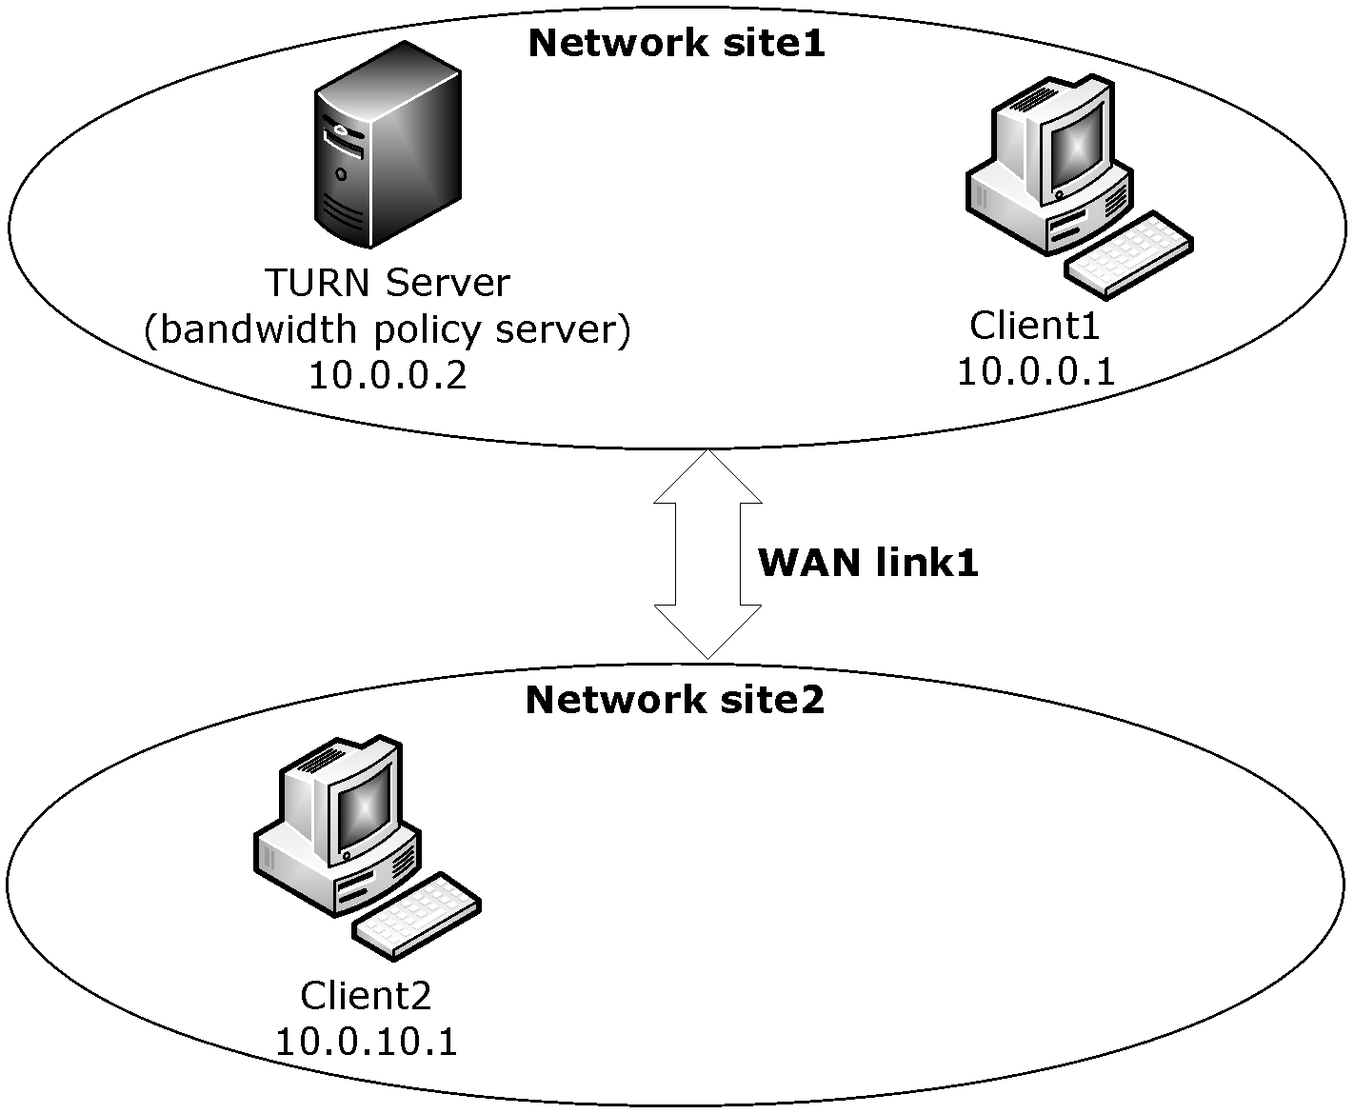
Figure 3: Two TURN clients connecting using SIP

Bandwidth Admission Control Message Flow with Sufficient Bandwidth
The following diagram shows the bandwidth admission control message flow for the network deployment described in section 4.1, where WAN Link1, between Network Site1 and Network Site2, has the full 1.54 megabytes of bandwidth available for use. TURN Client1 is attempting to make a voice call to TURN Client2 over WAN link1. The voice call requires between 64 kilobytes and 128 kilobytes of network bandwidth.
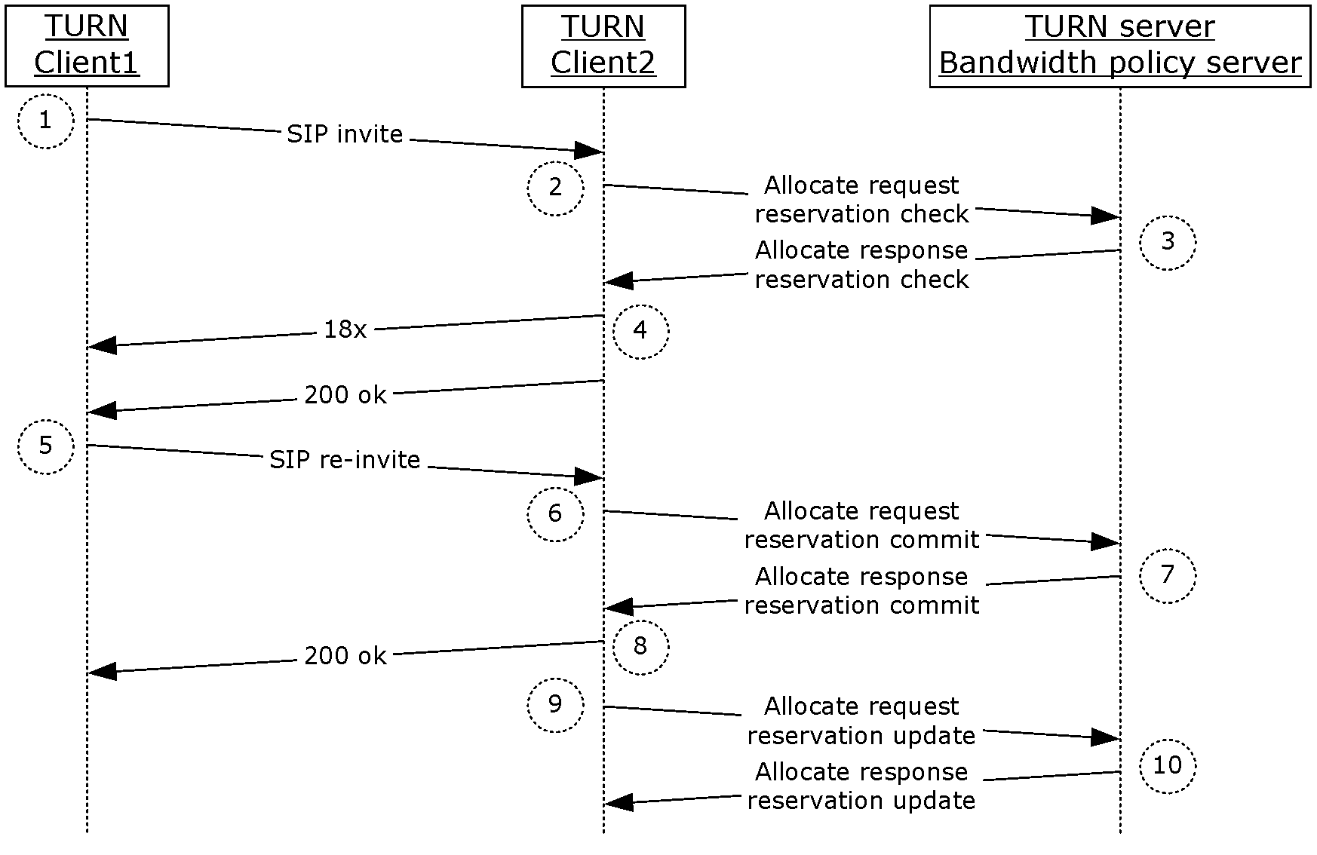
Figure 4: Bandwidth admission control message flow when sufficient bandwidth is available
- Client1 allocates a public transport from the TURN server following the procedures described in [MS-TURN] section 3.2.4.1. Client1’s relay transport address allocated by the TURN server is 192.0.2.20:55667. Client1 adds the relay transport address, along with its local transport address 10.0.0.1:12345, to the SDP of the SIP INVITE and sends the SIP INVITE to TURN Client2.
- When Client2 receives the SIP INVITE from Client1, it knows both the local transport address and the relay transport address of Client1. Client2 can now do a bandwidth check with the TURN server to verify the availability of network bandwidth between itself and Client1. It follows the procedure specified in section 3.2.4.1 to check for bandwidth admission control. It uses the following attributes in the Allocate Request carrying the Reservation Check message:
  - Bandwidth Admission Control Message attribute with a value of "Reservation Check".
  - A Remote Site Address attribute containing Client1’s local transport address XOR’d with the TURN message Transaction ID (specified in [MS-TURN] section 2.2.1).
  - A Remote Relay Site Address attribute containing Client1’s relay transport address XOR’d with the TURN message Transaction ID (specified in [MS-TURN] section 2.2.1).
  - A Local Site Address attribute containing Client2’s local transport address XORed with the TURN message Transaction ID (specified in [MS-TURN] section 2.2.1).
  - A Bandwidth Reservation Amount attribute with a value of 64 kilobytes for the minimum send/receive bandwidth and 128 kilobytes for the maximum send/receive bandwidth.
  - A MS-Service Quality attribute with a stream type of "Audio" and a service quality of "best effort delivery".
  - A Location Profile attribute with the Peer-Location set to "Intranet", the Self-Location set to "Intranet" and Federation set to "Not Federated".
- When the server (2) receives the Allocate Request message containing the Reservation Check, it follows the procedure specified in section 3.3.5.1 to determine if there is bandwidth available between Client1 and Client2. In this case, Client1’s local transport address maps to network site1, Client1’s relay transport address maps to network site1, Client2’s local transport address maps to network site2, and Client2’s relay transport address maps to network site1.
  - The server (2) checks the network path for each of the site addresses included in the Reservation Check request:
    - The server (2) checks the path between the Remote Site Address and the Remote Relay Site Address. Because both of these addresses map into the same network site, there are no bandwidth management constraints on that path and it is considered a valid network path. The server (2) marks the Remote Relay Site Address as valid for the full bandwidth amount, which is 128 kilobytes.
    - The server (2) checks the path between the Local Site Address and the Local Relay Site Address. In this case, the Local Site Address maps to network site2 but the Local Relay Site Address maps to network site1 and there is a bandwidth managed link, WAN link1, between these sites. The server (2) checks the amount of bandwidth requested in the Bandwidth Reservation Amount attribute against the amount of bandwidth currently available on WAN link1. Because this is the first call over this link there is still 1.54 megabytes available. The bandwidth amount being requested is 64 kilobytes-128 kilobytes, so the server (2) marks the Local Relay Site Address as valid for the full bandwidth amount, which is 128 kilobytes.
    - The server (2) checks the path between the Local Site Address and the Remote Site Address. In this case, the Local Site Address maps to network site2 but the Remote Site Address maps to network site1 and there is a bandwidth managed link, WAN link1, between these sites. The server (2) checks the amount of bandwidth requested in the Bandwidth Reservation Amount attribute against the amount of bandwidth currently available on WAN link1. Because this is the first call over this link, there is still 1.54 megabytes available. The bandwidth amount being requested is 64 kilobytes-128 kilobytes, so the server (2) marks both the Local Site Address and Remote Site Address as valid for the full bandwidth amount, which is 128 kilobytes.
  - The server (2) replies to Client2 with an Allocate Response message and includes the following attributes:
    - A Bandwidth Admission Control Message attribute with a value of "Reservation Check".
    - A Remote Site Address Response attribute with the Valid flag set (V="1") and a value of 128 kilobytes for the bandwidth amount value.
    - A Remote Relay Site Address Response attribute with a Valid flag set (V="1") and a value of 128 kilobytes for the bandwidth amount value.
    - A Local Site Address Response attribute with the Valid flag set (V="1") and a value of 128 kilobytes for the bandwidth amount value.
    - A Local Relay Site Address Response attribute with the Valid flag set (V="1") and a value of 128 kilobytes for the bandwidth amount values.
- When Client2 receives the Allocate Response message with the Reservation Check results, it follows the procedure specified in section 3.2.5.1 to determine which transport addresses can be used for the media stream. Because all network paths between both clients are marked as valid, it includes both its local and relay transport addresses in the SDP included in the SIP 200 OK message sent to Client1. In parallel, Client2 begins to explore the connectivity paths with Client1’s local and relay transport addresses.
- When Client1 receives the SIP 200 OK response that includes Client2’s transport addresses, it uses Client2’s transport addresses advertised in the SDP of the SIP 200 OK message to begin checking connectivity. In this example, Client1 and Client2 find that the best connectivity option is over each client’s local transport address. When Client1 finishes checking for connectivity, it sends a SIP re-INVITE to Client2 with SDP containing the local transport address.
- When Client2 receives the SIP re-INVITE from Client1, it uses the transport addresses advertised in the SDP along with the local transport addresses that passed the connectivity check to identify the network path over which the media stream will flow. In this example, the network path is between the local transport address of each client. Client2 uses these two transport addresses to do a Reservation Commit with the server (2). It follows the procedure specified in section 3.2.4.2 to commit a bandwidth admission control reservation. It uses the following attributes in the Allocate Request carrying the Reservation Commit message:
  - A Bandwidth Admission Control Message attribute with a value of "Reservation Commit".
  - A Remote Site Address attribute containing Client1’s local transport address XORed with the TURN message Transaction ID (specified in [MS-TURN] section 2.2.1).
  - A Local Site Address attribute containing Client2’s local transport address XORed with the TURN message Transaction ID (specified in [MS-TURN] section 2.2.1).
  - A Bandwidth Reservation Amount attribute with a value of 128 kilobytes for the minimum and maximum send/receive bandwidths.
  - A MS-Service Quality attribute with a stream type of "Audio" and a service quality of "best effort delivery".
  - A Location Profile attribute with the Peer-Location set to "Intranet", the Self-Location set to "Intranet" and Federation set to "Not Federated".
- When the server (2) receives the Allocate Request message containing the Reservation Commit, it follows the procedure specified in section 3.3.5.2 to commit the bandwidth reservation against the bandwidth policy for the network path specified by the site address attributes. In this example, the network path between the two clients is identified by the Local Site Address attribute and the Remote Site Address attribute, which map to WAN Link1. The server (2) commits 128 kilobytes, the amount of bandwidth from the Bandwidth Reservation Amount attribute, against the bandwidth policy covering WAN Link1. This leaves 1.412 megabytes (1.54 megabytes –128 kilobytes = 1.412 megabytes) of bandwidth available on WAN Link1. Once the server (2) has finished committing the bandwidth reservation against the bandwidth policy, it replies to Client2 in an Allocate Response message containing the following attributes:
  - A Bandwidth Admission Control Message attribute with a value of Reservation Commit.
  - A Bandwidth Reservation Identifier containing the reservation identifier created when the reservation was committed.
  - A Bandwidth Reservation Amount attribute containing 128 kilobytes for the minimum/maximum send/receive bandwidth values.
- When Client2 receives the Allocate Response message with the Reservation Commit results, it follows the procedure specified in section 3.2.5.2 and stores the Reservation ID returned in the Bandwidth Reservation Identifier attribute. The Reservation ID is used in subsequent Reservation Update messages sent to the server (2).
- When the Reservation Update timer fires on Client2, it refreshes the bandwidth reservation with the server (2). The refresh follows the procedure specified in section 3.2.4.3. It uses the following attributes in the Allocate Request carrying the Reservation Update message:
  - A Bandwidth Admission Control Message attribute with a value of "Reservation Update".
  - A Bandwidth Reservation Identifier attribute with a Reservation ID value that matches the reservation id received in response to the original Reservation Commit message.
  - A Bandwidth Reservation Amount attribute with the minimum/maximum send/receive bandwidth values set to 128 kilobytes, which is the amount of bandwidth reserved when the reservation was committed.
- When the server (2) receives the Allocate Request message containing the Reservation Update, it follows the procedure specified in section 3.3.5.3 to refresh the reservation. When the server (2) has reset the Bandwidth Reservation Lifetime timer, it replies to Client2 with an Allocate Response message containing the following attributes:
  - A Bandwidth Admission Control Message attribute with a value of "Reservation Update".
  - A Bandwidth Reservation Identifier containing the reservation identifier created when the reservation was committed.
  - A Bandwidth Reservation Amount attribute with the minimum/maximum send/receive bandwidth values set to 128 kilobytes, which is the amount of bandwidth reserved when the reservation was committed.

Bandwidth Admission Control Message Flow with Insufficient Bandwidth
The following diagram shows the bandwidth admission control message flow for the network deployment described in section 4.1, where WAN Link1, between Network Site1 and Network Site2, has no bandwidth available for use. TURN Client1 is attempting to make a voice call to TURN Client2 over WAN link1. The voice call requires between 64 kilobytes and 128 kilobytes of network bandwidth.
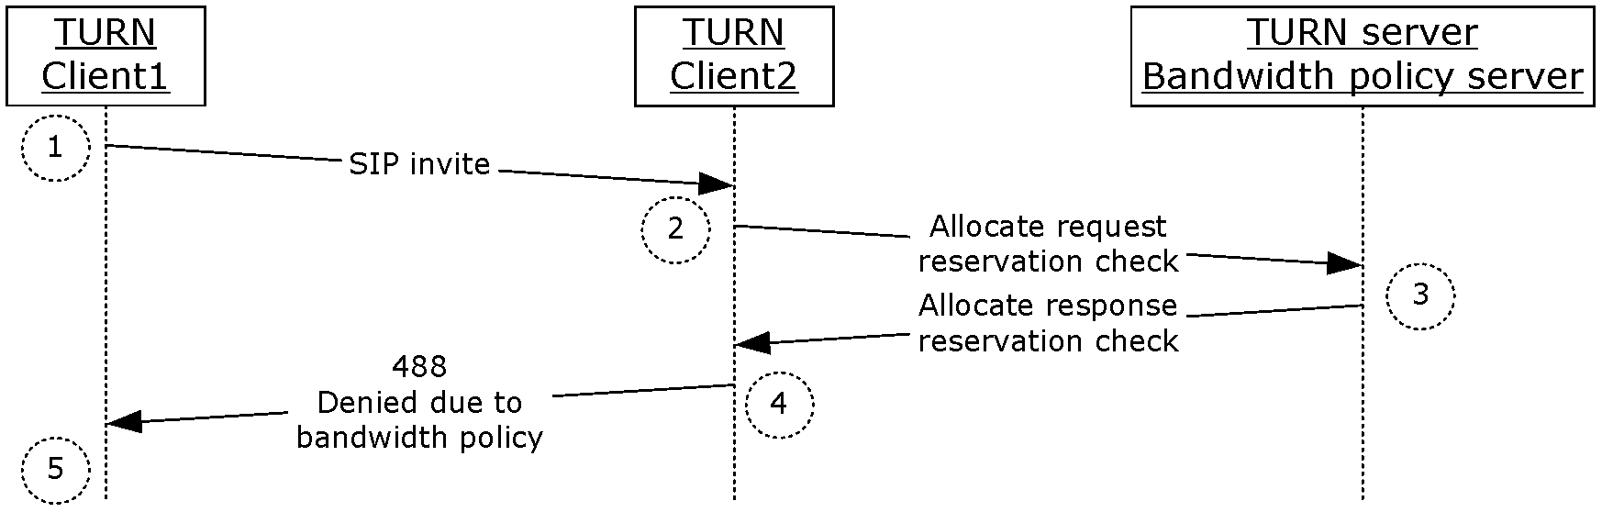
Figure 5: Bandwidth admission control message flow when insufficient bandwidth is available
- Client1 allocates a public transport from the TURN server following the procedures described in [MS-TURN] section 3.2.4.1. Client1’s relay transport address, allocated by the TURN server, is 192.0.2.20:55667. Client1 adds the relay transport address, along with its local transport address 10.0.0.1:12345, to the SDP of the SIP INVITE and sends the SIP INVITE to TURN Client2.
- When Client2 receives the SIP INVITE from Client1, it knows both the local transport address and relay transport address of Client1. Client2 can now do a bandwidth check with the TURN server to verify the availability of network bandwidth between itself and Client1. It follows the procedure specified in section 3.2.4.1 to check for bandwidth admission control. It uses the following attributes in the Allocate Request carrying the Reservation Check message:
  - A Bandwidth Admission Control Message attribute with a value of "Reservation Check".
  - A Remote Site Address attribute containing Client1’s local transport address XOR’d with the TURN message Transaction ID (specified in [MS-TURN] section 2.2.1).
  - A Remote Relay Site Address attribute containing Client1’s relay transport address XOR’d with the TURN message Transaction ID (specified in [MS-TURN] section 2.2.1).
  - A Local Site Address attribute containing Client2’s local transport address XOR’d with the TURN message Transaction ID (specified in [MS-TURN] section 2.2.1).
  - A Bandwidth Reservation Amount attribute with a value of 64 kilobytes for the minimum send/receive bandwidth and 128 kilobytes for the maximum send/receive bandwidth.
  - A MS-Service Quality attribute with a stream type of "Audio" and a service quality of "best effort delivery".
  - A Location Profile attribute with the Peer-Location set to "Intranet", the Self-Location set to "Intranet" and Federation set to "Not Federated".
- When the server (2) receives the Allocate Request message containing the Reservation Check, it follows the procedure specified in section 3.3.5.1 to determine if there is bandwidth available between Client1 and Client2. In this case, Client1’s local transport address maps to network site1, Client1’s relay transport address maps to network site1, Client2’s local transport address maps to network site2, and Client2’s relay transport address maps to network site1.
  - The server (2) checks the network path for each of the site addresses included in the Reservation Check request:
    - The server (2) checks the path between the Remote Site Address and the Remote Relay Site Address. Because both of these addresses map into the same network site, there is no bandwidth management constraints on that path and it is considered a valid network path. The server (2) marks the Remote Relay Site Address as valid for the full bandwidth amount, which is 128 kilobytes.
    - The server (2) checks the path between the Local Site Address and the Local Relay Site Address. In this case, the Local Site Address maps to network site2 but the Local Relay Site Address maps to network site1 and there is a bandwidth managed link, WAN link1, between these sites. The server (2) checks the amount of bandwidth requested in the Bandwidth Reservation Amount attribute against the amount of bandwidth currently available on WAN link1. Because all of the 1.54 megabytes that were available have been consumed by other calls, no bandwidth is available for a new call. The server (2) marks the Local Relay Site Address as invalid and sets the bandwidth value to zero.
    - The server (2) checks the path between the Local Site Address and the Remote Site Address. In this case, the Local Site Address maps to network site2 but the Remote Site Address maps to network site1 and there is a bandwidth managed link, WAN link1, between these sites. The server (2) checks the amount of bandwidth requested in the Bandwidth Reservation Amount attribute against the amount of bandwidth currently available on WAN link1. Because all of the 1.54 megabytes that was available has been consumed by other calls, no bandwidth is available for a new call. The server (2) marks both the Local Site Address and Remote Site Address as invalid and sets the bandwidth values to zero.
  - The server (2) replies to Client2 with an Allocate Response message and includes the following attributes:
    - A Bandwidth Admission Control Message attribute with a value of Reservation Check.
    - A Remote Site Address Response attribute with the Valid flag cleared (V="0") and a value of 0 kilobytes for the bandwidth amount values.
    - A Remote Relay Site Address Response attribute with a Valid flag set (V="1") and a value of 128 kilobytes for the bandwidth amount values.
    - A Local Site Address Response attribute with the Valid flag cleared (V="0") and a value of zero kilobytes for the bandwidth amount values.
    - A Local Relay Site Address Response attribute with the Valid flag cleared (V="0") and a value of zero kilobytes for the bandwidth amount values.
- When Client2 receives the Allocate Response message with the Reservation Check results, it follows the procedure specified in section 3.2.5.1 to determine which transport addresses can be used for the media stream. Because all network paths out of the local site are marked as invalid, Client2 is not able to check connectivity with Client1. Client2 sends a SIP 488 Call denied because of bandwidth policy failure response message to Client1.
- When Client1 receives the SIP 488 response, it notifies the user of the connection failure, indicating that no bandwidth was available to make the call.

Bandwidth Admission Control Message Flow with PSTN Gateways
The following diagram shows the bandwidth admission control message flow for the network deployment described in section 4.1, where WAN Link1, between Network Site1 and Network Site2, has no bandwidth available for use. Both Network Site1 and Network Site2 have PSTN gateway devices. TURN Client1 is attempting to make a voice call to TURN Client2 over WAN link1. The voice call requires between 64 kilobytes and 128 kilobytes of network bandwidth. Network Site1 is configured with a bandwidth policy that supports redirection of connections to PSTN if there is a bandwidth check failure.
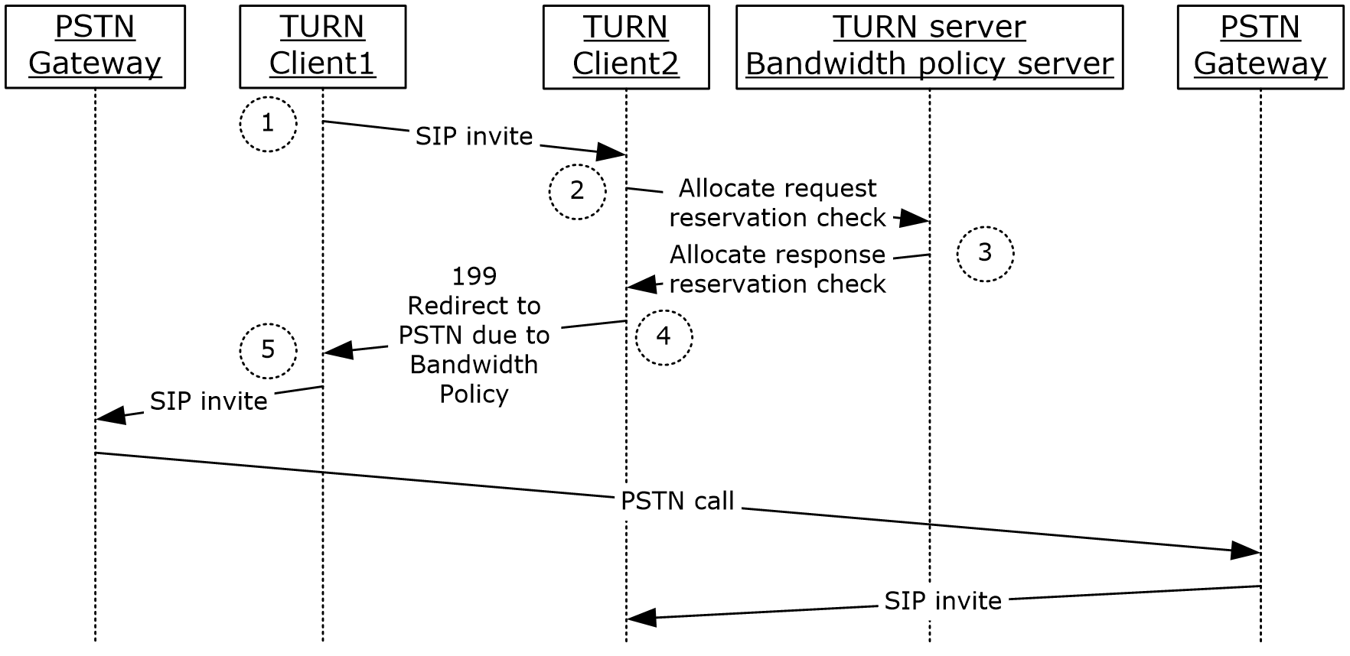
Figure 6: Bandwidth admission control message flow with PSTN Gateways
- Client1 allocates a public transport from the TURN server following the procedures described in [MS-TURN] section 3.2.4.1. Client1’s relay transport address, allocated by the TURN server, is 192.0.2.20:55667. Client1 adds the relay transport address, along with its local transport address 10.0.0.1:12345, to the SDP of the SIP INVITE and sends the SIP INVITE to TURN Client2.
- When Client2 receives the SIP INVITE from Client1, it knows both the local transport address and relay transport address of Client1. Client2 can now do a bandwidth check with the TURN server to verify the availability of network bandwidth between itself and Client1. It follows the procedure specified in section 3.2.4.1 to check for bandwidth admission control. It uses the following attributes in the Allocate Request carrying the Reservation Check message:
  - A Bandwidth Admission Control Message attribute with a value of "Reservation Check".
  - A Remote Site Address attribute containing Client1’s local transport address XOR’d with the TURN message Transaction ID (specified in [MS-TURN] section 2.2.1).
  - A Remote Relay Site Address attribute containing Client1’s relay transport address XOR’d with the TURN message Transaction ID (specified in [MS-TURN] section 2.2.1).
  - A Local Site Address attribute containing Client2’s local transport address XOR’d with the TURN message Transaction ID (specified in [MS-TURN] section 2.2.1).
  - A Bandwidth Reservation Amount attribute with a value of 64 kilobytes for the minimum send/receive bandwidth and 128 kilobytes for the maximum send/receive bandwidth.
  - A MS-Service Quality attribute with a stream type of "Audio" and a service quality of "best effort delivery".
  - A Location Profile attribute with the Peer-Location set to "Intranet", the Self-Location set to "Intranet" and Federation set to "Not Federated".
- When the server (2) receives the Allocate Request message containing the Reservation Check, it follows the procedure specified in section 3.3.5.1 to determine if there is bandwidth available between Client1 and Client2. In this case, Client1’s local transport address maps to network site1, Client1’s relay transport address maps to network site1, Client2’s local transport address maps to network site2, and Client2’s relay transport address maps to network site1.
  - The server (2) checks the network path for each of the site addresses included in the Reservation Check request:
    - The server (2) checks the path between the Remote Site Address and the Remote Relay Site Address. Because both of these addresses map into the same network site, there is no bandwidth management constraints on that path and it is considered a valid network path. The server (2) marks the Remote Relay Site Address as valid for the full bandwidth amount, which is 128 kilobytes.
    - The server (2) checks the path between the Local Site Address and the Local Relay Site Address. In this case, the Local Site Address maps to network site2 but the Local Relay Site Address maps to network site1 and there is a bandwidth managed link, WAN link1, between these sites. The server (2) checks the amount of bandwidth requested in the Bandwidth Reservation Amount attribute against the amount of bandwidth currently available on WAN link1. Because all of the 1.54 megabytes that were available have been consumed by other calls, no bandwidth is available for a new call. The server (2) marks the Local Relay Site Address as invalid and sets the bandwidth value to zero.
    - The server (2) checks the path between the Local Site Address and the Remote Site Address. In this case, the Local Site Address maps to network site2 but the Remote Site Address maps to network site1 and there is a bandwidth managed link, WAN link1, between these sites. The server (2) checks the amount of bandwidth requested in the Bandwidth Reservation Amount attribute against the amount of bandwidth currently available on WAN link1. Because all of the 1.54 megabytes that were available have been consumed by other calls, no bandwidth is available for a new call. The server (2) marks both the Local Site Address and Remote Site Address as invalid and sets the bandwidth values to zero. The server (2) checks the PSTN failover bandwidth policy for network site1 and finds that PSTN failover is supported, so it marks the PSTN Failover flag for the Remote Site Address as valid. The server (2) checks the PSTN failover bandwidth policy for network site2 and finds that PSTN failover is supported, so it marks the PSTN Failover flag for the Local Site Address as valid.
  - The server (2) replies to Client2 with an Allocate Response message and includes the following attributes:
    - A Bandwidth Admission Control Message attribute with a value of "Reservation Check".
    - A Remote Site Address Response attribute with the Valid flag cleared (V="0"), the PSTN Failover flag set (F="1") and a value of zero kilobytes for the bandwidth amount value.
    - A Remote Relay Site Address Response attribute with a Valid flag set (V="1") and a value of 128 kilobytes for the bandwidth amount value.
    - A Local Site Address Response attribute with the Valid flag cleared (V="0"), the PSTN Failover flag set (F="1") and a value of zero kilobytes for the bandwidth amount value.
    - A Local Relay Site Address Response attribute with the Valid flag cleared (V="0") and a value of 0 kilobytes for the bandwidth amount values.
- When Client2 receives the Allocate Response message with the Reservation Check results, it follows the procedure specified in section 3.2.5.1 to determine which transport addresses can be used for the media stream. Because all network paths out of the local site are marked as invalid, Client2 is not able to check connectivity with Client1. Because the PSTN Failover flag is set, Client2 sends a SIP 199 Call redirected to PSTN because of bandwidth policy failure response message to Client1.
- When Client1 receives the SIP 199 response redirecting it to attempt to use the PSTN gateway, it sends a SIP INVITE to a local PSTN gateway signaling it to use the PSTN to attempt to connect to Client2. The details of this signaling are omitted from this example. When Client2 receives the SIP INVITE from its local PSTN gateway device, it follows the example detailed in the diagram titled Bandwidth admission control message flow when sufficient bandwidth is available, and does a new Reservation Check and Reservation Commit for the media flow to the gateway

Security

Security Considerations for Implementers
This protocol has the same security considerations described in [MS-TURN] section 5. Additional considerations and mitigations for this protocol are as follows.
A client requests the bandwidth amount to reserve for a media stream in a Reservation Commit or a Reservation Update message. This makes it possible for a malicious client to make use of all of the available bandwidth for a bandwidth managed WAN link. It is recommended that a server have a configurable parameter that specifies the maximum reservation bandwidth amount that a client can reserve in a single Reservation Commit or Reservation Update message.

Index of Security Parameters
None.

Appendix A: Product Behavior
The information in this specification is applicable to the following Microsoft products or supplemental software. References to product versions include updates to those products.
- Microsoft Lync Server 2010
- Microsoft Lync Server 2013
- Microsoft Lync 2010
- Microsoft Lync Client 2013/Skype for Business
- Microsoft Skype for Business 2016
- Microsoft Skype for Business Server 2015
- Microsoft Skype for Business 2019
- Microsoft Skype for Business Server 2019
- Microsoft Skype for Business 2021
Exceptions, if any, are noted in this section. If an update version, service pack or Knowledge Base (KB) number appears with a product name, the behavior changed in that update. The new behavior also applies to subsequent updates unless otherwise specified. If a product edition appears with the product version, behavior is different in that product edition.
Unless otherwise specified, any statement of optional behavior in this specification that is prescribed using the terms "SHOULD" or "SHOULD NOT" implies product behavior in accordance with the SHOULD or SHOULD NOT prescription. Unless otherwise specified, the term "MAY" implies that the product does not follow the prescription.
<1> Section 2.2.4: Lync Server 2010, Lync 2010: IPv6 addresses are not supported.
<2> Section 2.2.4: Lync Server 2010, Lync 2010: IPv6 addresses are not supported.
<3> Section 2.2.4: Lync Server 2010, Lync 2010: IPv6 addresses are not supported.
<4> Section 2.2.4: Lync Server 2010, Lync 2010: IPv6 addresses are not supported.
<5> Section 2.2.5: Lync Server 2010, Lync 2010: IPv6 addresses are not supported.
<6> Section 2.2.5: Lync Server 2010, Lync 2010: IPv6 addresses are not supported.
<7> Section 2.2.5: Lync Server 2010, Lync 2010: IPv6 addresses are not supported.
<8> Section 2.2.5: Lync Server 2010, Lync 2010: IPv6 addresses are not supported.
<9> Section 2.2.6: Lync Server 2010, Lync 2010: IPv6 addresses are not supported.
<10> Section 2.2.6: Lync Server 2010, Lync 2010: IPv6 addresses are not supported.
<11> Section 2.2.6: Lync Server 2010, Lync 2010: IPv6 addresses are not supported.
<12> Section 2.2.6: Lync Server 2010, Lync 2010: IPv6 addresses are not supported.
<13> Section 2.2.7: Lync Server 2010, Lync 2010: IPv6 addresses are not supported.
<14> Section 2.2.7: Lync Server 2010, Lync 2010: IPv6 addresses are not supported.
<15> Section 2.2.7: Lync Server 2010, Lync 2010: IPv6 addresses are not supported.
<16> Section 2.2.7: Lync Server 2010, Lync 2010: IPv6 addresses are not supported.

Change Tracking
This section identifies changes that were made to this document since the last release. Changes are classified as Major, Minor, or None.
The revision class Major means that the technical content in the document was significantly revised. Major changes affect protocol interoperability or implementation. Examples of major changes are:
- A document revision that incorporates changes to interoperability requirements.
- A document revision that captures changes to protocol functionality.
The revision class Minor means that the meaning of the technical content was clarified. Minor changes do not affect protocol interoperability or implementation. Examples of minor changes are updates to clarify ambiguity at the sentence, paragraph, or table level.
The revision class None means that no new technical changes were introduced. Minor editorial and formatting changes may have been made, but the relevant technical content is identical to the last released version.
The changes made to this document are listed in the following table. For more information, please contact dochelp@microsoft.com.
Section | Description | Revision class
6 Appendix A: Product Behavior | Updated list of supported products. | Major

Index
A

Abstract data model
client (section 3.1.1 25, section 3.2.1 25)
proxy 25
server (section 3.1.1 25, section 3.3.1 29)
Applicability 12

B

Bandwidth admission control message flow with insufficient bandwidth example 38
Bandwidth admission control message flow with PSTN gateways example 40
Bandwidth admission control message flow with sufficient bandwidth example 34
Bandwidth Admission Control Message message 13
Bandwidth Reservation Amount message 14
Bandwidth Reservation Identifier message 13

C

Capability negotiation 12
Change tracking 46
Client
abstract data model (section 3.1.1 25, section 3.2.1 25)
higher-layer triggered events (section 3.1.4 25, section 3.2.4 26)
check for bandwidth admission control 26
commit a bandwidth reservation 26
update a bandwidth reservation 27
initialization (section 3.1.3 25, section 3.2.3 26)
message processing (section 3.1.5 25, section 3.2.5 27)
bandwidth admission control
check response 28
commit response 28
update response 29
other local events (section 3.1.7 25, section 3.2.7 29)
overview 25
sequencing rules (section 3.1.5 25, section 3.2.5 27)
bandwidth admission control
check response 28
commit response 28
update response 29
timer events (section 3.1.6 25, section 3.2.6 29)
timers (section 3.1.2 25, section 3.2.2 25)
Common
overview 25

D

Data model - abstract
client (section 3.1.1 25, section 3.2.1 25)
proxy 25
server (section 3.1.1 25, section 3.3.1 29)

E

Example
bandwidth admission control message flow with insufficient bandwidth 38
bandwidth admission control message flow with PSTN gateways 40
bandwidth admission control message flow with sufficient bandwidth 34
two TURN clients connecting using SIP 34
Examples 34

F

Fields - vendor-extensible 12

G

Glossary 6

H

Higher-layer triggered events
client (section 3.1.4 25, section 3.2.4 26)
check for bandwidth admission control 26
commit a bandwidth reservation 26
update a bandwidth reservation 27
proxy 25
server (section 3.1.4 25, section 3.3.4 30)

I

Implementer - security considerations 43
Index of security parameters 43
Informative references 8
Initialization
client (section 3.1.3 25, section 3.2.3 26)
proxy 25
server (section 3.1.3 25, section 3.3.3 30)
Introduction 6

L

Local Relay Site Address message 18
Local Relay Site Address Response message 22
Local Site Address message 17
Local Site Address Response message 21
Location Profile message 23

M

Message processing
client (section 3.1.5 25, section 3.2.5 27)
bandwidth admission control
check response 28
commit response 28
update response 29
proxy 25
server (section 3.1.5 25, section 3.3.5 30)
bandwidth admission control
check request 30
commit request 31
update request 32
Messages
Bandwidth Admission Control Message 13
Bandwidth Reservation Amount 14
Bandwidth Reservation Identifier 13
Local Relay Site Address 18
Local Relay Site Address Response 22
Local Site Address 17
Local Site Address Response 21
Location Profile 23
Remote Relay Site Address 16
Remote Relay Site Address Response 20
Remote Site Address 15
Remote Site Address Response 19
SIP Call Identifier 23
SIP Dialog Identifier 22
syntax 13
transport 13

N

Normative references 7

O

Other local events
client (section 3.1.7 25, section 3.2.7 29)
proxy 25
server (section 3.1.7 25, section 3.3.7 33)
Overview (synopsis) 8

P

Parameters - security index 43
Preconditions 12
Prerequisites 12
Product behavior 44
Proxy
abstract data model 25
higher-layer triggered events 25
initialization 25
message processing 25
other local events 25
sequencing rules 25
timer events 25
timers 25

R

References 7
informative 8
normative 7
Relationship to other protocols 11
Remote Relay Site Address message 16
Remote Relay Site Address Response message 20
Remote Site Address message 15
Remote Site Address Response message 19

S

Security
implementer considerations 43
parameter index 43
Sequencing rules
client (section 3.1.5 25, section 3.2.5 27)
bandwidth admission control
check response 28
commit response 28
update response 29
proxy 25
server (section 3.1.5 25, section 3.3.5 30)
bandwidth admission control
check request 30
commit request 31
update request 32
Server
abstract data model (section 3.1.1 25, section 3.3.1 29)
higher-layer triggered events (section 3.1.4 25, section 3.3.4 30)
initialization (section 3.1.3 25, section 3.3.3 30)
message processing (section 3.1.5 25, section 3.3.5 30)
bandwidth admission control
check request 30
commit request 31
update request 32
other local events (section 3.1.7 25, section 3.3.7 33)
overview 25
sequencing rules (section 3.1.5 25, section 3.3.5 30)
bandwidth admission control
check request 30
commit request 31
update request 32
timer events (section 3.1.6 25, section 3.3.6 33)
timers (section 3.1.2 25, section 3.3.2 29)
SIP Call Identifier message 23
SIP Dialog Identifier message 22
Standards assignments 12
Syntax 13

T

Timer events
client (section 3.1.6 25, section 3.2.6 29)
proxy 25
server (section 3.1.6 25, section 3.3.6 33)
Timers
client (section 3.1.2 25, section 3.2.2 25)
proxy 25
server (section 3.1.2 25, section 3.3.2 29)
Tracking changes 46
Transport 13
Triggered events – higher layer
client 25
Triggered events - higher-layer
client 26
check for bandwidth admission control 26
commit a bandwidth reservation 26
update a bandwidth reservation 27
server 30
Triggered events – higher-layer
proxy 25
server 25
Two TURN clients connecting using SIP example 34

V

Vendor-extensible fields 12
Versioning 12

