[MS-SIPCOMP]:
Session Initiation Protocol (SIP) Compression Protocol

Intellectual Property Rights Notice for Open Specifications Documentation
- Technical Documentation. Microsoft publishes Open Specifications documentation (“this documentation”) for protocols, file formats, data portability, computer languages, and standards support. Additionally, overview documents cover inter-protocol relationships and interactions.
- Copyrights. This documentation is covered by Microsoft copyrights. Regardless of any other terms that are contained in the terms of use for the Microsoft website that hosts this documentation, you can make copies of it in order to develop implementations of the technologies that are described in this documentation and can distribute portions of it in your implementations that use these technologies or in your documentation as necessary to properly document the implementation. You can also distribute in your implementation, with or without modification, any schemas, IDLs, or code samples that are included in the documentation. This permission also applies to any documents that are referenced in the Open Specifications documentation.
- No Trade Secrets. Microsoft does not claim any trade secret rights in this documentation.
- Patents. Microsoft has patents that might cover your implementations of the technologies described in the Open Specifications documentation. Neither this notice nor Microsoft's delivery of this documentation grants any licenses under those patents or any other Microsoft patents. However, a given Open Specifications document might be covered by the Microsoft Open Specifications Promise or the Microsoft Community Promise. If you would prefer a written license, or if the technologies described in this documentation are not covered by the Open Specifications Promise or Community Promise, as applicable, patent licenses are available by contacting iplg@microsoft.com.
- License Programs. To see all of the protocols in scope under a specific license program and the associated patents, visit the Patent Map.
- Trademarks. The names of companies and products contained in this documentation might be covered by trademarks or similar intellectual property rights. This notice does not grant any licenses under those rights. For a list of Microsoft trademarks, visit www.microsoft.com/trademarks.
- Fictitious Names. The example companies, organizations, products, domain names, email addresses, logos, people, places, and events that are depicted in this documentation are fictitious. No association with any real company, organization, product, domain name, email address, logo, person, place, or event is intended or should be inferred.
Reservation of Rights. All other rights are reserved, and this notice does not grant any rights other than as specifically described above, whether by implication, estoppel, or otherwise.
Tools. The Open Specifications documentation does not require the use of Microsoft programming tools or programming environments in order for you to develop an implementation. If you have access to Microsoft programming tools and environments, you are free to take advantage of them. Certain Open Specifications documents are intended for use in conjunction with publicly available standards specifications and network programming art and, as such, assume that the reader either is familiar with the aforementioned material or has immediate access to it.
Support. For questions and support, please contact dochelp@microsoft.com.
Revision Summary
Date | Revision History | Revision Class | Comments
4/4/2008 | 0.1 | New | Initial version
4/25/2008 | 0.2 | Minor | Updated based on feedback
6/27/2008 | 1.0 | Major | Updated based on feedback
8/15/2008 | 1.01 | Minor | Updated based on feedback
12/12/2008 | 2.0 | Major | Updated with latest template bug fixes (redlined)
2/13/2009 | 2.01 | Minor | Updated with latest template bug fixes (redlined)
3/13/2009 | 2.02 | Minor | Updated with latest template bug fixes (redlined)
7/13/2009 | 2.03 | Major | Revised and edited the technical content
8/28/2009 | 2.04 | Editorial | Revised and edited the technical content
11/6/2009 | 2.05 | Editorial | Revised and edited the technical content
2/19/2010 | 2.06 | Editorial | Revised and edited the technical content
3/31/2010 | 2.07 | Major | Updated and revised the technical content
4/30/2010 | 2.08 | Editorial | Revised and edited the technical content
6/7/2010 | 2.09 | Editorial | Revised and edited the technical content
6/29/2010 | 2.10 | Editorial | Changed language and formatting in the technical content.
7/23/2010 | 2.10 | None | No changes to the meaning, language, or formatting of the technical content.
9/27/2010 | 3.0 | Major | Significantly changed the technical content.
11/15/2010 | 3.0 | None | No changes to the meaning, language, or formatting of the technical content.
12/17/2010 | 3.0 | None | No changes to the meaning, language, or formatting of the technical content.
3/18/2011 | 3.0 | None | No changes to the meaning, language, or formatting of the technical content.
6/10/2011 | 3.0 | None | No changes to the meaning, language, or formatting of the technical content.
1/20/2012 | 3.1 | Minor | Clarified the meaning of the technical content.
4/11/2012 | 3.1 | None | No changes to the meaning, language, or formatting of the technical content.
7/16/2012 | 3.1 | None | No changes to the meaning, language, or formatting of the technical content.
10/8/2012 | 3.2 | Minor | Clarified the meaning of the technical content.
2/11/2013 | 3.2.1 | Editorial | Changed language and formatting in the technical content.
7/30/2013 | 3.2.1 | None | No changes to the meaning, language, or formatting of the technical content.
11/18/2013 | 3.2.1 | None | No changes to the meaning, language, or formatting of the technical content.
2/10/2014 | 3.2.1 | None | No changes to the meaning, language, or formatting of the technical content.
4/30/2014 | 3.2.1 | None | No changes to the meaning, language, or formatting of the technical content.
7/31/2014 | 3.3 | Minor | Clarified the meaning of the technical content.
10/30/2014 | 3.4 | Minor | Clarified the meaning of the technical content.
3/30/2015 | 4.0 | Major | Significantly changed the technical content.
9/4/2015 | 4.0 | None | No changes to the meaning, language, or formatting of the technical content.
7/15/2016 | 4.0 | None | No changes to the meaning, language, or formatting of the technical content.
9/14/2016 | 4.0 | None | No changes to the meaning, language, or formatting of the technical content.
9/29/2016 | 4.0 | None | No changes to the meaning, language, or formatting of the technical content.
10/17/2016 | 4.0 | None | No changes to the meaning, language, or formatting of the technical content.
4/27/2018 | 5.0 | Major | Significantly changed the technical content.
7/24/2018 | 6.0 | Major | Significantly changed the technical content.
8/28/2018 | 7.0 | Major | Significantly changed the technical content.
8/17/2021 | 8.0 | Major | Significantly changed the technical content.
Table of Contents
1 Introduction 6
1.1 Glossary 6
1.2 References 6
1.2.1 Normative References 6
1.2.2 Informative References 7
1.3 Overview 7
1.3.1 Message Flow 7
1.4 Relationship to Other Protocols 8
1.5 Prerequisites/Preconditions 9
1.6 Applicability Statement 9
1.7 Versioning and Capability Negotiation 9
1.8 Vendor-Extensible Fields 9
1.9 Standards Assignments 9
2 Messages 10
2.1 Transport 10
2.2 Message Syntax 10
2.2.1 NEGOTIATE Request Message Format 10
2.2.2 Response to NEGOTIATE Request 10
2.2.3 Compression SIP Header Field Syntax 10
2.2.4 Compression Packet Header Format 11
3 Protocol Details 12
3.1 Compression Negotiation Details 12
3.1.1 Abstract Data Model 12
3.1.2 Timers 12
3.1.3 Initialization 12
3.1.4 Higher-Layer Triggered Events 12
3.1.4.1 Initiating Compression Negotiation 12
3.1.5 Message Processing Events and Sequencing Rules 12
3.1.5.1 Sending NEGOTIATE Request from the Client 12
3.1.5.2 Processing NEGOTIATE Request in the Server 12
3.1.5.3 Processing Response of NEGOTIATE Request in the Client 13
3.1.6 Timer Events 13
3.1.7 Other Local Events 13
3.2 Compression Transport Details 13
3.2.1 Abstract Data Model 14
3.2.2 Timers 14
3.2.3 Initialization 14
3.2.4 Higher-Layer Triggered Events 14
3.2.5 Message Processing Events and Sequencing Rules 14
3.2.5.1 Compressing Data 15
3.2.5.1.1 Setting the Compression Flags 16
3.2.5.2 Decompressing Data 17
3.2.6 Timer Events 18
3.2.7 Other Local Events 19
4 Protocol Examples 20
4.1 NEGOTIATE Request for Compression Negotiation 20
4.2 OK to the NEGOTIATE Request 20
5 Security 21
5.1 Security Considerations for Implementers 21
5.2 Index of Security Parameters 21
6 Appendix A: Product Behavior 22
7 Change Tracking 23
8 Index 24

Introduction
The Session Initiation Protocol (SIP) Compression Protocol is the protocol for SIP signaling traffic compression. This protocol has two phases. The negotiation phase, which advertises and exchanges compression capabilities, and the transport phase that deals with encoding and decoding of the payload. This protocol is used by both the protocol client and the proxy.
Sections 1.5, 1.8, 1.9, 2, and 3 of this specification are normative. All other sections and examples in this specification are informative.

Glossary
This document uses the following terms:
200 OK: A response to indicate that the request has succeeded.
Augmented Backus-Naur Form (ABNF): A modified version of Backus-Naur Form (BNF), commonly used by Internet specifications. ABNF notation balances compactness and simplicity with reasonable representational power. ABNF differs from standard BNF in its definitions and uses of naming rules, repetition, alternatives, order-independence, and value ranges. For more information, see [RFC5234].
proxy: A computer, or the software that runs on it, that acts as a barrier between a network and the Internet by presenting only a single network address to external sites. By acting as a go-between that represents all internal computers, the proxy helps protects network identities while also providing access to the Internet.
Request-URI: A URI in an HTTP request message, as described in [RFC2616].
Session Initiation Protocol (SIP): An application-layer control (signaling) protocol for creating, modifying, and terminating sessions with one or more participants. SIP is defined in [RFC3261].
Transmission Control Protocol (TCP): A protocol used with the Internet Protocol (IP) to send data in the form of message units between computers over the Internet. TCP handles keeping track of the individual units of data (called packets) that a message is divided into for efficient routing through the Internet.
Transport Layer Security (TLS): A security protocol that supports confidentiality and integrity of messages in client and server applications communicating over open networks. TLS supports server and, optionally, client authentication by using X.509 certificates (as specified in [X509]). TLS is standardized in the IETF TLS working group.
MAY, SHOULD, MUST, SHOULD NOT, MUST NOT: These terms (in all caps) are used as defined in [RFC2119]. All statements of optional behavior use either MAY, SHOULD, or SHOULD NOT.

References
Links to a document in the Microsoft Open Specifications library point to the correct section in the most recently published version of the referenced document. However, because individual documents in the library are not updated at the same time, the section numbers in the documents may not match. You can confirm the correct section numbering by checking the Errata.

Normative References
We conduct frequent surveys of the normative references to assure their continued availability. If you have any issue with finding a normative reference, please contact dochelp@microsoft.com. We will assist you in finding the relevant information.
[MS-CONMGMT] Microsoft Corporation, "Connection Management Protocol".
[RFC2118] Pall, G., "Microsoft Point-To-Point Compression (MPPC) Protocol", RFC 2118, March 1997, http://www.ietf.org/rfc/rfc2118.txt
[RFC2119] Bradner, S., "Key words for use in RFCs to Indicate Requirement Levels", BCP 14, RFC 2119, March 1997, http://www.rfc-editor.org/rfc/rfc2119.txt
[RFC3261] Rosenberg, J., Schulzrinne, H., Camarillo, G., Johnston, A., Peterson, J., Sparks, R., Handley, M., and Schooler, E., "SIP: Session Initiation Protocol", RFC 3261, June 2002, http://www.ietf.org/rfc/rfc3261.txt
[RFC4346] Dierks, T., and Rescorla, E., "The Transport Layer Security (TLS) Protocol Version 1.1", RFC 4346, April 2006, http://www.ietf.org/rfc/rfc4346.txt
[RFC5234] Crocker, D., Ed., and Overell, P., "Augmented BNF for Syntax Specifications: ABNF", STD 68, RFC 5234, January 2008, http://www.rfc-editor.org/rfc/rfc5234.txt

Informative References
[MS-SIPAE] Microsoft Corporation, "Session Initiation Protocol (SIP) Authentication Extensions".

Overview
This protocol provides a way to perform compression between the protocol client and its first hop Session Initiation Protocol (SIP) proxy. This protocol defines the usage of a modified form of the Microsoft Point-to-Point Compression (MPPC) protocol to perform compression of SIP data. This protocol also defines the protocol for negotiating compression capability. The protocol client and server can operate as the sender of compressed data.

Message Flow
The following figure shows the message flow for a typical compression session for this protocol.
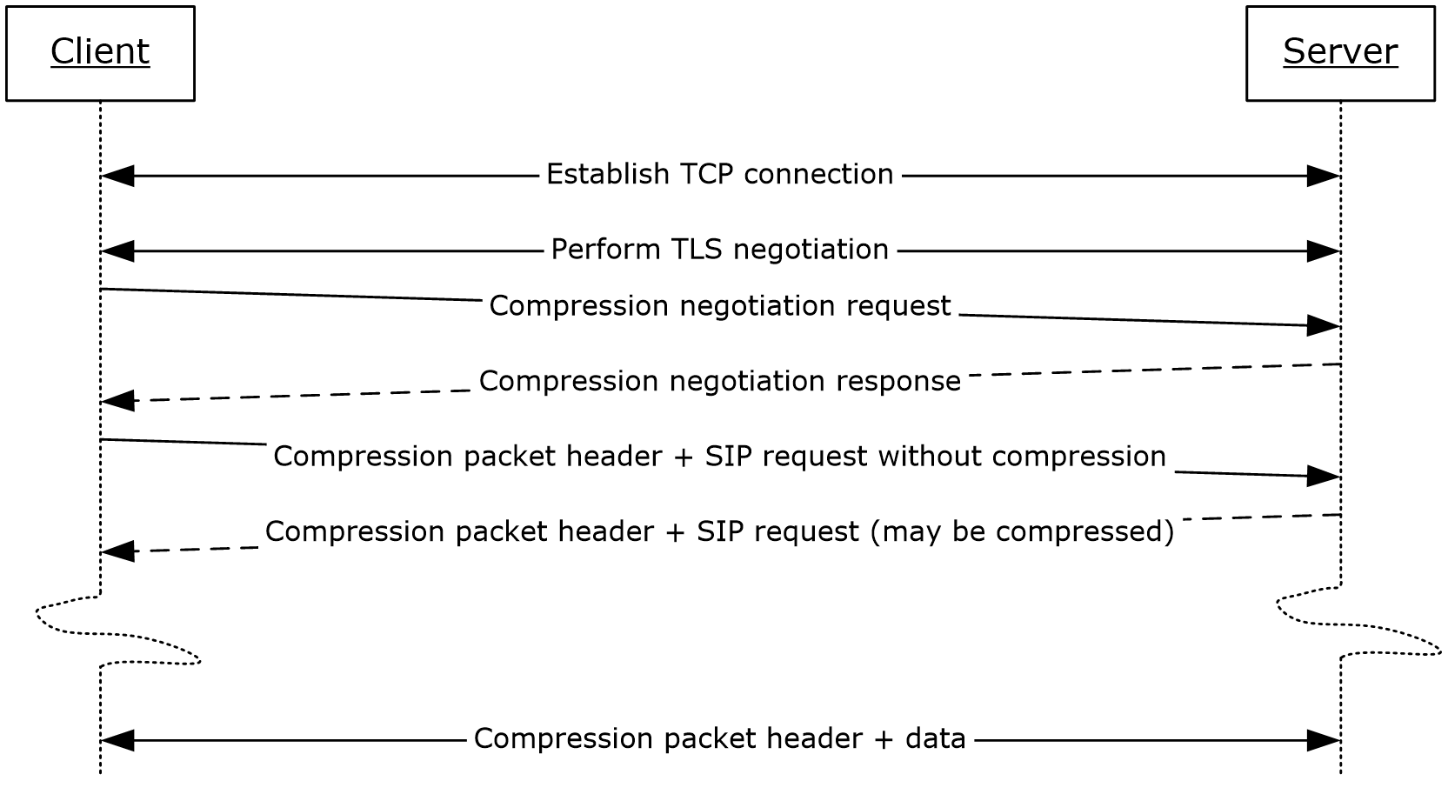
Figure 1: Typical message flow for this protocol
This protocol begins immediately following Transport Layer Security (TLS) negotiation. A protocol session has a negotiation phase and a transport phase. In the negotiation phase, the protocol client and server exchange a compression negotiation request and a compression negotiation response. In the transport phase, the protocol client and server exchange compression packet headers and data.
Some negotiation functions require the negotiation request to be sent before other SIP traffic begins to flow across the connection, and may also affect the format of subsequent packets. For example, Figure 2 illustrates a typical negotiation exchange that seeks to establish a compression session between the endpoints:
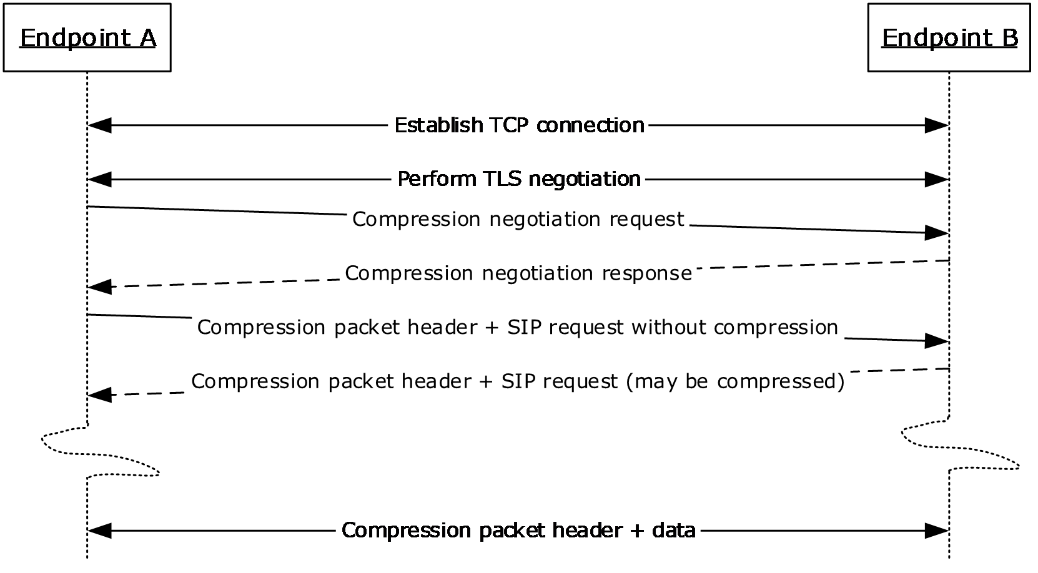
Figure 2: Typical message flow for compression negotiation
A successful compression negotiation response establishes a compression session, which alters the format of subsequent packets that flow across the connection by inserting a compression packet header ahead of the regular packet data. This session remains in effect until the connection is closed.

Relationship to Other Protocols
This protocol depends on the Microsoft Point-to-Point Compression (MPPC) protocol described in [RFC2118] for encoding and decoding compressed data. The compressed data is transported over a TLS channel.
The negotiation phase of the session determines whether data is compressed using this protocol or is sent uncompressed.
The following figure shows the logical relationship among the various protocols.
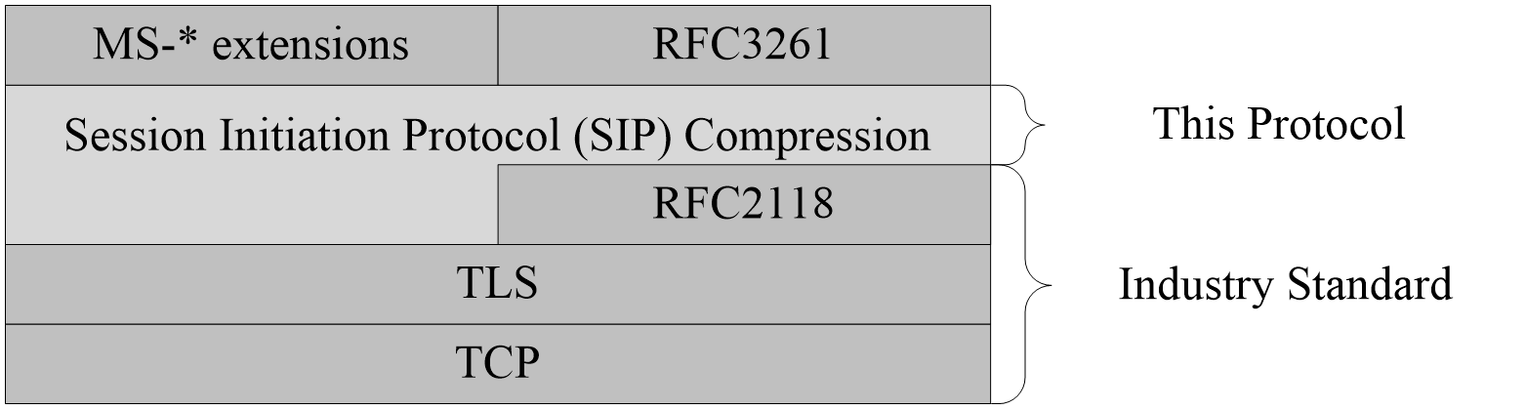
Figure 3: This protocol in relation to other protocols

Prerequisites/Preconditions
The TLS channel has to be established before this protocol starts the compression negotiation. In addition, the protocol client and server cannot have sent any SIP traffic on this connection before the compression negotiation.

Applicability Statement
This protocol is applicable when both the protocol client and the server support SIP and will use the enhancement offered by this protocol.

Versioning and Capability Negotiation
Protocol clients and servers supporting this protocol negotiate compression capability using the new NEGOTIATE method specified in section 2.2.1. The compression algorithm is negotiated using the Compression header field specified in section 2.2.3.

Vendor-Extensible Fields
None.

Standards Assignments
None.

Messages

Transport
The negotiation messages and payload for this protocol MUST be transported over an established TLS channel.

Message Syntax
All of the message syntax specified in this document is described in both prose and an Augmented Backus-Naur Form (ABNF), as defined in [RFC5234].

NEGOTIATE Request Message Format
This protocol extends [RFC3261] in defining a new SIP method for negotiation of compression. The capitalized NEGOTIATE token is an extension-method conforming to the method and extension-method grammar specified in [RFC3261] section 25.1 as follows:
Method = INVITEm / ACKm / OPTIONSm / BYEm
/ CANCELm / REGISTERm
/ extension-method
extension-method = token
The NEGOTIATE request MUST include the CSeq, Via, Call-ID, From, and To header fields constructed as specified in [RFC3261].
The NEGOTIATE request MUST<1> have a Max-Forwards header field value of 0. The NEGOTIATE method is not intended to be proxied beyond the first hop proxy.
The NEGOTIATE request MUST also include the Compression header field specified in section 2.2.3.
The NEGOTIATE request SHOULD NOT contain a Content-Type header field and it SHOULD NOT contain a message body.

Response to NEGOTIATE Request
The response for a NEGOTIATE request is constructed following the steps specified in [RFC3261] section 8.2.6.
In addition, the 200 OK response for the NEGOTIATE request MUST contain a Compression header field, as specified in section 2.2.3.

Compression SIP Header Field Syntax
This protocol defines a new Compression SIP header field.
Compression = "Compression" HCOLON compression-value
compression-value = "LZ77-8K" / token
The Compression header field is used to exchange the compression algorithm to be used. Currently, "LZ77-8K" is the only supported value.

Compression Packet Header Format
Once compression capability is negotiated, a Compression Packet header MUST precede a data segment to be sent over the compression negotiated TLS channel, as specified in [RFC4346].
The size of the Compression Packet header MUST be 6 bytes. The Compression Packet header has the following format.
0 | 1 | 2 | 3 | 4 | 5 | 6 | 7 | 8 | 9 | 1  0 | 1 | 2 | 3 | 4 | 5 | 6 | 7 | 8 | 9 | 2  0 | 1 | 2 | 3 | 4 | 5 | 6 | 7 | 8 | 9 | 3  0 | 1
flags |  |  |  | type |  |  |  | reserved
Uncompressed size |  |  |  |  |  |  |  |  |  |  |  |  |  |  |  | Data (variable, not part of the header)
...
flags (4 bits): The size of the flags MUST be 4 bits. The value is produced by performing a logical OR of the values in PACKET_FLUSHED, PACKET_AT_FRONT, and PACKET_COMPRESSED. The use of this value is further specified in section 3.2.5.1.1.
Name | Value | Description
PACKET_FLUSHED | 0x8 | If this flag is set, the data is not compressed and the receiver MUST reset the history buffer state. This flag MUST NOT be used in conjunction with PACKET_COMPRESSED.
PACKET_AT_FRONT | 0x4 | If this flag is set, uncompressed data is set at the beginning of the history buffer.
PACKET_COMPRESSED | 0x2 | If this flag is set, it indicates that the data is compressed. This flag MUST NOT be used in conjunction with PACKET_FLUSHED.
Undefined | 0x1 | This flag is not used. This flag MUST NOT be set.
type (4 bits): A 4-bit value used for the type of compression used. This value MUST be set to zero for this protocol. The server and client SHOULD ignore this value.
reserved (3 bytes): Three bytes that are not used. All bits MUST be set to zero by the sender, and MUST be ignored by the receiver.
Uncompressed size (2 bytes): The uncompressed size MUST be a 16-bit unsigned value containing the size of the original data before compression. An incorrect size MAY cause decompression to fail.
Data (variable): The data for the packet. This is not part of the header.

Protocol Details

Compression Negotiation Details
Both the protocol client and the server can operate as senders of compressed data. The protocol client and server advertise their compression capability and algorithm using the mechanism specified in this section.

Abstract Data Model
None.

Timers
After the protocol client sends the NEGOTIATE request, the protocol client MUST set timer F for the non-INVITE protocol client transaction, as specified in [RFC3261] section 17.1.2.2. However, instead of setting timer F to T1*64 seconds (with T1 having a default of 500ms as specified in [RFC3261] section 17.1.1.1), the protocol client SHOULD set timer F to 5 seconds. This smaller timer F value forces compression negotiation to complete within 5 seconds and shortens the maximum transport establishment delay between protocol client and server.

Initialization
The protocol client participating in this protocol MUST obtain the IP address of the first hop SIP proxy and the remote port with which the protocol client established the Transmission Control Protocol (TCP) connection and successfully negotiated the TLS channel. The first hop SIP proxy IP address and port is used to construct the Request-URI of the NEGOTIATE request.

Higher-Layer Triggered Events

Initiating Compression Negotiation
To participate in compression, a protocol client MUST send the compression negotiation request to the first hop SIP proxy after TLS negotiation is successfully finished and before sending any data on the TLS channel.

Message Processing Events and Sequencing Rules
This protocol uses the NEGOTIATE SIP non-INVITE transaction to negotiate compression capability. The NEGOTIATE request communicates the request to start compression. The NEGOTIATE is always sent from the protocol client to the server. The server MUST NOT start compression negotiation by sending a NEGOTIATE request to the protocol client.

Sending NEGOTIATE Request from the Client
The protocol client participating in compression MUST construct a NEGOTIATE message, as specified in section 2.2.1.

Processing NEGOTIATE Request in the Server
The server can receive a NEGOTIATE request after a TCP connection to a protocol client is established and TLS negotiation completes successfully. To participate in compression, the server MUST inspect the Compression header field and match the value "LZ77-8K". If the Compression header field does not contain "LZ77-8K", the server MUST respond to the NEGOTIATE request with a failure response code greater than or equal to 400.
If the server is unable to support compression negotiation for any reason, including internal causes such as resource limitations, the server MUST respond to the NEGOTIATE request with a failure response code greater than or equal to 400.
If the server receives a NEGOTIATE request with a Max-Forwards header field value greater than 0, it MUST<2> respond to the NEGOTIATE request with a failure response code greater than or equal to 400.
If the server receives a NEGOTIATE request with a Content-Type header field, it SHOULD ignore the header field.
If the server receives a NEGOTIATE request with a message body, it SHOULD ignore the message body. To proceed with compression negotiation, the server MUST construct a 200 OK response to the NEGOTIATE request, as specified in section 2.2.2.
The server MUST send a response to the NEGOTIATE request within 5 seconds, to prevent timer F in the protocol client from expiring.

Processing Response of NEGOTIATE Request in the Client
When the protocol client receives a response for the NEGOTIATE request, the protocol client MUST cancel the pending timer F. The protocol client then inspects the response code. Any response code other than 200 is treated as compression declined, and the protocol client and server MUST NOT start the transport phase of this protocol. If the response code is 200, the protocol client MUST inspect the Compression header field. If the header field value does not match "LZ77-8K", the server supports a compression algorithm that is different from the one used in this protocol. In this case, the protocol client MUST fail compression negotiation and tear down the TCP connection. If the header field value matches the expected value, the negotiation phase is successfully finished. This protocol then moves into the transport phase.

Timer Events
The protocol client's timer F for the NEGOTIATE non-INVITE transaction fires when the protocol client does not receive a response to the NEGOTIATE request. This is treated as compression declined, and the protocol client MUST reject any compressed data sent by the server, and MUST NOT start the transport phase of this protocol.

Other Local Events
If the established TCP connection is torn down on either the protocol client side or the server side, the negotiation phase is aborted and the connection is torn down, as specified in [MS-CONMGMT].

Compression Transport Details
Once the compression capability and algorithm are negotiated successfully, this protocol enters the transport phase. This protocol uses a modified form of the Point-to-Point Compression (MPPC) protocol specified in [RFC2118]. Unlike MPPC, instead of assuming an unreliable transport, this protocol compressed data is carried over a TLS channel on top of a TCP connection, which guarantees in-order transport.
Each data packet MUST include the compression packet header specified in section 2.2.4 when transporting over a connection on which this protocol has been successfully negotiated.

Abstract Data Model
This section describes a conceptual model of data organization that an implementation can maintain to participate in this protocol. The described organization is provided to facilitate the explanation of how the protocol behaves. This document does not mandate that implementations adhere to this model as long as their external behavior is consistent with that described in this protocol.
The shared state necessary to support the transmission and reception of compressed data between a protocol client and server requires a history buffer and a current offset into the history buffer (HistoryOffset). The size of the history buffer is 8 kilobytes. While compressing data, the sender inserts the uncompressed data that does not exceed 8 kilobytes at the position in the history buffer given by the HistoryOffset. After insertion, the HistoryOffset is advanced by the length of data added. If the data does not fit into the history buffer (the sum of the HistoryOffset and the size of the uncompressed data exceeds the size of the history buffer), the HistoryOffset MUST be reset to the start of the history buffer (offset 0).
As the receiver endpoint decompresses the data, it inserts the decompressed data at the position in the history buffer given by its local copy of HistoryOffset. If a reset occurs, the sender MUST notify the target receiver by setting the PACKET_FLUSHED flag in the compression packet header so it can reset its local state. After the data is decompressed, the receiver's history buffer and HistoryOffset are identical to the sender's history buffer and HistoryOffset.
Because the protocol client and server can send and receive compressed data, the protocol client and server MUST maintain two sets of state, one for sending and the other for receiving. Thus, the server maintains a history buffer and a HistoryOffset to send data to the protocol client, and a history buffer and a HistoryOffset to receive data from the protocol client. Similarly, the protocol client maintains a history buffer and a HistoryOffset to send data to the server, and a history buffer and a HistoryOffset to receive data from the server.
Both the protocol client and server SHOULD also maintain output buffers to store the output for compression and decompression operation.

Timers
None.

Initialization
The history buffer and HistoryOffset MUST both start initialized to zero.

Higher-Layer Triggered Events
None.

Message Processing Events and Sequencing Rules
The protocol server MAY start sending compressed data immediately after enters the transport phase. The protocol server SHOULD start sending compressed data only after it validates client identity to avoid committing memory and other resources for clients that were not yet validated. The server SHOULD use an authentication mechanism for client identity validation, such as the one those which are described in [MS-SIPAE] and MAY use any other mechanism of its choice.
The protocol client MUST NOT start compression before it receives the first compressed data from the server. The protocol client SHOULD start sending compressed data after it receives first compressed data from the server.

Compressing Data
The uncompressed data is first inserted into the local history buffer at the position indicated by the sender's HistoryOffset. The compressor then searches the uncompressed data for repeated series of characters, and produces output that is comprised of a sequence of literals (bytes to be sent uncompressed) and copy-tuples. Each copy-tuple represents a series of repeated characters, and consists of a <copy-offset, length-of-match> pair.
The copy-offset component of the copy-tuple is an index into the history buffer (counting backwards from the current byte towards the start of the buffer) to the most recent match of the data represented by the copy-tuple. The length-of-match component of the copy-tuple is the length of that match in bytes.
For example, consider the following string:
0 1 2 3 4
012345678901234567890123456789012345678901234567890
for whom the bell tolls, the bell tolls for thee.
The compressor produces the following:
for whom the bell tolls,<16,15> <40,4><19,3>e.
The <16,15> tuple is the compression of ".the.bell.tolls" and <40,4> is "for.", <19,3> gives "the".
The period (.) values indicate space characters.
After all data in the buffer is compressed into a sequence of literals and copy-tuples, it is then encoded using the MPPC protocol encoding scheme specified in [RFC2118] section 4.1 and section 4.2.
The tuple is constructed with the offset followed by the length-of-match.
According to [RFC2118], the offset in the tuple is to be encoded as follows:
- If the offset value is less than 64, the offset is encoded as 1111 followed by the lower 6 bits of the offset value.
- If the offset value is between 64 and 320, the offset is encoded as 1110 followed by the lower 8 bits of the offset value.
- If the offset value is between 320 and 8191, the offset is encoded as 110 followed by the lower 13 bits of the offset value.
- The offset value cannot be great than 8191 because the size of the history buffer is only 8 kilobytes.
According to [RFC2118], the length-of-match is to be encoded as follows:
- Bytes of a match of length less than 3 are encoded as literals.
- Length of 3 is encoded with bit 0.
- Length values from 4 to 7 are encoded as 10 followed by lower 2 bits of the value.
- Length values from 8 to 15 are encoded as 110 followed by lower 3 bits of the value.
- Length values from 16 to 31 are encoded as 1110 followed by lower 4 bits of the value.
- Length values from 32 to 63 are encoded as 11110 followed by lower 5 bits of the value.
- Length values from 64 to 127 are encoded as 111110 followed by lower 6 bits of the value.
- Length values from 128 to 255 are encoded as 1111110 followed by lower 7 bits of the value.
- Length values from 256 to 511 are encoded as 11111110 followed by lower 8 bits of the value.
- Length values from 512 to 1023 are encoded as 111111110 followed by lower 9 bits of the value.
- Length values from 1024 to 2047 are encoded as 1111111110 followed by lower 10 bits of the value.
- Length values from 2048 to 4095 are encoded as 11111111110 followed by lower 11 bits of the value.
- Length values from 4096 to 8191 are encoded as 111111111110 followed by lower 12 bits of the value.
To use the preceding example, the <16,15> tuple is encoded as 1111010000110111 where the higher 10 bits 1111010000 represents the offset (16) and the lower 6 bits 110111 represents the length of match (15).
If the resulting data after encoding is greater than the original bytes (that is, expansion instead of compression results), this results in a flush and the data is sent uncompressed to avoid sending more data than the original uncompressed bytes.

Setting the Compression Flags
The sender MUST always specify the compression flags associated with a compressed payload. These flags MUST be set in the flags field in the compression packet header.
The compression flags are produced by performing a logical OR of the values in PACKET_FLUSHED, PACKET_AT_FRONT, and PACKET_COMPRESSED.
PACKET_FLUSHED: Indicates that the history buffer MUST be reinitialized. This value corresponds to the MPPC protocol bit A, as specified in [RFC2118] section 3.1. This flag MUST be set without setting any other flags.
This flag MUST be set if the compression generates an expansion of the data and the flag indicates to the decompressor that it needs to reset its history buffer, reset its HistoryOffset value, and then restart the reception of the next batch of compressed bytes. If this condition occurs, the data MUST be sent in uncompressed form.
PACKET_AT_FRONT: Indicates that the decompressed data MUST be placed at the beginning of the local history buffer. This value corresponds to the MPPC protocol bit B, as specified in [RFC2118] section 3.1. This flag MUST be set in conjunction with the PACKET_COMPRESSED (0x2) flag.
The following conditions on the compressor side generate this scenario:
- This is the first packet to be compressed.
- The data to be compressed will not fit at the end of the history buffer but, instead, needs to be placed at the start of the history buffer.
PACKET_COMPRESSED: Indicates that the data is compressed. This value corresponds to the MPPC protocol bit C, as specified in [RFC2118] section 3.1. This flag MUST be set when the data is compressed.
The following figure shows the general operation of the compressor and the production of the various flag values.
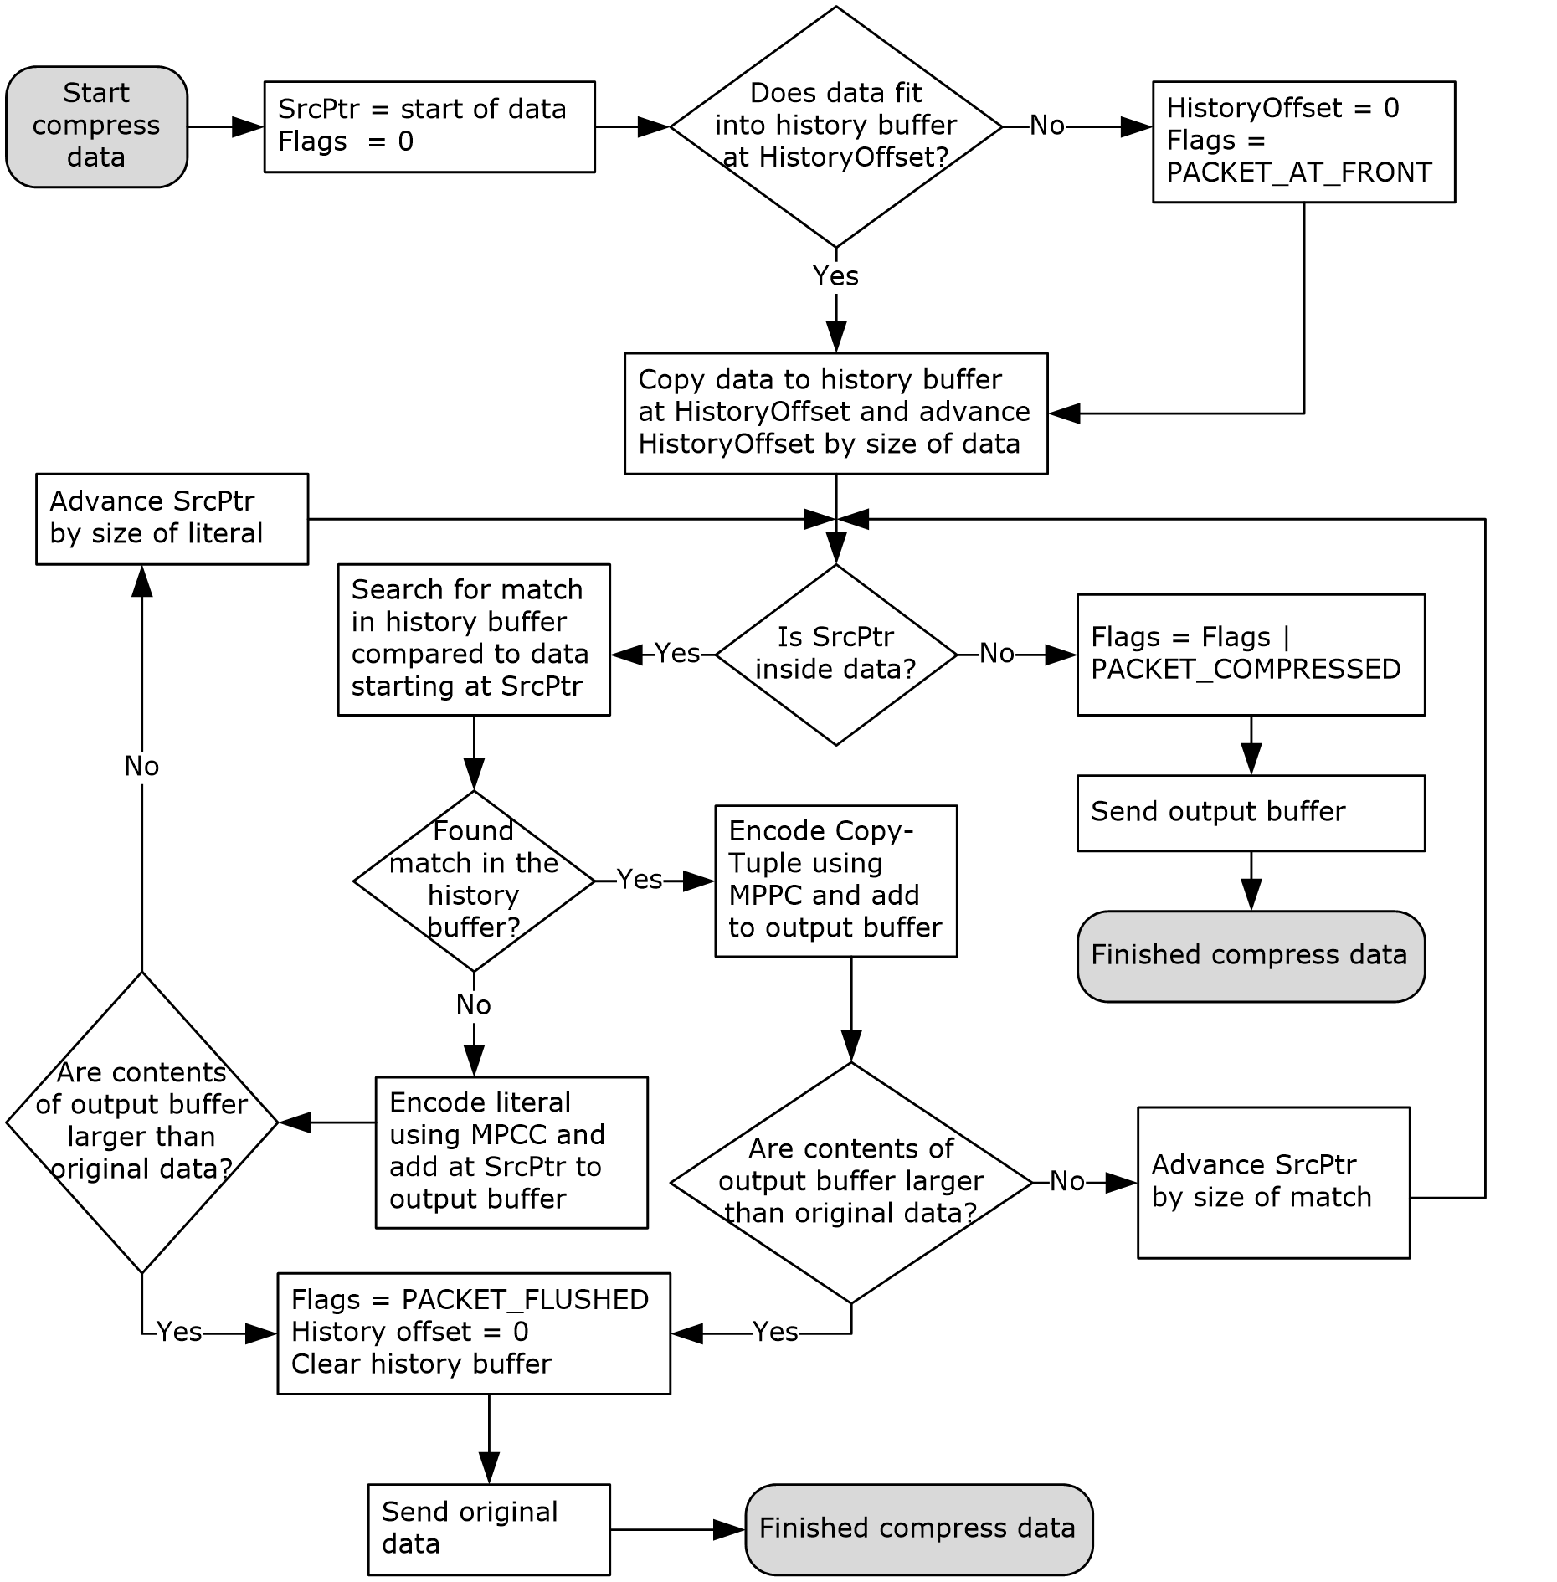
Figure 4: Compression flowchart

Decompressing Data
An endpoint which receives compressed data MUST decompress the data and store the resultant data at the end of the history buffer. The order of actions depends on the compression flags associated with the compressed data.
PACKET_FLUSHED: If this flag is set, the decompressor MUST reset its state by clearing the history buffer and resetting the HistoryOffset to 0.
PACKET_AT_FRONT: If this flag is set, the decompressor MUST start decompressing to the start of the history buffer, by resetting the HistoryOffset to 0. Otherwise, the decompressor MUST append the decompressed data to the end of the history buffer.
PACKET_COMPRESSED: If this flag is set, the decompressor MUST decompress the data, appending the decompressed data to the history buffer and advancing the HistoryOffset.
If the compression flags associated with the compressed data are inconsistent, the decompressor has reached an undefined state, and the receiving endpoint MUST tear down the TCP connection. Compression flags are inconsistent when PACKET_FLUSHED is set while PACKET_COMPRESSED is set.
The following diagram shows the general operation of the decompressor.
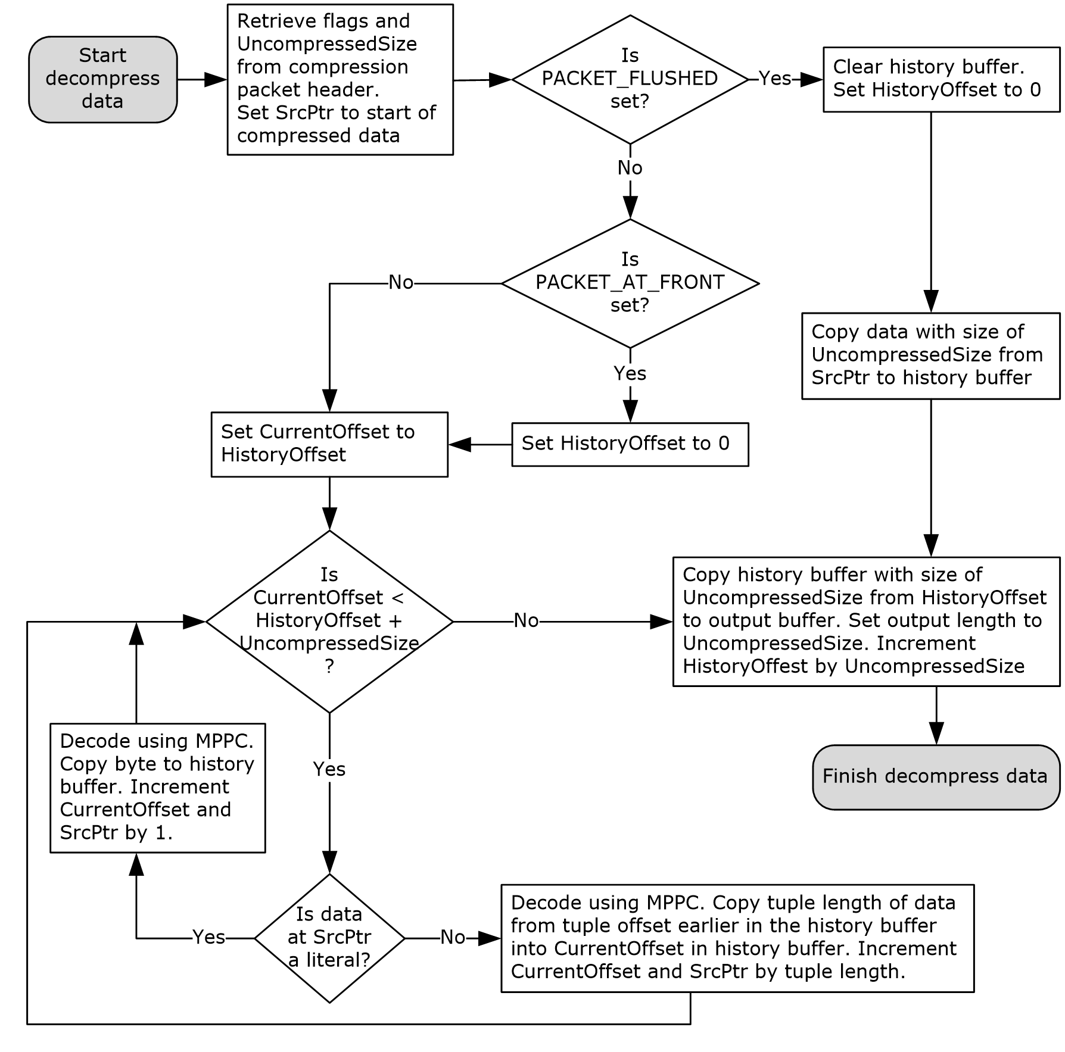
Figure 5: Decompression flowchart

Timer Events
None.

Other Local Events
None.

Protocol Examples

NEGOTIATE Request for Compression Negotiation
NEGOTIATE sip:192.0.0.1:5061 SIP/2.0
Via: SIP/2.0/TLS 192.0.0.2:2616
CSeq: 1 NEGOTIATE
Call-ID: 8d8b20f87c9c4221a732f3a70f57e9b8
From: <sip:192.0.0.2:2616>;tag=984721fb59b64e45b469c91aba8a9f8f
To: <sip:192.0.0.1:5061>
Compression: LZ77-8K
Max-Forwards: 0
Content-Length: 0

OK to the NEGOTIATE Request
SIP/2.0 200 OK
Compression: LZ77-8K
From: <sip:192.0.0.2:2616>;tag=984721fb59b64e45b469c91aba8a9f8f
To: <sip:192.0.0.1:5061>;tag=D76F601D7239923FBE84D78BF8821C85
Call-ID: 8d8b20f87c9c4221a732f3a70f57e9b8
CSeq: 1 NEGOTIATE
Via: SIP/2.0/TLS 192.0.0.2:2616;ms-received-port=2616;ms-received-cid=545400
Content-Length: 0

Security

Security Considerations for Implementers
None.

Index of Security Parameters
None.

Appendix A: Product Behavior
The information in this specification is applicable to the following Microsoft products or supplemental software. References to product versions include updates to those products.
- Microsoft Office Communications Server 2007
- Microsoft Office Communicator 2007
- Microsoft Office Communications Server 2007 R2
- Microsoft Office Communicator 2007 R2
- Microsoft Lync 2010
- Microsoft Lync Server 2010
- Microsoft Lync Client 2013/Skype for Business
- Microsoft Lync Server 2013
- Microsoft Skype for Business 2016
- Microsoft Skype for Business Server 2015
- Microsoft Skype for Business 2019
- Microsoft Skype for Business Server 2019
- Microsoft Skype for Business 2021
Exceptions, if any, are noted in this section. If an update version, service pack or Knowledge Base (KB) number appears with a product name, the behavior changed in that update. The new behavior also applies to subsequent updates unless otherwise specified. If a product edition appears with the product version, behavior is different in that product edition.
Unless otherwise specified, any statement of optional behavior in this specification that is prescribed using the terms "SHOULD" or "SHOULD NOT" implies product behavior in accordance with the SHOULD or SHOULD NOT prescription. Unless otherwise specified, the term "MAY" implies that the product does not follow the prescription.
<1> Section 2.2.1: Office Communications Server 2007 R2 can accept a NEGOTIATE request that does not have a Max-Forwards header, which is different from the specifications in [RFC3261] section 8.1.1.
<2> Section 3.1.5.2: Office Communications Server 2007 R2, Office Communicator 2007 R2: If the server receives a NEGOTIATE request with a Max-Forwards header field value greater than 0, it ignores the header field value.

Change Tracking
This section identifies changes that were made to this document since the last release. Changes are classified as Major, Minor, or None.
The revision class Major means that the technical content in the document was significantly revised. Major changes affect protocol interoperability or implementation. Examples of major changes are:
- A document revision that incorporates changes to interoperability requirements.
- A document revision that captures changes to protocol functionality.
The revision class Minor means that the meaning of the technical content was clarified. Minor changes do not affect protocol interoperability or implementation. Examples of minor changes are updates to clarify ambiguity at the sentence, paragraph, or table level.
The revision class None means that no new technical changes were introduced. Minor editorial and formatting changes may have been made, but the relevant technical content is identical to the last released version.
The changes made to this document are listed in the following table. For more information, please contact dochelp@microsoft.com.
Section | Description | Revision class
6 Appendix A: Product Behavior | Updated list of supported products. | Major

Index
A

Abstract data model
compression negotiation 12
compression transport 14
Applicability 9

C

Capability negotiation 9
Change tracking 23
Compression negotiation
abstract data model 12
higher-layer triggered events 12
initialization 12
local events 13
message processing 12
process NEGOTIATE request 12
process response to NEGOTIATE request 13
send NEGOTIATE request 12
overview 12
sequencing rules 12
process NEGOTIATE request 12
process response to NEGOTIATE request 13
send NEGOTIATE request 12
timer events 13
timers 12
Compression Packet Header Format message 11
Compression SIP Header Field Syntax message 10
Compression transport
abstract data model 14
higher-layer triggered events 14
initialization 14
local events 19
message processing 14
compress data 15
decompress data 17
overview 13
sequencing rules
compress data 15
decompress data 17
timer events 18
timers 14

D

Data model - abstract
compression negotiation 12
compression transport 14

E

Examples
200 OK to NEGOTIATE request 20
NEGOTIATE request 20

F

Fields - vendor-extensible 9

G

Glossary 6

H

Higher-layer triggered events
compression negotiation 12
compression transport 14

I

Implementer - security considerations 21
Index of security parameters 21
Informative references 7
Initialization
compression negotiation 12
compression transport 14
Introduction 6

L

Local events
compression negotiation 13
compression transport 19

M

Message flow 7
Message processing
compression negotiation 12
process NEGOTIATE request 12
process response to NEGOTIATE request 13
send NEGOTIATE request 12
compression transport 14
compress data 15
decompress data 17
Messages
Compression Packet Header Format 11
Compression SIP Header Field Syntax 10
NEGOTIATE Request Message Format 10
Response to NEGOTIATE Request 10
transport 10

N

NEGOTIATE request 200 OK example 20
NEGOTIATE request example 20
NEGOTIATE Request Message Format message 10
Normative references 6

O

Overview (synopsis) 7

P

Parameters - security index 21
Preconditions 9
Prerequisites 9
Product behavior 22
Protocol overview
message flow 7

R

References 6
informative 7
normative 6
Relationship to other protocols 8
Response to NEGOTIATE Request message 10

S

Security
implementer considerations 21
parameter index 21
Sequencing rules
compression negotiation 12
process NEGOTIATE request 12
process response to NEGOTIATE request 13
send NEGOTIATE request 12
compression transport
compress data 15
decompress data 17
Standards assignments 9

T

Timer events
compression negotiation 13
compression transport 18
Timers
compression negotiation 12
compression transport 14
Tracking changes 23
Transport 10
Triggered events
compression negotiation 12
compression transport 14

V

Vendor-extensible fields 9
Versioning 9

