[MS-OCEXUM]:
Call Control for Exchange Unified Messaging Protocol Extensions

Intellectual Property Rights Notice for Open Specifications Documentation
- Technical Documentation. Microsoft publishes Open Specifications documentation (“this documentation”) for protocols, file formats, data portability, computer languages, and standards support. Additionally, overview documents cover inter-protocol relationships and interactions.
- Copyrights. This documentation is covered by Microsoft copyrights. Regardless of any other terms that are contained in the terms of use for the Microsoft website that hosts this documentation, you can make copies of it in order to develop implementations of the technologies that are described in this documentation and can distribute portions of it in your implementations that use these technologies or in your documentation as necessary to properly document the implementation. You can also distribute in your implementation, with or without modification, any schemas, IDLs, or code samples that are included in the documentation. This permission also applies to any documents that are referenced in the Open Specifications documentation.
- No Trade Secrets. Microsoft does not claim any trade secret rights in this documentation.
- Patents. Microsoft has patents that might cover your implementations of the technologies described in the Open Specifications documentation. Neither this notice nor Microsoft's delivery of this documentation grants any licenses under those patents or any other Microsoft patents. However, a given Open Specifications document might be covered by the Microsoft Open Specifications Promise or the Microsoft Community Promise. If you would prefer a written license, or if the technologies described in this documentation are not covered by the Open Specifications Promise or Community Promise, as applicable, patent licenses are available by contacting iplg@microsoft.com.
- License Programs. To see all of the protocols in scope under a specific license program and the associated patents, visit the Patent Map.
- Trademarks. The names of companies and products contained in this documentation might be covered by trademarks or similar intellectual property rights. This notice does not grant any licenses under those rights. For a list of Microsoft trademarks, visit www.microsoft.com/trademarks.
- Fictitious Names. The example companies, organizations, products, domain names, email addresses, logos, people, places, and events that are depicted in this documentation are fictitious. No association with any real company, organization, product, domain name, email address, logo, person, place, or event is intended or should be inferred.
Reservation of Rights. All other rights are reserved, and this notice does not grant any rights other than as specifically described above, whether by implication, estoppel, or otherwise.
Tools. The Open Specifications documentation does not require the use of Microsoft programming tools or programming environments in order for you to develop an implementation. If you have access to Microsoft programming tools and environments, you are free to take advantage of them. Certain Open Specifications documents are intended for use in conjunction with publicly available standards specifications and network programming art and, as such, assume that the reader either is familiar with the aforementioned material or has immediate access to it.
Support. For questions and support, please contact dochelp@microsoft.com.
Revision Summary
Date | Revision History | Revision Class | Comments
4/4/2008 | 0.1 | New | Initial version
4/25/2008 | 0.2 | Minor | Revised and edited technical content
6/27/2008 | 1.0 | Major | Revised and edited technical content
8/15/2008 | 1.01 | Minor | Revised and edited technical content
12/12/2008 | 2.0 | Major | Revised and edited technical content
2/13/2009 | 2.01 | Minor | Revised and edited technical content
3/13/2009 | 2.02 | Minor | Revised and edited technical content
7/13/2009 | 2.03 | Major | Revised and edited the technical content
8/28/2009 | 2.04 | Editorial | Revised and edited the technical content
11/6/2009 | 2.05 | Editorial | Revised and edited the technical content
2/19/2010 | 2.06 | Editorial | Revised and edited the technical content
3/31/2010 | 2.07 | Major | Updated and revised the technical content
4/30/2010 | 2.08 | Editorial | Revised and edited the technical content
6/7/2010 | 2.09 | Editorial | Revised and edited the technical content
6/29/2010 | 2.10 | Editorial | Changed language and formatting in the technical content.
7/23/2010 | 2.10 | None | No changes to the meaning, language, or formatting of the technical content.
9/27/2010 | 3.0 | Major | Significantly changed the technical content.
11/15/2010 | 3.0 | None | No changes to the meaning, language, or formatting of the technical content.
12/17/2010 | 3.0 | None | No changes to the meaning, language, or formatting of the technical content.
3/18/2011 | 3.0 | None | No changes to the meaning, language, or formatting of the technical content.
6/10/2011 | 3.0 | None | No changes to the meaning, language, or formatting of the technical content.
1/20/2012 | 4.0 | Major | Significantly changed the technical content.
4/11/2012 | 4.0 | None | No changes to the meaning, language, or formatting of the technical content.
7/16/2012 | 4.0 | None | No changes to the meaning, language, or formatting of the technical content.
10/8/2012 | 4.0.1 | Editorial | Changed language and formatting in the technical content.
2/11/2013 | 4.0.1 | None | No changes to the meaning, language, or formatting of the technical content.
7/30/2013 | 4.0.1 | None | No changes to the meaning, language, or formatting of the technical content.
11/18/2013 | 4.0.1 | None | No changes to the meaning, language, or formatting of the technical content.
2/10/2014 | 4.0.1 | None | No changes to the meaning, language, or formatting of the technical content.
4/30/2014 | 4.1 | Minor | Clarified the meaning of the technical content.
7/31/2014 | 4.2 | Minor | Clarified the meaning of the technical content.
10/30/2014 | 4.3 | Minor | Clarified the meaning of the technical content.
3/30/2015 | 5.0 | Major | Significantly changed the technical content.
9/4/2015 | 5.0 | None | No changes to the meaning, language, or formatting of the technical content.
7/15/2016 | 5.0 | None | No changes to the meaning, language, or formatting of the technical content.
9/14/2016 | 5.0 | None | No changes to the meaning, language, or formatting of the technical content.
4/27/2018 | 6.0 | Major | Significantly changed the technical content.
7/24/2018 | 7.0 | Major | Significantly changed the technical content.
8/28/2018 | 8.0 | Major | Significantly changed the technical content.
8/17/2021 | 9.0 | Major | Significantly changed the technical content.
Table of Contents
1 Introduction 5
1.1 Glossary 5
1.2 References 6
1.2.1 Normative References 6
1.2.2 Informative References 6
1.3 Overview 6
1.4 Relationship to Other Protocols 7
1.5 Prerequisites/Preconditions 7
1.6 Applicability Statement 7
1.7 Versioning and Capability Negotiation 7
1.8 Vendor-Extensible Fields 7
1.9 Standards Assignments 7
2 Messages 8
2.1 Transport 8
2.2 Message Syntax 8
2.2.1 Ms-Exchange-Command 8
2.2.2 Ms-Sensitivity 8
3 Protocol Details 10
3.1 Ms-Exchange-Command Details 10
3.1.1 Abstract Data Model 10
3.1.2 Timers 10
3.1.3 Initialization 10
3.1.4 Higher-Layer Triggered Events 10
3.1.5 Message Processing Events and Sequencing Rules 10
3.1.6 Timer Events 10
3.1.7 Other Local Events 10
3.2 Ms-Sensitivity Details 11
3.2.1 Abstract Data Model 11
3.2.2 Timers 11
3.2.3 Initialization 11
3.2.4 Higher-Layer Triggered Events 11
3.2.5 Message Processing Events and Sequencing Rules 11
3.2.6 Timer Events 11
3.2.7 Other Local Events 12
4 Protocol Examples 13
4.1 Ms-Exchange-Command 13
4.2 Ms-Sensitivity 13
5 Security 15
5.1 Security Considerations for Implementers 15
5.2 Index of Security Parameters 15
6 Appendix A: Product Behavior 16
7 Change Tracking 17
8 Index 18

Introduction
The Call Control for Exchange Unified Messaging Protocol Extensions, which consist of proprietary extensions to the Session Initiation Protocol (SIP), is used to play voice messages and to manage the unified messaging mailbox using voice commands. SIP is used to establish, modify, and terminate multimedia sessions or calls. These protocol extensions are used to integrate with other telephony networks or systems, such as a private branch exchange (PBX).
Sections 1.5, 1.8, 1.9, 2, and 3 of this specification are normative. All other sections and examples in this specification are informative.

Glossary
This document uses the following terms:
Augmented Backus-Naur Form (ABNF): A modified version of Backus-Naur Form (BNF), commonly used by Internet specifications. ABNF notation balances compactness and simplicity with reasonable representational power. ABNF differs from standard BNF in its definitions and uses of naming rules, repetition, alternatives, order-independence, and value ranges. For more information, see [RFC5234].
authentication: The act of proving an identity to a server while providing key material that binds the identity to subsequent communications.
endpoint: A device that is connected to a computer network.
Exchange Web Service (EWS): A service that is provided by Microsoft Exchange Server and that enables clients to access mailbox content.
INVITE: A Session Initiation Protocol (SIP) method that is used to invite a user or a service to participate in a session.
personal identification number (PIN): A number that is used by Exchange Unified Messaging to authenticate a user.
server: A replicating machine that sends replicated files to a partner (client). The term "server" refers to the machine acting in response to requests from partners that want to receive replicated files.
Session Initiation Protocol (SIP): An application-layer control (signaling) protocol for creating, modifying, and terminating sessions with one or more participants. SIP is defined in [RFC3261].
SIP message: The data that is exchanged between Session Initiation Protocol (SIP) elements as part of the protocol. An SIP message is either a request or a response.
subscriber access: The ability of a user to gain access to features of a Unified Messaging server, such as using a phone to listen to telephony voice messages or email messages.
Transmission Control Protocol (TCP): A protocol used with the Internet Protocol (IP) to send data in the form of message units between computers over the Internet. TCP handles keeping track of the individual units of data (called packets) that a message is divided into for efficient routing through the Internet.
Transport Layer Security (TLS): A security protocol that supports confidentiality and integrity of messages in client and server applications communicating over open networks. TLS supports server and, optionally, client authentication by using X.509 certificates (as specified in [X509]). TLS is standardized in the IETF TLS working group.
Uniform Resource Identifier (URI): A string that identifies a resource. The URI is an addressing mechanism defined in Internet Engineering Task Force (IETF) Uniform Resource Identifier (URI): Generic Syntax [RFC3986].
user agent client (UAC): A logical entity that creates a new request, and then uses the client transaction state machinery to send it. The role of UAC lasts only for the duration of that transaction. In other words, if a piece of software initiates a request, it acts as a UAC for the duration of that transaction. If it receives a request later, it assumes the role of a user agent server (UAS) for the processing of that transaction.
MAY, SHOULD, MUST, SHOULD NOT, MUST NOT: These terms (in all caps) are used as defined in [RFC2119]. All statements of optional behavior use either MAY, SHOULD, or SHOULD NOT.

References
Links to a document in the Microsoft Open Specifications library point to the correct section in the most recently published version of the referenced document. However, because individual documents in the library are not updated at the same time, the section numbers in the documents may not match. You can confirm the correct section numbering by checking the Errata.

Normative References
We conduct frequent surveys of the normative references to assure their continued availability. If you have any issue with finding a normative reference, please contact dochelp@microsoft.com. We will assist you in finding the relevant information.
[MS-EUMR] Microsoft Corporation, "Routing to Exchange Unified Messaging Extensions".
[MS-OXWUMS] Microsoft Corporation, "Voice Mail Settings Web Service Protocol".
[MS-SIPRE] Microsoft Corporation, "Session Initiation Protocol (SIP) Routing Extensions".
[RFC2119] Bradner, S., "Key words for use in RFCs to Indicate Requirement Levels", BCP 14, RFC 2119, March 1997, http://www.rfc-editor.org/rfc/rfc2119.txt
[RFC3261] Rosenberg, J., Schulzrinne, H., Camarillo, G., Johnston, A., Peterson, J., Sparks, R., Handley, M., and Schooler, E., "SIP: Session Initiation Protocol", RFC 3261, June 2002, http://www.ietf.org/rfc/rfc3261.txt

Informative References
[RFC5234] Crocker, D., Ed., and Overell, P., "Augmented BNF for Syntax Specifications: ABNF", STD 68, RFC 5234, January 2008, http://www.rfc-editor.org/rfc/rfc5234.txt

Overview
The unified messaging server provides a Session Initiation Protocol (SIP) interface toward a server or gateways. By default, the unified messaging server requires a personal identification number (PIN) to be entered to access the voice mail in a user's inbox. This protocol allows previously authenticated protocol clients to bypass the PIN requirement, thus streamlining the connection with the unified messaging server.
This protocol is used to support calls between a protocol client and the unified messaging server (2) supported by this protocol.
There are two types of calls between a protocol client and the unified messaging server (2):
- Call-in: Using the protocol client user interface (UI), a user calls into the unified messaging server to access the voice mail system. This is also known as subscriber access.
- Dial Out (Play-On-Phone): Upon receiving an appropriate event, the unified messaging server sends a SIP INVITE to the client for the purpose of playing back the recorded voice message on a protocol server endpoint identified by a phone number.
This protocol can be used in Play-On-Phone scenarios to prevent a protocol server from rerouting the message back to voice mail back and call forwarding when the Play-On-Phone call is not answered by the user.
Please refer to [MS-EUMR] for details on how the Lync Server routes the call from client to the unified messaging server.

Relationship to Other Protocols
This protocol depends on Session Initiation Protocol (SIP).
This protocol depends on all the protocols on which SIP depends.

Prerequisites/Preconditions
None.

Applicability Statement
This protocol is designed to be used to support calls between a protocol client and the unified messaging server (2) supported by this protocol.

Versioning and Capability Negotiation
None.

Vendor-Extensible Fields
None.

Standards Assignments
None.

Messages

Transport
Messages MUST be transported over Transmission Control Protocol (TCP) or Transport Layer Security (TLS).

Message Syntax
Messages are formatted as SIP messages, as specified in [RFC3261] section 7, with the custom headers and parameters described in this document.

Ms-Exchange-Command
The Ms-Exchange-Command custom Session Initiation Protocol (SIP) header is added to the INVITE method in calls originating from a protocol client. This header is used to indicate an action to be performed by the unified messaging server.
The syntax of this header, in the Augmented Backus-Naur Form (ABNF) notation, as defined in [RFC5234], is as follows:
Ms-Exchange-Command header = "Ms-Exchange-Command" HCOLON param
param = "skip-pin"
The only supported action is specified by the valueless parameter, skip-pin, which indicates to the unified messaging server not to prompt the user for a personal identification number (PIN). Before this parameter can be set, the protocol client MUST be authenticated by the SIP server, and the additional level of authentication in the form of a PIN is not needed for the INVITE transaction.
The syntax of the Ms-Exchange-Command header with the skip-pin parameter is illustrated as follows:
INVITE ... SIP/2.0
From: ...
To: ...
Ms-Exchange-Command: skip-pin

Ms-Sensitivity
The Ms-Sensitivity custom Session Initiation Protocol (SIP) header, as specified in [MS-SIPRE], is used to instruct a protocol server not to reroute the call back to the unified messaging server and to prevent call forwarding. When the value of this header is set to "private-no-diversion", a protocol server does not reroute the message back to voice mail when a Play-On-Phone call is not answered by the user.
The syntax of this header, in the Augmented Backus-Naur Form (ABNF) notation, as defined in [RFC5234], is as follows:
Ms-Sensitivity header = "Ms-Sensitivity" HCOLON privacy
privacy="private-no-diversion"
The syntax of the Ms-Sensitivity header is illustrated as follows:
INVITE ... SIP/2.0
From: ...
To: ...
Ms-Sensitivity: private-no-diversion

Protocol Details

Ms-Exchange-Command Details
The Ms-Exchange-Command header with the skip-pin parameter is used when the protocol client uses subscriber access to the voice mail system, and to provide a better user experience, requires the unified messaging server to skip the personal identification number (PIN) prompt. When the unified messaging server receives this command, it MUST skip the PIN prompt, provided that the INVITE is received over a trusted transport, such as a Transport Layer Security (TLS) transport, to the unified messaging server. The assumption here is that the voice mail system trusts the authentication mechanism for requests that are received by it over the trusted transport.
Protocol Client Behavior
A user agent client (UAC) accessing the subscriber access feature of the voice mail system over a trusted transport SHOULD provide a Ms-Exchange-Command header with the skip-pin parameter to provide a better user experience.
Unified Messaging Server Behavior
If a unified messaging server receives a SIP INVITE over a trusted transport with a Ms-Exchange-Command header containing the skip-pin parameter, it MUST skip personal identification number (PIN) prompt.

Abstract Data Model
None.

Timers
None.

Initialization
None.

Higher-Layer Triggered Events
None.

Message Processing Events and Sequencing Rules
None.

Timer Events
None.

Other Local Events
None.

Ms-Sensitivity Details
The Ms-Sensitivity header, as specified in [MS-SIPRE], SHOULD be used in Dial Out (Play-On-Phone), scenarios when the user requests a voice mail message to be played on the phone from an application. In such a scenario, the unified messaging server sends an INVITE to the user and uses this header to indicate to the protocol server that the call MUST NOT be rerouted back to voice mail and call forwarding when the Play-On-Phone call is not answered by the user. In this case, unanswered call forwarding or immediate call forwarding MUST NOT be applied. The unified messaging server sends such an INVITE through the Exchange Web Service (EWS), as specified in [MS-OXWUMS]. The trigger point for this is an event sent by EWS.<1>
The unified messaging server supported by this protocol uses the Ms-Sensitivity header with the private-no-diversion parameter, as specified in section 2.2.2.
Use of other parameters, as specified in [MS-SIPRE], is out of the scope of this extension.
Note that in Play-On-Phone INVITEs that originate from the unified messaging server, the URIs in the From header and the To header MUST point to same address. This is because the protocol clients have special logic that checks for this condition and allows the protocol client to ring for Play-On-Phone calls, even if the user has manually set himself or herself to the "Appear Offline" presence state.
Unified Messaging Server Behavior
A unified messaging server SHOULD send a Ms-Sensitivity header with the private-no-diversion parameter in Dial Out or Play-On-Phone scenarios.
Protocol Server Behavior
If a SIP INVITE contains a Ms-Sensitivity header with the private-no-diversion parameter, unanswered call forwarding or immediate call forwarding MUST NOT be applied.

Abstract Data Model
None.

Timers
None.

Initialization
None.

Higher-Layer Triggered Events
None.

Message Processing Events and Sequencing Rules
None.

Timer Events
None.

Other Local Events
None.

Protocol Examples

Ms-Exchange-Command
The Ms-Exchange-Command header can be used to skip pin verification for previously authenticated protocol clients.
The following figure shows the flow of the Session Initiation Protocol (SIP) INVITE transaction for subscriber access to voice mail.
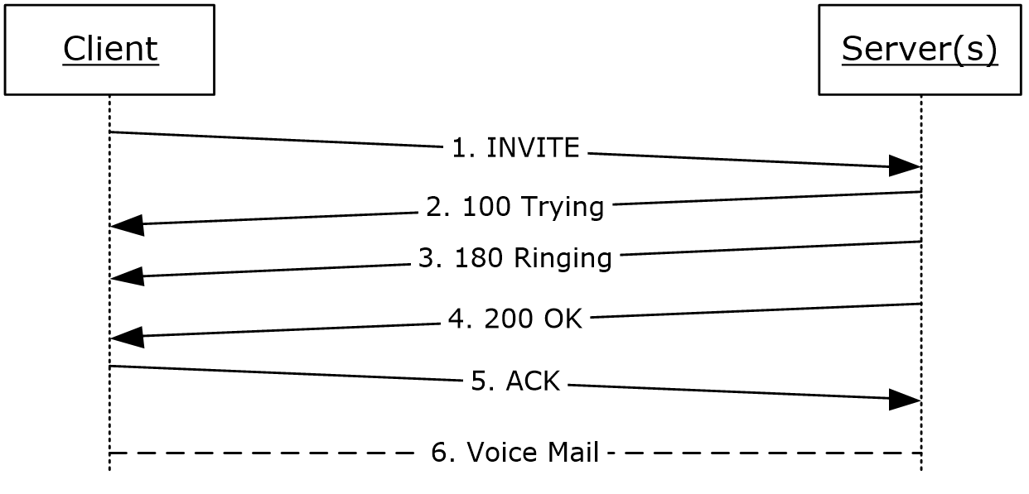
Figure 1: Subscriber access flow
The INVITE message carries the Ms-Exchange-Command header with the skip-pin parameter, as shown in the following example.
INVITE sip:alice@contoso.com;opaque=app:voicemail SIP/2.0
Via: SIP/2.0/TLS 10.56.65.37:33876
Max-Forwards: 70
From: <sip:alice@contoso.com>;tag=01742a55e6;epid=6b5d10e663
To: <sip:alice@contoso.com;opaque=app:voicemail>
Call-ID: f7c2efff9240413cb6e5125fdca4b63a
CSeq: 1 INVITE
Contact: <sip:alice@contoso.com;opaque=user:epid:ihclvAI6-FmKSGLKr_2rtAAA;gruu>
Ms-Exchange-Command: skip-pin
… SDP SNIPPED …

Ms-Sensitivity
The following figure shows the flow for the Ms-Sensitivity header that is added by the unified messaging server when dialing out to the protocol client.
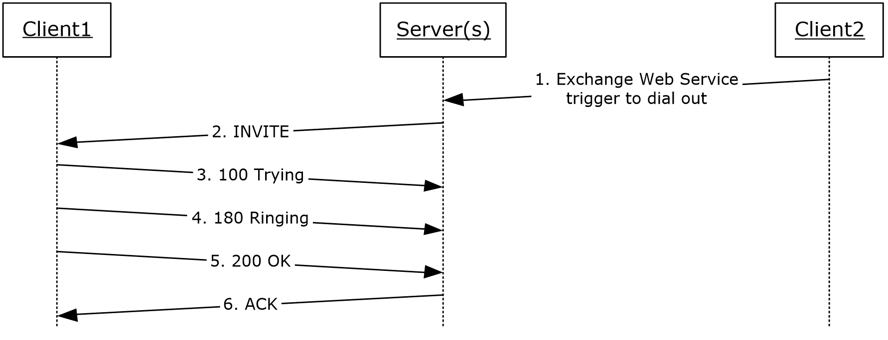
Figure 2: Play-On-Phone dial out
The INVITE message in step 2 of the preceding figure is shown in the following example.
INVITE sip:172.19.58.98:2280;transport=tls;ms-opaque=ce5f21cc9d;ms-received-cid=D0A300 SIP/2.0
Max-Forwards: 68
Content-Length: 317
From: <sip:alice@contoso.com>;epid=1944B98832;tag=7534fa434
To: <sip:alice@contoso.com>;epid=d793aff63a
CSeq: 5 INVITE
Call-ID: 7a7378c9-7b3c-4cec-b6da-ec27d752e904
Contact: <sip: exchange.contoso.com:5066;transport=Tls;ms-opaque=a752506cbee22182>;automata
User-Agent: RTCC/3.0.0.0
Content-Type: application/sdp
Allow: UPDATE
Ms-Sensitivity: private-no-diversion
Allow: Ack, Cancel, Bye,Invite,Message,Info,Service,Options,BeNotify
…SDP SNIPPED…

Security

Security Considerations for Implementers
None.

Index of Security Parameters
None.

Appendix A: Product Behavior
The information in this specification is applicable to the following Microsoft products or supplemental software. References to product versions include updates to those products.
- Microsoft Office Outlook 2007
- Microsoft Office Outlook 2007 Service Pack 1
- Microsoft Outlook 2010
- Microsoft Exchange Server 2007 Service Pack 1 (SP1)
- Microsoft Exchange Server 2010
- Microsoft Exchange Server 2013
- Microsoft Exchange Server 2016
- Microsoft Exchange Server 2019
- Microsoft Lync 2010
- Microsoft Lync Client 2013/Skype for Business
- Microsoft Lync Server 2010
- Microsoft Lync Server 2013
- Microsoft Office Communications Server 2007
- Microsoft Office Communications Server 2007 R2
- Microsoft Office Communicator 2007
- Microsoft Office Communicator 2007 R2
- Microsoft Skype for Business 2016
- Microsoft Skype for Business Server 2015
- Microsoft Skype for Business 2019
- Microsoft Skype for Business Server 2019
- Microsoft Skype for Business 2021
Exceptions, if any, are noted in this section. If an update version, service pack or Knowledge Base (KB) number appears with a product name, the behavior changed in that update. The new behavior also applies to subsequent updates unless otherwise specified. If a product edition appears with the product version, behavior is different in that product edition.
Unless otherwise specified, any statement of optional behavior in this specification that is prescribed using the terms "SHOULD" or "SHOULD NOT" implies product behavior in accordance with the SHOULD or SHOULD NOT prescription. Unless otherwise specified, the term "MAY" implies that the product does not follow the prescription.
<1> Section 3.2: Office Outlook 2007, Office Outlook 2007 SP1, and Outlook 2010 support Play-On-Phone as an option. Any of these clients can be used to raise the event.

Change Tracking
This section identifies changes that were made to this document since the last release. Changes are classified as Major, Minor, or None.
The revision class Major means that the technical content in the document was significantly revised. Major changes affect protocol interoperability or implementation. Examples of major changes are:
- A document revision that incorporates changes to interoperability requirements.
- A document revision that captures changes to protocol functionality.
The revision class Minor means that the meaning of the technical content was clarified. Minor changes do not affect protocol interoperability or implementation. Examples of minor changes are updates to clarify ambiguity at the sentence, paragraph, or table level.
The revision class None means that no new technical changes were introduced. Minor editorial and formatting changes may have been made, but the relevant technical content is identical to the last released version.
The changes made to this document are listed in the following table. For more information, please contact dochelp@microsoft.com.
Section | Description | Revision class
6 Appendix A: Product Behavior | Updated list of supported products. | Major

Index
A

Abstract data model
Ms-Exchange-Command 10
Ms-Sensitivity 11
Applicability 7

C

Capability negotiation 7
Change tracking 17

D

Data model - abstract
Ms-Exchange-Command 10
Ms-Sensitivity 11

E

Examples
Ms-Exchange-Command 13
Ms-Sensitivity 13

F

Fields - vendor-extensible 7

G

Glossary 5

H

Higher-layer triggered events
Ms-Exchange-Command 10
Ms-Sensitivity 11

I

Implementer - security considerations 15
Index of security parameters 15
Informative references 6
Initialization
Ms-Exchange-Command 10
Ms-Sensitivity 11
Introduction 5

L

Local events
Ms-Exchange-Command 10
Ms-Sensitivity 12

M

Message processing
Ms-Exchange-Command 10
Ms-Sensitivity 11
Message syntax 8
Messages
message syntax 8
Ms-Exchange-Command 8
Ms-Sensitivity 8
transport 8
Ms-Exchange-Command
abstract data model 10
example 13
higher-layer triggered events 10
initialization 10
local events 10
message processing 10
overview 10
sequencing rules 10
timer events 10
timers 10
Ms-Exchange-Command message 8
Ms-Sensitivity
abstract data model 11
example 13
higher-layer triggered events 11
initialization 11
local events 12
message processing 11
overview 11
sequencing rules 11
timer events 11
timers 11
Ms-Sensitivity message 8

N

Normative references 6

O

Overview (synopsis) 6

P

Parameters - security index 15
Preconditions 7
Prerequisites 7
Product behavior 16

R

References 6
informative 6
normative 6
Relationship to other protocols 7

S

Security
implementer considerations 15
parameter index 15
Sequencing rules
Ms-Exchange-Command 10
Ms-Sensitivity 11
Standards assignments 7

T

Timer events
Ms-Exchange-Command 10
Ms-Sensitivity 11
Timers
Ms-Exchange-Command 10
Ms-Sensitivity 11
Tracking changes 17
Transport 8
Triggered events
Ms-Exchange-Command 10
Ms-Sensitivity 11

V

Vendor-extensible fields 7
Versioning 7

